Kanosh Town Corporation held the official Municipal Canvass Wednesday, November 10, 2021, electronically and in the town office at 7:00 p.m.
Members present:
Mayor Frank Paxton, Councilmember's: Brandon Stephenson, Rodney Whatcott, Neil Shumway, and Hayden George, and Kanosh Town Treasurer Karen Crook, Kanosh Town Clerk: Cindy Turner

Others in attendance: CERT Captain Geri Minton, Stan Koyle, Kooyey, Steve Crabb, Wenda Crabb, Ben Coray, David Whitaker, Scott McDonald, and Josh Whitaker

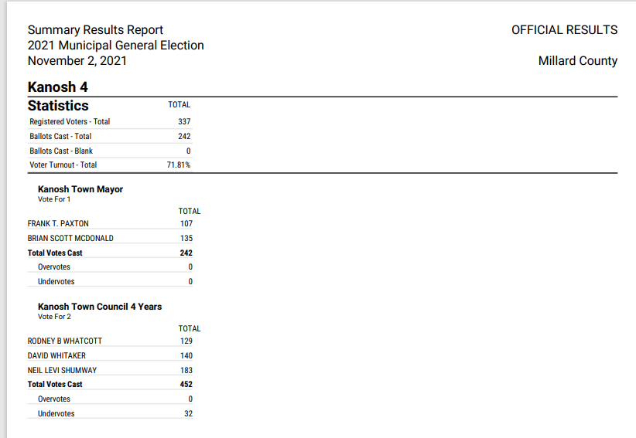

Councilmember Hayden George motioned to accept the official canvass votes. Councilmember Brandon Stephenson provided a second to the motion, all Council members voted in favor as noted below:
Mayor Frank Paxton: Aye
Council members
Rodney Whatcott: Aye
Brandon Stephenson: Aye
Neil Shumway: Aye
Hayden George - Aye

Kanosh Town Corporation held the regular council meeting on Wednesday, November 10, 2021, electronically and in the town office at 7:00 p.m.
Members present:
Mayor Frank Paxton, Councilmember's: Brandon Stephenson, Rodney Whatcott, Neil Shumway, and Hayden George, and Kanosh Town Treasurer Karen Crook, Kanosh Town Clerk: Cindy Turner

Others in attendance: CERT Captain Geri Minton, Stan Koyle, Jim Kooyey, Steve Crabb, Wenda Crabb, Ben Coray, David Whitaker, Scott McDonald, Josh Whitaker

Councilmember Neil Shumway offered the invocation.

Councilmember Brandon Stephenson led everyone in the Pledge of Allegiance.

Minutes of the October 13, 2021 meeting were read and were approved as amended through motion by Councilmember Neil Shumway Councilmember Rodney Whatcott provided a second to the motion, all Council members voted in favor as noted below:
Mayor Frank Paxton: Aye
Council members
Rodney Whatcott: Aye
Brandon Stephenson: Aye
Neil Shumway: Aye
Hayden George - Aye

Warrants for November 2021 were read discussed and approved to be paid through a motion by Councilmember Brandon Stephenson, Councilmember Hayden George seconded the motion, all Council members voted in favor as noted below:
Mayor Frank Paxton: Aye
Council members
Rodney Whatcott: Aye
Brandon Stephenson: Aye
Neil Shumway: Aye
Hayden George: Aye

CERT
CERT Captain Geri Minton provided a brief update on the CERT team stating there will be no meeting in December.

The CERT team has been taking an inventory of the medical supplies they will need to order and submit their request in the January meeting.

They are also working on the conference usually held at the end of March.

Fire Department:
Fire Chief Lorin Shumway reported it has been pretty quiet.

The Volunteers are getting ready for registration for winter fire school. Efforts are also underway to get back on track with training.

Planning and Zoning:
Nothing new to report at this time.

Culinary Well Project:
Mayor Frank Paxton appointed Councilmember Brandon Stephenson to serve as the Town's representative for the Well Project. Councilmember Stephenson accepted the appointment, all Councilmembers voted in favor of the appointment favor as noted below:
Mayor Frank Paxton: Aye
Council members
Rodney Whatcott: Aye
Brandon Stephenson: Aye
Neil Shumway: Aye

Councilmember Rodney Whatcott drafted the following letter to water users, thanking them for all of the efforts made to conserve our water supply during this drought:

November 2021
Thank You Kanosh Town Culinary Water Users!
The Kanosh Mayor and Town Council would like to express their deepest gratitude to each of you for your water conservation efforts this past summer.
Our town's spring water flows this past summer were some of the lowest we have on record; it was because of your conscience efforts the town had sufficient water for our needs this past year.
We realize that our town has grown recently and is continuing to grow. As a Town Council, we want to do all we can to meet the future demands on our water system.
In an effort to better provide for the water needs of our community, we are excited to report that funding for a new culinary well has been approved and that the project is already in the preliminary stages.
As always, if you have any questions or comments regarding this, or any other town matter, feel free to contact us.
Thank you again for your efforts and may we all continue to work together to make this a wonderful place to live.
Wishing each of you a Happy Holidays!!!
Kanosh Mayor and Town Council
Mayor: Frank Paxton
Councilmembers: Rodney Whatcott, Neil Shumway, Hayden George, Brandon Stephenson

Councilmember Rodney Whatcott motioned to approve letter and send it out to the Kanosh Town water users, Councilmember Hayden George seconded, all Council members voted in favor as noted below:
Mayor Frank Paxton: Aye
Council members
Rodney Whatcott: Aye
Brandon Stephenson: Aye
Neil Shumway: Aye
Hayden George: Aye

Kanosh Town Christmas Celebration:
The Candy was ordered back in August, there are a only few things left to pick up.
Santa is scheduled to attend the celebration!! Everything is moving forward as planned!

Park:
Councilmember Hayden George questioned the status of getting the signs up? It is imperative to have the signs in place before the snow comes, helping educate people NOT to shovel the snow from the pickleball courts.

Cemetery:
Councilmember Hayden George noted that the roads in the cemetery need to be crack sealed. Due to the temperature, we may have to wait until spring to do the project, in the meantime cost estimates will be obtained.

Electrical Department
Councilmember Neil Shumway stated that he has nothing new to report on the electrical department at this time.

Roads:
Councilmember Brandon Stephenson received a letter from UDOT for a safe sidewalk program. This program is a 25% match, money has been set aside for this kind of project. Councilmember Stephenson will look into it and report on his findings, he will also look into the Safe route to school program in an effort of seeing which program will benefit Kanosh Town the most.

Water:
Councilmember Rodney Whatcott reported that there have been a few leaks, however, they have been repaired.

Councilmember Whatcott noted that as the well project continues, it is a great project for the town. He reiterated his feelings that Councilmember Stephenson will do a great job!

Review of Utility Delinquencies:
Councilmembers reviewed the monthly delinquency list. It was determined, again, to handle those accounts in arrears according to established Town policy.

Kanosh Town Treasurer presented the following names for refunds:
*Water refunds
Allyson Kristopherson 75.00
Bryant Cummings 75.00

*Park Reservation refunds:
Merla Rutherford: 100.00
Owen Staples 150.00
Great Lake Cheese 100.00

*Building inspections:
Mrs. Crook has been in contact with Millard County concerning the cost of building inspections resulting in the following information: Millard County stated that Kanosh had paid as the inspections were completed however, Millard County bills 60% of the building permit plus the plan check.

Public comments: limit of 3 minutes
There were no Public comments at this time.

Old Business
* F450
The F450 is now in Kanosh and needs to be auctioned off.
As soon as the Town Employee Lorin Shumway gets pictures to the clerk, it will go out for bid.

*Corn Creek Project
Councilmember Hayden George reported the board is having a meeting each week to iron out various issues. Some of the members feel we could be waiting for a lawsuit, if that is the case should they use the town's attorney or obtain their own legal counsel? Council members felt it would be in the best interest of everyone involved if the irrigation company found their own attorney. The irrigation company can hire Justin Wayment, to serve their legal needs at their own cost. CCI is doing their best in trying to move forward with the project.

There being no further business to come before the board, the meeting adjourned.

Frank Paxton, Cindy Turner,
Kanosh Town Mayor Kanosh Town Clerk

