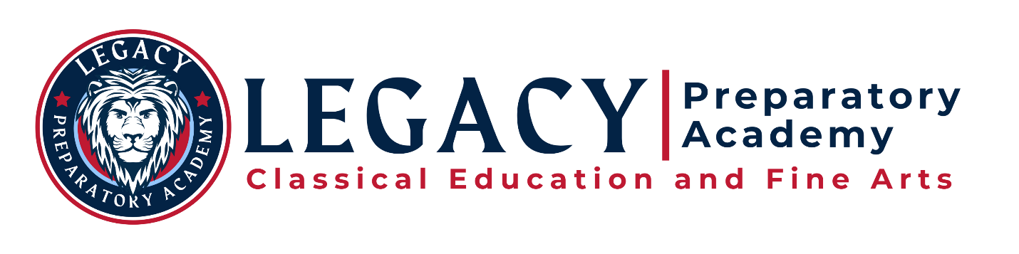
Note-Location
Governing Board Meeting | December 9, 2021
Woods Cross Campus,
2214 South 1250 West, Woods Cross UT 84087
Thursday, December 9, 2021, 7:00 PM, In-Person/Virtual Meeting
Online Meeting Access - Link https://us02web.zoom.us/s/87161130023

AGENDA

Mission Statement of Legacy Preparatory Academy:
Legacy Preparatory Academy will cultivate intellectual and moral virtue
according to classically based pillars of truth, goodness, and beauty.

Areas of Focus, Schoolyear 2021-2022
  - Management of successful k-9 transition and administrative restructure
  - (Re)Focus on classical education and branding
  - Timely progress of campus consolidation and construction, including prep. for physical consolidation
  - Board communication improvements (quality, cadence, transparency, etc.)
  - Mission/Vision/Values education and promotion
  - Physical and mental well-being of LPA staff and students
  - Promotion and measurement of high-quality educational practices as a core competency and marketing differentiation
  - Professional development for teachers and administrators
  - Monthly accountability and review/approval of board and school policies in accordance with a policy calendar
  - Process, policy, and procedure audit and remedy where appropriate
  - Board conducts meaningful and timely reviews of administrative staff
Business of the Governing Board
7:00 OPEN MEETING: ROLL CALL AND WELCOME – Al Pranno
- Roll Call, Opening comments
- Welcome! to Kelsey Richardson, Board Liaison with Academica West

7:00 BOARD MEMBERSHIP UPDATE – Al Pranno
- Attempting to schedule meeting with current applicant
- Other/comments

7:10 EDUCATION AND TRAINING – Al and Anna Mark
- Email sent from Anna outlining required training (we already completed module 1 re: Fiscal training(?)). Please confirm to Anna when completed
7:10 COMMITTEE REPORTS
  - Audit committee – additional training
  - Governance committee update
    - Bonding policies review and vote:
      - Disclosure Policy and Procedures
      - Financial and Risk Management Plan
      - Succession Plan
  - Executive committee:
    - Academica West – hitting the ground running!
    - Research/analysis of Helpside Inc., Dec 6, 2021 vote

Business of Administration and Staff
7:25 Success Celebrated!
- Liberty Elementary Service Project
7:30 ENROLLMENT UPDATE– Jules Snarr, Brandie Evans, Priscilla Stringfellow
- Enrollment status update
- Enrollment Lottery status and numbers
- Direction (ongoing) from the Board: progress update

7:35 COMMUNICATION AND MARKETING – Jules Snarr, Brandie Evans
- Nova Leonum: December 6, 2021 – January 2, 2022 edition
  - New Kindergarten options
  - Giving Tree project
  - Intent to Enroll dates
- Direction from the Board: advise of any revisions or updates; any recipient feedback

7:45 MANAGING DIRECTORS REPORTS – Brandie Evans & Priscilla Stringfellow
- Director’s Report review and highlights
- Safety of Administration, Teachers and Staff, Students and Stakeholders:
  - COVID – 19 status and protocols; current status/dashboard
  - How are the students doing? Teachers and staff?
- Organization Updates:
  - Difficult life circumstances experienced by staff recently
  - Promotions/placements
  - Vacancies
  - Teachers status (paras and instructors, also)
  - Business Management
    - Following contracting with Academica West and Helpside, brainstorm on other vendor service contracts no longer needed, timing, process

8:05 CAMPUS CONSOLIDATION AND DEVELOPMENT– Lee Peterson, Jim Collings, Brandie Evans
- Construction status
  - Weekly meetings – owner meetings and construction meetings
- Status of OneWest AIA Contract to the State – Lee
- Access road status

8:20 FINANCIAL MANAGEMENT REPORT, GRANTS, & OTHER APPROVAL – Brandie Evans, Alisha Johnson, and Roger Simpson with Academica West
- Financial report review
- Construction Bonding:
  - Rating received after November 10, 2021 presentation
  - ‘Credit letter’ receipt
  - Other status update
- Key state reports
- Purchases over $5000 – Alisha Johnson

8:40 PUBLIC COMMENT – Al Pranno
- Review of public comment protocol and feedback
- Online and in-person comment

8:50 CONSENT AGENDA – Brandie Evans, Priscilla Stringfellow, David Ray
- Approval of November 11, 2021 meeting minutes
- Approval of November 18, 2021 special session meeting minutes
- Approval of December 6, 2021 special session meeting minutes
- From Managing Directors
- Rob Morton - PE/Health teacher/athletic director
- Dallin Brown - SpEd paraeducator (Nephew of Paul Maloy, not a direct report)
- Debbie Anderson - SpEd paraeducator
8:55 CLOSED MEETING (if necessary): To discuss character, professional competence, physical or mental health of an individual (employee or student), and any of the following topics, if necessary: strategy sessions to discuss the purchase, exchange, lease or sale of real property; collective bargaining; or pending litigation, or other matters appropriate pursuant to statute(s).

Description | Owner | Due Date
Upload Approved Minutes, Audio and Materials to Utah Public Notice website for month of the original meetings – Label file as Approved with Date | David Ray | 12/12/2021
Upload Approved Minutes, Audio and Materials to Legacy Preparatory Academy Website for month of the original meetings – Label as Approved with Date | Jules Snarr | 12/12/2021

~9:00 ADJOURN

LPA Governing Board: 2022: Al Pranno (President), Andrew Lavin (Vice-President), Jim Collings (Member). 2023: Alisha Johnson (Treasurer), David Ray (Secretary). 2024: Lee Peterson (Member), Anna Mark (Member).

