City of Ephraim
Request for Qualifications: Library Park

Introduction

The City of Ephraim, Utah is requesting qualifications (RFQ) to provide services supporting the overall design and construction of an inclusive playground at a park site in Ephraim. The City of Ephraim has received multiple grants and donations to financially support this project.

The City of Ephraim will form a committee to evaluate qualifications submitted and select a preferred company. After selection of the preferred company, a specific agreement for services will be negotiated and presented to the City of Ephraim City Council for approval.

Scope of Work

The scope of work for this proposal should include the ability of the submitting company to provide the following services:

- Design of an ADA Accessible 5-12-Year-Old play structure with features that:
  - Incorporates high play value (physical, cognitive, and social development)
  - Be used by all
  - Complementary to the environment and overall park surroundings.
  - Meet and/ or exceed all applicable standards: ADA, CPSC, ASTM, ISO, etc.
- Delivery playground equipment to site location in an appropriate time outlined in the section titled “Project Schedule”.
- Provide a professional who is qualified and has obtained the National Recreation and Park Association (NRPA) certification to be a Certified Playground Safety Inspector (CPSI) to assist with the assembly of the project.
- Provide and install 3,577 total sq. ft. of playground surfacing made of poured-in-place safety surfacing. The poured-in-place safety surfacing shall provide appropriate impact attenuation for the play area.

The City of Ephraim will provide the following:

- Dismantle and remove the current playground equipment and structures.
- Site preparation, which includes grading for surfacing installation and grubbing.
- Installation, placement, and assembly of all playground equipment.

The scope of work as listed above must be completed within the budget of $165,000.00.

Project Schedule

The following project schedule is proposed:
Publish of RFQ: December 3rd, 2021
Response Deadline for RFQ: December 13th, 2021
Review and Selection of RFQ: December 14th, 2021
City Council Award and Contract: 12/15/2021
Manufacture and Freight of Project: December 2021- March 2022
Project Construction: March 2022
Substantial Completion: April 2022
Project Completion: April 2022

Selection Process

A selection committee will review the experience and qualifications of each proposal based on the information provided in the response to this RFQ. Responses to this RFQ will be awarded points based on the breakdown provided below. Points will be totaled from all members of the committee. The highest cumulative points awarded will recognize the winner proposal.

The selection committee will select the proposal that received the highest points. The Ephraim City Council will negotiate a contract with the proposal with the highest points. If negotiations cannot be reached with the company that submitted the proposal, the second highest point proposal will be selected. This process will continue until a negotiated contract can be presented to council for approval.

The following is the breakdown of how points will be awarded:

- Performance Standards, Approach, and Ability to Fulfill Scope of Work- 15 Points
Each member of the selection committee will assess to the best of his/her judgement the proposal’s approach to the project and the ability to perform all work. The selection committee will assess the proposal’s creativity, cost saving ideas, and additional components. The selection committee will also review the number and types of features in the proposed play structure.

- Experience, Qualifications, and Quality of Work- 15 Points
Each member of the selection committee will assess to the best of his/her judgement whether the company’s proposal has sufficient qualifications and experience to successfully perform the scope of work and evaluate the quality of work as presented. The selection committee will also assess the applicability and the relevance of the company’s experience and previous projects.

- Project Timeline- 10 Points
Each member of the selection committee will review the proposed timeline in the proposal. The selection committee will award points based on the company’s ability to fulfill the proposed timeline in this RFQ.

- Conceptual Design- 10 Points
Each member of the selection committee to the best of his/ her judgement, will review the proposal’s conceptual design. The design provided must fulfill the project’s scope of work, meet the project’s budget, and be completed within the project’s timeline.

Evaluation

The following is the rubric that the selection committee will use to evaluate proposals:

Company | Performance Standards, Approach, and Ability to Fulfill Scope of Work- 15 Points | Experience, Qualifications, and Quality of Work- 15 Points | Project Timeline- 10 Points | Conceptual Design- 10 Points | Total-  50 Points

Information and Instruction for RFQ

Proposals will be received until December 13th, 2021 at 5:00 PM. Proposals can be delivered to Ephraim City via email to michael.patton@ephraimcity.org mailed to Ephraim City at 5 South Main Street, Ephraim, Utah or can be hand-delivered to Ephraim City Hall, located at 5 South Main Street, Ephraim, Utah 84627. Any proposals received at the stated date and time will be rejected for review.

In order to be considered for selection, proposals must arrive to the City in the manner and on or before the date and time specified in the RFQ. Any proposer mailing responses should allow normal mail delivery time to ensure timely receipt of their materials. Any proposal received after the scheduled closing time for receipt of proposals, or incorrectly addressed, will not be considered. Delivery in the manner stated herein and completeness of submittals as required by this RFQ shall be solely the responsibility of the proposer. Submission of proposals or additional information offered after the closing date and time will not be accepted or considered.

Required Information to be Included in Proposal
The following is information that should be included in the proposal from those that answer this RFQ:

- Completion of the Project Form (located on page 8 of the RFQ).
- General Information about the company and of the person that will oversee this project.
- List of previous projects completed related to inclusive and all-abilities playgrounds and poured-in-place rubber playground surfacing.
- Proposed Project Timeline.
- Proposed Conceptual Design.
- A list of playground features and items that are presented in the conceptual design.

Right to Modify Process:

The City reserves the right to modify the selection process or other aspects of this RFQ process at its sole discretion. The City will take reasonable steps to ensure that any modification or clarification to the RFQ shall be distributed in writing to all persons who have requested a copy of the RFQ through the City.

Additional Information:

The City reserves the right to request additional information following its initial review of the proposal documents. City staff may conduct a review and verification of confidential information with staff and consultants.

Equal Employment Opportunity Policy:

It is the policy of the City to promote equal opportunity to all persons regardless of race, color, religion, national origin, sex, age, or disability, in respect to employment, housing, public services, facilities, and accommodations. This policy is reinforced by obligations assumed by the City as a condition of receipt of federal and state funds. This policy thus becomes an obligation that must be assumed by the successful proposer as well.

Pre-Proposal Interpretation and Addenda of Contract Documents:

Any clarification or interpretation of the RFQ will be made only by written notification. The City is not responsible for any explanation, clarification, or interpretation given in any manner except by written notification and/or addendum.

Accept or Reject Proposals:

The City reserves the right to accept or reject any or all proposals in response to this RFQ without cause or delay or cancel this RFQ process without liability to the City if the City determines it is in the public’s interest to do so.
Additional Project Details

The following are pictures of the current playground structure at the park facility:

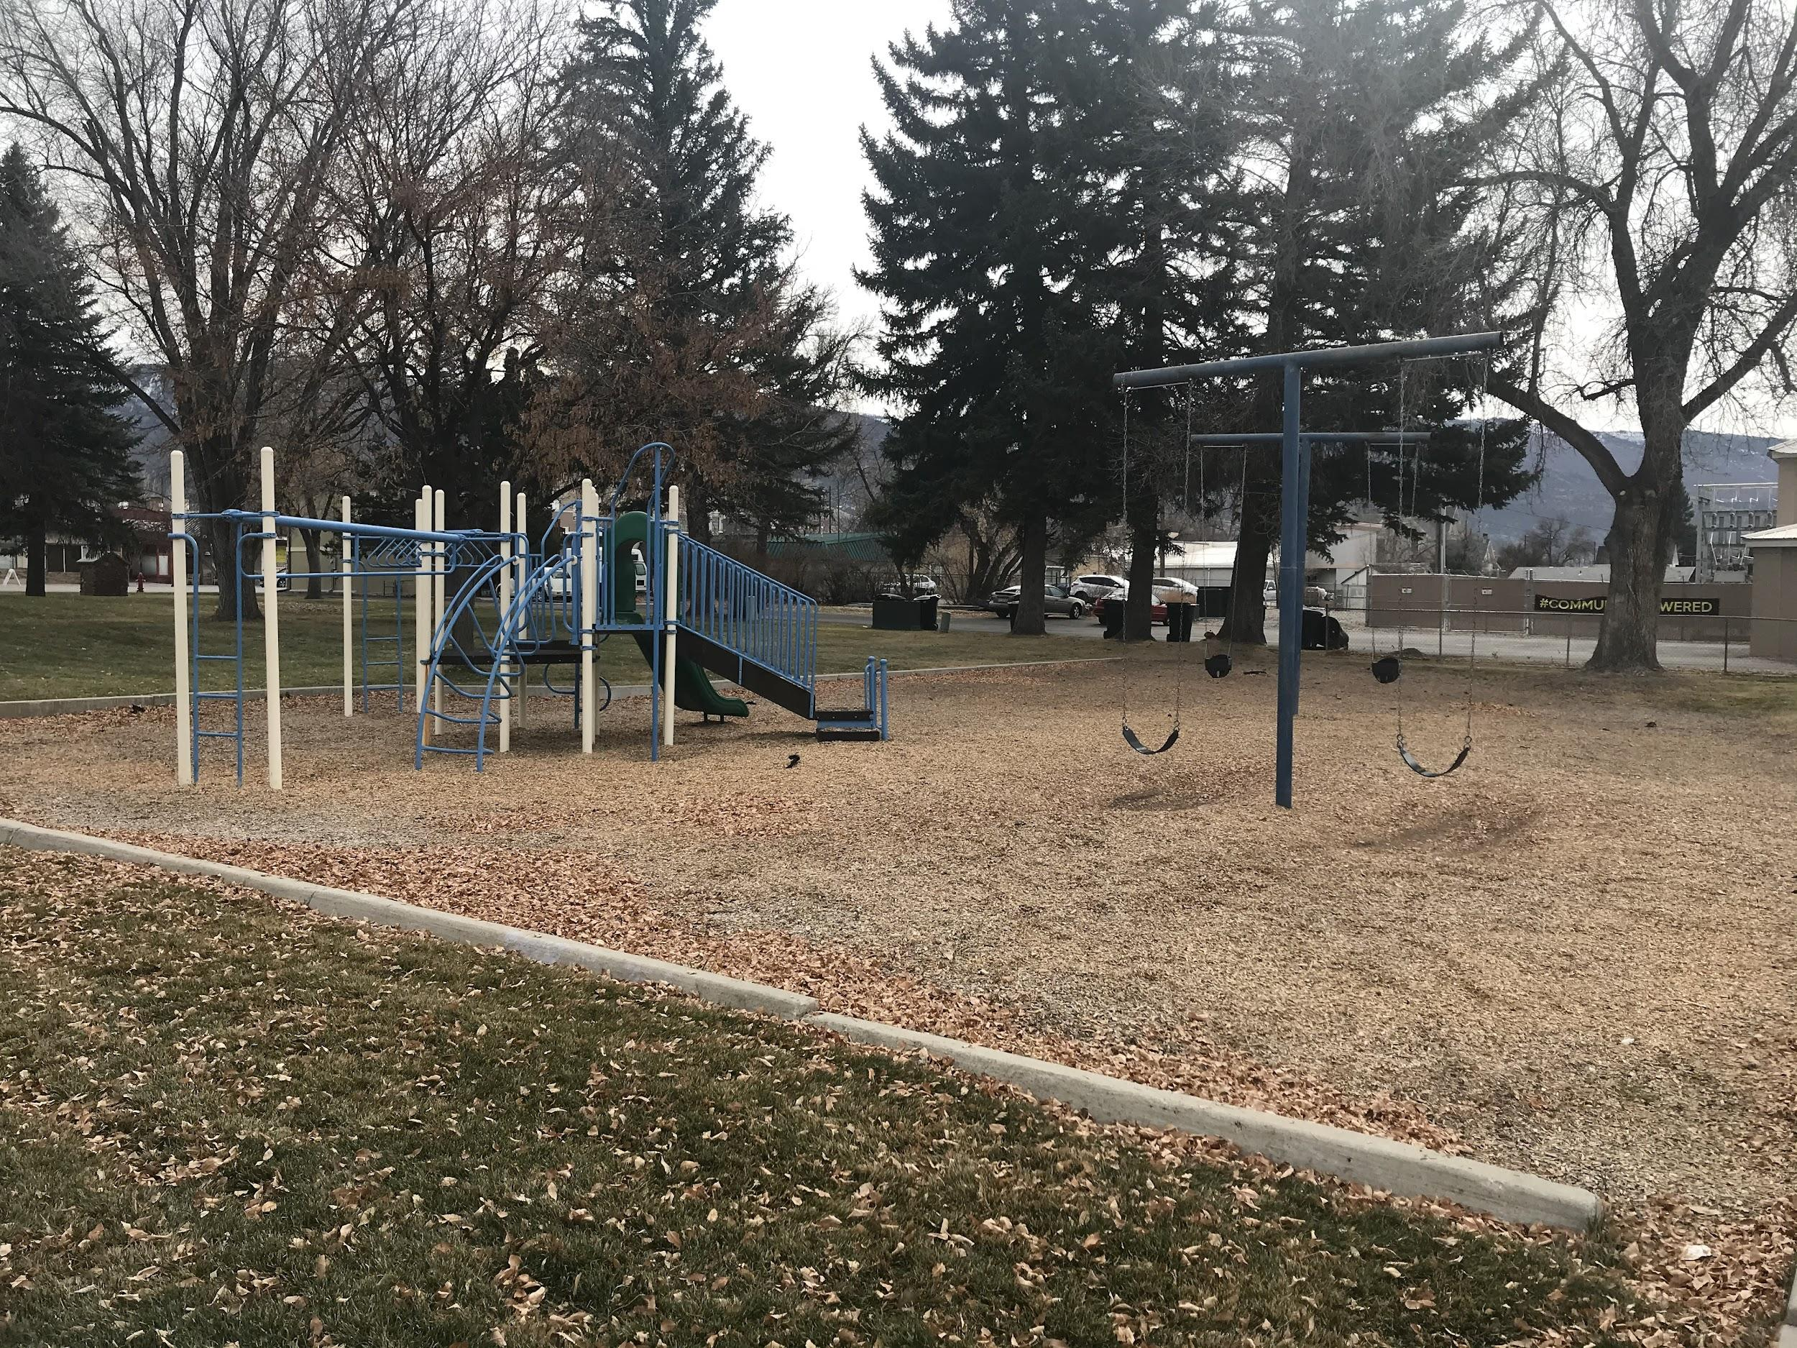
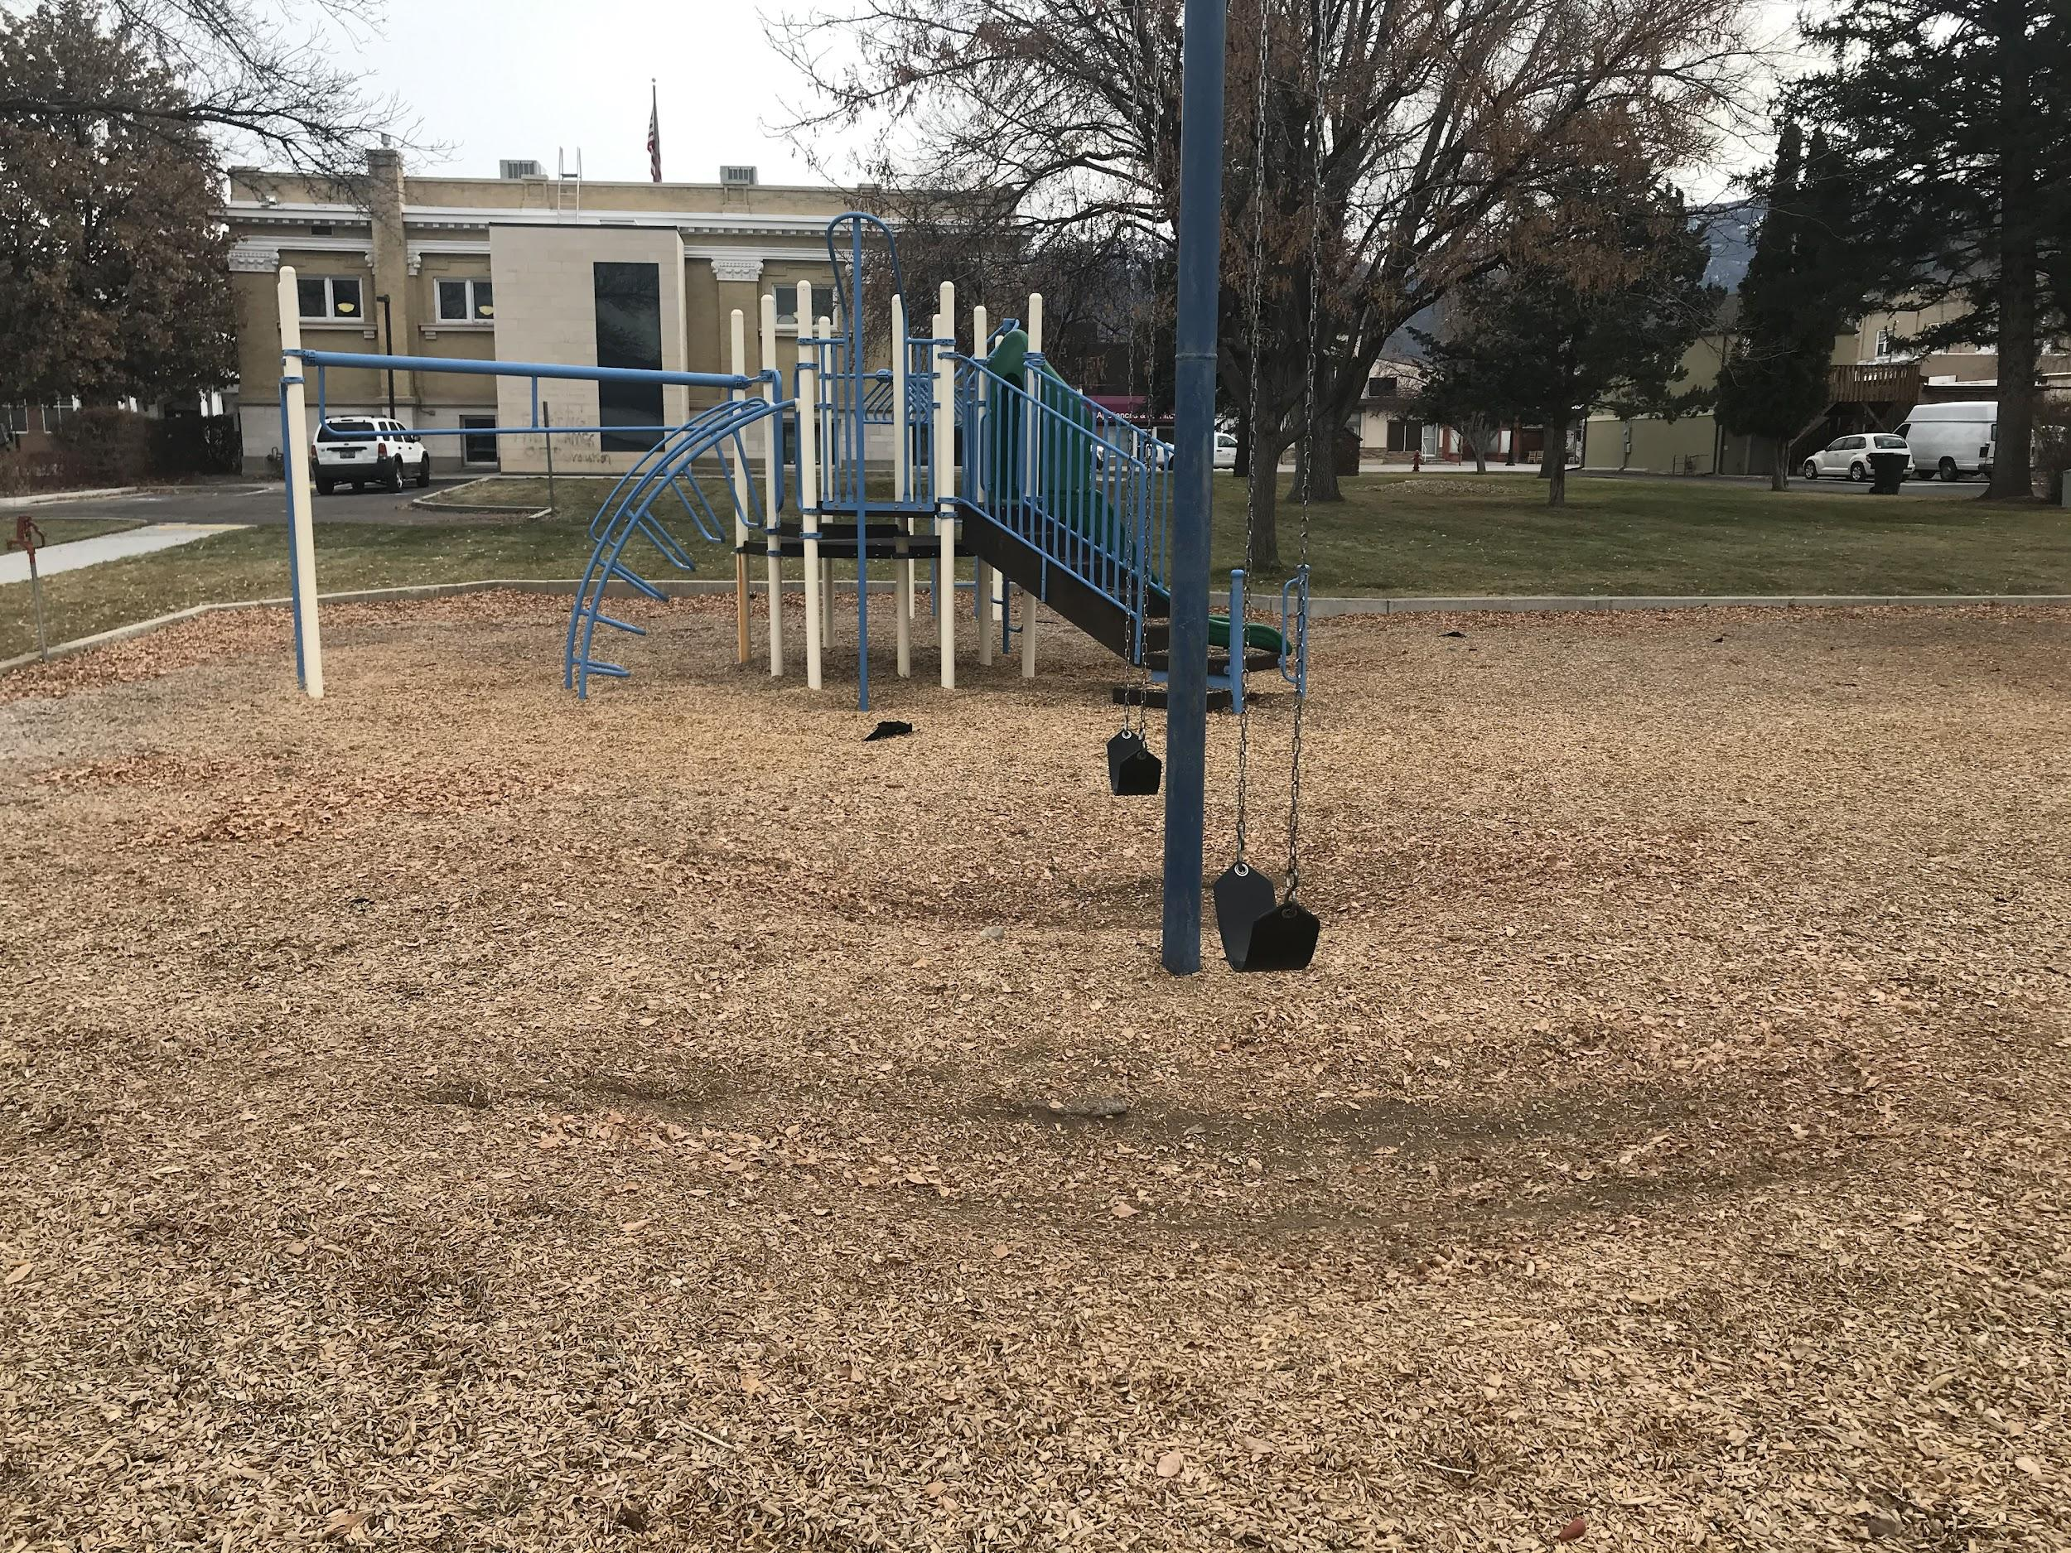

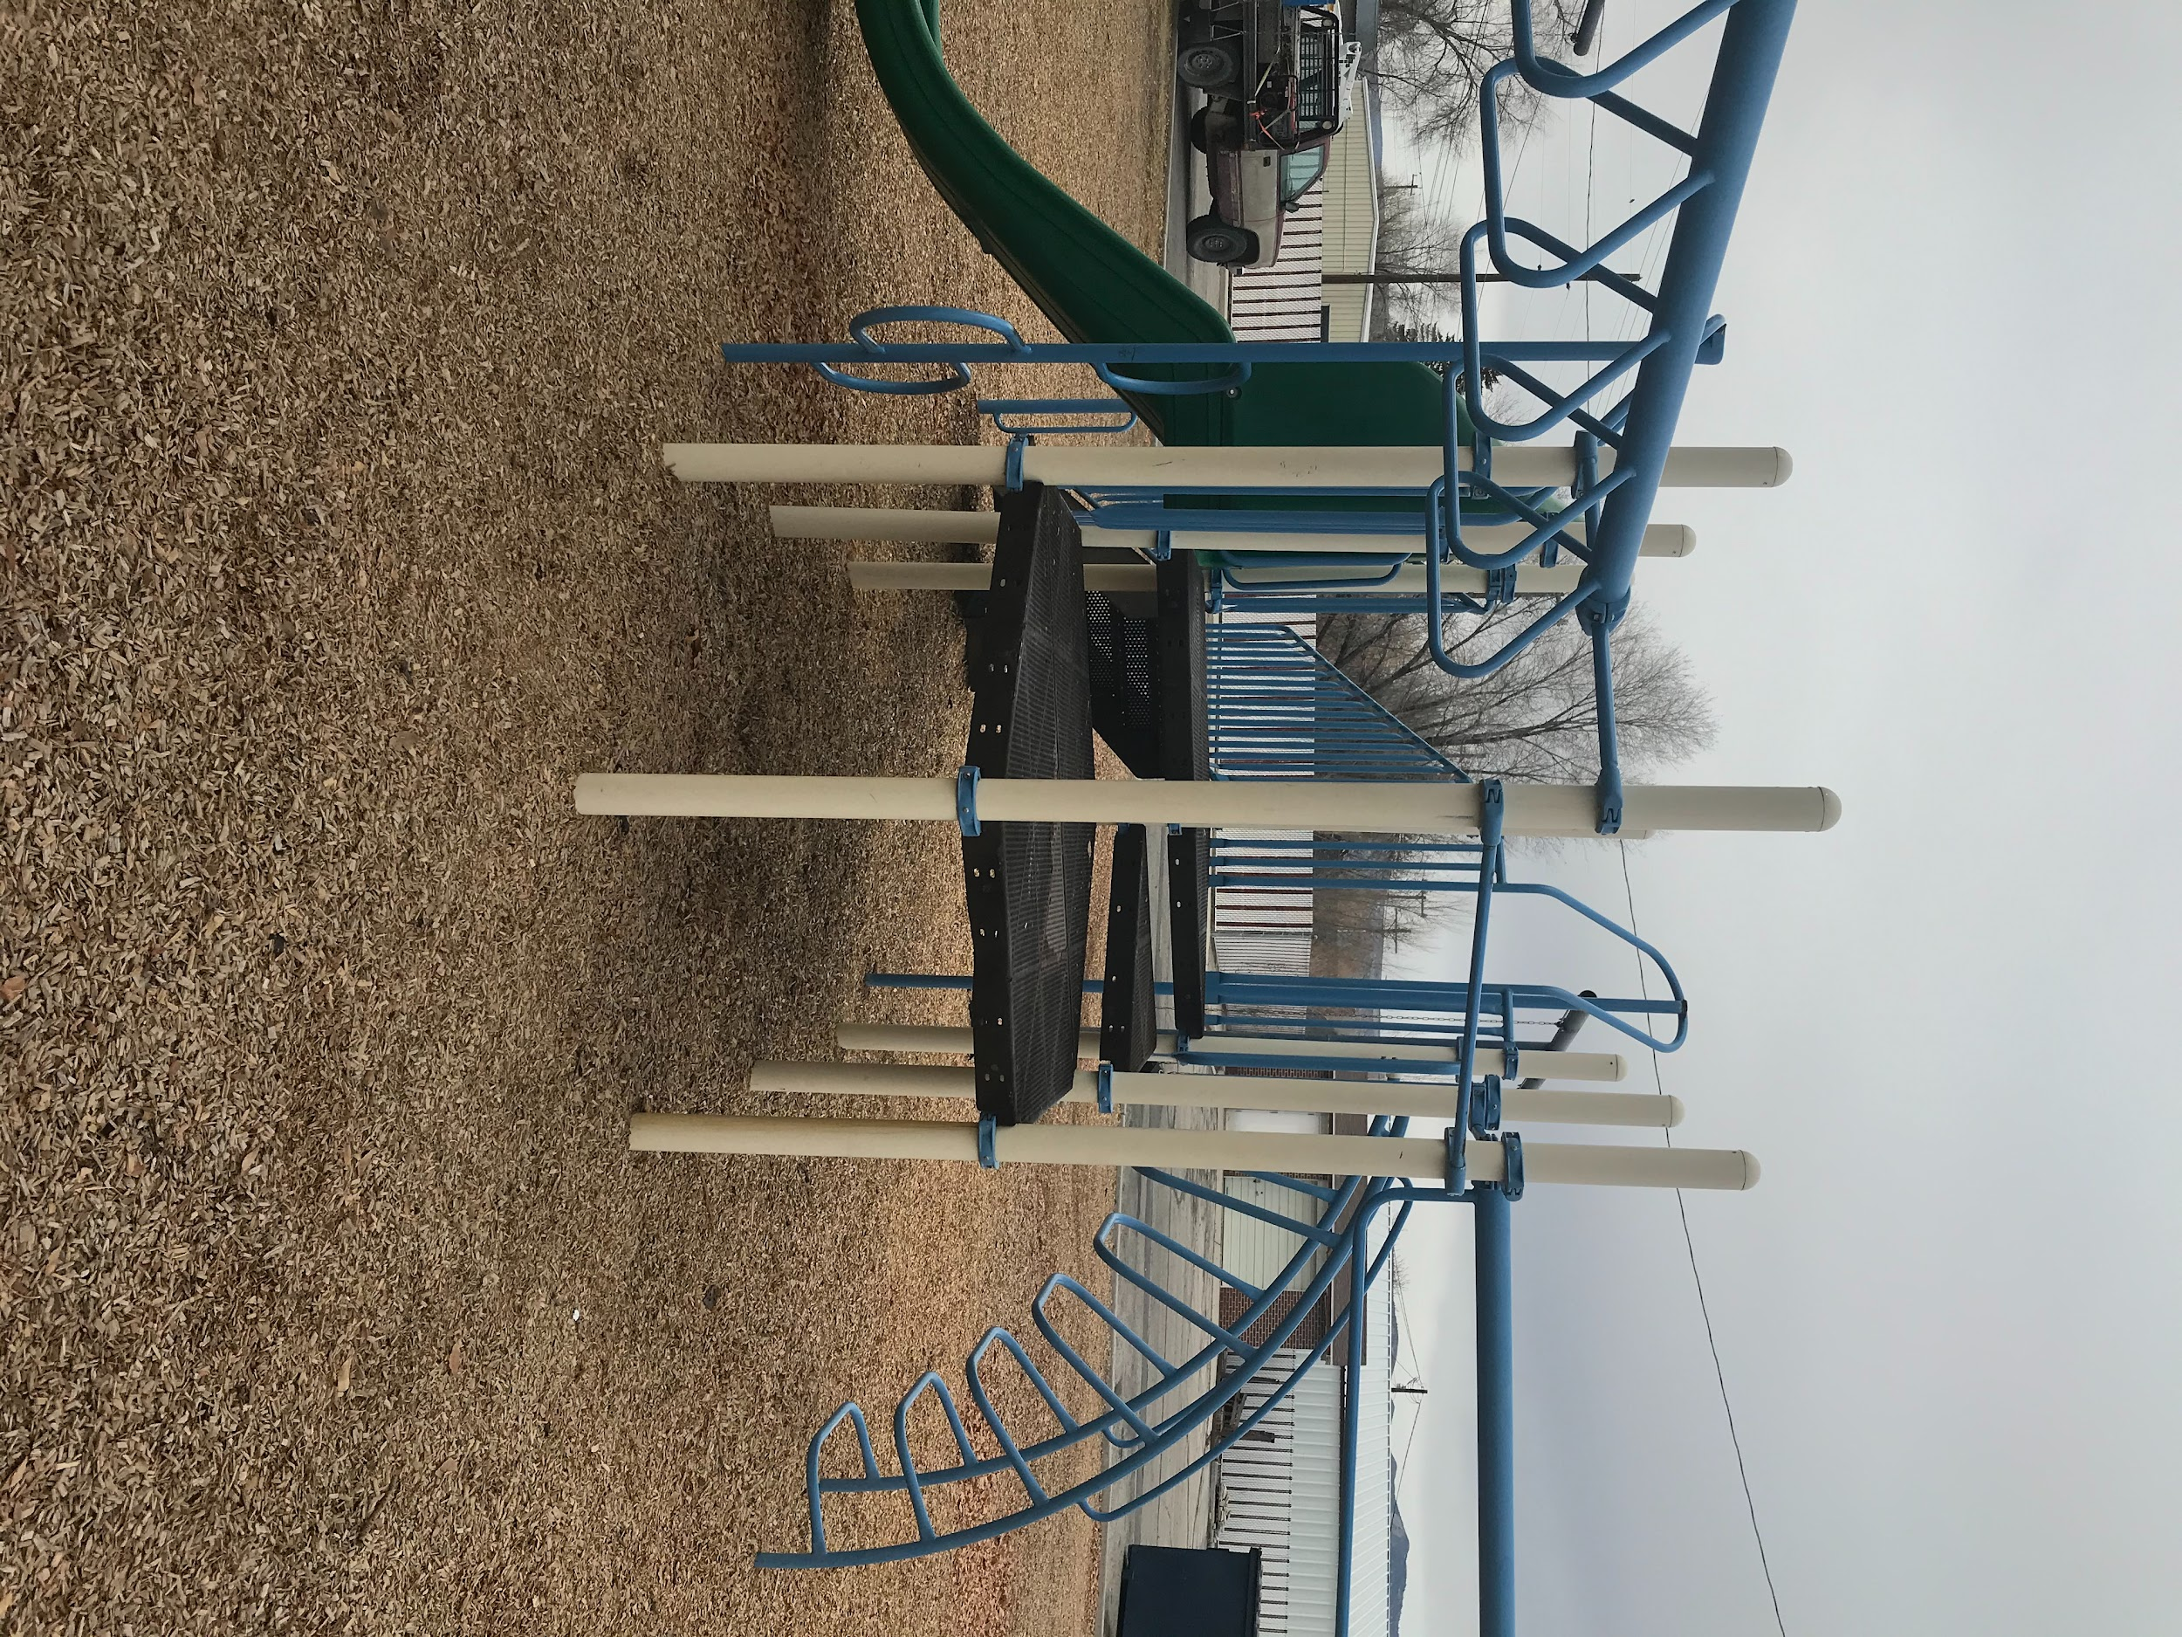
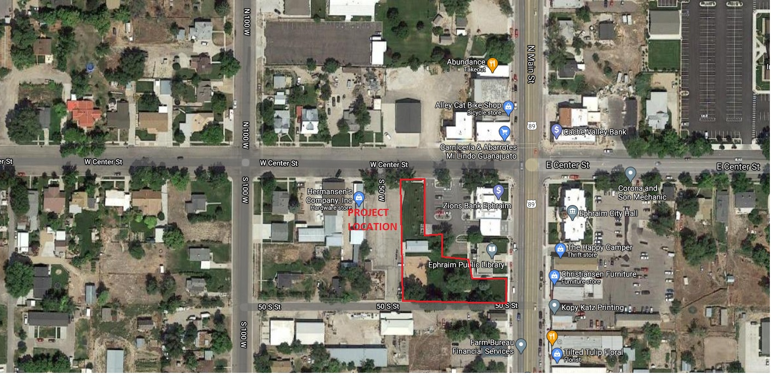

Contact Information

Please contact Michael Patton if there are questions, concerns, or comments about the Request for Qualifications document and all addenda.

Michael Patton
Ephraim City Recreation Director
5 South Main Street, Ephraim, Utah, 84627
Phone: (435) 283-4631
Email: michael.patton@ephraimcity.org

Ephraim City Library Park
Project Form

Organization Name:___________________________________________________________

Organization Address:_________________________________________________________

Organization Phone Number:___________________________________________________

Name of Contact:_____________________________________________________________

Contact Email:_______________________________________________________________

Signature
By signing below, the proposer and organization understands and agrees to all the terms and conditions outlined in Ephraim City’s Request for Qualifications for the Ephraim City Library Park Project.

Applicant Signature

_______________________________________

Applicant Printed Name

_______________________________________

