OPEB Board Meeting
Wednesday, February 10, 2021 – 11:30 AM – 12:30 PM
WebEx – Electronic Meeting Only
Meeting video/audio (log in first)
- Roll Call
Trustees Present:
Darrin Casper, Chief Financial Officer
K. Wayne Cushing, Treasurer
David Delquadro, Council Fiscal Manager
Lori Okino, Mayor Operations
Other Attendees:
Jim Sakellariou, Chief Deputy Treasurer
Jason Williams, Moreton
Brett Carlson, Mayor’s Financial Administration
Shanell Beecher, Mayor’s Financial Administration
Mari Vellido, Mayor’s Financial Administration
Absent:
No members of the public attended.
- Review minutes from 09/21/20 and move to approve.
Mr. Casper asked the board members if they had a chance to review the minutes from September 21, 2020 and asked if they had any edits or corrections.
Ms. Okino and Mr. Delquadro had suggested changes and Mr. Casper asked them to send them over to Ms. Vellido for modification.
The modifications and edits are attached.

- Investments Standing
Mr. Casper moved on to discuss item #3 (Investment Standings) and asked Mr. Carlson if he had any information on the standings of the fund balances and results of operations for the year.
Mr. Carlson shared the OPEB Trust Fund Comparison of Revenues and Expenditures query and noted that all the expenses were in except for a few RX receivables. (Attached spreadsheet)
As of December 31, 2020, there was a revenue of $5.489 million in 2020, expenses projected were $4.205 million and the revenue/overage was $1.284 million. RX rebates receivable and reinsurance receivables were projected to help reduce expenses.
Mr. Carlson shared a scenario of what would have happened if COVID had not hit:
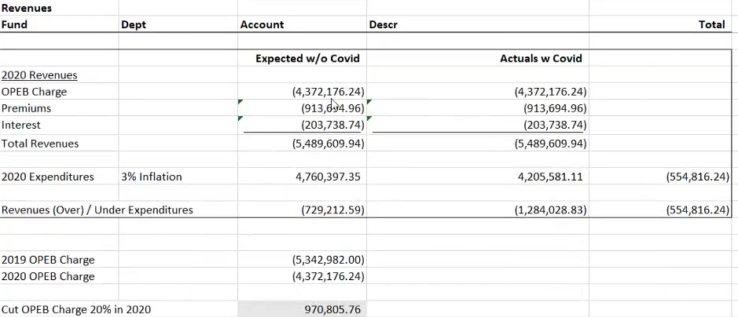
Mr. Carlson assumed that the revenue would have been the same, OPEB charge was cut by 20% ($970,805.76) in 2020, added a 3% inflation unto the 2019 expenditures, and about a million was expected in less revenue. Mr. Carlson said that without the OPEB revenue cut, it would have been expected to be positive about $729,000.
Claims over 2019 had dropped about $416,000 in straight claims. Due to COVID, there are not as many retirees willing to go to the doctor to have procedures right now so that helped out with the claims.
This really helped boost to the positive $1.2 million for 2020.
Mr. Cushing asked if it was anticipated that there would be more doctor visits by retirees this year. Mr. Carlson asked the consultants and they stated that it is possible, and they do not know how it will rebound back. Mr. Carlson continued: “nobody knows what post-COVID would look like, if we’re going to catch up or maybe ramp up a little, and it is possible that there will be a spike in claims.”

Mr. Carlson moved on to the Balance Sheet – Fiduciary Costs
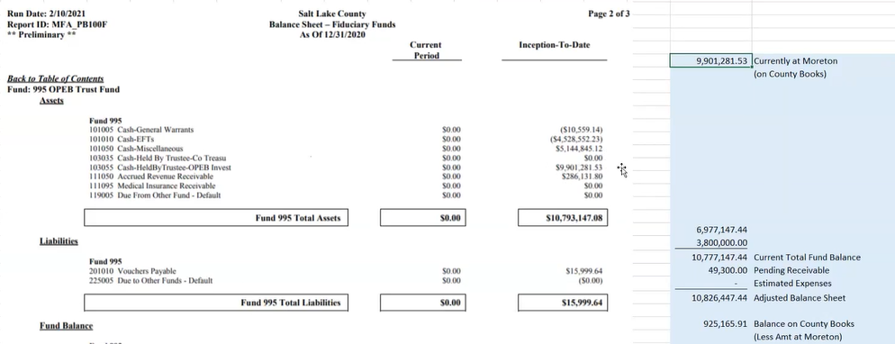
The current total fund balance is $10.777 million and $49,300 pending receivables for a total of an adjusted balance sheet of $10.826 million. Mr. Carlson said $9.9 million is held by the trustees. Mr. Cushing asked where the $9.9 million came from. Mr. Carlson explained this was the amount transferred to Morton plus any interest earnings that they recorded.
Mr. Cushing was curious about the $9.9 million amount and asked Ms. Beecher if there was a market adjustment on Morton. Mr. Cushing noted that there is $9.7 million on the books that did not include unrecognizable gains which are over $1.4 million. Ms. Beecher then said that Becky Timothy (Mayor’s Finance accountant) records the monthly interest entries at the end of the year, Ben Hokanson (Financial Reporting Manager) records the change and unrealized gain/loss change. Ms. Beecher continued, “the balance should be a result of whatever last year’s balances and any related unrecognized gain/loss plus the monthly entries that Becky was doing to the interest.”
Mr. Carlson then shared the 2020 Balance Sheet activity (Bal Sht tab):
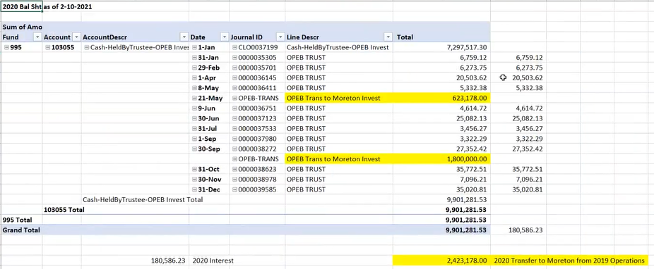

He continued with the beginning balance of $7.2 million, interest adjustments, and the two transfers that totaled $9.9 million. There were no adjustments to investments yet.
Mr. Casper then said that the whole point was to ascertain a comfortable amount to transfer this year to the trust and asked if there was something to indicate that it would not be $1.2 million.
Mr. Carlson explained that the $10.8 million on the books, minus the $9.9 million that Moreton currently has ($9.9 million) you end up with a balance of $925,000 that would be available to transfer. He went on to say that last year there was the $1.8 million transfer that included the MSD and when this happened, it was a double transfer.
Mr. Delquadro recalled a discussion where the trust recognized that there was no liability associated with the MSD and it was moved over to Moreton and was not going to have an impact to the $1.8 million transfer.
Mr. Carlson then said the $1.8 million transfer was included in his calculations when he ran the balance sheet. Mr. Delquadro then said that he recalled that the conversation said that “it should be held outside the normal discussions because it was considered a break-even, so the MSD was recognizing a liability that was theirs and that it was going to be independent of the discussion that we had on everything else, and that is my recollection.”
Mr. Casper added that he also recalled this discussion but nevertheless, that they should look at considering an additional $600,000 transfer that could be a healthy buffer for the operations for this year. Mr. Casper suggested that he and Mr. Delquadro look at reducing the cut by half, if not, entirely, that was made to the OPEB charge during the June budget process.
Mr. Delquadro said that a minimum there was no plan for an additional reduction, and that the $600,000 would be safe in that regard, and that then it can be increased. He then asked input from Mr. Cushing and Ms. Okino.
Mr. Cushing said that the transfer would be very safe to do but he would like to see Mr. Carlson be certain of the numbers.
Mr. Casper then motioned to approve the $600,000 transfer and then revisit the numbers for potential additional transfers. All board members motioned to approve the transfer after it passed unanimously.

- Moreton Presentation
Jason Williams from Moreton went over the performance of the OPEB trust fund, market updates, and recommendations to the committee on additional funds to be invested.
Mr. Williams commenced with asking the members to remember that the stock market goes up and down and that it does correct. The following is a representation of the last five or six S&P 500 most recent corrections, and noted that it is a much tighter index than what is being pursued for the OPEB fund:

(Screenshot of Moreton Stock Market Corrections)
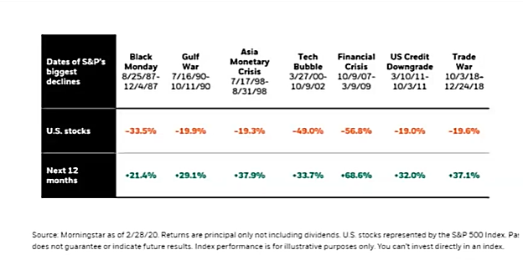
He continued, “when we are talking about allocations and what is being recommended for the target, just keep in mind that the stock market does go up and down.”
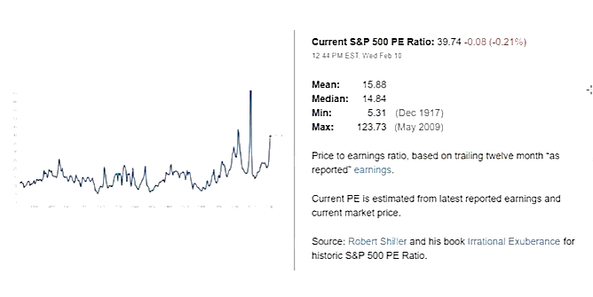
Mr. Williams illustrated that the Price Earnings ratio vs the S&P 500 has been high relative to the long term mean and median. At the time of the presentation, they were at 40 times earnings for the PE ratio for the S&P 500. As shown on the graph, you can see that the the investment crept up in terms of long term historical and that helps with the recommendations.

SLCo OPEB as of 02.10.21 (attached)
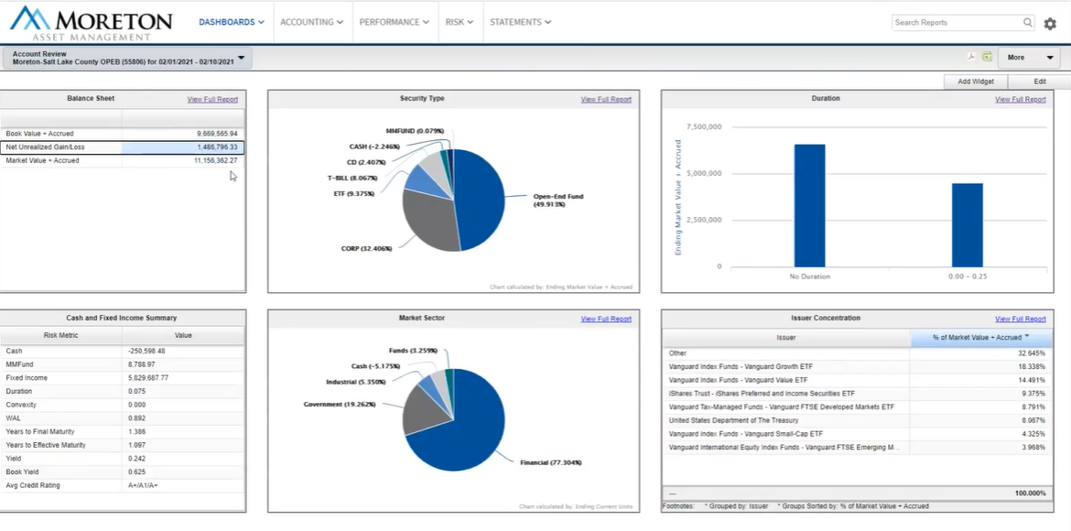
Mr. Williams demonstrated that the book value roughly equated to the contribution that was made in cash to the trust. He continued that there was $1.5 million in gains in the account that were recognized mostly through the equity part of the portfolio, and the total market value is $11.1 million.
He noted that the goal of the OPEB trust at the outset was to reduce as much volatility as much as they could and go after a long-term rate of return. The projections looked at were somewhere between 5.5% and 6% rate of return that were given to the actuaries.
Mr. Williams stated that “a long-term projection with a conservative forecast with 50% allocation to the stock market, it was expected to be on the 6.5% or higher side.
Back in September, Moreton had found and then recommended to the committee an index of preferred stock ETF with a 10% position recommendation. It is now less than 10% since the portfolio has grown so much and that part of the portfolio performed very well from a low volatility, high income standpoint.

Illustration of in terms of how the portfolio is doing vs the benchmark (attached)
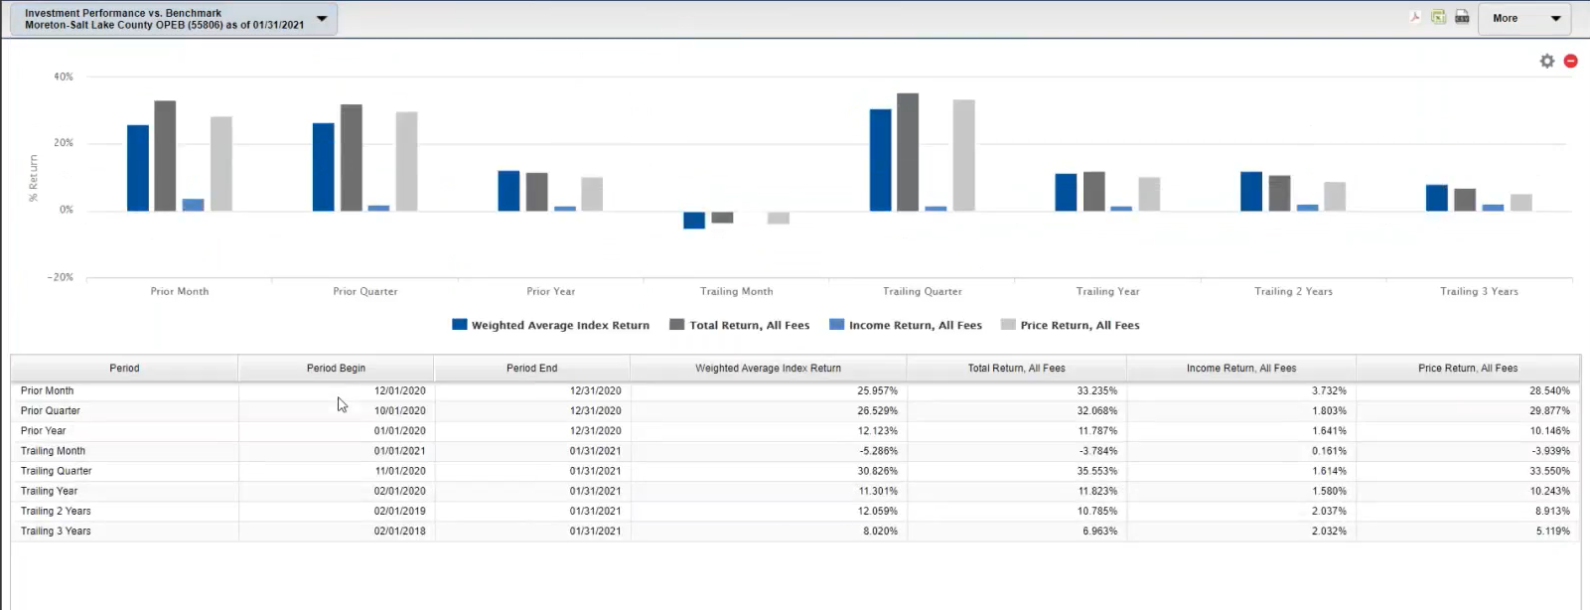
The preceding snapshot illustrates a total return, income return, and comparison to the portfolio weighted average index return.
The S&P 500 index 50/50 blend with a medium duration fixed income portfolio is compared to the OPEB trust portfolio and is less broad. The trust’s portfolio has a mix of total stock market indexes and international stock market indexes, so it is more concentrated.
Mr. Williams continued that on a trailing two-year basis total return is 10.7, trailing year is 11.8 – well above what was forecasted and given to the actuaries. On a trailing three-year basis, the portfolio is performing on the high side (stock market exposure start).
He continued, “the other one that we are proud of -- if there is bad news in the market, it’s the zero-rate environment which made it very difficult as far as the fixed income side of the portfolio. We are spinning off just over 2% in income for the portfolio, but what we will recommend adding is a larger position to the low volatility preferred stock.”
Mr. Cushing asked how much of the $1.8 million was left to allocate. Mr. Williams replied that there is $800,000 left to allocate.
Mr. Williams said that there is a great return on gains in the market, even on the trailing 3 years, the portfolio is well above what was budgeted from an actuarial standpoint.
As for the recommendation regarding the intended $600,000 transfer, Mr. Williams suggested to include another couple of small buys to keep the portfolio at a 50% allocation on the equity side and that the preferred stock side should be increased. The lower 4.5% income return for that lower volatility is another place to go and take up as much as 20% of the portfolio and that would be considering the zero-rate environment.
In summation, the recommendation from Moreton is the allocation would be 50% in total stock market index (very low-cost approach) and 50% in fixed income, 20% of it is the recommendation in the preferred, and the other 30% a mixture of bonds and CDs.
Mr. Casper then asked if there were any questions for Mr. Williams and he thanked him for his time and his diligence on the fantastic presentation. There were no questions after this presentation that altered the recommendation.

- Operations of the OPEB plan for 2020
Mr. Casper moved on to item 5 (Operations of the OPEB Plan for 2020) to be presented by Mr. Carlson, but Mr. Casper believed that this was covered already on item 3 (Investments Standings) Mr. Casper asked if there were further questions, comments or need of direction of the OPEB plan. Mr. Delquadro then asked who was going to initiate the increase of the OPEB charge to which Mr. Casper said that he would and subsequently asked Mr. Carlson to initiate the transfer.
Mr. Casper motioned to approve a 10% OPEB charge increase in June, and all members were in favor and the motion was approved.
After this, Mr. Casper asked if anyone had any new items of business or motion to adjourn.
The group did not have any and the meeting was adjourned at 12:32 PM.

The next OPEB meeting was scheduled for Wednesday, June 30th, 2021, at 11:30 AM via WebEx.

