 | DELTA City Planning & Zoning Commission Meeting
 | Wednesday, August 11, 2021 at 7:00 PM
 | Delta City Municipal Complex Council Chambers*
 | Minutes
CALL TO ORDER
PRESENT
Richard Jones
Kelly Carter
Megan Davies
Chad Droubay
ABSENT
Derek Curtis
Phil Diaz
Sarah Kimball
Betty Jo Western
Also present:
Mayor John Niles
Travis Stanworth
Brett Bunker
Jose Marquez
Nick Killpack
Dent Kirkland
Michelle Lovejoy
Sherri Westbrook
Rob Droubay
Kiley Chase
Michael Zurn
Tom Souvall

Planning and Zoning Commission Chairman Jones called the meeting to order at 7: 13 p. m. He stated that notice of the time, place and the agenda of the meeting had been posted at the City Municipal Complex, on the Utah Public Notice website, on the Delta City website and had been provided to the Millard County Chronicle-Progress and to each member of the Commission at least two days prior to the meeting.

MINUTES APPROVAL

- Minutes Approval: 2021-04-14
The minutes of the Planning and Zoning Meeting held 4/14/21 were presented for approval. Commission Member Carter MOVED to approve the minutes of the Planning and Zoning Meeting held 4/14/21. The motion was SECONDED by Commission Member Davies. Chairman Jones asked if there were any questions or comments regarding the motion. There being none, he called for a vote.
Voting Yea: Jones, Carter, Davies, Droubay
Commission Members Curtis, Diaz, Kimball, and Council Representative Western were absent.
- Minutes Approval: 2021-06-09 Public Hearing
The minutes of the Planning and Zoning Public Hearing held 6/09/21 were presented for approval. Commission Member Droubay MOVED to approve the minutes of the Planning and Zoning Meeting held 3/10/21. The motion was SECONDED by Commission Member Carter. Chairman Jones asked if there were any questions or comments regarding the motion. There being none, he called for a vote.
Voting Yea: Jones, Carter, Davies, Droubay
Commission Members Curtis, Diaz, Kimball, and Council Representative Western were absent.
- Minutes Approval: 2021-06-09
The minutes of the Planning and Zoning Meeting held 6/09/21 were presented for approval. Commission Member Droubay MOVED to approve the minutes of the Planning and Zoning Meeting held 3/10/21. The motion was SECONDED by Commission Member Davies. Chairman Jones asked if there were any questions or comments regarding the motion. There being none, he called for a vote.
Voting Yea: Jones, Carter, Davies, Droubay
Commission Members Curtis, Diaz, Kimball, and Council Representative Western were absent.
BUSINESS – Any such business as may come before the Commission.
4. Rob Droubay
Zone Change Discussion
Rob Droubay would like a zone change on 30 acres which is currently zoned as RR2 to RR1. The curb and gutter were installed on 990 on both sides of the road. Water pressure and the rise in elevation are concerns but will work with Delta City. This change would include roughly 25 lots. Public Works Director Kirkland advised Mr. Droubay that he would need to pay the fee and then they can proceed with a public hearing and noticing.
5. Jose A. Marquez
Minor Subdivision Discussion/Consideration
Jose Marquez would like to subdivide a lot on 200 East and 200 South into three pieces and build a duplex on the northwest and do it in phases. Marquez owns a quarter of a block. Delta City owns a right of way that has never been improved, which should be a 33 foot road. Location of the lot is in the redevelopment area, and adjacent to existing curb and gutter. Sewer, water and storm drains are in, it would need curb, gutter, and sidewalk. Marquez would like two small lots and one large lot, and would like to install curb and gutter in phase 2. Marquez will take to City Council to get some clarification.
Commission Member Droubay MOVED to approve the preliminary plat with improvements based on the current code. The motion was SECONDED by Commission Member Davies. Chairman Jones asked if there were any questions or comments regarding the motion. There being none, he called for a vote.
Voting Yea: Jones, Carter, Davies, Droubay
Commission Members Curtis, Diaz, Kimball, and Council Representative Western were absent.
6. Nick Killpack, Councilmember
Land Use Amendments & Transportation Plan
Council Member Nick Killpack presented a transportation road plan for Delta City. Killpack would like a grid system for future development. There are a few obstacles in the way such as the river, railroad tracks, and Hwy 6 and 50. Rural Millard County and Delta City have two different grids. Millard County is 10 blocks to the mile, and there are county roads in Delta City that are numbered with Millard County numbers. Alleys will not be built again. Killpack would like to have a Public Meeting before presenting the plan to City Council. Discussions with Millard County is that they have the desire that if they are near Delta City, they should be annexed into the city. Every county road in Delta would need a proper name except 500 West because they line up with Delta’s grid.
PUBLIC COMMENT PERIOD
Tom Souvall presented that they were working and modifying their concept plan so there is a preliminary plat to bring to the next Planning and Zoning meeting. Public Works Director Kirkland advised the Commission that City Council made the decision to give them vested interest from March.

ADJOURN
8:40 p.m.
Motion made by Droubay, Seconded by Carter.
Voting Yea: Jones, Carter, Davies, Droubay
Commission Members Curtis, Diaz, Kimball, and Council Representative Western were absent.

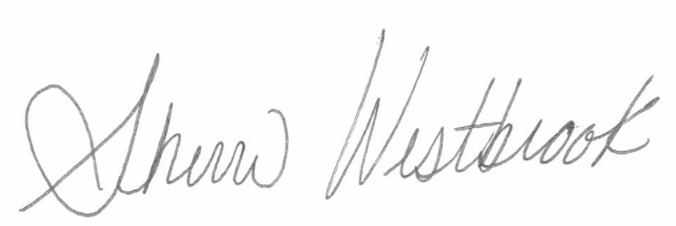
Sherri Westbrook, Recorder

