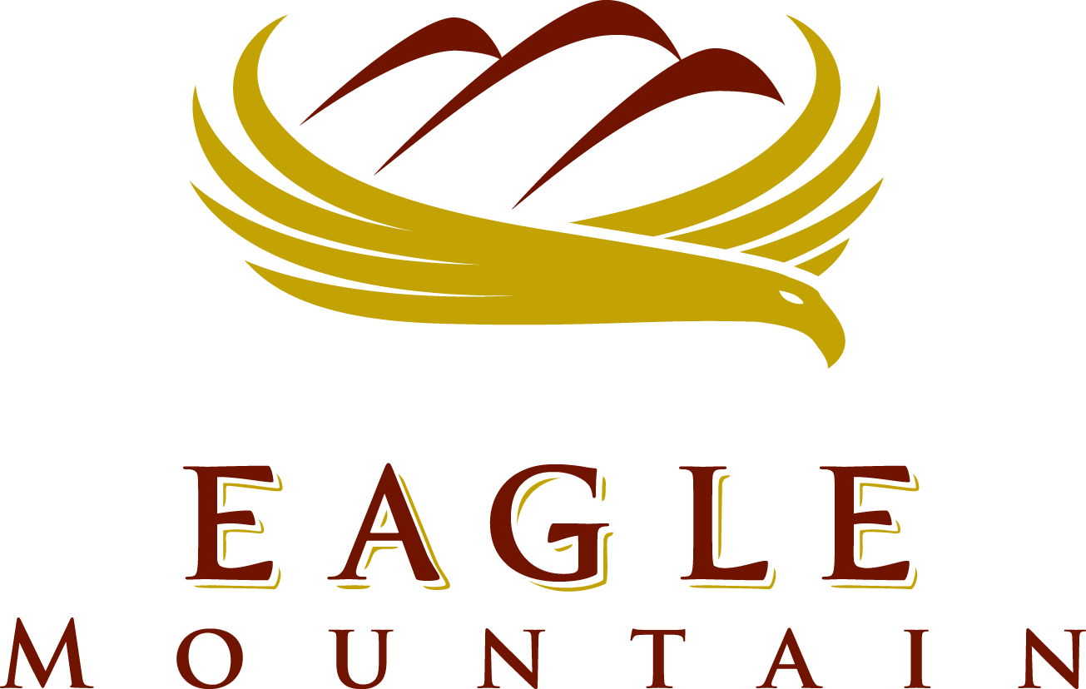

CEMETERY Advisory BOARD

September 22, 2021 6:00 p.m.
Eagle Mountain City Council Chambers
1650 East Stagecoach Run, Eagle Mountain, Utah 84005

6:00 PM – Eagle Mountain Cemetery Advisory Board

- Call to Order
2. Update from Brad
3. Status on master plan proposal
4. Next scheduled meeting: 27 October 2021
5. Adjournment

CERTIFICATE OF POSTING

The undersigned, duly appointed City Recorder, does hereby certify that the above agenda notice was posted on this 21st of September, 2021, on the Eagle Mountain City bulletin boards, the Eagle Mountain City website www.emcity.org, posted to the Utah State public notice website http://www.utah.gov/pmn/index.html, and was emailed to at least one newspaper of general circulation within the jurisdiction of the public body.

Fionnuala B. Kofoed, MMC, City Recorder

