Minutes Of the Regular Meeting of The Mayor and Town Council
Central Valley Town, Sevier County, Utah
August 18th, 2021

A regular meeting of the Mayor and Town Council of Central Valley Town was held on Wednesday, August 18th 2021 at the Central Valley Town Hall, 50 West Center Street, Central Valley, Utah at the hour of 7:30 pm after due and timely notice had been provided pursuant to Section 52-4-6, UCA, 1953 as amended.

MAYOR & COUNCIL MEMBERS PRESENT:
Mayor Susan Outzen, David Nielson, Gary Barney, Charles Evans, Kody Winkel
STAFF MEMBERS PRESENT:
Town Clerk: Sheyenne Tenney
Treasurer: Shelley Brown
Bill Davis, Maintenance Department
PUBLIC PRESENT:
Robyn Ames, Parker Vercimak (Jones and Demille), Mason Eyre, Brad Eyre, Scott Thomsen, Dale Gifford
AGENDA:
- Pledge of Allegiance was led by Mason Eyre. Opening remarks were made by Mayor Outzen. Meeting called to order and roll call. Mayor Outzen welcome those in attendance. Prayer was given by Sheyenne Tenney.

- Approval of minutes: Date: July 21, 2021
Minutes were presented for review and approval. Mayor reported two errors. Sheyenne reported those errors were corrected. Gary Barney made a motion to approve the Minutes. Charles Evans seconded the motion. Voting: David Nielson voted aye; Gary Barney voted aye and Charles Evans voted aye. Motion carried. Minutes were approved as updated.

- Review and approval of monthly expenditures
The bank reconciliation, bank statement and PTIF accounts for July were reviewed by the town council. Mayor Susan Outzen reviewed the Monthly Operational Budget Analysis for the Water and General Funds. Mayor also noted that the CARES money has been received in the town’s PTIF account and in the coming weeks a decision will need to be made as to what purpose the money will expended. A motion was made by Gary Barney to approve the monthly expenditures. Dave Nielson seconded the motion. Voting: David Nielson voted aye; Gary Barney voted aye; Charles Evans voted aye and Kody Winkel voted aye. Motion Carried. Monthly Expenditures were approved.

- Youth Council- Mason Eyre
Mason Eyre brought to the town council’s attention the need for a youth council in Central Valley. He presented to the council several ideas of ways they could help throughout the year including: town cleanups, 4th of July celebration, cemetery upkeep, children’s activities, moving of historical monument, repainting or maintenance of the park and other town needs. Mr. Eyre also said that he expected the process to staff the youth council will be done like any other job seeking opportunity. The youth interested will have to fill out an application and apply through the town where interviews will be held to select the applicants for youth council. The Town Council and Mayor discussed the benefits and believe it to be a good thing for the town to implement. Gary Barney made the motion to adopt the Central Valley Town Youth Council. Charles Evans second the motion. Voting: David Nielson voted aye; Gary Barney voted aye; Charles Evans voted aye and Kody Winkel voted aye. Motion Carried. The Youth Council for Central Valley Town was adopted.

- Jones and Demille- Downtown Well Report
Parker with Jones and Demille presented a quote/bid for the reconstruction, upgrade and functionality of the Downtown well. See addendum “A” to this minute record.

- Adoption of Resolution 2008-002; Amended 2021: Consolidated Fee Schedule
Changes and concerns about some fees were brought up by Kody and the Mayor. Because the decision as to water hook up fee couldn’t be made at that time this topic was moved to the next meeting which will be held September 15th, 2021. Charles Evans was assigned to compile a price list comparing high vs. low installation of water meters.

- Adoption of Resolution 2021-002: Compensation of Elected officials, Statutory Officers and Employees of Central Valley Town
Mayor Outzen presented Town Council with a rough draft of compensation for town employees and officers. After much discussion they came to the agreement that follows.
Mayor and Town council members will not be receiving a raise this year. Motion was made by Gary Barney. Kody Winkel second the motion. Voting: David Nielson voted aye; Gary Barney voted aye; Kody Winkel voted aye; Charles Evans voted aye.
Sheyenne Tenney, Town Clerk, will be compensated for the work she has done thus far and because she has proven her abilities over the 90-day probation. Her wage will increase to $19.00 per hour per the motion made by Gary Barney. Charles Evans second the motion. Voting: David Nielson voted no; Gary Barney voted aye; Kody Winkel voted aye; Charles Evans voted aye. Motion Carried. Sheyenne Tenney’s wage was set to $19.00 an hour.
Gary Barney stated that Shelley Brown, Treasurer, has asked to not receive a raise this year, she stated she is compensated enough and doesn’t need more. Kody Winkel made the motion to keep Shelley’s wage the same. Charles Evans second the motion. Voting: David Nielson voted no; Gary Barney voted aye; Kody Winkel voted aye; Charles Evans voted aye. Motion carried. No wage was increased for Shelley Brown.
Bill Davis/ Maintenance dept. wage was increased to $3423 monthly equivalent to $21.00 per hour. Gary Barney made the motion to approve an increase in Mr. Davis’ wage subject to a 90-day reevaluation. Charles Evans second the motion. Voting: David Nielson voted aye; Gary Barney voted aye; Kody Winkel voted aye; Charles Evans voted aye. Motion carried. Bill Davis’ wage was set to $3423.00 per month.
All other employees as authorized will be at $15 per hour this includes Gary Barney, Kody Winkel, Karen Busk and any others as approved by Mayor and Town Council. Charles Evans will remain the same, $25.23 per hour.
Resolution 2021-002 was adopted as amended.

- Adoption of Resolution 2021-003: Public Entity
Resolution 2021-003: Public Entity was presented for review. Mayor Outzen explained this resolution was needed when any changes for authorization were made to existing bank and PTIF accounts for the town. With new officers taking Oath, the old resolution hadn’t been updated to reflect those changes. This resolution once approved, signed and notarized corrects that. David Neilson made the motion to approve the resolution. Gary Barney second the motion. Voting: David Nielson voted aye; Gary Barney voted aye; Charles Evans voted aye and Kody Winkel voted aye. Motion Carried. Resolution 2021-003: Public Entity was adopted.

- Adoption of Resolution 2021-004: Emergency Response Plan (ERP) for Central Valley Town Water System
Mayor Outzen reported that because the town has USDA grants for water, the town is required to have an ERP in place. Mayor Outzen alongside Charles Evans and previous Town Clerk, Tan Sitthichai, worked for several months to put together a plan that met the requirements by the USDA. The ERP for Central Valley Town Water System and Resolution 2021-004 were presented to the Town Council for review and discussion. No discussion was had. Mayor Outzen stated the copies of the ERP given to each council member was to be turned in to Sheyenne for safe keeping at the office. Kody Winkel made a motion to adopt the emergency plan and resolution. Charles Evans second the motion. Voting: David Nielson voted aye; Gary Barney voted aye; Charles Evans voted aye and Kody Winkel voted aye. Motion Carried. Resolution 2021-004 and Emergency Response Plan for Central Valley Town was passed.

- Department concerns and council member reports
David Nielson had concerns about the diesel fuel used for equipment and the amount the town current has left.
Gary Barney reported that his tentative date to close the splash pad for the winter season will be September 10th, 2021. He also reported that the Teeter Totter at the park was broken again. The town council debated whether to fix it or just pull it out and replace it. This is the second time it has broken in the past several years and third time overall. The amount to fix it would be more than they believe it is worth to do so. Gary also reported that the wood shavings in the park are due to be replaced this next spring.
Kody Winkel reported that the Planning and Zoning Committee hasn’t had any meetings, however they have reformatted their 1700 Ordinance about land use general maps and amendments and would like the town council to review the content and prepare to discuss any changes needed in next month’s meeting.
Charles Evans didn’t have anything to report. He is still waiting on this month’s water samples and will discuss them in the next town council meeting held in September.

- Other business as needed
Mayor Outzen stated Sheyenne had business to discuss about Central Valley Town investing in a website. This topic was moved to the September 15th, 2021 Town Council Meeting due to the amount of time spent for above topics.

- Adjournment
Gary Barney made a motion to adjourn. Kody Winkel second the motion. Voting: David Nielson voted aye; Gary Barney voted aye; Kody Winkel voted aye; Charles Evans voted aye. Motion Carried. Meeting Adjourned.

Next town council meeting: September 15th, 2021.

Minutes prepared by Town Clerk; Sheyenne Tenney

_________________________________
Mayor Susan Outzen
Attest:
____________________________
Sheyenne Tenney, Town Clerk

Date approved by Town Council _____________________

Addendum A

Central Valley Town
Downtown Well Modifications- 2021
August 18, 2021
By: Parker Vercimak
Well House Modifications |  |  |  | QUANTITY UNIT |  | UNIT PRICE | COST
1 | Pump Control Valve |  |  | 1 | LS | 5,000.00 | 5,000.00
2 | Piping Modifications |  |  | 1 | LS | 2,500.00 | 2,500.00
3 | SCADA |  |  | 1 | LS | 15,000.00 | 15,000.00
 |  |  |  | WELL HOUSE MODIFICATIONS SUBTOTAL |  |  | 22,500.00
Chlorine Upgrades
4 | Mobilization |  |  | 1 | LS | 32,000.00 | 32,000.00
5 | Liquid Chlorine Equipment |  |  | 1 | LS | 2,500.00 | 2,500.00
6 | 6" Ø Water Pi e |  |  | 9600 | LS | 35.00 | 336,000.00
7 | Sevier River Crossin |  |  | 1 | LS | 55,000.00 | 55,000.00
8 | 6" Gate Valves |  |  | 2 | Each | 4,000.00 | 8,000.00
9 | 8" Gate Valves |  |  | 2 | Each | 8,000.00 | 16,000.00
10 | Gravel Driveway Repair |  |  | 2000 | S.Y. | 15.00 | 30,000.00
11 | As halt Road Re air |  |  | 300 | S.Y. | 40.00 | 12,000.00
12 | Tie in to Distribution S stem |  |  | 1 | LS | 10,000.00 | 10,000.00
 |  |  |  | CHLORINE UPGRADES SUBTOTAL |  |  | 501,500.00
13 | Construction Contingency |  |  |  | LS | 80,000.00 | 80,000 00
 |  |  |  | TOTAL PROBABLE CONSTRUCTION COST |  |  | 604,000.00
ENGINEERING, LEGAL, AND PROFESSIONAL SERVICES
a. | Pre-Construction Engineering Services |  |  |  | LS | 42,000.00 | 42,000.00
b. | Construction Engineering Services |  |  | 1 | LS | 42,000.00 | 42,000.00
c. | Environmental Studies/NEPA/Permitting |  |  | 1 | LS | 12,000.00 | 12,000.00
d. | Easement/ROW Coordination |  |  |  | LS | 10,000.00 | 10,000.00
 | Admin/Legal/Bonding |  |  | 1 | LS | 10,000.00 | 10,000.00
 |  |  |  | TOTAL PROBABLE PROJECT COST |  |  | 720,000.00
PRELIMINARY OPINION OF PROBABLE
In providing estimates of probable construction cost, the Client understands that the Consultant has no control over the cost or availability of labor, equipment or materials, or over market conditions or the Contractor's method of pricing, and that the Consultants estimates of probable construction costs are made on the basis of the Consultant's professional judgment and experience. The Consultant makes no warranty, express or implied, that the bids or the negotiated cost of the Work will not vary from the Consultant's estimate of probable construction cost.
RESOLUTION 2021-002
PROVIDING FOR THE COMPENSATION OF ELECTED OFFICERS,
STATUTORY OFFICERS AND EMPLOYEES OF CENTRAL VALLEY TOWN

WHEREAS, The Town Council of Central Valley has determined the need to establish a new salary and hourly schedule for town officials and employees:

THEREFORE, be it ordained by the Central Valley Town Council:

- All previous salary or compensation ordinances regarding statutory officers and employees are hereby repealed.

- The compensation of statutory officers of Central Valley Town shall be as follows:

Mayor $506 Staying as is.
Council Members $348 Staying as is.
Town Clerk $19.00/hour
Town Treasurer $2075.25 monthly salary Staying as is
(Equivalent to $25.94 per hour)

Other Town Employees as Authorized
Bill Davis Maintenance $3423.00 monthly salary
(Equivalent to $21.00 per hour subject to reevaluation in 90 days)

Charles Evans $25.23/hr. Staying as is.
Gary Barney $15.00/hr.
Karen Busk- P&Z $15.00/hr.
Kody Winkel $15.00/hr.

- Each elected officer shall be paid the first week of the new quarter for the previous quarter. Each statutory officer and the maintenance man shall be paid monthly the first week of the new month for the previous month. Payment will be received by check drawn on the municipal’s checking account. Each officer and employee will be responsible for picking up their check at the town office.

- Each member of the governing body and authorized town employees shall receive mileage and per diem for all trips approved by the governing body according to the schedules adopted by the Central Valley Town Council. (For rates see Central Valley Town Policies Packet)

- This resolution shall become effective on adoption and posting.

Adopted this 18th Day of August 2021.

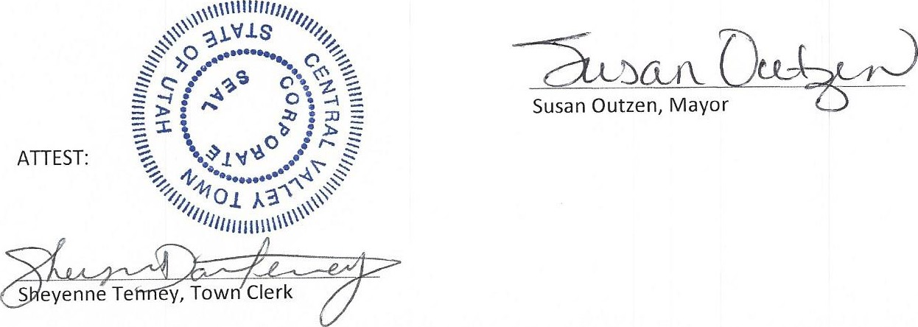

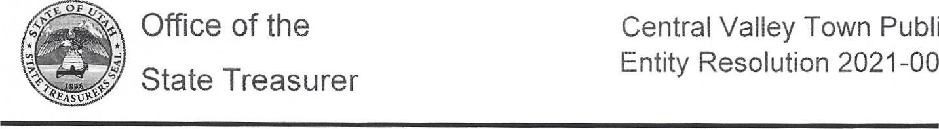
- Certification of Authorized Individuals
Public
2021-003
l, Susan Outzen hereby certify that the following are authorized to add or delete users to access and/or transact with P TIF accounts; to add, delete, or make changes to bank accounts tied to PTIF accounts; to open or close PTIF accounts; and to execute any necessary forms in connection with such changes on behalf of Central Valley Town. Please list at least two individuals. Each individual must have a unique email.

Name | Title | Email
Sheyenne Tenney | Town Clerk | sheyennedtenney@gmail.com
Shelley Brown | Treasurer | dandsbrown3@gmail.com
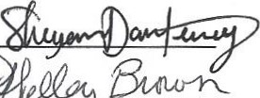

The authority of the named individuals to act on behalf of Central Valley Town
(Name of Legal Entity) shall remain in full force and effect until written revocation from
Central Valley Town (Name of Legal Entity) is delivered to the Office of the State Treasurer.

- Signature of Authorization
l, the undersigned, Mayor of the above-named entity, do hereby certify that the forgoing is a true copy of a resolution adopted by the governing body for banking and investments of said entity on the 18th day of August 2021 at which a quorum was present and voted; that said resolution is now in full force and effect; and that the signatures as shown above are genuine.

Signature   |  | Date   |  | Printed Name Susan Outzen | Mayor | Title

Utah Notary Acknowledgment
STATE OF UTAH
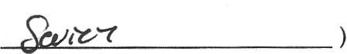
COUNTY OF
Subscribed and sworn to me on this 19th day of August 2021 by Susan Outzen, as Mayor of Central Valley Town (Name of Entity), proved to me on the basis of satisfactory evidence to be the person(s) who appeared before me.

CHRISTOPHER JUAN BIFFATH
Notary Public - State of Utah
Comm. No. 712042
My Commission Expires on May 19, 2024
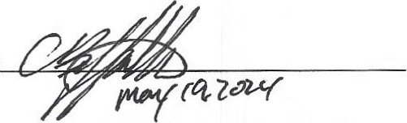
Notary Signature

Notary (seal)

Resolution 2021-004
A RESOLUTION TO ADOPT THE EMERGENCY RESPONSE PLAN (ERP) FOR CENTRAL VALLEY TOWN WATER SYSTEM.
WHEREAS, Central Valley Town maybe subject to emergencies and disasters with the water system; and
WHEREAS, The United States Department of Agriculture, Rural Development (USDA/ RD) is requiring that all system that receive USDA/ RD funding must complete an Emergency Response Plan (ERP).
WHEREAS, Central Valley town will continue to explore vulnerabilities, make improvements and establish procedures to follow in an emergency; and
WHEREAS, Central Valley Town will be prepared to respond during emergencies and disasters by planning and practicing in accordance to the ERP for Central Valley Town Water System.
WHEREAS, such planning and practicing can save lives, prevent illness, enhance system security, minimize property damage and lessen liability.
NOW, THEREFORE, BE IT RESOLVED, that Central valley Town has developed the Emergency Response Plan for Central Valley Town Water System. Resolution 2021-004 is hereby approved and adopted on this 18th day of August, 2021 and shall serve as the basis to assist Central Valley Town and citizens in the time of a water emergency or disaster.

Adopted by the Town of Central Valley this 18th Day of August, 2021


Section 10.
Certificate of Completion
Once you have developed your Emergency Response Plan (ERP) that incorporates the results of a Security Vulnerability Assessment (SVA) you will need to complete the information on the certificate of completion. If RCAP or Rural Water assisted you in completing your Security Vulnerability Assessment and/or Emergency Response Plan be sure to check the appropriate box. If you have completed both the Security Vulnerability Assessment and Emergency Response Plan, please check both boxes.
I certify that this document was prepared under my direction or supervision. I am aware that there are significant penalties for submitting false information (Safe Drinking Water Act (42U.S.C. 300f et seq.).
Mail the completed certificate only (do not send your SVA or ERP) to the appropriate USDA Rural Development office.
Public Water System ID Utah Division of Drinking Water: 21006 Number:

System Name: Central Valley Town Water System

Address: 50 W Center Street, Central Valley UT 84754

Print Name of Person Authorized to Sign this Certification on behalf of the System:
Susan Outzen Title: Mayor
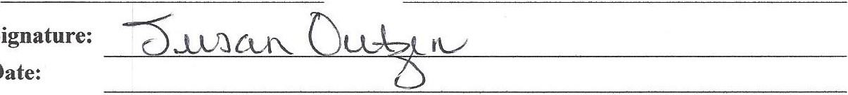
Signature:
Date:
Phone: 435-893-9178 Fax: Email: cvtownmayorl@gmail.com
Received Technical Assistance from the following:
Rural Community Assistance Partnership
(CRG, Great Lakes RCAP/WSOS, MAP, RCAC, RCAP Solutions, Southeast RCAP)
- Rural Water Association
Completion of the following:
- Security Vulnerability Assessment
Emergency Response Plan
Emergency Response Plan for Central Valley Town Water System Page 30

