Kanosh Town Corporation held the regular council meeting on Wednesday, July 14, 2021, electronically and in the town office at 7:30 p.m.

Members present:

Mayor Frank Paxton, Councilmember's: Brandon Stephenson, Rodney Whatcott, Neil Shumway, Kanosh Town Treasurer Karen Crook, and Kanosh Town Clerk: Cindy Turner. Councilmember Hayden George was not in attendance at tonight’s meeting.

Others in attendance: CERT Captain Geri Minton, john and Deb Hogan, Carol Hardy, Dave Hatton, Ilene Hatton, Star Cummings, Stan Koyle, Ben Coray

Councilmember Neil Shumway offered the invocation.

Mayor Frank Paxton led everyone in the Pledge of Allegiance.

Mayor Paxton noted the Kanosh Council members have been invited to ride in the 4th of July parade in Fillmore. The parade will be held on Saturday, July 3rd.

Minutes of the June 9, 2021 meeting were approved as amended through motion by Councilmember Neil Shumway, Councilmember Brandon Stephenson provided a second to the motion, all Council members voted in favor as noted below:

Mayor Frank Paxton: Aye

Council members

Rodney Whatcott: Aye

Brandon Stephenson: Aye

Neil Shumway: Aye

Warrants for July 2021 were read discussed and approved to be paid through a motion by Councilmember Rodney Whatcott, Councilmember Neil Shumway seconded the motion, all Council members voted in favor as noted below:

Mayor Frank Paxton: Aye

Council members

Rodney Whatcott: Aye

Brandon Stephenson: Aye

Neil Shumway: Aye

CERT:

Nothing new to report at this time.

Planning and Zoning:

Nothing new to report at this time.

Fire Dept:

Fire Chief Lorin Shumway reported there have been several fires, however, the volunteers have been able to respond quickly. Millard County again expressed their gratitude for the quick responding.

The supplies for the fundraiser scheduled for the 24th have been ordered, hoping this will be a good opportunity for everyone!

**Elimination of electrical surcharge:**

In 2013 the council members had agreed to implement a monthly surcharge of $10.00/month to each electrical customer to offset the cost of upgrading our electrical infrastructure. We have since squared up with Flowell Electric, they have completed the work and have been paid. Councilmember Neil Shumway motioned to remove or rescind resolution #10102013 Resolution implementing an electrical surcharge, the improvements have been made and everything has been settled with Flowell Electric. Councilmember Rodney Whatcott provided a second to the motion, all Council members voted in favor as noted below:

Mayor Frank Paxton: Aye

Council members

Rodney Whatcott: Aye

Brandon Stephenson: Aye

Neil Shumway: Aye

**Dump truck Bid opening:**

The following notice was posted on social media and in four separate locations throughout town:

NOTICE:

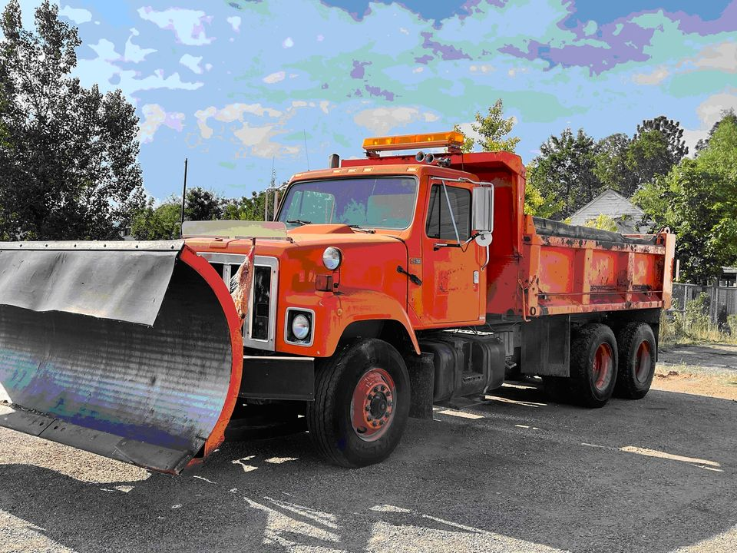

Kanosh Town will be taking sealed bids on the pictured

1987 International Dump Truck

Minimum bid of $1500.00

Bids can be submitted to:

Kanosh Town Corp.

P.O. Box 9

Kanosh, Utah 84637

Bid opening July 14th at the regular council meeting. All bids must be submitted before the 14th of July.

.

Kanosh Town Reserves the right to reject any and all bids.

For additional information please contact Lorin Shumway.

Posted this 22nd day of June 2021.

The following sealed bids were received:

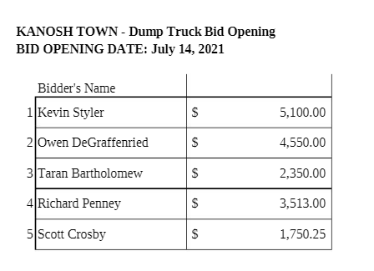

Councilmember Brandon Stephenson motioned to accept the high bid of $5100.00 from Kevin Styler, Councilmember Neil Shumway seconded the motion, all in favor, all Council members voted in favor as noted below:

Mayor Frank Paxton: Aye

Council members

Rodney Whatcott: Aye

Brandon Stephenson: Aye

Neil Shumway: Aye

**Encroachment ordinance:**

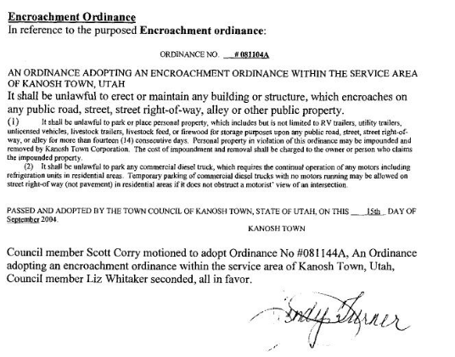

There are several encroachment "violations" throughout town resulting in 27 offenders being noted. In the past, posting the ordinance has not been as effective as we would have hoped. Councilmember Brandon Stephenson expressed his desire to present the problem with a more personal approach. Possibly working with the offenders on setting a date for clean-up or to come into compliance. Councilmember Brandon Stephenson volunteered to write a letter addressing the problem.

Councilmember Brandon Stephenson motioned to draft and send out a letter encouraging the people of our community to follow the encroachment ordinance, complete with a copy of the ordinance. Councilmember Rodney Whatcott seconded the motion, all Council members voted in favor as noted below:

Mayor Frank Paxton: Aye

Council members

Rodney Whatcott: Aye

Brandon Stephenson: Aye

Neil Shumway: Aye

**Hiring of contract employee:**

Councilmember Neil Shumway motioned to table the hiring of a contract employee for the park at this time, Councilmember Brandon Stephenson seconded, all Council members voted in favor as noted below:

Mayor Frank Paxton: Aye

Council members

Rodney Whatcott: Aye

Brandon Stephenson: Aye

Neil Shumway: Aye

**F450 rebuild:**

Several options for the F450 were discussed, the majority of the Councilmembers stated this was not a good purchase and should have gotten rid of the truck a while ago. It was also pointed out the fact that it would be unwise to continue to put money into hopeful repairs. It will be expensive to replace. It is not running; the engine replacement would cost around $12,000.00 and still no guarantee it would operate. Councilmember Brandon Stephenson motioned to auction off the F450, as is with Dump bed and plow, through the sealed bidding process. The bid opening will be scheduled for August 11. Kanosh Town will reserve the right to reject any and all bids. Councilmember Neil Shumway seconded the motion, all Council members voted in favor as noted below:

Mayor Frank Paxton: Aye

Council members

Rodney Whatcott: Aye

Brandon Stephenson: Aye

Neil Shumway: Aye

**24th of July celebration**:

Councilmember Hayden George has asked Mr. Cleve Christensen to help with the celebration. Mr. Christensen agreed to serve as the 24th of July celebration interim chairman.

Everything is moving forward as planned, Councilmembers each agreed to help in any way possible.

Council members agreed to the purchase of a couple of additional large Dutch ovens for the celebration. We will also purchase a few more before the 2022 celebration.

**Park**

*Town Treasurer Karen Crook presented names of park reservations eligible for refunds:

Jennifer Woods

Lorraine Whitaker

Paul Blad

Glen Whitaker

Mrs. Crook will follow up with Councilmember Hayden George before the refunds are made.

**Cemetery**

Nothing to report at this time.

**Electric Department:**

Nothing further to address at this time.

**Roads**

Mr. Stan Koyle has been mowing the town streets. Note: This was an act of volunteerism.

**Water Dept.:**

*Councilmember Rodney Whatcott stated that we have been maintaining the overflow, we get down but has been recovering by the next day. The town employees will begin to put out the “A” frame signs making people aware of the status. The rains have helped considerably.

*It was noted that the townspeople seem to be conserving water.

*Town Employees have been steadily working to repair any leaks.

*Nothing new to report on the ECWAG funding, they are working on it.

**Public comment:**

David Hatton questioned who is running for mayor

*Frank Paxton

*Debbie Hogan

*Scott McDonald

*TJ Lovato

Ilene Hatton questioned where the water conservation sign will be located

*Signs will be located in front of the Town Hall

Carol Hardy via Star Cummings, several times Carol has been at the turn off for the landfill complete with her blinker on and someone passed her. She would like there to be a solid line if at all possible.

*It is a State Highway, this concern should be followed up with the State UDOT, a possible initial contact would be Bryce Whitaker.

Carol is also concerned with the number of gopher holes there are at the Cemetery.

*Councilmember Hayden George will follow up.

**Review of Delinquencies:**

Councilmembers reviewed the monthly delinquency list. It was determined, again, to handle those accounts in arrears according to established Town policy.

**Old Business:**

*Web Site: We are close to being able to offer payments online!

*American rescue money: Utah League of Cities and Towns will hire a temporary employee and for a $250.00 assessment fee this individual would assess our needs, help us justify the cost of getting this money, and get us an estimated $57,000.00 from the ARPA.

Municipalities can use ARPA funds to:

* Support public health expenditures;
* Address the negative economic impacts caused by the public health emergency;
* Replace lost public sector revenue;
* Provide premium pay for essential workers; and.
* Invest in water, sewer, and broadband infrastructure.

Councilmember Brandon Stephenson motioned to submit The American Rescue Plan Act of 2021 (“ARPA”) funding request form, Councilmember Rodney Whatcott seconded the motion, all Council members voted in favor as noted below:

Mayor Frank Paxton: Aye

Council members

Rodney Whatcott: Aye

Brandon Stephenson: Aye

Neil Shumway: Aye

There being no further business to come before the board, the meeting adjourned.

Frank Paxton, Cindy Turner,

Kanosh Town Mayor Kanosh Town Clerk

Millard County tourism: donation for celebration