Minutes of Sigurd Town Board Meeting
Wednesday, May 5th, 2021
7:00 p.m.

The meeting was called to order by Mayor Kelly Alvey at 7:00 p.m.

Opening remarks:

Present: Mayor Kelly Alvey, Bud Bullard, Jason Jacobson,
Also present: Vickie Houston, Sheryl Kirkwood
Citizens present: Kayla Bullard, Jeff Wanlass

Minutes of Meeting held March 9th, 2021 were reviewed.

Bud Bullard moved that the Minutes of April 14th, 2021, be approved. Jason Jacobson seconded the motion. Mayor Kelly Alvey – aye.

Citizens Request:

Jeff Wanlass addressed the council in request for a building permit for their new home. The council advised Wanlass to fill out a building permit and obtain a plat map from the county to sign it off.

Mayor Alvey opened and closed the Second Public Hearing for CBDG. See attachment for minutes.

Mayor Alvey opened and closed the First CIB Public Hearing for a new firehouse. See attachments for minutes.

Councilman Jason askes Stacey with USG for possible donation of sheetrock for the new fire station project. Stacy advises the council to come up with an estimated amount needed and she will see what they can do.

The bills and finances were reviewed.

Bills and Finances:

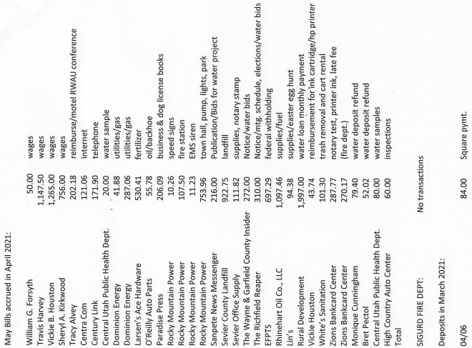

Bud Bullard moved that the bills acquired in April 2021, be approved to pay. Jason Jacobson seconded the motion. Kelly Alvey – aye.

Outdoor bathrooms were discussed with Travis over the phone. The council would like to keep these restrooms open and maintained during the summer months. Sheryl will get copies of the restroom key for all the councilmen and extras for the shop and office.

The toilet in the men’s bathroom in the office needs repairs. The council approved Travis to purchase a new toilet to replace the broken one in the office.

Travis is having blue stakes mark up the park so he can dig up the water leak. He is hopeful to do it in the next two weeks.

Delinquent Accounts:
Council reviewed town delinquent list. Clerks will continue to call to collect payments. No shutoff actions required at this time.

Mayor Alvey presents the council with the idea of a town newsletter. The council likes the idea of having a newsletter sent out including water restrictions, fire regulations, reminders of animals on leashes, etc. The clerks will compose one and get approval to send it out.

Parks & Cemeteries:
Angie came in lower rate than Scott Parsons, so the council awarded the park and cemetery bid to her for lawn care for the year 2021.
The council discussed having the youth council putting the Memorial Day flags up this year. Clerks will make sure the Veteran’s list is current and ready to go. Travis will make more flag poles.

Water:
M.M. had popped the top off her water meter, so we were not able to read her usage last month. We need to send Alma to let them know this is a Federal Offence and legal action will be taken if it happens again.

The town should be charging the higher rates now we have been awarded the funding. The council will have a work meeting with Janell at Rural Waters to finalize rates and a second work meeting to pass a resolution for the new water rates and they will be applied to the next billing cycle.

Roads:
Bud Bullard addressed the council, there are not any major cracks in the road that need to be addressed at this time.

Streetlights:
Streetlights have been purchased and Travis will put them in at the park. Travis is waiting on poles to hang the 10 lights up at the park.

Fire:
The radio for the town has been purchased and Jason will get it programed and placed. The two small fire trucks have been inspected. Big red and the general need to go to Kenworth for inspection and will be set up on a schedule with masons for routine maintenance.

Emergency place cards are done, and the Fire Dept. will distribute them accordingly.

Office:
The budget for 2021/2022 was reviewed by the council.

Jason made the motion to set the Sigurd Town budget for fiscal year 2021/2022 at $1,687,160.00 be approved. Bud Bullard second the motion; Kelly Alvey -aye.

The Black Knolls subdivision was addressed, and the question was asked how many times a property can be subdivided within a time frame. We are going to look up Sigurd Town ordinances on subdividing and adopting properties into town limits. Kathleen and Gerome would have to bring a plat map to the council with exact plans before the council for approval.

Kevin Johnson has been taking water without the council’s approval. The council wants to have Kevin attend the next meeting with his exact plans for water and his property. He is currently out of compliance with ordnances of making a camp trailer a permanent residence. The clerks will look up past meeting minutes on what was originally agreed upon and set deadlines with Kevin for permanent structure to be in place as well as a waterline being buried.

The council discussed several trailers with permanent residents living in them. The clerks will send out reminders of the current ordinance, and possibly send around a county building inspector to these “residents” if necessary.

Jason Jacobson moved that meeting be adjourned. Bud Bullard seconded the motion, Mayor Kelly Alvey – aye. Meeting was adjourned at 8:55 p.m.

