Minutes of Sigurd Town Board Meeting
Wednesday, June 16th, 2021
7:00 p.m.

The meeting was called to order by Mayor Kelly Alvey at 7:00 p.m.

Opening remarks:

Present: Mayor Kelly Alvey, Alma Borg, Bud Bullard, Jason Jacobson, Joe Kirkwood
Also present: Vickie Houston, Sheryl Kirkwood
Citizens present: Kayla Bullard, Kathleen Black, Gerome Black, Andrew Black, Karen Pritchett, Kevin Johnsen, Tyson Jewkes, Travis Harvey, Brenna Roberts, Branton Nielson, Craig Black, Darrel Yowe, Gary Hart

Minutes of Meeting held May 5th, 2021, were reviewed.

Bud Bullard moved that the Minutes of May 5th, 2021, be approved. Jason Jacobson seconded the motion. Joe Kirkwood – aye; Alma Borg – aye; Mayor Kelly Alvey – aye.

Youth Council:
Kayla Bullard addressed the council about a possible flea market in August. She is going to advise later any help needed. Youth Council will also be running the concessions for the Sigurd Town Pioneer Day celebration as a YC fundraiser.

Citizens Request:

Sevier County Mosquito abatement gave the council an update on current services. They currently have traps in 2 locations in Sigurd and they will add a few more smokers throughout Sigurd. They are willing to drive into citizens driveways upon request from homeowners.

Kevin Johnsen is out of compliance for having mobile homes as permanent resident.
They are having issues boring under the road to get water to their property.

Kathleen Black, Gerome, and Andrew Black let the council know their property purchase is complete. They distributed a draft of their subdivision plans and looking for information for annexation. The council will meet with the Blacks about setting up a work meeting for the next phase of annexation and moving forward for the subdivision at Black Knolls.

Tyson Jewkes with Ensign Engineering let the Council know we are now just waiting on bonds; we should be ready to have a closing date within two weeks. After closure it will depend on when Barton Excavation can start. Last week ensign met with Dastrup’s and they have begun potholing to see where the spring lines are. They are confirming locations of spring lines before the project begins. The Dastrups are doing backhoe work for $80 per hour. Still waiting on the shippo environmental approval by the cabin on Dastrups property. Mayor Kelly Alvey will follow up with USDA on the status of our application.

Gary Hart advised the town about why he would be a good candidate to work for the town. Willard co.

The bills and finances were reviewed.

Bills and Finances:

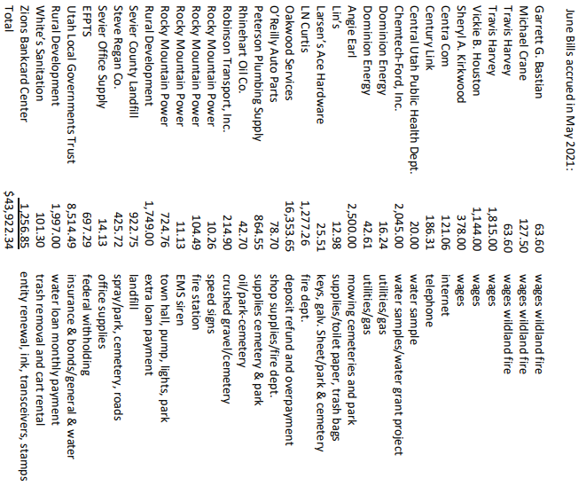

Alma Borg made the motion to pay the bills for May 2021. Jason Jacobson seconded the motion. Joe Kirkwood – aye; Bud Bullard – aye; Mayor Kelly Alvey – aye.

Delinquent Accounts:
Council reviewed town delinquent list. Clerks will continue to call to collect payments. No shutoff actions required at this time.

Parks & Cemeteries:
Sunrise survey gave us a quote for surveying and doing plat maps for both our cemeteries. We will ask them to come to our next meeting to give us more information on what they are offering.

Joe proposes instead of building mountain style restrooms that we fix up our current bathrooms for far less money.

Playground equipment, we are ripping out the small kid slide area, 2 broken bounce horses, the tall twisty slide, salvage the older equipment? The council will ask Harward and Reese to donate gravel to the new park.

Water:
The council decided to give K. Johnsen 3 months to get water access to his property. To get any water you must contact Travis Harvey prior to getting water. Is this a commercial subdivision or a camp trailer park? Must have answers by next council meeting. Required to pay a monthly base rate and it must be metered.

No water from 8am – 8pm 1st warning $50.00, second warning $150.00 and 3rd warning $500.00.

Roads:
Buds does not have anything to report.

Streetlights:

Fire:
Jason Jacobson stated that Sigurd Town needs to create a bill to Georgia Pacific for $16885.42 for usage. In exchange for this GP will give Sigurd Town a water truck.

Office:
Stamps are going up. The council approves to purchase 3-month supply.
Newsletter – will draft and have the council approve to send out with water bills.
Vickie Houston stated that the certified rate 0.000808 county tax revenue to $20,722.00. This needs to be adopted by resolution for the tax year 2021.

Alma Borg made the motion to adopt Resolution 6-16-2021. Adopting Final Tax Rates and Budgets which sets the tax rate for Sigurd at 0.000808 and a budgeted property tax revenue of $20,722.00. Joe Kirkwood second the motion; Jason Jacobson - aye, Bud Bullard – aye, Mayor Kelly Alvey -aye.

The budget for 21/22 was reviewed and approved by the council.

Jason Jacobson made the motion to set the 2021-22 budget at $1894.610.00. Bud Bullard seconded the motion. Mayor Kelly Alvey -aye, Joe Kirkwood -aye, Alma Borg- aye.

Mayor Kelly Alvey asked the council to submit names to consider for members of a town Planning Commission – Those names submitted were Johnathan Alvey, Gary Hart, Mike Crane, Marlee Bastian, Gene Fordham, Cheyenne Harvey, Jennifer Bastian, Danny Anderson.

Vickie Houston stated that Bagley’s had a water leak. The Council will look at their next water bill.

Joe Kirkwood moved that meeting be adjourned. Alma Borg seconded the motion. Mayor Kelley Alvey – aye; Bud Bullard – aye; Jason Jacobson – aye. Meeting was adjourned.

