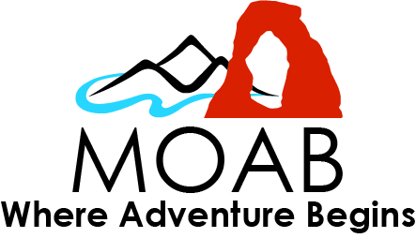
Moab Area Travel Council
Advisory Board Meeting
Board Applicants Interviews
2;00 PM to 4:00 PM
July 20, 2021

Join Zoom Meeting
https://us02web.zoom.us/j/88529977182?pwd=RjNGV2M0UW5WdTVGR1A2Rytvbnp5QT09
Meeting ID: 885 2997 7182
Passcode: 055168
One tap mobile
+13462487799,,88529977182#,,,,*055168# US (Houston)
Dial by your location
+1 346 248 7799 US (Houston)
+1 669 900 6833 US (San Jose)
Meeting ID: 885 2997 7182
Passcode: 055168
Find your local number: https://us02web.zoom.us/u/kANuVL56f
2:00 pm Meeting Called to Order:

1: Board Applicant Interviews:

Dalton Lopez, Assistant General Manager and Director of Radcliffe Hotel, Moab
Daniel Loveridge, General Manager, Hoodoo Hotel, Moab
Thomas Bunn, Business Owner and Instructural Design, Moab
Jenny Gleason, Director of Sales and Marketing, Red Tail Air, Moab
Shanelle Marinuzzi, General Manager, Homewood Suites, Moab

2: Discussion and Action Items

Discuss applicants and confirm the three that will be approved to move on to the Grand County Commission for final approval.

- Future agenda items:
- The Next Board meeting will be on August 17th, 2021 @ 3:00 PM

Closed Session(s) if necessary. – Adjourn

Note: In accordance with ADA requirements, those needing assistance or accommodations need to notify the Travel Council at 259-1370 at least 48 hours prior to the meeting.

