
Architectural Review Committee
Thursday, July 08, 2021, at 5:30 PM
Court Room/Council Chambers (2nd Floor) and Online
MEETINGS HELD IN PERSON & ONLINE
The public is invited to participate as outlined below:
- In Person – Meetings are held on the 2nd floor in the Court Room/Council Chambers at City Hall
- YouTube Live – Public meetings will be shown live on the Santaquin City YouTube Channel, which can be found at https://bit.ly/2P7ICfQ
or by searching for Santaquin City Channel on YouTube.

ADA NOTICE
If you are planning to attend this Public Meeting and due to a disability need assistance in understanding or participating in the meeting, please notify the City Office ten or more hours in advance and we will, within reason, provide what assistance may be required.
AGENDA
NEW BUSINESS
1. Commercial Building in Ridley's Development Pad Site A (Fiiz Drinks)
An architectural review of a commercial building which will be located at approximately 30 N. and 400 E.
2. Commercial Building in Ridley's Development (Tommy's Car Wash)
An architectural review of a commercial building which will be located at approximately 60 N. 400 E.
MEETING MINUTES APPROVAL
3. May 24, 2021
ADJOURNMENT

CERTIFICATE OF MAILING/POSTING
The undersigned duly appointed City Recorder for the municipality of Santaquin City hereby certifies that a copy of the foregoing Notice and Agenda was e-mailed to the Payson Chronicle, Payson, UT, 84651, posted on www.santaquin.org, as well as posted on the State of Utah’s Public Notice Website.

BY: | 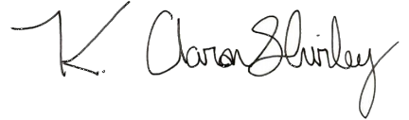
 | K. Aaron Shirley, City Recorder

