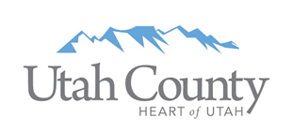

Utah County Tourism and Tax Advisory Board Meeting
Monday, April 12, 2021 @ 11:30am
Utah Valley Convention Center

Board Members Present:
Chair - John Garfield, Provo Marriott
Danny Wheeler, Utah Valley Convention Center
Rita Wright, Springville Museum of Art
Kevin Santiago, Local Restaurant Owner
Grayden Pearson, Pearson Hospitality
Chad Linebaugh, Sundance
Jared Kearns, UCCU Center
Kurt Christensen, Hyatt House PG/Provo

County Representatives Present:
Ezra Nair, Utah County Commission Liaison
Tom Sakievich, Utah County Commissioner
Lisa Shepherd, Utah County Commission
Paul Jones, Utah County Attorney’s Office
Adam Beck, Utah County Attorney’s Office

Others Present:
Kathi Lewis, Orem City
Jill Spencer, Payson City
Karl Teemant, Payson City

11:30 am Welcome & Working Lunch

Utah Valley Convention Center received the Global Biorisk Advisory Board's highest accreditation on disinfection, sanitation and cleaning.
Shauna Smith resigned from the board due to increased demands in her work life.
Adam Beck is the new reviewing attorney from the Utah County Attorney’s Office for new board applications.
Introductions.

11:40 am TTAB 2021 Items
Funding Review – Danny Wheeler

Danny Wheeler proceeded to review a ten year projection and plan for the TRCC/TRT funding that has been compiled in conjunction with Ezra so the board would have the opportunity to continue to be better informed regarding current/future obligations and projected growth of the TRCC/TRT funds.
Overall, COVID-19 impact on these funds were not as bad as originally anticipated. TRCC was down 4% from 2019 - 2020. Compared nationally, the tourism industry in Utah County has not felt the same impact due in large part to less restrictive policy decisions but the TRT took a larger hit than the TRT. If the board desires to continue keeping a 1 year reserve of these funds, that is roughly $15 million. Prior contracts were reviewed. The percentage of TRT funds that can be used for brick and mortar projects rather than tourism promotion is obligated to the Convention Center Bond. The full document can be found at this link: https://drive.google.com/file/d/1b-9WjCsl2o8c6toW2CuUxFCN5jMPzZ1Q/view?usp=sharing
Kurt asked a question about Bond Service coverage, requirements for those such as if we need to establish a baseline reserve to maintain the rating that the County received.
Ezra answered that we do not, our bond rating and rate are established when the bond is initiated and doesn’t change unless we choose to refinance, which the County did so at a better rate and slightly shorter term. Ezra also clarified that TRCC funds can also be used for brick & mortar projects that are allowed by the non-tourism promotion specific portion of the TRT so that’s why the County uses those first for the bond payment.

John noted this is the best financial review we’ve ever had. Ezra clarified, many of the projects are listed in the year 2021 many projects will be paid out in the next few years depending on when entities request their reimbursements.

John wanted to give accolades to state county and local leaders that have allowed us to keep this fund healthy based on policies that were strategically implemented to balance so many competing priorities over the past year. 2020 was our second best year.

12:00 pm FOREBAY TRAILHEAD: Payson City
Project Funding Request: $40,000 (Total Project: $279,666.50)
Project Reviewer: Danny Wheeler
Project Presenter: Jill Spencer, Payson City Planner

Danny explained that the project is up Payson Canyon and has multiple funding sources. Jill also serves on the Nebo Loop National Scenic Byway and introduced her college Karl Teemant, Payson City Rec Director. She reviewed the materials at the following link: https://drive.google.com/file/d/1a32zpFwTAnmMlpNGnB8tcQfUO7P4giWu/view?usp=sharing
Key Points that Jill made
- The city has invested in South Utah County with events and activities along these trails.
- This area attracts visitors from other parts of the county and even outside of the county
- Utah County continues to grow and is expected to be over 1,000,000 residents by 2040, Payson is projected to be 50,000
- Along the Scenic Byway they want people to have opportunity to park and explore and use the trails and camp facilities instead of just driving by
- The goal is for more open space and recreation in the larger community
- There is an impressive mountain biking trail system in that area

The funding request would support building a restroom facility at the trailhead. The TTAB funding would only represent 15% of the total investment in the larger facility and provide safe access for residents and tourists alike.

John opened it up for questions and none were asked. John mentioned the Nebo Loop “Iron Butts” (people who ride long distances on motorcycles) and they’re coming through and want to ride the Nebo Loop and Alpine Loop to point out the tourism aspect of this area. John explained the procedures that the Board will take this up for a recommending vote later at the meeting.

12:30 pm NORTH FORK SPECIAL SERVICE DISTRICT: Sundance
Project Funding Request: $1,500,000 (Total Project: $3,000,000)
Project Reviewer: John Garfield
Project Presenter: Stephen Miche, Public Works Director, NFSSD & Chad Linebaugh Board Member, NFSSD

John introduced the project and that countywide people view this area as recreational. Chad mentioned that he is speaking in his role as a member of the NFSSD and will recuse himself from the TTAB discussion on this item. He introduced the District and the other members of the Board that were with him. Stephen Miche has served as the Public Works Director for the NFSSD, Dr. Minton, a neonatologist, is chair of the Board and has been a resident at Sundance since 1979. Chad went through the information in this presentation
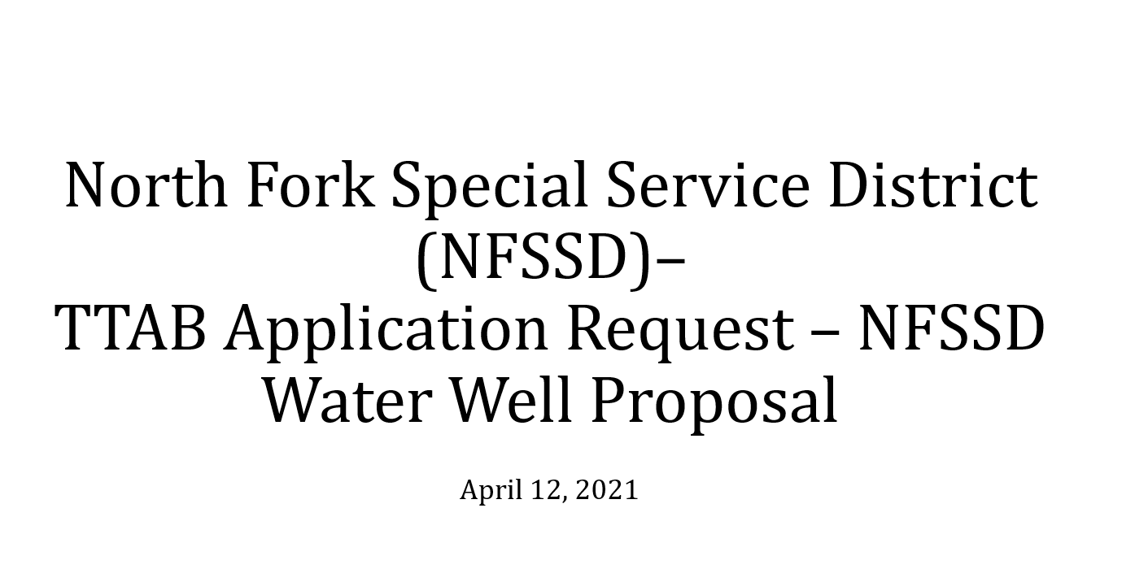
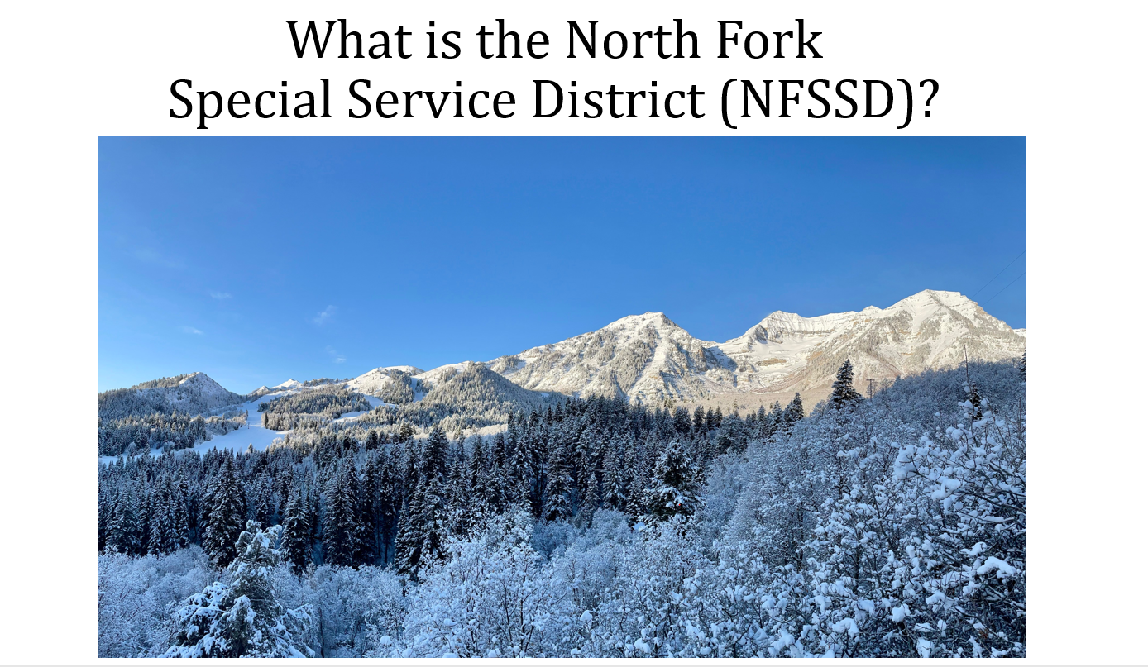
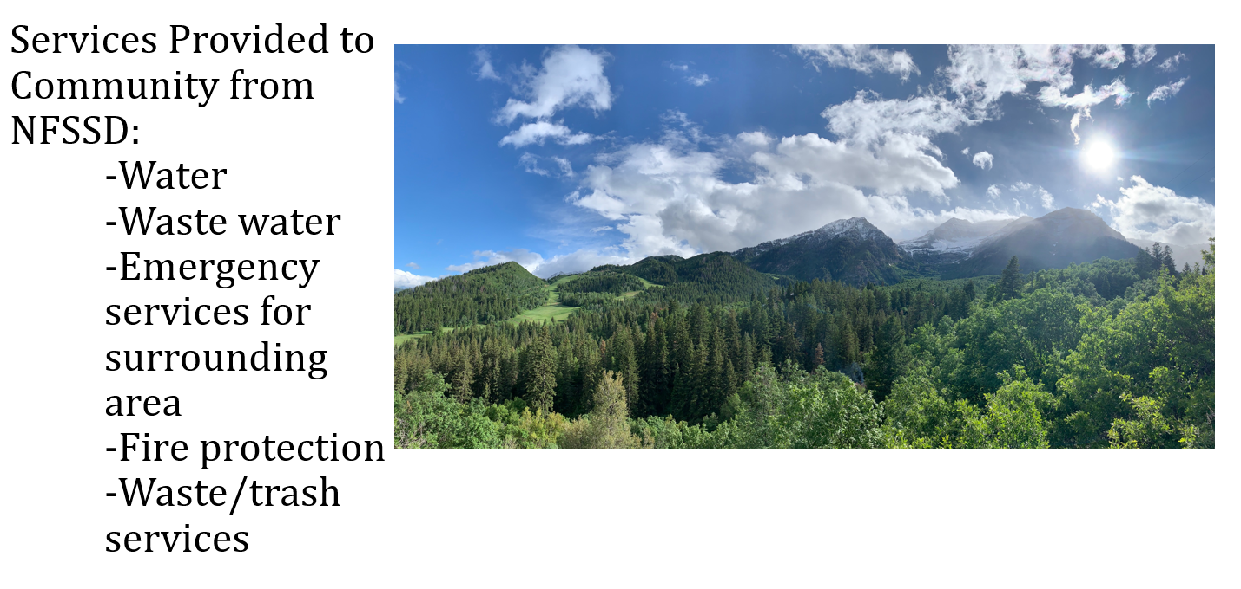
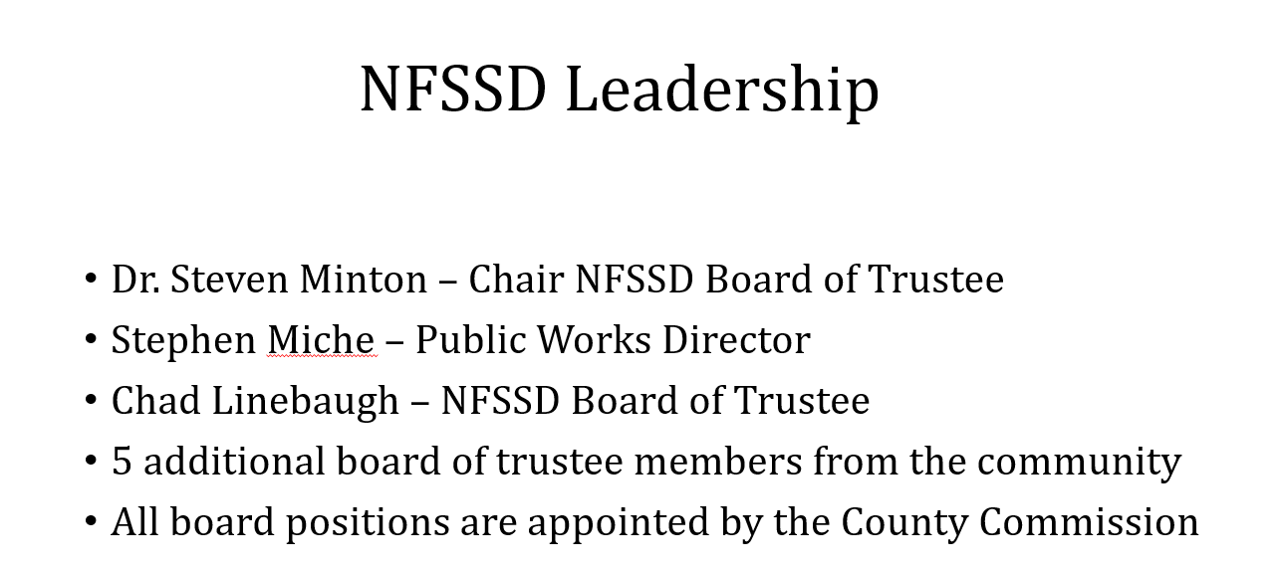
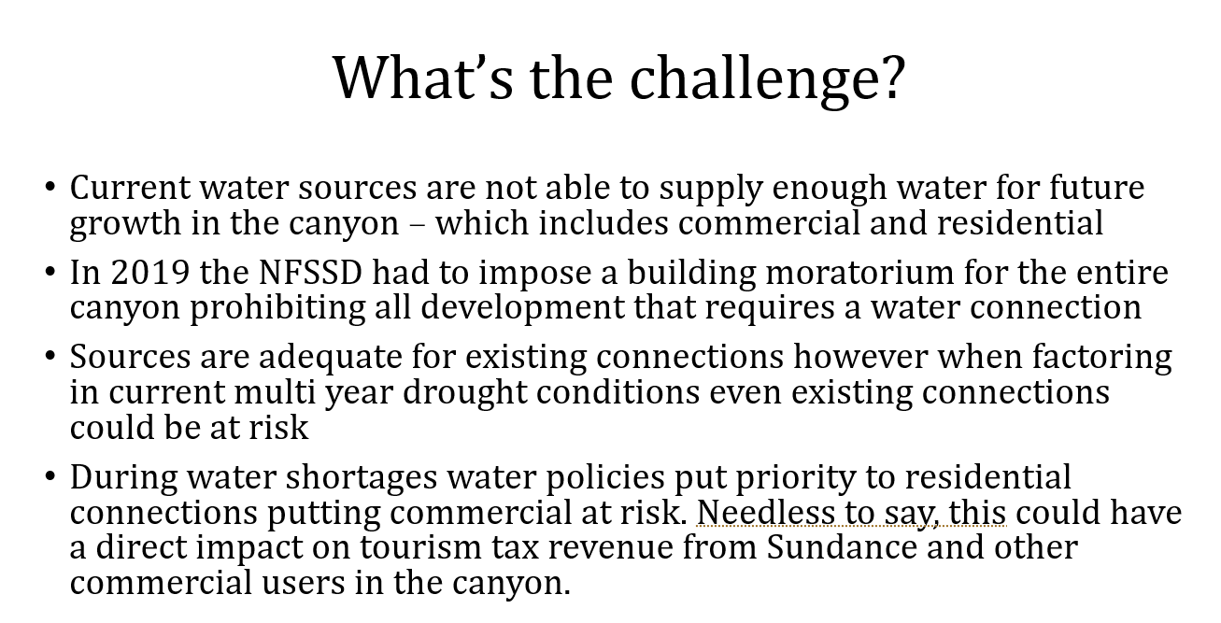
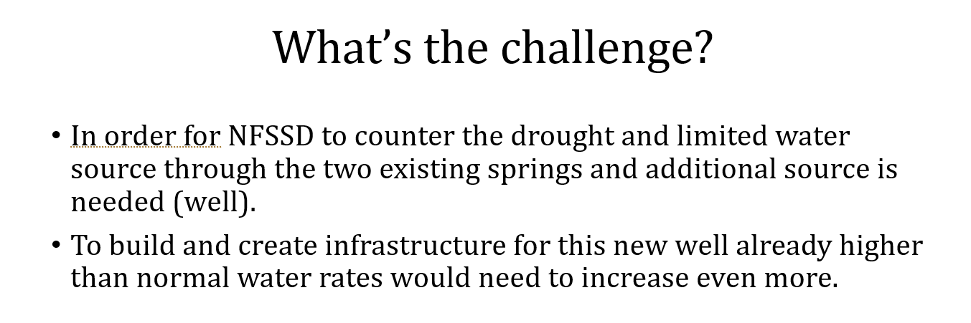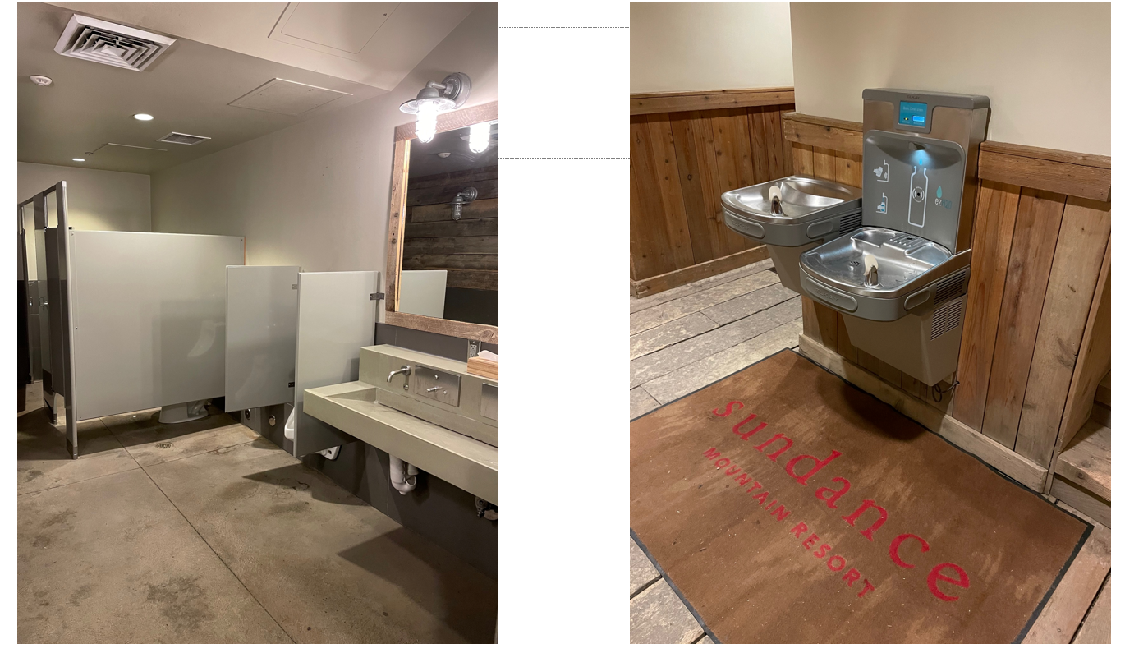
Chad mentioned these facilities are available and open to the public but without additional infrastructure investment it may be difficult to continue.
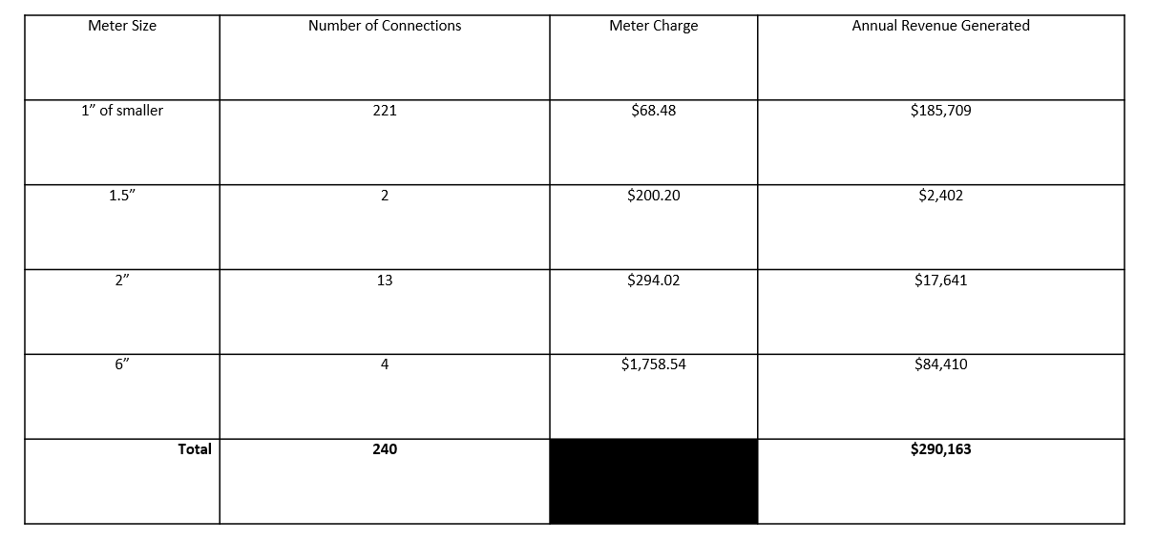
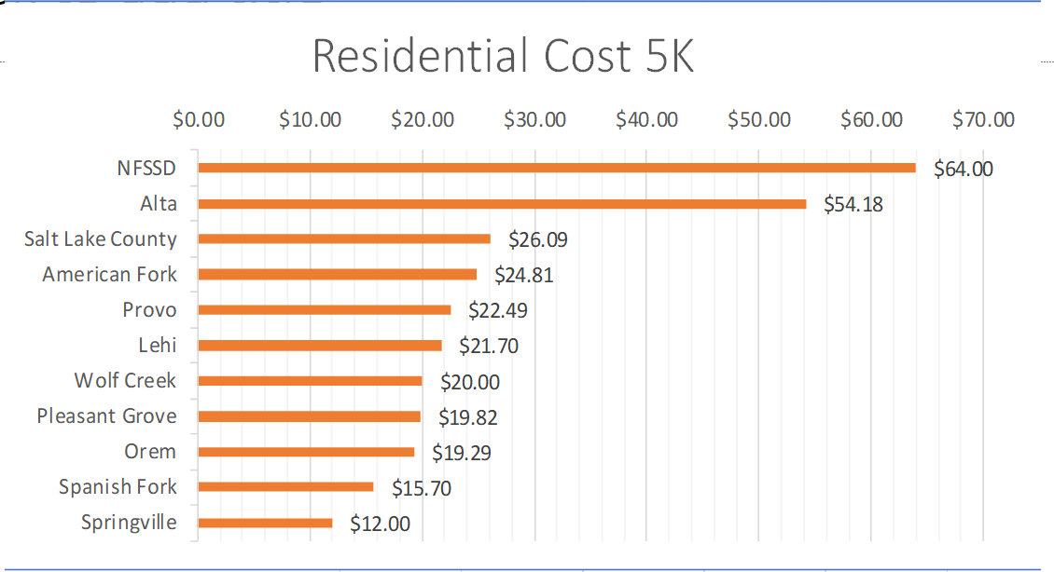
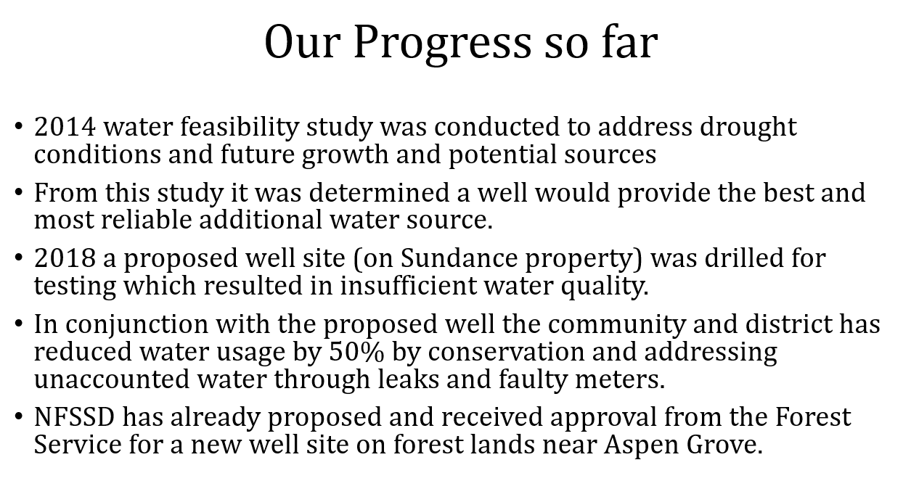
Chad put on his Sundance hat for a moment to discuss the new management of Sundance and the desire to add additional lodging and that for a business like Sundance, the increase to the water rate adds thousands of dollars of additional tax for all of the businesses in the district.

Dr. Minton provided a brief history of the district and talked about the water needs over time and the 50 year drought in the canyon. Water is essential to the future of the area and the well will be the most cost effective way to do it.
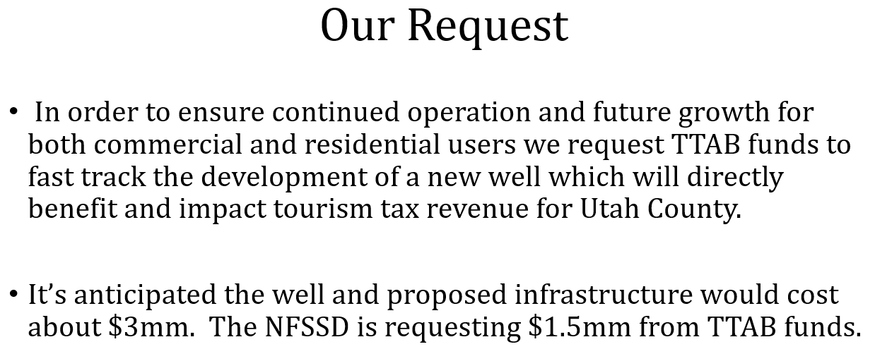

After the presentation John opened it up for questions. Commissioner Sakievich asked how much water do we have in NFSSD? There was some discussion but ultimately there is difficulty finding non-contaminated freshwater. A deep well would solve this issue.

Kurt asked about the quality of the water historically and how we ensure the water quality remains healthy. Dr. Minton talked about the previous efforts and some mistakes that they potentially made in drilling the old well. Stephen Miche has done some additional research but there hasn’t been a lot of drilling farther north yet but they know at the Aspen Grove Site, there’s a joining of good water sources and will be more ideal than the previous sites.
Chad said water engineers hired by the district have identified this new site as ideal.

Danny asked to explain oversight and funding sources for SSDs. Chad emphasized that NFSSD is a public entity and the board oversees everything. Dr. Minton said the County appoints and delegates certain duties and it has responsibilities for water and wastewater among them. But it’s completely funded by the residents taxes.

Chad said the Board is also seeking funding from the State and on the Sundance side they’re looking to hire lobbyists as well to access some State funding.

1:00pm HALE CENTER FOUNDATION FOR THE ARTS: Orem City
Project Funding Request: $3,000,000 (Total Project: $30,000,000)
Project Reviewer: Chad Linebaugh
Project Presenter: Jamie Davidson (Orem), Jeffrey Fisher (Hale Theater)

Time was turned to Chad to introduce, Chad is reintroducing the request from a few years ago. Land has been secured for the theater. Chad loves the arts and has respect for the theatre business. Sees it as a huge benefit to the entire community and has a lot of respect for the Hales and Swensons. Enjoyed working with Jeff on this.

Jeff introduced, Cody Hale, Linda Hale, Ann Swenson, Cody Swenson. Kathi Lewis and Ryan Clark. Jeff handles funding and works for the theater.

Jeff said slides are pretty straightforward. He mentioned Commissioner Lee is the only person left on the Commission from the original presentation.

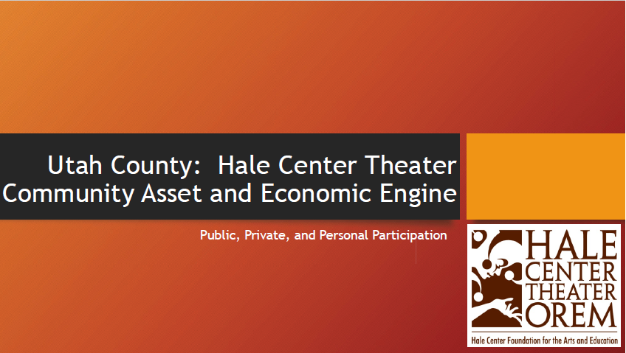

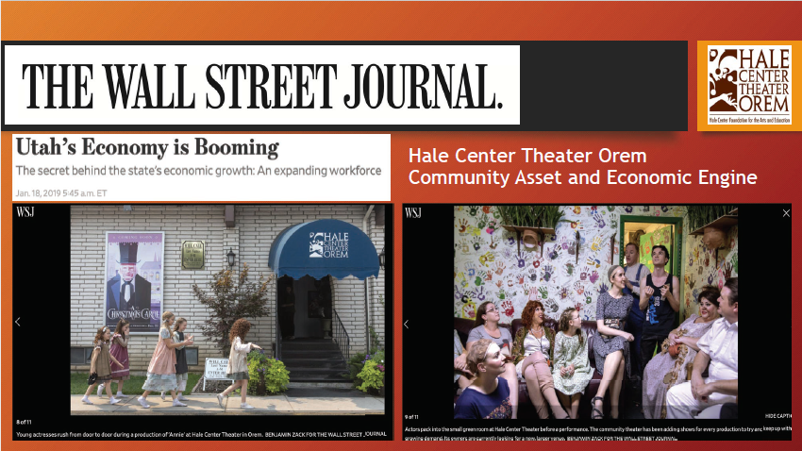
These are examples that the Theater is a community asset and that when people come to the theater they go out into the community and shop and generate economic impact.
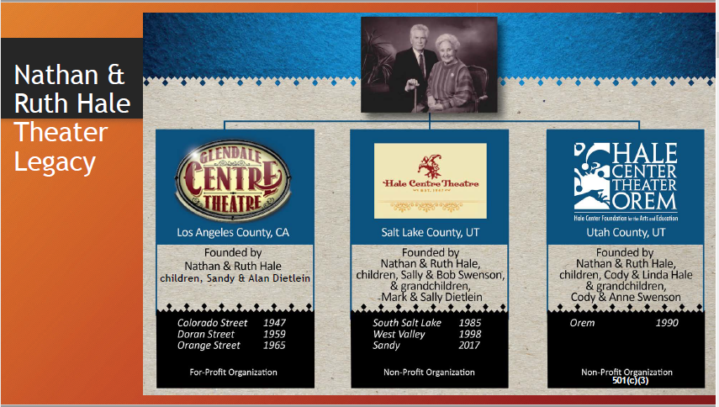
Groups are separate 501(c)(3)’s with separate boards. John asked how many seats the Sandy theater has. Jeff answered 900 seats. The Current Orem theater has 300 seats. Goal in new project is 600 seats to put things in perspective.

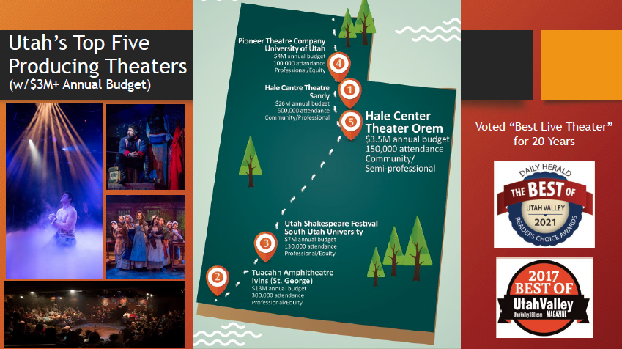
Fifth largest producing theater in Sandy which went from $9M to $26M. More patrons coming through from Shakespeare and Pioneer theaters
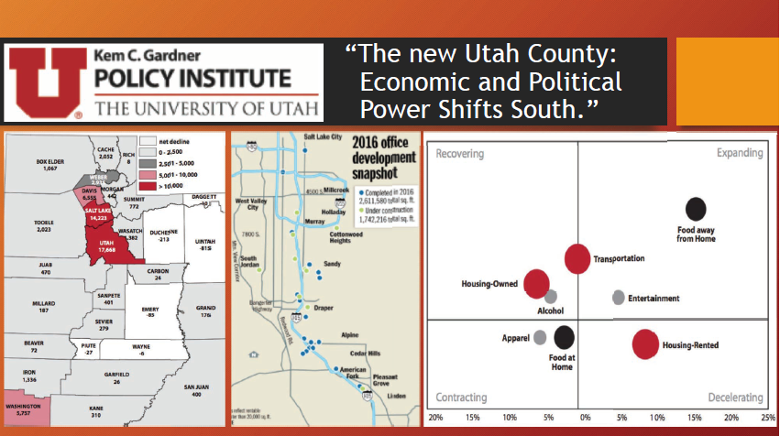
Food away from home is an expanding sector

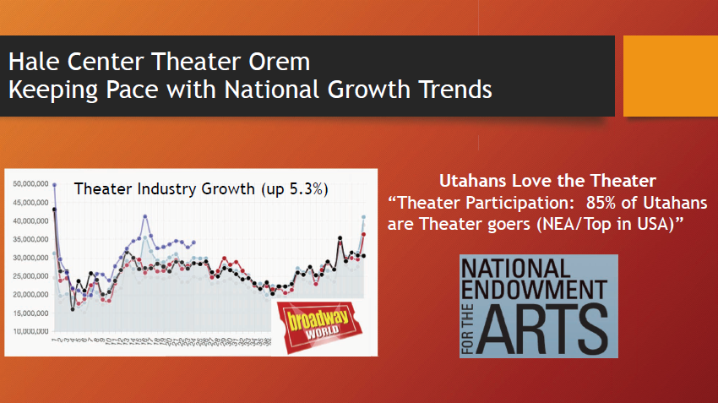
Theater industry was growing at a 5% clip pre-pandemic.
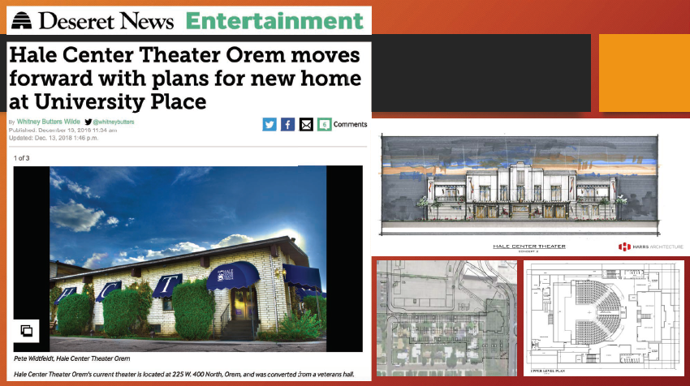
Woodbury donation received so location was announced and started some media attention. City of Orem is now acquiring property and building theater at University Place.

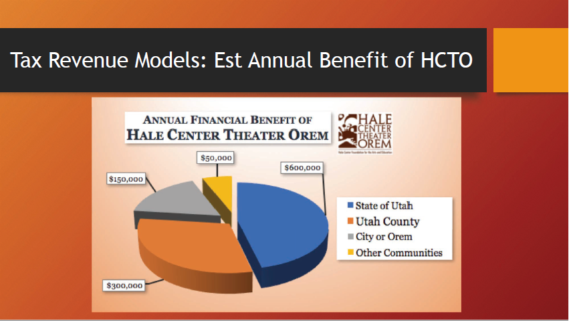

Currently theater brings in $300K of tax revenue to county. That would triple with this expansion.
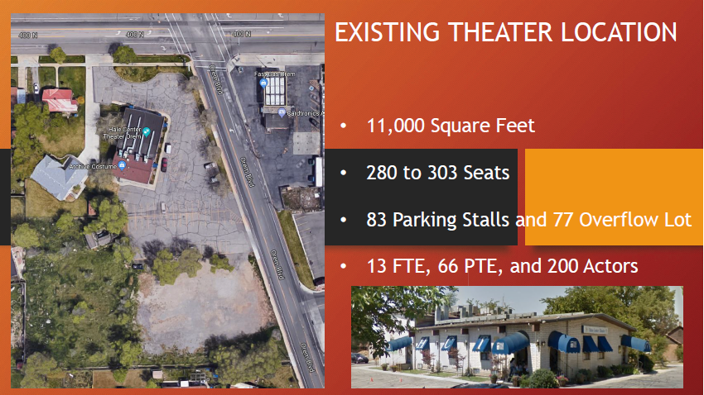

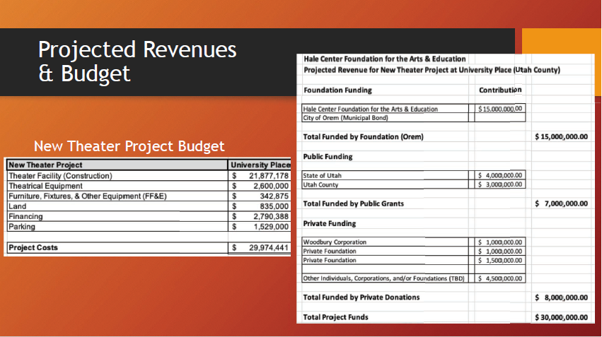
This $3M contribution in light of the entire project. State of Utah has committed ongoing funding so only funding left is to resecure 2017 recommended funding.
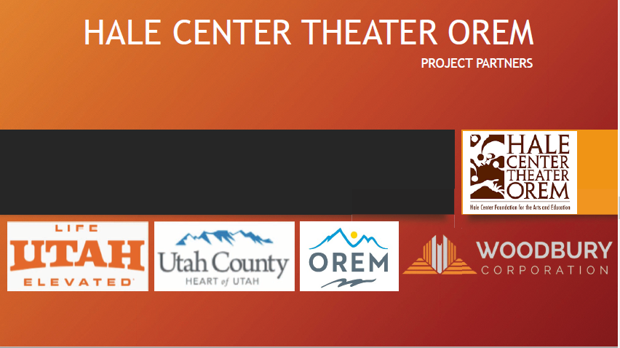

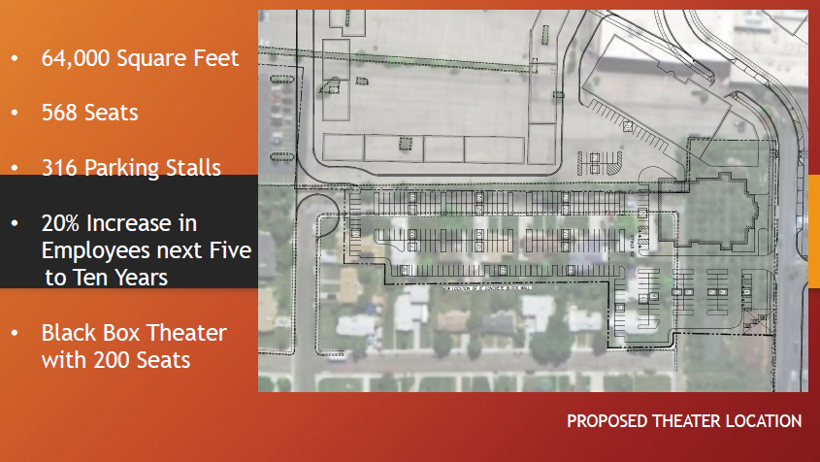
Theater would be located between H&M at University Place and Costco. Woodbury already owns the homes and they have been raised. All area is already being used.
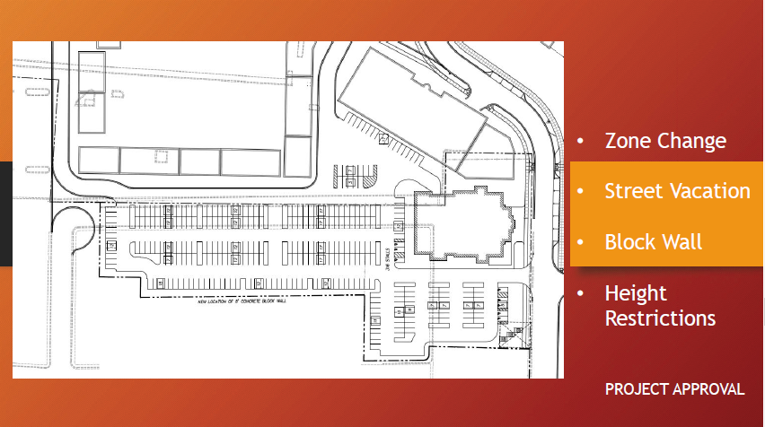
Site is ready for plans.

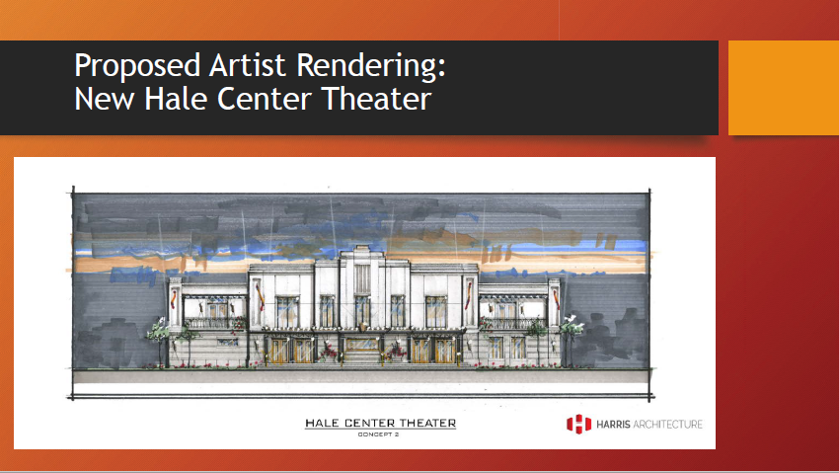

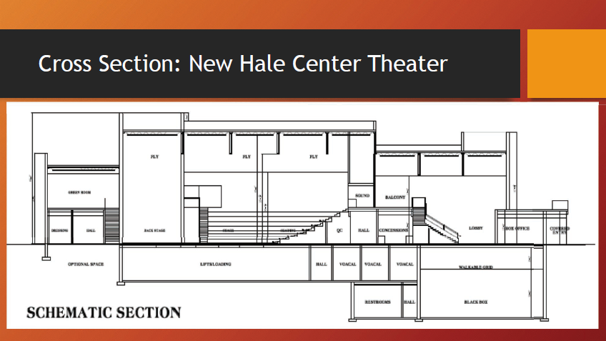

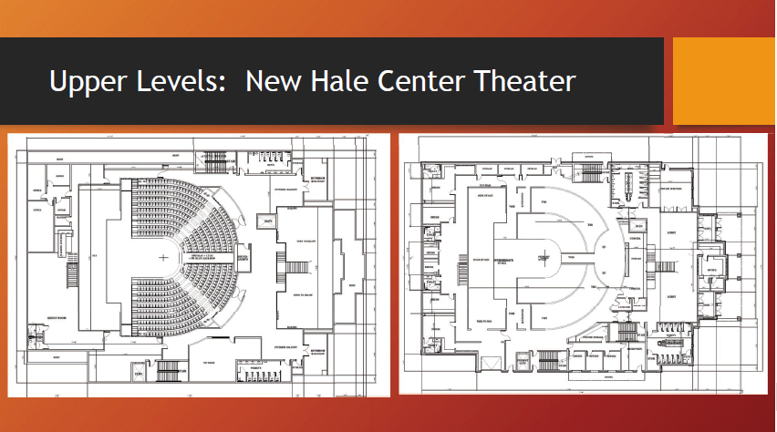

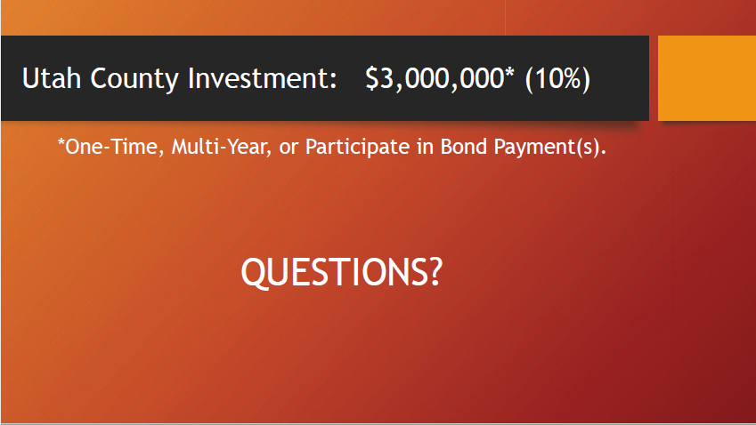
Jeff opened it up to questions. Brain can answer any questions from the city. John : Intent was to keep it in Orem? Jeff, yes Orem has contributed RAP tax funding ongoing they have been a great partner. John clarified the location. It’s in the huge parking empty parking lot that’s right near the Orem Costco at the moment.
Covey is a pure community theater owned by Provo. They don’t produce content unlike Hale. Rita asked about ongoing funding necessity. There’s a small operating percentage that’s granted by the city. Jeff Wilkes put together a pro forma and $15M will be paid from their own costs. They are confident they can handle the ongoing costs. They will triple in size but revenue from extra seats should cover the operating costs for the most part.
It was modeled similarly after Sandy’s pro-forma and Sandy has far exceeded that.
They are trying to find the sweet spot between intimate theater and larger theater.
John talked about the MoMA theater and their model. Jeff said they are operating at capacity right now so generally they don’t repurpose because they are at capacity.

Jeff talked about the theaters in the immediate area. Eccles in Salt Lake houses traveling shows. County owned building used for traveling shows. Hale produces in that venue and would never have travelling shows. The need for a travelling theater in Utah County is probably 10-15 years away but there isn’t quite the demand for it because Salt Lake has Eccles. Travelling shows are more drawn there. John asked if they looked at other sites in Orem. All locations were looked at. Cost of land was too expensive anywhere generally but with Woodbury partnership they are able to make this work. Also there is a good synergy with the local eateries and shops nearby. Other cities have requested Hale coming to their city but with Orem partnership with bonding they are staying.

Kurt talked about his experience with theater. He has trouble taking his kid to the Sandy theater just because of the vibe there so he wanted to know about the family-friendly aspect and scope of the theater. There is a deep appreciation for the intimacy of the current Hale Theater.

They are still keeping the intimacy by keeping the ceiling low and utilizing different design aspects to try to keep this theater as intimate as possible while still expanding. Intimate theater is their product and they don’t want to change the product.

There will also be a youth theater area for shows catered to youth. They are taking lot of patron input in shaping this vision.

Danny asked about the state funding. State has granted an ongoing appropriation for 300K a year to help with the bond payments. Danny asked about parking and the UVX line that’s there. Wanted to know if there had been any conversations with UVX to partner like some universities have done with UVX. They haven’t started those conversations with UVX being free right now but is a great idea they will consider into the future.

No other questions. John reviewed the process and that the vote today will be a recommendation to the County Commission and it will be up to the County to decide if they move forward.

John suggested limiting presentations to three. First come first serve. Reminded about the procedures to get groups in at least 30 days before the meeting.

1:30pm Ropes Course Letter of Support: $150,000 State of Utah Grant

John just brought this to the group's attention. Someone had requested a letter of recommendation on a Ropes Course at 5 mile pass. John answered that that wasn’t really something that this group does as far as letters of recommendations. Board feels comfortable with the premise that this group is just focused on recommendations to the Commission.

1:40 pm TTAB Priority Listing & Additional Discussion
Review current requests
Motions

Payson Forebay Project:
Motion: Approve recommendation for Payson Forebay Trail at $40,000 for parking restroom by Kurt Christensen
Second: Chad Linebaugh

Kurt added that this project seems like it more than pays for itself with the small contribution from the County and would be a worthwhile investment.

NFSSD Well Project:
Paul mentioned that this project has not been through attorney review between turnover in the attorney’s office and Paul has some reservations about the project. There was some discussion back and forth on opinions of whether this would qualify or not. The Special Service District, while a public entity, is not a tourist facility so it is likely that this would not be a qualifying use but Paul is willing to review and get back an answer. While North Fork is a Special Service District, the primary beneficiary could be private facilities. Other cities couldn’t necessarily ask for this funding of an allowed use outright. Chad explained that Sundance does provide a public benefit and some free amenities for those who recreate there free-of-charge. It was also explained that the source of the revenue doesn’t determine which agencies necessarily qualify as well. Paul just wanted to give the disclaimer that at this time he is not sure whether the UCAO will determine that this is a qualifying use. Chad brought up water rates among a few other ski resorts in place and how the building moratorium has significantly affected the opportunity to grow and contribute additional revenue to the TRCC fund.

Ezra recommended that the Board makes a recommendation conditional upon review from the Attorney’s office since the Commission will ultimately decide whether to enter into an agreement or not.

Kurt expressed some concerns doing that and re-emphasized the vetting process that this board had established. He is currently reviewing a project that was not ready for this month’s meeting and it was pushed back to a future meeting.

Ezra mentioned that we didn’t have any items on the agenda for this meeting 30 days prior to this meeting but the 30 day timeline is appropriate for attorney review. The Board reaffirmed their desire to follow the one month in advance timeline that was originally adopted.

Danny discussed the previous notion that Commissioners have discussed on what percentage people are asking for with these projects. John explained some of the history with percentage asks. Commissioners have had different opinions on it. John sees the percentage as a cap but ultimately TTAB is just a recommending board that can recommend whatever they feel and the Commissioners can pick what percentage to fund.

Chad brought up all the additional infrastructure needs for the NFSSD but that this project seemed to relate directly to tourism.

Danny asked about other funding sources and what Tom’s thoughts were on CARES Act or other federal funding coming in. Chad hadn’t looked into that but saw this as a project that bottom line affects tourism.

Second Motion: Approve the NFSSD conditional upon the approval of legality of the project by Greydon.
Second: Rita Wright

John said other option would be just to wait and see but this motion has to be considered first.
Danny wanted to make note on the risk of this. He would hate to spend this money on this project from this fund if there is a better funding source for it.

Kurt has been working through a project that has taken quite a bit of time to bring forward to the Board because of its uniqueness and prefers to see more adherence to the structure that was agreed to by the TTAB.

Motion passes 4-2, Chad Linebaugh abstained.

Moving forward John won’t accept anything unless its 30 days prior to the meeting date. Ezra suggested we get some written bylaws in place to help us follow this structure.

Hale Center Foundation

Danny thinks its a worthy project and that 10% is a fair ask but it’s still a lot of money. He’s looking at other projects in the $3M range which have recently been the sports park and the Provo Airport contribution and he doesn’t see the same level of economic impact coming from the theater as from those other projects but he thinks it is still a very worthy project that would add a lot.

Rita asked about the funding from the state. It’s a commitment that they are spreading over a number of years to contribute to the bond payments.

Kurt said there’s no question in his mind that the demand would be there for a Hale Center theater with more seats. In his experience he always goes to surrounding restaurants after going to the theater. But wants to look more into the ROI on the additional seats.

Danny said numbers they have given are economic impact numbers. Last time they presented they presented an economic impact number that appeared to be way more inflated and this has been tamped down since then.

There was discussion about the unique aspect of theaters that perform their own productions and what is currently available in the county. There was a general consensus on supporting the project but at a different dollar amount.

Graydon asked if we want to go back to them and have them give us a different number. John talked about this number being a financed number.

Third Motion: Chad motioned to support $1.5M, Danny said he could get behind $1.5M knowing that it sends a message to the Commission that they are supportive of this project but not at the level considering the available funds.
Jared second

Unanimous approval.

1:50 pm Other Business
Roundtable

There was some additional speculation on whether NFSSD could be approved.

Next Meeting was set for after some discussion on whether it could be scheduled for the 14th.

Meeting adjourned

