STAFF REPORT

Date: July 8th, 2020
To: Davis County Agriculture Protection Advisory Board
From: Andrew McDonald, Planner I
Re: Agriculture Protection Application

We have received an application for an agriculture protection zone located in what is now unincorporated Hooper (see included maps). The application was submitted by Kurt and Marsha Fowers; and includes multiple parcels, with various owners, that total approximately 1,132.609 acres. The area is currently zoned A-10 Agriculture Farm Production which; promotes and preserves agricultural production, promotes and protects open space and areas that can produce agricultural and/or farm animal products, and creates space for an appropriate number of farm animals and fowl to be kept or managed for personal use or for sale.

A notification of this proposal was mailed to each property owner involved in the application and to each owner within 1,000 feet of the proposed boundary lines of this zone. Each recipient had (15) calendar days from the date of the notice to submit in writing their objections, wishes to modify the proposal, or comment on the proposal. As of July 7th, 2020, no objections have been received, however, we have received support of the application from members of the surrounding community (See Attached).

By state code the Agriculture Advisory Board is required to make a recommendation to the County Commission on these applications. The Agriculture Advisory Board is charged with the following:

- Determine whether or not the land is currently being used for agriculture production.
- Determine whether or not the land is zoned for agriculture use.
- Determine the extent and nature of existing or proposed farm improvements.
- What are the anticipated trends in agricultural technological conditions.
- Recommend any modifications to the land proposed in the ag protection area.
- Analyze and evaluate any objections to the proposal.
- Make a recommendation to the County Commission.

Recommendations

Staff believes all the criteria set out by state law has been met with this application.
(1) The properties are clearly being used for agricultural production/livestock.
(2) All of the land is zoned for agriculture.
(3) We have not received any objections.

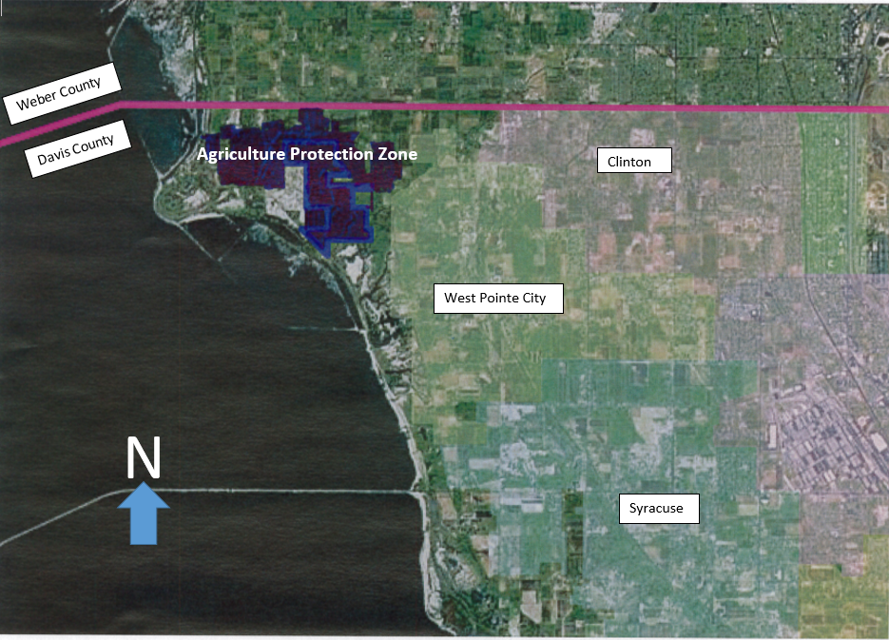

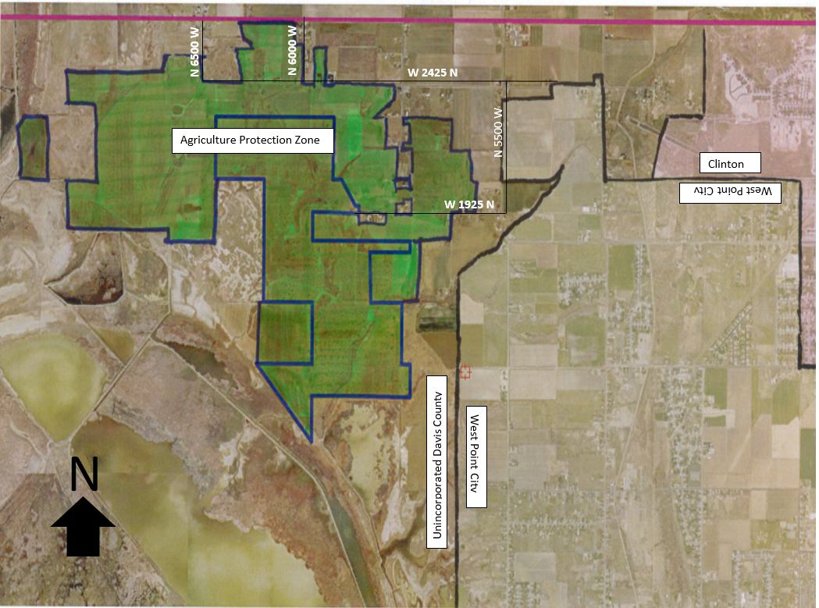
Approx. 1,132.609 acres

