185 South main



Holden Town Council
Work Meeting
June 1, 2021

The following are draft minutes from the Council Work Meeting held on June 1, 2021. Minutes are unofficial until approved by the council in the next meeting and are subject to change.
Started: 6:00 pm
Present: Mayor Darren Fox, Council Members: Josalyn Stevens, Jim Blodgett, David Wood and Phil Whatcott
Staff: Tina Stevens
Visitors: Jim Stephenson and Linda Nixon

On June 1, 2021, the town council held an emergency town meeting to discuss the effects of the drought and how best to manage the drought. Public notice was posted on the town door on May 27th, when the meeting was planned. This included preserving water, rate changes and secondary water.

The council came up with 3 goals that need to be addressed immediately.

- Conserve water immediately
- Build up a financial reserve for an additional water source (well)
- Water connection redundancy
Jim Stephenson and Linda Nixon both gave information regarding the last rate change and how they as a past council handled it. Mayor Stephenson was supportive.

BUILD UP A FINANCIAL RESERVE FOR AN ADDITIONAL WATER SOURCE (WELL)

The council went over different rates configuration and base amounts on the spread sheet from rural water. The council decided on the following rate modifications and will present it to the town on June 9, 2021, at the regularly scheduled town board meeting. A public notice was published, and a public hearing will be held.

Residential Meters
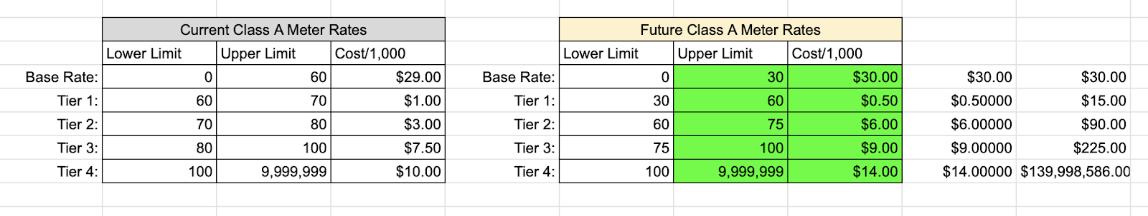

Class B Meters/ Livestock
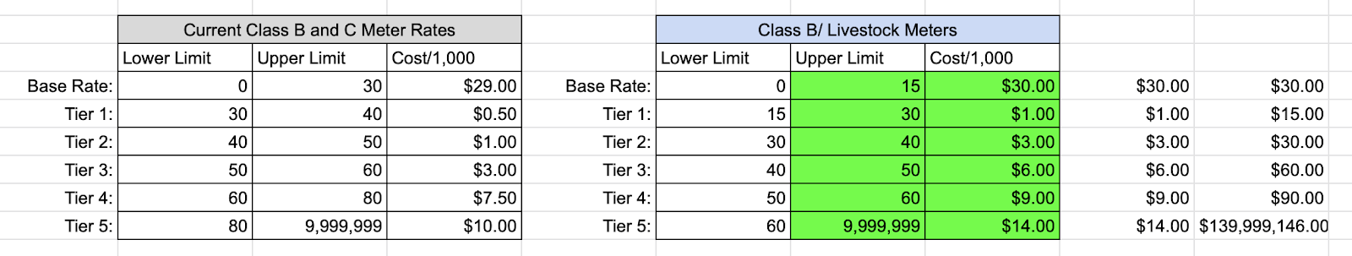

Class C Meters/Secondary
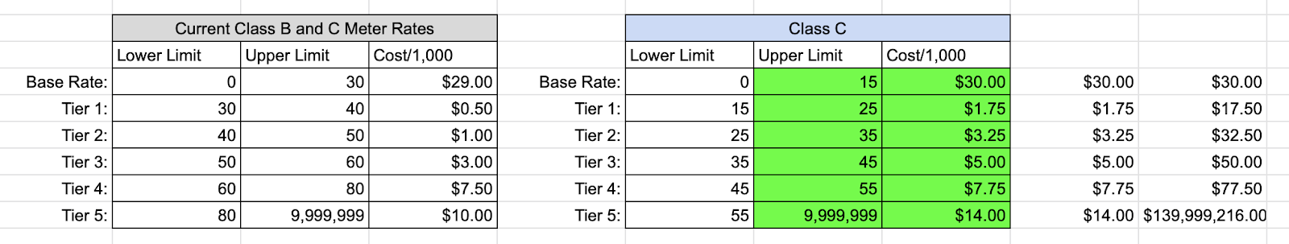
Dormant Meter
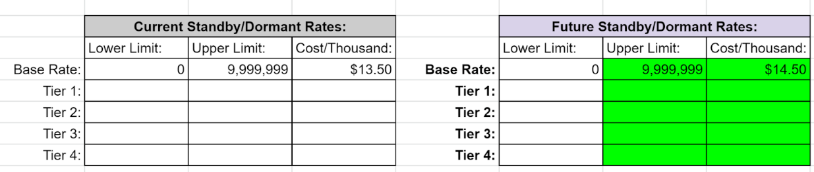

The rate change is necessary to prepare for a future secondary source. They will help meet the requirements to receive grants and save for infrastructure upgrades.
CONSERVE WATER IMMEDIATELY
The water flow has not increased since the spring of 2020 and continues to slowly decrease. The council recognizes the importance of conserving water now. They put the following restrictions in place:

NO OUTSIDE WATERING between 10am and 6pm!

East Side of Main Street water ONLY on Monday, Wednesday, and Friday
West Side of Main Street water ONLY on Tuesday, Thursday, and Saturday.
ABSOLUTELY no watering on Sunday.

Meeting ended at 8pm.

