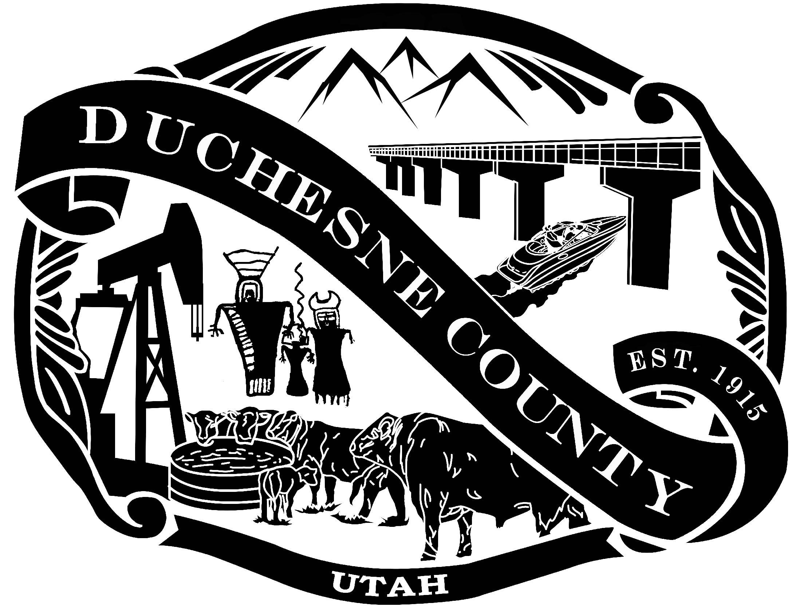
NOTICE OF A MEETING WITH THE DUCHESNE COUNTY ECONOMIC ADVISORY BOARD

PUBLIC NOTICE is hereby given that the Duchesne County Economic Advisory Board will meet on Tuesday, June 15, 2021, beginning at 2:00 p.m. in the Duchesne County Administration Building in Duchesne, Utah, as well as on Zoom (please see information below on how to join the meeting) to discuss and act on the following:

Duchesne County Administration Building
734 North Center Street, Duchesne City, Utah

- Opening Comments & Welcome
- Approval of the Agenda
- Approval of Minutes

Discussion of current projects & programs 2020/2021 Highlights
- Business Advertising Program - Irene Hansen
- Business Expansion and Retention (BEAR) - Dorothy Carter & Jenny Adams
- Small Business Gift Certificate Program - Dorothy Carter & Jenny Adams
- Customer Service Business and Employee Training

Explanation of County Policy: Board Expense Reimbursement

Introduction: Rocky Mountain Consultants (Thomas Winterton & Brandon Fugal)

Discussion of 2021/22 projects and Grant Cycle with the State of Utah:
- Suggested Budget $200,000.00 Match $60,000.00
- Prioritization of Projects:
- Training
- Advertising Grants
- Matching Main Street Grants
- B.E.A.R.
- Gift Certificates
- New Business Pitch Competition
- Other

Adjournment

Join Zoom Meeting https://us02web.zoom.us/j/7230771778
Meeting ID: 723 077 1778
One tap mobile +16699009128,,7230771778# US (San Jose) +12532158782,,7230771778# US (Tacoma)
Dial by your location 1 669 900 9128 US (San Jose) 1 253 215 8782 US (Tacoma) 1 346 248 7799 US (Houston)
1 646 558 8656 US (New York) 1 301 715 8592 US (Washington DC) 1 312 626 6799 US (Chicago)

I, Chelise Jessen, Duchesne County Commission Executive Assistant, certify that on June 10, 2021, pursuant to U.C.A., 52-4-202, this notice was posted 24 hours prior to the meeting time. Notice also given to the Radio Station, KNEU, and the Uintah Basin Standard.
__________________________________
Chelise Jessen
Duchesne County Commission Executive Assistant

IN COMPLIANCE WITH THE AMERICANS WITH DISABILITIES ACT, PERSONS NEEDING AUXILIARY COMMUNICATIVE AIDS AND SERVICES FOR THIS MEETING SHOULD CALL THE DUCHESNE COUNTY CLERK’S OFFICE (435)738-1100

