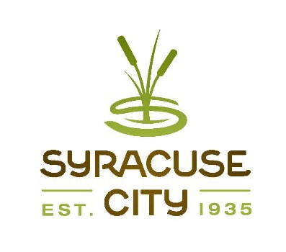SYRACUSE CITY

Syracuse City Redevelopment Agency Agenda
June 8, 2021 – immediately following the City Council Business Meeting, which begins at 6:00 p.m.

In-Person Location: Syracuse City Hall, 1979 W. 1900 S. Electronic: Via Zoom Meeting
Streamed on Syracuse City YouTube Channel

This public meeting will be held in a ‘hybrid’ in-person/electronic format in accordance with House Bill 5002, Open and Public Meetings Act Amendments, signed into law on June 25, 2020. In-person attendance will be allowed in the Syracuse City Council Chambers, 1979 W. 1900 S. In consideration of the COVID-19 pandemic, social distancing and mask wearing is encouraged, but not required. The meeting will be streamed live on the Syracuse City YouTube Channel and public participation will be allowed via Zoom.

Connect to the meeting using: https://us02web.zoom.us/j/86280129708 Meeting ID: 862 8012 9708
Connect via telephone: +1-301-715-8592 US Meeting ID: 862 8012 9708

- Meeting called to order Adopt agenda
- Public Hearing: Proposed Resolution RDA21-02 adopting the annual budget for the Fiscal Year 2021-2022 as required by section 17C-1-601, Utah Code Annotated, 1953. Board discussion, if necessary, will commence with Boardmember Bolduc.
- Adjourn.

~~~~~
In compliance with the Americans Disabilities Act, persons needing auxiliary communicative aids and services for this meeting should contact the City Offices at 801-825-1477 at least 48 hours in advance of the meeting.

CERTIFICATE OF POSTING
The undersigned, duly appointed City Recorder, does hereby certify that the above notice and agenda was posted within the Syracuse City limits on this 3rd day of June, 2021 at Syracuse City Hall on the City Hall Notice Board and at http://www.syracuseut.com/. A copy was also provided to the Standard- Examiner on June 3, 2021.
CASSIE Z. BROWN, MMC SYRACUSE CITY RECORDER

