NOTICE OF VACANCY

PUBLIC NOTICE is hereby given by the Board of Trustees of the Taylorsville-Bennion Improvement District that there is a mid-term vacancy on the Board. The Board will appoint a replacement to serve out the unexpired term, which will end December 31, 2023. The Board will appoint someone to fill the vacancy in its regularly scheduled Board meeting on June 17, 2021 at 2:00 pm at the District offices located at 1800 W 4700 South, Taylorsville, UT 84129.

Persons interested in being appointed to fill the vacancy may submit their names for consideration by submitting a resume with a cover letter which should include an explanation on why they seek to serve on the Board, what value they feel they will bring to the Board, and declare their adherence to the qualifications listed below. The resume and cover letter must be received by the District on or before June 14, 2021 by one of the following ways:

IN PERSON:
ATTN: Mark Chalk
1800 W. 4700 S.
Taylorsville, UT 84129
BY MAIL send to:
ATTN: Mark Chalk
P.O. Box 18579
Taylorsville, UT 84118
Or VIA EMAIL:
mark@tbid.org

Applicants will be notified if they are requested to attend an interview with the board, which will be done in an open public meeting in accordance with Utah Law.

Board Member Qualifications are:
- Be a U.S. Citizen at the time of filing
- Be a registered voter
- Be a resident within the boundaries of Division 2 of the Taylorsville-Bennion Improvement District. The map below shows the boundaries of Division 2 in pink.

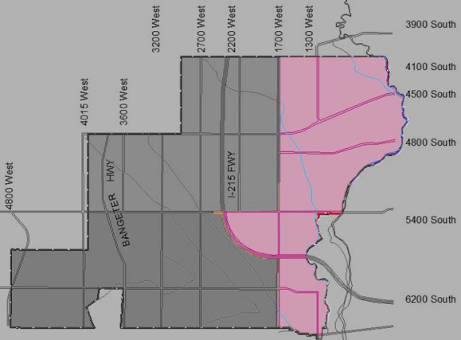

For additional information or questions regarding this notice, please contact Taylorsville-Bennion Improvement District at 801-968-9081.

