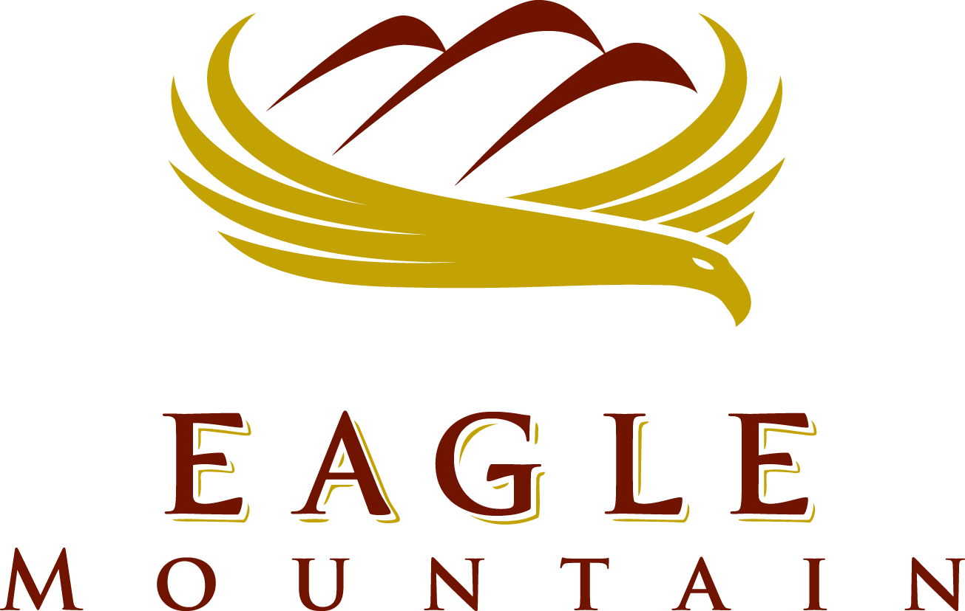

CEMETERY Advisory BOARD

May 26, 2021 6:00 p.m.
Eagle Mountain City Council Chambers
1650 East Stagecoach Run, Eagle Mountain, Utah 84005

6:00 PM – Eagle Mountain Cemetery Advisory Board

- Call to Order
- Action and Advisory Items
- Review and Finalize Memorial Day Program
- General update
- Next Scheduled Meeting: June 23, 2021
4. Adjournment

CERTIFICATE OF POSTING

The undersigned, duly appointed City Recorder, does hereby certify that the above agenda notice was posted on this 25th May, 2021, on the Eagle Mountain City bulletin boards, the Eagle Mountain City website www.emcity.org, posted to the Utah State public notice website http://www.utah.gov/pmn/index.html, and was emailed to at least one newspaper of general circulation within the jurisdiction of the public body.

Fionnuala B. Kofoed, MMC, City Recorder

