Kanosh Town is committed to taking steps to protect the health, safety, and well-being of our community. With the recent spread of COVID-19, some changes are necessary for conducting Kanosh Town public meetings. To follow the "Stay Safe, Stay Home" directive given by Governor Gary Herbert on March 26, 2020, we will suspend all Kanosh Town face-to-face public meetings until this directive is lifted and conditions within our State are deemed safe for social interaction.
Kanosh Town Corporation held the regular council meeting on Wednesday, April 14, 2021, in the town office at 7:00 p.m.

Members present:, Mayor Frank Paxton, Council members Rodney Whatcott, Neil Shumway, Hayden George and Brandon Stephenson. Kanosh Town Treasurer: Karen Crook and Kanosh Town Clerk: Cindy Turner.

Others in attendance Kanosh Town Employee Lorin Shumway, CERT Captain Geri Minton, Thayne Christensen, Star Cummings, Alexi Hadean, Peter Davis, Attorney Justin Wayment, Keith Kesler and Dan Rowley.
Councilmember Hayden George led everyone in attendance in a moment of reverence.

Council member Neil Shumway led everyone in attendance in the pledge of allegiance.
Councilmember Brandon Stephenson reported that the Corn Creek Irrigation Virtual kick off meeting is scheduled for tomorrow morning from 9-10. We have the contract in place from the NRCS. It is planned to kick off the environmental portion of the project. This meeting will not do anything with design, it is all environmental.
The main objective of the project is to address concerns about flooding potential, potential failure of the existing debris basin due to seepage that is occurring in the embankment’s foundation and water shortages each irrigation season caused by reduced flow in Corn Creek as the year progresses, which increases demand on groundwater resources, limits crop production and cropping options, and impacts economic development in Kanosh.
Minutes of the March 10, 2021 meeting were approved as amended through motion by Councilmember Brandon Stephenson, Councilmember Neil Shumway provided a second to the motion, all Council members voted in favor as noted below:
Mayor Frank Paxton: Aye
Council members
Rodney Whatcott: Aye
Brandon Stephenson: Aye
Neil Shumway: Aye

Warrants for April 2021 were read discussed and approved to be paid through a motion by Councilmember Rodney Whatcott , Councilmember Hayden George seconded the motion, all Council members voted in favor as noted below:
Mayor Frank Paxton: Aye
Council members
Rodney Whatcott: Aye
Neil Shumway: Aye
Brandon Stephenson: Aye
Hayden George: Aye

CERT:
Kanosh CERT Captain Geri Minton stated there is nothing new to report, there are no meetings scheduled for April however, there is talk of allowing meetings to continue in May!

Some of our CERT team have continued to help with the traffic control needed for the COVID immunizations in Fillmore but should conclude by the end of the month.

Fire Department:
Fire Chief Lorin Shumway reported that things have been quiet on fires. The department have had a couple of good trainings which were well attended. Last Thursday, the volunteers received additional training with Fillmore and another training is planned for tomorrow night.
Chief Shumway questioned using some of the COVID money for masks, the department is having trouble with radios used for communication. Chief Shumway questioned if they could use some of the COVID money for the hand held radios rather than masks. Council members were in agreement that the money should be used where it is needed the most.
Planning and Zoning:
Planning and Zoning spokesperson Geri Minton presented the building permit of Scott and Laurie Stevens to the council for approval. Utilities are already located on the property.
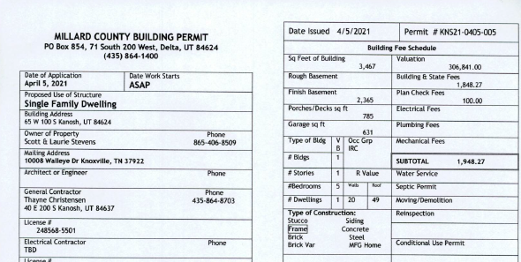
Councilmember Hayden George motioned to approve the Stevens permit as presented Councilmember Rodney Whatcott seconded the motion, all Council members voted in favor as noted below:
Mayor Frank Paxton: Aye
Council members
Rodney Whatcott: Aye
Neil Shumway: Aye
Brandon Stephenson: Aye
Hayden George: Aye

Star Cummings and Alexis Hadean Easter Egg Hunt:
Mrs. Cummings and Mrs. Hadean provided a follow up on the Easter Egg Hunt. Approximately 95 children participated in the hunt, usually we have quite a few more participants. In light of the ever increasing costs it was recommended that next year $250.00 should be budgeted for the Easter Egg Hunt.

Park Rules and signs:
Council member Hayden George reported that the park signs have been ordered, they are
24"x 18", black and white in color, they will be hard to miss!

It was also noted that there will be bike racks installed at the park. The bike racks hold nine bicycles each.

The vandalism in the park ensued in a lengthy discussion. Hopefully, the signs will help to
alleviate future problems. The vandalism has been reported to the sheriff's office.

Cemetery Care:
Council member Hayden George posted the following notice for Cemetery Caretaker bids:

Cemetery Caretaker Bid Opens
April 15- Oct 15
Duties Include:
- Mow cemetery as need, but no longer than 2 weeks between mowing’s, more in the spring less in the fall.
- Mow and trim the welcome to Kanosh sign at same frequency as cemetery.
- Grass trim each head stone and trees as needed, but no longer than 2 weeks between trimmings.
- Trim/weed the perimeter fence prior to Memorial Day.
- Responsible for maintaining equipment IE, fueling mowers and trimmers, checking oil levels, and belt inspections.
- Water dry spots with hose and sprinkler as needed.
- Monitor exterior trees.
- Monitor general appearance of gates, fence and storage building, and report any issues to town employee.
- Gopher control can be optional for a bonus if wanted.

All bids must be completed by April 14 before 7:00 P.M. Bids may be given to Hayden George.
Or mailed to Kanosh Town P.O. Box 9 Kanosh UT 84637.

There were two responses to this Bid advertisement:
1) Good ol’ boys construction
Keith Kesler 9750.00/ yr. gophers were not included

2) Pete Davis:
800/month or $4800.00 yr gophers were not included

Councilmember Hayden George motioned to accept Pete Davis bid to take care of the cemetery and the Kanosh sign. Councilmember Rodney Whatcott seconded the motion, all Council members voted in favor as noted below:
Mayor Frank Paxton: Aye
Council members
Rodney Whatcott: Aye
Neil Shumway: Aye
Brandon Stephenson: Aye
Hayden George: Aye
Park:
1) Park Signs ordered

Cemetery:
Councilmember Hayden ask for council opinion in reference to the Board at the cemetery, should we still have a hard copy on hand or just refer everyone to the computer program. Council agreed that many people do not know how to operate the app and therefore the hard copy would benefit many. Sunrise Engineering will be contacted requesting that the list of the names of the deceased and the map will be printed on a 24x36 page, more pages if needed.

Electrical Department:
Councilmember Neil Shumway has been in touch with Meadow Council member Dustan Starley about accepting their offer, he said that they would get us a check and a contract, of which we have already received!
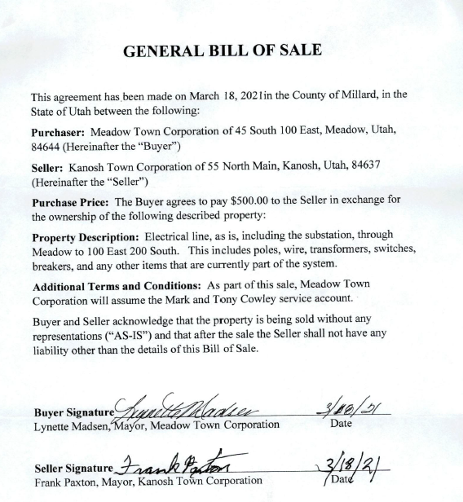

Roads:
Councilmember Brandon Stephenson reported everything is going well with the roads to date.

Water Department:
Councilmember Rodney Whatcott provided all in attendance with a copy of the following letter for the townspeople, encouraging everyone to be a little more proactive in water conservation.

Dear Kanosh Culinary Water Users,
We hope this letter finds you well.
As summer approaches we want to inform you of our current water situation.
As most of you are aware, on March 17, 2021, Governor Spencer Cox declared a ‘State of Emergency’ for the state of Utah due to “Extreme Drought” conditions.
The Town of Kanosh, along with the state of Utah, has been impacted by the lack of snow from the previous winters. We have been blessed to have our water needs met thus far. Throughout the past few years we have experienced a significant amount of growth within our community which we are grateful for. This growth has led to an increased demand on our water system.
The Kanosh Town Council has been proactively looking for ways to meet the increased water demand on the town by applying for “Emergency” Federal funding to increase the Towns water source.
As we wait for this and other funding to become available, we would like to encourage all water users to reevaluate your water use, so that we all will have enough water to see us through this drought.
According to the Executive Order 2021-7 Signed March 17, 2021:
“Cities and counties should consider developing and implementing water restriction plans for the upcoming irrigation season.
Residents should:
- Reduce indoor water waste;
- Fix irrigations inefficiencies;
- Convert unnecessary turf areas to waterwise landscapes;
- Consider purchasing a smart-timer controller or low flow toilet; and
- Reduce indoor water use by taking shorter showers, turning off water when not in use and replacing appliances with water efficient models where practical.”
The Kanosh Mayor and Town Council encourage the conservative use of water. While we prefer to not implement restrictions on the town and its water use, we will draft a water restriction plan for this upcoming season in the event our water conservation efforts are not enough. We ask that all town water users work together to implement better water conservation practices this season.
For more water saving ideas, please visit: www.slowtheflow.org
If you have any questions regarding this, or any other town matter, feel free to contact us.
Thank you for continuing to make Kanosh a great place to live!

In the executive order Counties and cities are encouraged to come up with restriction plans. Hopefully, next month we can work on a water restriction plan.
Following a record dry summer and fall, this winter’s snowpack is about 70% of average for the year. For snowpack to reach average, Utah’s mountains would need to receive the remaining 30% before it starts to melt significantly, typically the first week in April. There is around a 10% chance of this occurring. Current soil moisture is also at the lowest levels since monitoring began in 2006. “Extremely dry soils mean that when we do receive precipitation, the ground will soak it up first and reduce the runoff that typically fills reservoirs, lakes and streams.

Our drought map:
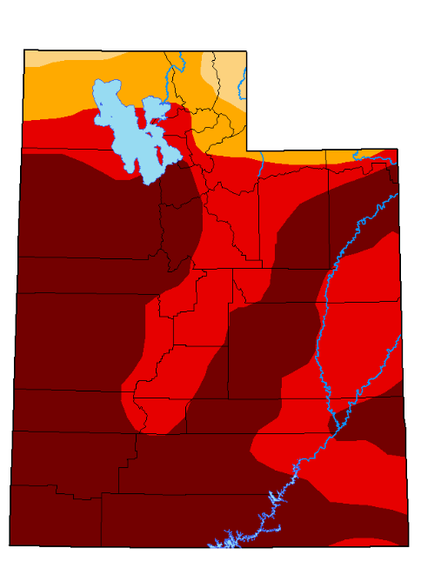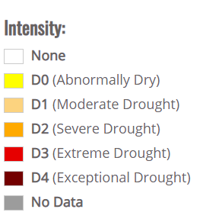
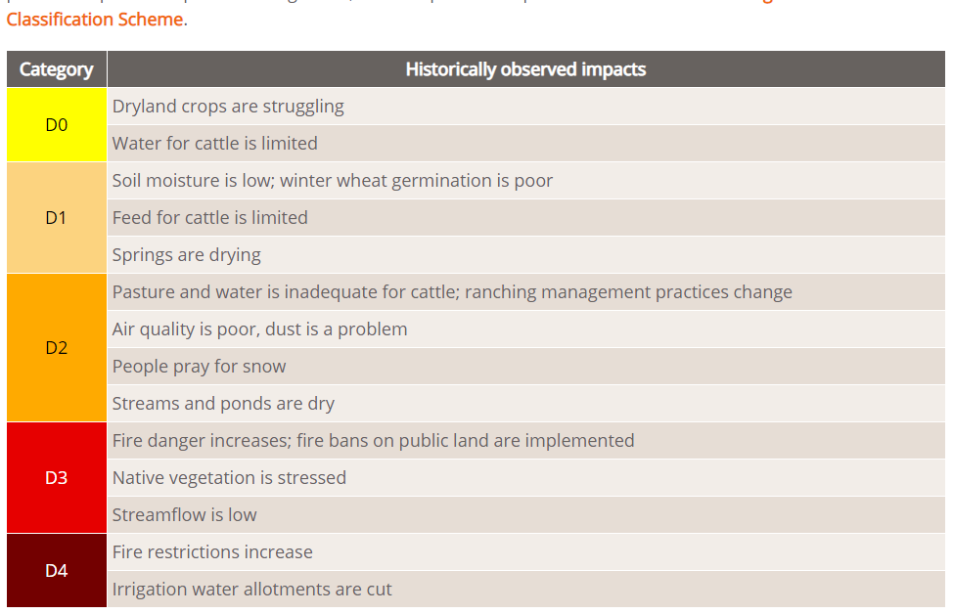

*The Well citing project is hopeful, optimistic. As far as a well, it won't be able to help us with this summer.
**Town Employee Lorin Shumway reported that the GPM is a few gallons per minute higher right now that at our lowest point last year.

Old Business:
Car Show Dan Rowley:
Mr. Dan Rowley addressed the Council members requesting financial support the Fillmore Car Show. The Fillmore Car Show is put on by the Old Capital Cruisers car club. It is held every year on the last weekend of June. The show kicks off with a cruise on Friday night, followed by the car show held at the Territorial Statehouse State Park on Saturday. Things get heated up with the Old Capital Cruisers' annual burn-out competition.

The Kanosh Town donation for the Car Show will be listed as an agenda item for next month.

CIB:
Met with Tyler and Travis, submitted the survey and they are meeting next week to prioritize the list.

Web site:
Meeting next week.

Meter deposit refund
Kanosh Town Treasurer, Karen Crook presented the name of Lorin Shumway as being eligible for a meter refund, in two years he has not been on the delinquency list. The refunds are according to policy and procedure and therefore do not require the vote of the council.

Review of Delinquencies:
Councilmembers reviewed the monthly delinquency list. It was determined, again, to handle those accounts in arrears according to established Town policy.

Public Comments:
No public comments at this time.

There being no further business to come before the board, the meeting adjourned.

Kanosh Town Mayor Kanosh Town Clerk

