May 7, 2021
DETERMINATION REGARDING CONDUCTING TOWN OF HIDEOUT PUBLIC MEETINGS
WITHOUT AN ANCHOR LOCATION

The Mayor of the Town of Hideout hereby determines that conducting a meeting with an anchor location presents a substantial risk to the health and safety of those who may be present at the anchor location pursuant to Utah Code section 52-4-207(5) and Hideout Town Ordinance 2020-03. The facts upon which this determination is based include: The seven-day rolling percent and number of positive COVID-19 cases in Utah has been over 6.48% of those tested since May 4, 2021. The seven-day average number of positive cases has been over 342 since May 5, 2021.
This meeting will not have a physical anchor location. All participants will connect remotely. All public meetings are available via YouTube Live Stream on the Hideout, Utah YouTube channel at: https://www.youtube.com/channel/UCKdWnJad-WwvcAK75QjRb1w/
Interested parties may join by dialing in as follows:
Meeting URL: https://zoom.us/j/4356594739
To join by telephone dial: US: +1 408-638-0986
Meeting ID: 4356594739
Additionally, comments may be emailed to hideoututah@hideoututah.gov. Emailed comments received prior to the scheduled meeting will be read during the public comment portion and entered into public record.
This determination will expire in 30 days on June 6, 2021.
BY:
____________________________
Phil Rubin, Mayor
ATTEST:
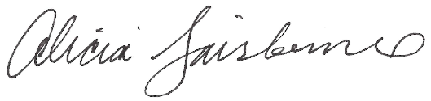
________________________
Alicia Fairbourne, Town Clerk

