1| Page Council Meeting________________________________________________April 20, 2021

SPECIAL MEETING OF THE HENEFER TOWN COUNCIL
April 20, 2021
Henefer Town Council Room
150 W Center Street
Henefer, UT 84033

Minutes of the Speciall Meeting of the Henefer Town Council held April 20, 2021.

Roll Call: Detton Fawcett, Matthew Shill, James Rees, Shelley Richins, Casey Ovard, Cameron Richins, Mattea Van De Wiele, Justin Richins, Kevin Joiner, Allie Greenhalgh, Kaden Vernon, Ashley Vernon, Cory McQueen, Terry Diston, Micah Richins, Jason Stolle, Courtney Richins.

Mayor Kay H. Richins was unable to attend. Matthew P. Shill, acting as Mayor interim opened the meeting at 7:00 p.m. The prayer was offered by Detton Fawcett and the Pledge of Allegiance was led by Richard Butler.

The first item on the agenda was Cory McQueen and Courtney Richins with a request for water connections outside of the Henefer Town limits. Matt Shill explained that Cory McQueen had attended the April 6, 2021 Henefer Town Council meeting with an inquiry about culinary water connections for the Joye Ovard property. This is property outside the Henefer Town limits that is under contract to be purchased by Cory and Courtney. At that time, Mayor Kay Richins called for a special meeting to further discuss and make a decision on the request.

Matt Shill asked Cory to briefly explain his request and proposed plans for the property.

Cory addressed the council. Cory explained that himself and Courtney Richins are under contract to purchase the Joye Ovard property. Cory informed the council that they would like to build 2 homes on the property within the next 2 or 3 years. One home would be for Cory and the other for Courtney or a member of his family. Cory explained that Courtney was in possession of two culinary water hook up certificates that were purchased from the Willa Dearden family. They would like to use these to connect to Henefer culinary water. Cory informed the council that he is sensitive to the current water shortage facing Henefer. He is asking for connections once the moratorium is lifted, or special exceptions to the moratorium are made.

Matt Shill asked Cory and Courtney if they were asking for something in writing in regards to the connections. Cory responded that they would like formal approval in the minutes to guarantee connections. Cory informed the council that if granted permission, himself and Courtney would incur the cost to extend the culinary water line approximately 200’ from John’s Park onto the Joye Ovard property. A licensed contractor would be hired to extend the line and it would be warrantied for 1 year. Matt questioned if there was a spring on the property. Courtney informed Matt that there is a spring on the property that provides water to the existing home on the property.

Jim Rees questioned Terry Diston about how many acre feet are in a Franklin Canyon water share. Terry responded that 3- acre feet are in a Franklin Canyon water share. Richard Butler explained that he thought it was 3 ½ acre feet in a Franklin Canyon water share. Richard also explained that some of the

2| Page Council Meeting________________________________________________April 20, 2021
water connection certificates that were issued at the time of the Franklin Canyon water project were specifically for use by family members of the water share owners. Jim Rees presented a copy of the following document:
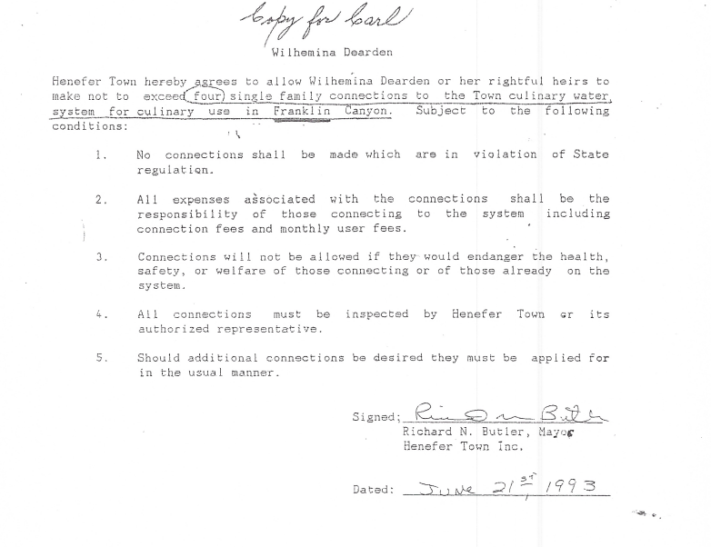
Jim explained that the document states that the hook-ups were for Willa Dearden or her rightful heirs in Franklin Canyon. Jim informed the council that the connections requested by Cory and Courtney are not in Franklin Canyon.

Terry Diston questioned if his connection certificates were the same way. Jim explained that he was not on the council when the agreements were made, so he does not have knowledge of the agreement with Rick Diston.

Matt questioned why Henefer Town allowed hook-ups outside the Town limits as part of the Franklin Canyon water agreement. Richard Butler explained that most of the Franklin Canyon water shares required for the project were owned by individuals outside the Henefer Town limits. In order to secure the water shares, Henefer Town granted the hook-ups. Matt questioned if there are any documents, which commit Henefer to water connections outside the Town limits. Richard Butler indicated that there is a document with Rick Diston regarding out-of-town connections. Richard also informed the council that there is a document with signatures of everyone that was granted a water share. Henefer Town received money from USDA, CDBG, and CIB for the Franklin Canyon water project. The attorney’s reviewed everything for the project before it was started. Matt explained that the current ordinance regarding connections outside the Town limits states that Henefer must have excess water to grant a hook-up, which Henefer does not currently have. Matt voiced concern that these signed commitments were made in the past when Henefer had excess water. Matt questioned how Henefer can honor them now, if it does not have excess water. Matt suggested that Henefer needs to determine how many existing commitments are on file and how many have been used. Richard indicated that he remembers approximately 17 hook-ups.

Terry Diston questioned if all the promised connections were for use in Franklin Canyon, due to the fact that most of the individuals they were issued to were not property owners in Franklin Canyon. Richard informed Terry that the only two agreements with the Franklin Canyon stipulation were the ones given

3| Page Council Meeting________________________________________________April 20, 2021
to Rick Diston and Willa Dearden. Matt questioned if any of those connections were sold. Courtney Richins informed the council that he had purchased one from Willa Dearden in 2003, Shelley Sargent purchased one for use when her well went dry in 2008, Jason Stolle purchased one 3 years ago, and Courtney purchased another connection in 2017. Matt questioned if any of the purchasers were direct descendants of Willa Dearden. Courtney informed the council that they were not. Cory stated that he doesn’t think the Willa Dearden family would have sold the connections if they were aware of the stipulation.

Matt Shill asked Jason Stolle when he had built and used the purchased water connection. Jason informed the council that he had built in 2018. Jason explained that he had tried to drill a well, but hit very little water. At this time, Jason spoke with former Mayor Randy Ovard and was informed that if he purchased a connection from Dave Holland, he would be allowed to connect to the culinary water. Matt questioned how Shelly Sargent and Jason Stolle were allowed to use these connection certificates if they were not descendants or in Franklin Canyon.

Detton questioned if these water connection documents specify that they are Franklin Canyon water shares.

Jim explained that there is nowhere on the documents that he has reviewed stating they are Franklin Canyon water shares. Jim informed the council that an ordinance was adopted in 2003 which requires 3 -acre feet of Franklin Canyon water for any connection outside the Town limits. Since that time, connections have been allowed with 3- acre feet of water surrendered to Henefer Town.

Jim Rees questioned what the definition of a subdivision is. Richard Butler explained that it is any ground that is divided more than once. Jim read from Henefer Town ordinance which states as follows: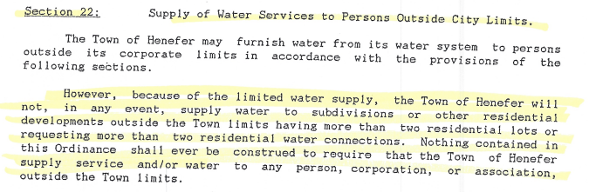
Jim informed Courtney and Cory that if they are dividing into two lots, that would be considered a subdivision, plus there is already an existing home on the property. Therefore, Jim does not see any way possible that Henefer Town can guarantee culinary water connections outside the Town limits.

Detton Fawcett expressed his opinion that there are many residents within the Town limits that need to be supplied water before water is supplied outside of the Henefer Town limits. Cory explained that they are not asking for connections right now. They are asking when the moratorium is lifted. Detton

4| Page Council Meeting________________________________________________April 20, 2021
explained that Henefer Town cannot commit right now due to the fact that they have no way to predict what the future will bring.

Terry Diston questioned if he subdivides his property to build a home, will it make his promised connection null and void. Jim explained that currently there is a moratorium, so the connection can not currently be used. When the moratorium is lifted, the issue will have to be discussed. The State of Utah would have final determination on what constitutes a subdivision.

Micah Richins stated that he was under the impression that Henefer Town had accounted for all of the water obligations that they had committed to. Micah informed the council that he had used one of the connection certificates to build his home on South Henefer Road. Matt indicated that the current council is not aware of how many connections Henefer is currently obligated to.

Courtney questioned if a connection would be given if only one home was going to be put on the property. Jim Rees explained that there is already an existing home on the property. Courtney informed the council that the home is already on a lot of record. Courtney questioned if the water connection certificates would ever be able to be used outside or inside the Henefer Town limits. Jim Rees responded that currently, with the moratorium in place, no new water connections can be granted. Detton indicated that once the moratorium is lifted, new connections within the Henefer Town limits can be allowed. Courtney informed the council that if he can’t use his certificates outside the Town limits, he can name 25 plus certificates that still exist. Courtney questioned if they will be allowed to be used for connections outside the Town limits. Courtney read a list of homes outside the Town limits that are currently connected to Henefer Town culinary water. Courtney indicated that most of these connections could be traced back to water connections certificates. Shelley Richins informed Courtney that most of those connections had surrendered 3-acre feet of water for the connection.

Courtney Richins informed the council that they would just build one home on the property. Jim Rees informed Courtney that he would still not commit to a connection out of the Town limits. Cory McQueen questioned the reason for that. Jim questioned Cory on the number of lots that would be on the property in the end. Cory did not feel that question was pertinent to the meeting. Cory informed the council that he has no intentions of putting a subdivision on the property. He is purchasing it for open space. Jim questioned if Cory and Courtney would give a guarantee that the land would not be subdivided. Jim requested a breakdown of how many lots would be sold on the property. Cory stated that no lots will be sold. In the future, family may want to put additional houses, but that was difficult to predict. Matt explained that once the secondary water is in place, in order for connections out of Town to be granted, excess water would have to be determined. Matt explained that it would be irresponsible to commit to something 2 to 3 years down the road. Matt would like to determine how many past obligations are committed to before any new commitments are made. Courtney explained that the water connection certificates that he had purchased from Dave Holland can’t be worthless. Henefer Town had made a commitment to Willa Dearden for connections. Jim agreed that a commitment had been made to Willa or her heirs, in which Dave Holland is a son-in-law.

Matt Shill questioned if Courtney was aware of the agreement made with Willa Dearden when he purchased the certificates. Courtney explained that he had attended a Henefer Town Council meeting for permission to use the connection certificate, should his well for his home go dry, before he
5| Page Council Meeting________________________________________________April 20, 2021
purchased it. Courtney indicated that permission was given. Courtney feels that everyone should be treated fairly. Matt explained that by granting permission for others to use the Willa Dearden water connections, the previous council had operated outside the conditions of the agreement. Cory presented a letter from Dave Holland, at the time he sold the water connection certificates which indicates that Henefer Town has the certificates for transfer. Cory feels that Dave did not have the understanding that only heirs could use the certificates at the time that they were sold. Richard Butler informed the council that Dave Holland was not present at the time the agreement was made with Willa. Terry Diston indicated that he had sold 2 of his connection certificates to Bill White and Dick Rudd.

Matt informed Cory and Courtney that if you put aside the agreement with Willa Dearden, and just petition the council for out-of-town water connections, they could still not be granted. Cory questioned if the moratorium could be lifted before the secondary water system is in place. The moratorium cannot be lifted until the secondary water system is up and running. Matt explained that it would be irresponsible for Henefer Town to commit either in the minutes or in writing to an out of-town culinary water connection at this time. Matt explained that the data must be considered once the secondary water system is implemented to determine if Henefer Town has enough excess water to allow out of town connections.

Cory informed the council that he feels that they are assuming that this property is being purchased for a development. Cory firmly stated that it is not for development. Eventually, family may want to build other homes there, but that is unknown at this time. Cory expressed that there are two water connections certificates in question and that is all they are asking for to be allowed.

Courtney questioned if Micah Richins would be able to use a connection certificate since he has subdivided his property. Jim explained that Micah is within the Henefer Town limits. Jim reminded the council that the issue at hand was Cory McQueen and Courtney Richins request for out-of-town water connections, not other issues at this time.

Richard explained that at the time of the Franklin Water Project, shareholders that gave water to Henefer Town were given a collective agreement for water connections. The agreements with Rick Diston and Willa Dearden were separate from the collective agreement, due to the fact that they were surrendering more water than all the others. Matt questioned if the agreement with Rick Diston has an heir stipulation. Shelley Richins indicated that it did not. Matt questioned, if the agreement with Willa had an heir stipulation, how was Jason allowed to use it for a culinary connection. Jim explained that permission was granted during a previous administration that the current council had no knowledge of.

Terry Diston expressed concern for his ability to use his connection certificates.

Casey Ovard explained that some shares are unable to be sold. If a share is able to be sold, does it also sell the right as an heir. Jim did not have an answer to the question.

Cory McQueen wanted to know if the water connection certificates are legitimate and if they can be used once water is available, or if they are worthless. Matt explained that it is his opinion that they can’t be used due to the terms of the agreement with Willa Dearden. Matt expressed concern that 2 of the certificates had been used, not in accordance with the agreement.

6| Page Council Meeting________________________________________________April 20, 2021
Matt expressed that it is his opinion that if commitments were made in order to complete the Franklin Canyon water project, they should be honored. Matt questioned if Courtney had knowledge of the agreement with Willa Dearden before he purchased the shares. Courtney answered, no, he attended a Henefer Town Council meeting before he purchased the certificates to see if he could use them. Courtney expressed that he had no knowledge of the agreement with Willa. Courtney presented a notarized document indicating the sell of one single family water connection for $10.00 in March of 2003 Courtney also presented a water connection certificate which was signed by Mayor, Randy Ovard, and Town Clerk, Shelley Richins in 2017.
Micah Richins explained that when these certificates were issued to Willa Dearden, she owned property in Franklin Canyon. That property has since been sold to Rick Diston.
Matt Shill suggested that once Henefer has a secondary water system in place, the moratorium has been lifted, and data regarding surplus water has been compiled, Cory and Courtney petition the council for water connections. Cory asked for affirmation that the certificates that had been purchased from Willa are worth something, due to the fact that a commitment was made to Willa. Matt explained that a determination would have to be made at the time of petition. Matt explained that a decision can’t be based on the precedent that was set in the past. It is Matt’s opinion that the Henefer Town Council cannot make a commitment for connections at this time. Matt reviewed the Henefer Town Culinary Water certificate that Courtney was in possession of that was signed by Randy and Shelley. Matt questioned if there was any documentation that tied this certificate to the Willa Dearden agreement. Courtney indicated that he was informed by Dave Holland to pick up the certificate from Henefer Town at the time of the sell in 2017. Matt would like to review minutes of past meetings to see if stipulations of the Willa Dearden agreement were ever waived. Cory feels that the certificate gives a guarantee for a water connection.
Matt Shill feels that Dave Holland has made $48,000 off of certificates that never should have been sold. Cory questioned how the Council could make exceptions for 2 of the certificates, but not for the other two. Matt explained that setting everything aside, Henefer has a moratorium and cannot allow any culinary connections at this time.
Detton explained that water would have to provided inside Henefer, before it will be provided out of town.
Matt suggested that Courtney formally request all documentation pertaining to the water connection certificates, so that he is prepared to petition the town at the time water becomes available.
Kevin Joiner informed the council that Vicki Haderlie had purchased a water share to connect to the culinary system in 2004. Due to unspecified reasons, she was never allowed to connect to the system. Jim explained that this meeting is for Cory McQueen and Courtney Richins, not issues that occurred in 2004.
7| Page Council Meeting________________________________________________April 20, 2021
Matt explained that it is his opinion that all documents relating to the Franklin Canyon water project need to be reviewed to determine what obligations were made. Matt also explained that those documents and arguments would have to be presented at the time a petition for an out-of-town water connection is made.
Matt Shill called for motion that the Henefer Town Council NOT commit to any culinary water connections outside the Henefer Town limits at this time, but will review upon petition to the Henefer Town Council in the future. Detton L. Fawcett made the motion. James A. Rees seconded the motion. VOTE: AYE: Detton L. Fawcett, Matthew Shill, James A. Rees NAY: none, ABSTAINING: none, ABSENT: Mayor Kay H. Richins, Robin K. Riches

Matt Shill called for motion to adjourn. Detton L. Fawcett made a motion to adjourn the April 20, 2021 special meeting. James A. Rees seconded the motion. VOTE: AYE: Detton L. Fawcett, Matthew Shill, James A. Rees NAY: none, ABSTAINING: none, ABSENT: Mayor Kay H. Richins, Robin K. Riches

____________________ __________________________
Kay H. Richins, Mayor Shelley D Richins, Town Clerk

