Business Description

Business Name:
Hazard Motorsports
Type of business:
Manufacturing or “building” and restoration of “classic” vehicles. The main focus is on older Jeeps. I restore them to pristine condition and modify or replace components for better performance. I own the vehicles being worked on and they are built to my own spec and then sold as a whole and delivered to the customer’s home.
Employees:
I complete these projects on my own and may hire an employee part time as needed. After a couple years, I may hire a full-time employee and a part time employee as needed.
Proposed hours of operation:
9AM to 5PM, Monday - Friday.
Deliveries:
Any mail deliveries will be from average UPS, FedEx, and USPS trucks a few times a week. These will mainly consist of parts needed to complete the current project.
Waste:
Waste will be collected by local refuse services; we will use 2 trash cans collected weekly. Any old oils, antifreeze, brake fluids, etc. will be safely collected and discarded, and recycled whenever possible.
Equipment:
Equipment will include a vehicle lift, drills, impact guns, air compressor, pressure washer, sanders, etc. low to average noise output from all equipment running in on-and-off fashion.
Parking:
We do not have regular in-person customers. Onsite we plan to have parking spots for my personal vehicle, and 5 others for a future employee and any visitors as per Hyde Park City requirements. Any completed vehicles and Vehicles being worked on will be kept inside the shop space.

Building and landscape design

There will be two buildings used on the site for performing all work and storage of vehicles. They will be steel construction conforming to the surrounding buildings. Below is a rendering showing the style with modern monochromatic colors.

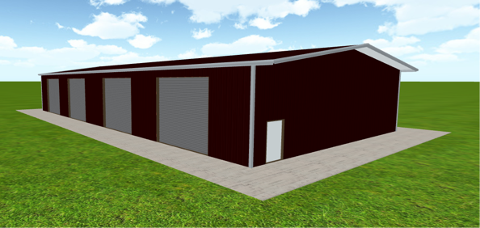

Landscaping:
Landscaping will conform to the surrounding development, with gravel and decorative rocks in the landscaping strips and water retention pond.

