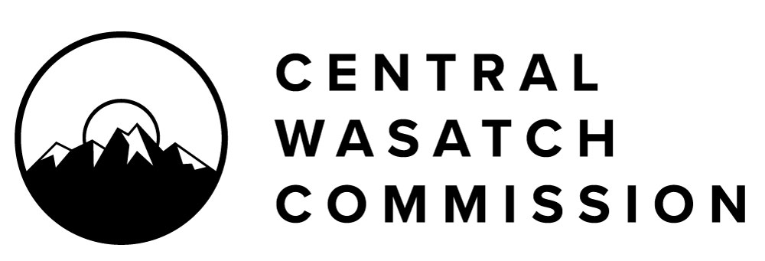

FOR IMMEDIATE RELEASE
May 4, 2021

CENTRAL WASTACH COMMISSION (CWC)
Lindsey Nielsen, Associate Director
801-706-1004, lindsey@cwc.utah.gov

CENTRAL WASATCH COMMISSION OPENS A CALL FOR STAKEHOLDERS COUNCIL APPLCANTS NOW THROUGH MAY 31, 2021

SALT LAKE CITY, UT -- The Central Wasatch Commission (CWC) invites applications to serve on the advisory Stakeholders Council. The Stakeholders Council, mandated by the CWC Interlocal Agreement, acts in an advisory capacity to the CWC board, and currently includes 29 members and four committees: the Trails Committee, which meets publicly on the 2nd Thursday of each month at 2:00 p.m.; the Millcreek Canyon Committee, which meets publicly on the 3rd Monday of each month at 1:00 p.m.; the Visitor-Use Committee, which meets on an as-needed basis; and the Preservation Committee, which meets publicly on the 3rd Thursday of each month at 2:00 p.m. The Stakeholder Council represents a diverse array of interests relating to the Central Wasatch Mountains, including community organizations, environmental groups, ski resorts, residents and property owners, and the general public. The Stakeholders Council meets as a whole on a quarterly basis in January, April, July, and October on the third Wednesday of the month, 3:00 – 5:00 p.m.

The Stakeholders Council assists the CWC board and staff in their decision making, providing expertise, opinions, and resources. Stakeholders are invited to gather information, conduct fact-finding, counsel together, provide analysis, conduct feasibility studies, and otherwise collaborate with broader constituencies with interests in the Central Wasatch Mountains in order to make recommendations to the CWC Board and the Commission's staff. As a condition of being appointed, Stakeholders Council members agree to support a consensus-based process for issues impacting the CWC’s project area, share information, and collaborate with other Stakeholders Council members.

Applications will be accepted through May 31st at 5:00 p.m. The public may learn more by visiting the Central Wasatch Commission website at cwc.utah.gov. To submit an application, complete the application form and email the required documents to Central Wasatch Commission Deputy Director, Blake Perez at blake@cwc.utah.gov.

ABOUT THE CENTRAL WASATCH COMMISSION
The Central Wasatch Commission is an inter-governmental entity with jurisdictions in the Town of Alta, the Town of Brighton, Cottonwood Heights, Millcreek City, Park City, Salt Lake City, Salt Lake County, Sandy City, Summit County, with the Utah Transit Authority as an ex-officio member. Its mission is to implement Mountain Accord. Building on the work of Mountain Accord, the Commission seeks to engage the public, build consensus, and coordinate the actions in the Central Wasatch Mountains. Learn more at cwc.utah.gov.
###

For further information, please contact Lindsey Nielsen at 801-706-1004, or lindsey@cwc.utah.gov

