Kanosh Town is committed to taking steps to protect the health, safety, and well-being of our community. With the recent spread of COVID-19, some changes are necessary for conducting Kanosh Town public meetings. To follow the "Stay Safe, Stay Home" directive given by Governor Gary Herbert on March 26, 2020, we will suspend all Kanosh Town face-to-face public meetings until this directive is lifted and conditions within our State are deemed safe for social interaction.
Kanosh Town Corporation held its regular Council on Wednesday, March 10, 2021, at 7:00 p.m.

Members present Mayor Frank Paxton, Council members Rodney Whatcott, Hayden George, and Brandon Stephenson. Kanosh Town Treasurer: Karen Crook and Kanosh Town Clerk: Cindy Turner. Councilmember Neil Shumway came later in the meeting.

Others in attendance: Kanosh Town Employee Lorin Shumway, CERT Captain Geri Minton, Zoie Whitaker, Tim and Savana White, via teleconference: Justin Wayment and Janice Shumway.

Councilmember Brandon Stephenson led all in attendance in a moment of reverence.

Councilmember Hayden George led all in attendance in the Pledge of Allegiance.

Minutes of the February 2021 meeting were read and approved as amended through motion by Councilmember Rodney Whatcott, Councilmember Brandon Stephenson provided a second to the motion, all Councilmembers voted in favor as noted below:
Mayor Frank Paxton: Aye
Council members
Rodney Whatcott: Aye
Brandon Stephenson: Aye
Hayden George: Aye

Warrants for March 2021 were read and approved for payment through motion by Councilmember Brandon Stephenson, Councilmember Hayden George provided a second to the motion, all Councilmembers voted in favor as noted below:
Mayor Frank Paxton: Aye
Council members
Rodney Whatcott: Aye
Brandon Stephenson: Aye
Hayden George: Aye

CERT Geri Minton:
CERT Captain Geri Minton reported CERT members she and Star Cummings and two people from Scipio has been helping with the COVID vaccine at the Fillmore Fire Station. This service will continue until the vaccinations can be administered at the health department.

Fire Department:
Fire Chief Lorin Shumway stated the fire department has nothing new to report.

Plans are underway to get going with the red card training.

April 14th at 6:00 p.m. the fire department and the Councilmembers will take part in the sexual harassment training.

Planning and Zoning:
Planning and Zoning spokesman Geri Minton presented two building permit applications to the Council for approval. The first permit is Savanna and Tim White, everything has been approved through P&Z and signed off by the inspector.
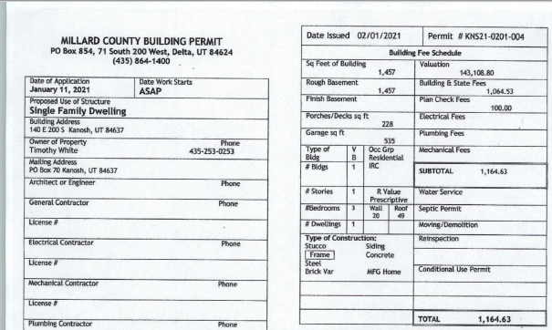

The owner of the second permit is Shannon, Garrett, and Brendan Barlow, this permit has been updated with a change to the house plan to include a partial basement with a crawl space.

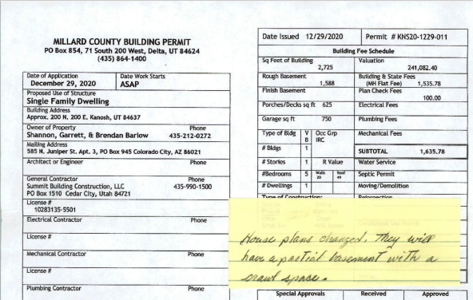

Due to the inclusion of the partial basement the building fee has been "verbally" increased by the Millard County building inspector. $1,729.00.

Councilmember Hayden George motioned to approve the permits as presented, Councilmember Rodney Whatcott provided a second to the motion, all Councilmembers voted in favor as noted below:
Mayor Frank Paxton: Aye
Council members
Rodney Whatcott: Aye
Brandon Stephenson: Aye
Hayden George: Aye

Zoie Whitaker:
Zoie and Emma Whitaker have been selected to attend the HOBY Leadership Conference at Snow College. Zoie addressed the council seeking financial support. They were each selected following the submission of a short essay on "What Leadership Means to You".
During this three- to four-day HOBY seminar, students gather at university sites across the U.S. to explore and discover their leadership strengths and learn how to apply them to serve their community.
HOBY’s Community Leadership Workshops are developed and implemented across the country by volunteers from local businesses, civic groups, and HOBY alumni for students to grow as inspired, confident leaders. This six- to eight-hour program for 30 to 50 high school freshmen may be hosted anytime during the year at a local school or community center. During a HOBY, student participants will:
- Interact with local community leaders, from CEOs to politicians to leaders of nonprofits, through keynote presentations about real-world issues and in-depth group discussions
- Learn to form diverse relationships with adult professionals, volunteer mentors, and students with diverse leadership styles and backgrounds
- Participate in activities to explore and exercise leadership on personal and group levels
- Conduct a community service project, putting leadership into action and implementing social change
Cost of the conference: $395/each includes rooms, education, boarding, etc.

The girls agreed to each donate 50 hours of community service to Kanosh Town as compensation of sponsorship.

Note: Councilmember Neil Shumway attended the meeting from this point forward.

Councilmember Brandon Stephenson motioned to sponsor the cost of the conference for each girl, (Zoie Whitaker and Emma Whitaker) to attend the HOBY conference at the cost of $395.00 each, with the stipulation they each provide 50 hours of community service to the town. Each girl will also report to the council on the conference upon its completion. Councilmember Hayden George provided a second to the motion all Councilmembers voted in favor as noted below:
Mayor Frank Paxton: Aye
Council members
Rodney Whatcott: Aye
Brandon Stephenson: Aye
Hayden George: Aye
Neil Shumway: Aye

Our Attorney Justin Wayment verbalized his desire to take $400 off of his bill to be used to help sponsor the girls attending the HOBY conference.

Annual Kanosh Community Easter Egg Event:
Ms. Geri Minton reported that the volunteers: Star Cummings, Alexi Haden, Sharon Taylor, Jessica Whitaker, and the Kanosh Ward Young Women. The Easter Event will be held at the Kanosh Ward and the Kanosh Park on Saturday, April 3rd at 9:00 a.m. The volunteers thanked the benefactor for the $200.00 donation for the event. In doing so they are making an itemized journal with original receipts for the Kanosh Town and the benefactor. Councilmember Hayden George motioned to pass the donation along to the volunteers and approve the use of the park for this purpose. Councilmember Rodney Whatcott seconded the motion, all Councilmembers voted in favor as noted below:
Mayor Frank Paxton: Aye
Council members
Rodney Whatcott: Aye
Brandon Stephenson: Aye
Hayden George: Aye
Neil Shumway: Aye
Note: This was not a Town sponsored event it was sponsored privately.

Sale of Electrical Assets to the Town of Meadow:
Councilmember Neil Shumway reported that Meadow has made us an offer to purchase our power lines running through their town. They have also agreed to supply power to the Cowleys, and to make necessary upgrades and connections at their cost. They are offering $500.00 for our poles, lines, and transformers, etc. I have attached their offer to this email. Attorney Justin Wayment noted that Since this is a sale to another Government Entity, it would not have to be put out to bid as surplus property.

Councilmember Neil Shumway motioned to sell the infrastructure to the Town of Meadow for $500.00, Councilmember Rodney Whatcott seconded the motion, all Councilmembers voted in favor as noted below:
Mayor Frank Paxton: Aye
Council members
Rodney Whatcott: Aye
Brandon Stephenson: Aye
Hayden George: Aye
Neil Shumway: Aye

Spring Clean up:
Councilmembers agreed to proceed with town clean up as outlined in town clean up resolution 06092010B
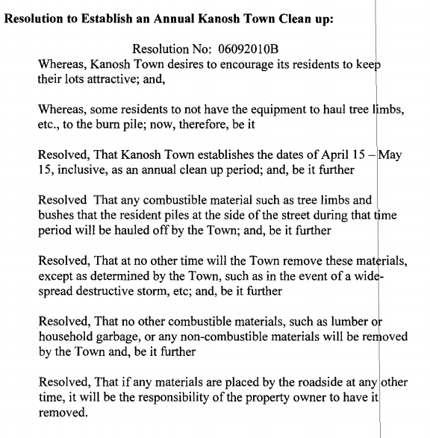

The Town Treasurer, Karen Crook will have the clean-up posted on the next power bills.
Ground Maintenance Services:
Councilmember Brandon Stephenson reported receipt of 2 bids to provide fertilizer, herbicide, and other ground maintenance for our community.

The following is a summary of these bids, the lower is an updated bid from Central Utah Landscaping:
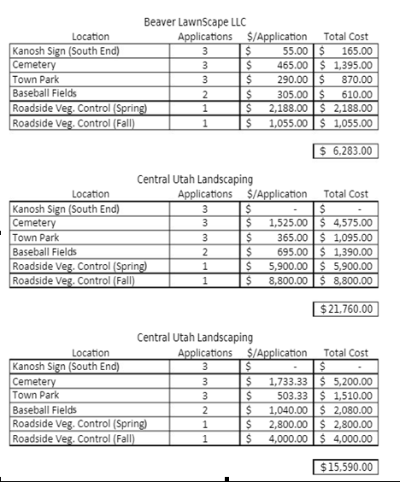

Councilmember Brandon Stephenson motioned to go forward with Central Utah Landscaping. Following a review of the budget, Councilmember Brandon Stephenson rescinded this motion.

While Councilmembers would like to support our local businesses there is a substantial difference in the bids, therefore Councilmember Brandon Stephenson motioned to proceed with the contract with Beaver Lawnscape for the period of one year only. Councilmember Neil Shumway seconded the motion, all Councilmembers voted in favor as noted below:
Mayor Frank Paxton: Aye
Council members
Rodney Whatcott: Aye
Brandon Stephenson: Aye
Hayden George: Aye
Neil Shumway: Aye

Corn Creek Irrigation Project:
We have great news, the grant agreement has been approved for signature by NRCS. After signing the agreement, the next step is a kickoff meeting. We will be setting up that meeting with NRCS. Hopefully in the next two or three weeks. The biggest challenge is to find a time that works for the many NRCS team members that need to participate in the kickoff meeting. Eight other projects will be trying to schedule kickoff meetings with many of the same people. We started working to schedule the kickoff meeting a couple of weeks ago so hopefully, we can get a meeting scheduled soon. We will determine some times that work for NRCS and contact you to determine the best time for a kickoff meeting. Following the kickoff meeting, there will be monthly progress meetings. Hopefully, these meetings can happen in person in Kanosh. The first meeting to obtain public input will occur in May. The schedule and scope of work will be discussed in far more detail at the kickoff meeting.

Mayor Paxton will need to sign the agreement, scan the signed agreement, and email it back to Layne Jensen, P.E., and Norm Evenstad.

Councilmember Brandon Stephenson motioned to proceed as recommended in approving in signing the agreement with the NRCS subject to review of legal counsel
3. Councilmember Hayden George seconded the motion, all Councilmembers voted in favor as noted below:
Mayor Frank Paxton: Aye
Council members
Rodney Whatcott: Aye
Brandon Stephenson: Aye
Hayden George: Aye
Neil Shumway: Aye

Gopher and Rodent problem:
Kanosh Town has a very definite rodent and gopher problem, particularly in the cemetery. Due to health concerns, our gopher trapper is unable to provide this service. The following suggestions were discussed:
*Beaver Lawnscape offered to sell the town his rodenator.
*Suggestion to include gopher trapping in the cemetery maintenance contract.

Cemetery Contract:
*It was suggested that the bids should specify if the town would provide the equipment or if the bidder would bring their equipment.
*Council will reserve the right to reject any and all bids.
*Rodent and gopher control will be included in the cemetery contract.
Councilmember Brandon Stephenson motioned to proceed to bid out the seasonal cemetery care contract after the council member George revises the contract, emailing the contract to each councilmember to review the contract. Councilmember Hayden George seconded the motion, all Councilmembers voted in favor as noted below:
Mayor Frank Paxton: Aye
Council members
Rodney Whatcott: Aye
Brandon Stephenson: Aye
Hayden George: Aye
Neil Shumway: Aye

Park:
Councilmember Hayden George has been contacted by individuals wishing to have a softball league using the ballpark every Saturday night.
They have also requested to use the old concession stand (located at the ball diamond) for fundraisers for the high school athletic department. Councilmembers agreed the group can use the old concession stand without any charge, if they opt to use the new concession stand user fees will apply.

Cemetery:
Councilmember Brandon Stephenson received a contract from Kelly Gillins, Sunrise Engineering, for GIS mapping. It could be used for water, power, and/or cemetery. It could be placed on our website when that is up and running, linked to a smartphone. The contract could be 100% covered by COVID money for the first year with a $1,600.00 annual fee afterward. This would serve as a great benefit to the Town of Kanosh.

Electrical Department:
Councilmember Neil Shumway reported continued trouble with our street lights going out, he is going to check with Brandon Cummings with Dixie Power, to have them replaced rather than just repaired, not all at once but continual converting over in time.

Water Department:
Councilmember Rodney Whatcott provided an update on the well-citing project. Robert Worley has been in contact with Councilmember Whatcott stating that the application is being reviewed at the State level, we were in line before the weather disaster in Texas.

REVIEW OF UTILITY DELINQUENCIES:
Council members reviewed the monthly delinquency list. It was determined, again, to handle those accounts in arrears according to established Town policy.

Old business:
*Hiring full-time employee: we are part of the Utah State Retirement Plan, we have been inactive for a long time. The legislature has now changed the filing requirements and now we have to file a report annually regardless of whether or not we have a full-time employee.
*COVID money: Fire Chief Lorin Shumway has requested the town use some of the COVID cares money to purchase masks for the fire department if there are access funds available. Councilmember Brandon Stephenson motioned to proceed with spending the COVID cares act money as discussed, through the purchase of electronic equipment for the council members, the contract with Kelly Gillins, fire dept. masks, radios, etc. only spending the COVID cares money. Councilmember Rodney Whatcott seconded the motion, all Councilmembers voted in favor as noted below:
Mayor Frank Paxton: Aye
Council members
Rodney Whatcott: Aye
Brandon Stephenson: Aye
Hayden George: Aye
Neil Shumway: Aye

*CIB meeting: Representatives from 6 county will be at Kanosh Town Hall at 4:15 P.M. on March 29 to discuss CIB funding.
*Power up the canyon road at the Steven Safford property. The property has been sold. If the meter shows usage we will have to have it pulled. We do have the ending read.
*We need a shredder for the town hall.
* ALL elections including Municipal Election should be run by mail. Under 20A-3a-202(1) all municipalities should be conducting their election by mail, "an election officer shall administer an election primarily by mail, in accordance with this section." We will contract with the County to run the election, however, in contracting with the County, they only manage the ballots and the vote centers.. Kanosh is still responsible for candidate filings, notices, posting requirements, Canvass, etc.. The County will provide us with all the information we will need to conduct the canvass.

Public Comment:
There were no public comments.

There being no further business to come before the board, the meeting adjourned.

Frank Paxton Cindy Turner
Kanosh Town Mayor Kanosh Town Clerk

