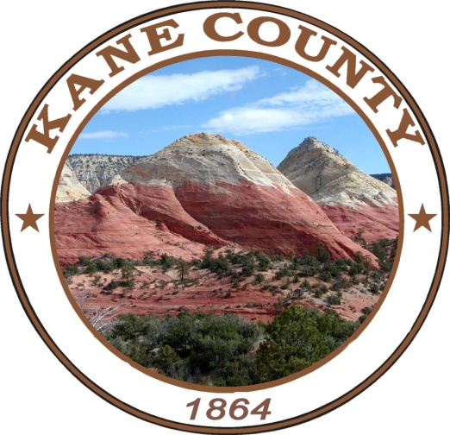
Kane County Commission
Commissioner Chairman Gant
Commissioner Heaton
Commissioner Chamberlain
435-644-2458

March 18, 2021

Dear Property Owners and Taxing Entities,

The Kane County Redevelopment Agency (the “Agency”) will hold a public hearing on April 27, 2021, commencing at 1:00 p.m. or as soon thereafter as possible, at the Kane County Offices located at 76 North Main St. Kanab, UT 84741 in the County Commission Chambers. The purpose of the public hearing is to accept public comment on draft amendments to the adopted project area plan and budget for the East Zion Community Reinvestment Project Area.

The governing body of the Agency previously adopted a resolution authorizing the preparation of one or more draft community reinvestment project area plan(s) and budget(s) for the proposed project area(s) within the East Zion Survey Area. Agency staff and consultants have prepared a plan for the project area, along with a budget, within the survey area. The original plan and budget were adopted on September 10, 2019.

The project area plan provides for the Agency to receive tax increment. Property tax revenues resulting from an increase in valuation of property within the project area will be paid to the Agency for project area development rather than to the taxing entity to which the tax revenues would otherwise have been paid; if the proposed project area is created and the use of tax increment is approved by interlocal cooperation agreement with one or more of those taxing entities. The plan and budget also contemplate revenues from incremental sales tax, restaurant tax, and transient room tax.

Originally, the Agency requested $25,022,828 in tax revenues that will be generated by development within the project area to fund a portion of project costs within the project area.

The proposed amendments contemplate changes to:
- the project area map,
- legal description,
- tax increment projections, and
- cost benefit analysis.

In the proposed amendments, the Agency requests $62,180,334 in incremental tax revenues that are anticipated to be generated by development within the project area. Said incremental tax revenues will be used by the Agency to fund a portion of project costs within the proposed project area. The increase in Agency requested funds is a result of the Agency identifying potential for additional imminent development within the project area, detailed in the amended plan and budget. Tax increment (as defined in the amended plan and budget) will be used as follows:

Uses | Total
Project Area Administration | $1,554,508
CRA Housing Requirement | 6,218,033
Redevelopment Activities | 54,407,793
Total Uses of Tax Increment Funds | $62,180,334

Redevelopment Activities may include, but are not limited to, development consistent with the overall East Zions Initiative, which is a master plan for the east side of ZNP. This includes the visitor’s center, grand lodge hotel, workforce housing, hiking trails and improved and expanded shuttle and transportation services.

These incremental taxes (or Tax Increment) will be taxes levied by the following governmental entities, and, assuming current tax rates, the incremental taxes paid to the Agency for this project area from each taxing entity will be as follows:

Entity | Total
Kane County School District | $ -
Kane County Water Conservancy District | 2,215,763
Kane County | 59,964,572
Total Tax Increment Paid to Agency | $62,180,334

All the taxes to be paid to the Agency for the development in the project area are incremental taxes that will be generated only if the project area is developed.

The Project Area is located immediately east of Zion National Park where Highway 9 connects with the Park’s entrance. Part of the Project Area extends north while another portion extends east along Highway 9. The proposed area contains 6,518 acres, more, or less. Persons may receive a copy of the boundary description at no cost by contacting Karla Johnson, Kane County Clerk/Auditor, (435) 644-2458.

All persons interested, and present will be given an opportunity to be heard in this matter. Written comments may also be submitted to the Agency regarding the draft plan and budget prior to the date of the public hearing. All concerned citizens are invited to attend the hearing. Any person objecting to the proposed project area plan or budget or contesting the regularity of any of the proceedings to adopt the proposed amendments to the project area plan or budget, may appear before the board at the hearing to show cause why the proposed amendments should not be adopted. The proposed amendments will be available in a substantially final form for public inspection at the Kane County Offices and on the County’s website, https://kane.utah.gov/.

People with disabilities may make requests for reasonable accommodation, which may include alternate formats, interpreters, and other auxiliary aids and services. Please make requests at least two days prior to the meeting date. To make a request, please contact the County Clerk’s Office by phone at (435) 644-2458.

All the best,

Brent Chamberlain
Kane County Commissioner
(435) 644-4904

Map of Current Adopted Project Area
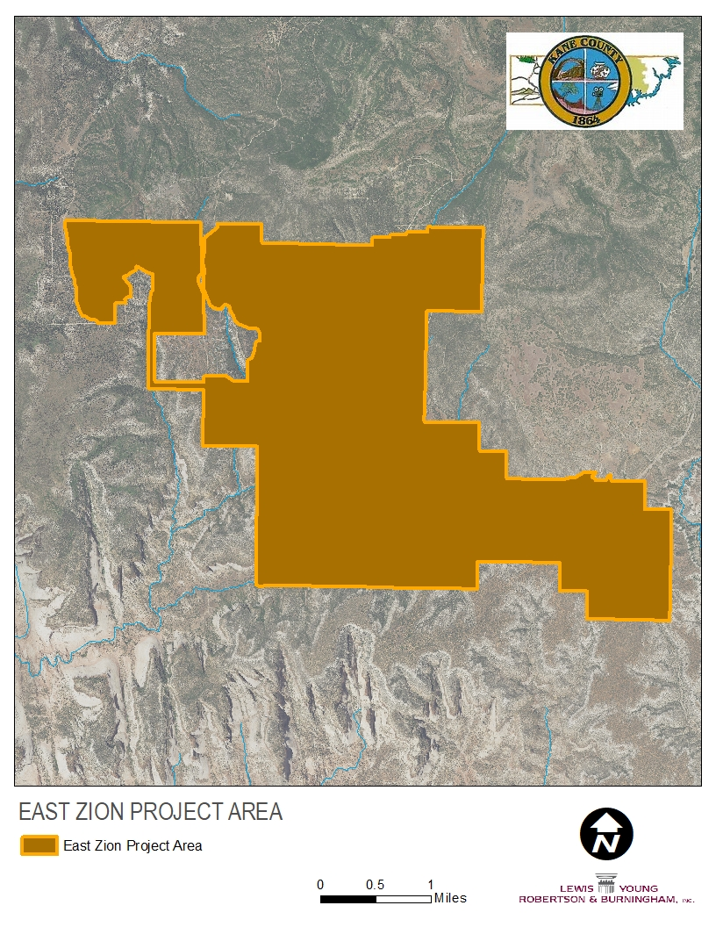

Zion National Park

East Entrance *
Ranger Station

Map of Proposed Amended Project Area
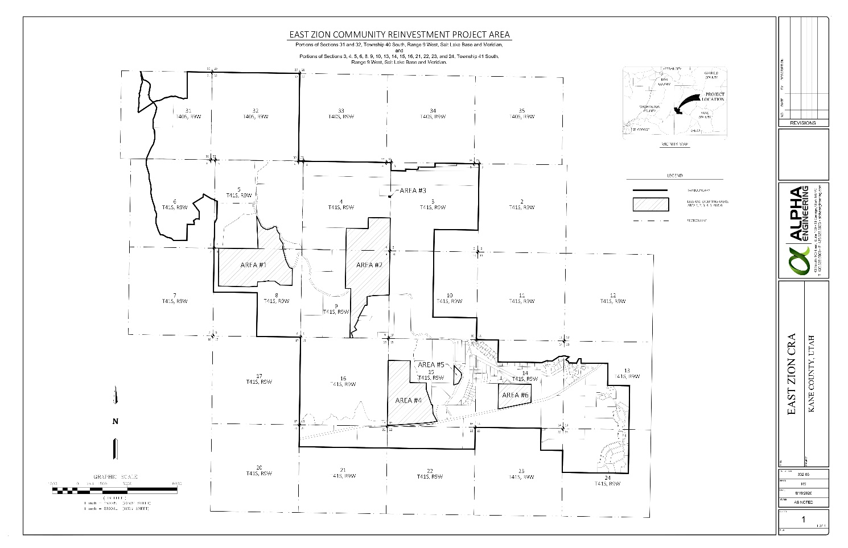

Parcels Included Within the Proposed Amended Project Area

