
Wednesday, April 7, 2021
County Commission Meeting
BOX ELDER COUNTY CLERK
01 South Main Street
Brigham City, Utah 84302

NOTICE AND AGENDA
Public notice is hereby given that the Box Elder County Board of County Commissioners will hold an Administrative/Operational Session commencing at 4:45 P.M. and a regular Commission Meeting commencing at 5:00 P.M. on April 7, 2021 in the Commission Chambers of the Box Elder County Courthouse, 01 South Main Street, Brigham City, Utah.
1. ADMINISTRATIVE / OPERATIONAL SESSION
A. Commissioners' Correspondence
B. Staff Reports
2. CALL TO ORDER 5:00 P.M.
A. Invocation Given by: Chairman Summers
B. Pledge of Allegiance Given by: Treasurer Shaun Thornley
C. Minutes from March 17, 2021
3. ADMINISTRATIVE REVIEW / REPORTS / FUTURE AGENDA ITEMS
4. FORMER AGENDA ITEMS
5. EMERGENCY MANAGEMENT ISSUES
6. PUBLIC INTERESTS / PRESENTATIONS / CONCERNS
A. 5:05 P.M. Request Use of County Grounds - Linda Lowe / Susan Neidert
B. 5:07 P.M. Use of County Grounds / Chalk Art Festival - Lisa Wyatt
C. 5:09 P.M. Address Recourse for 2020 Assessment as a Secondary Home on Parcel #03-223-0030 - Alexander Szmidt
D. 5:14 P.M. Presentation on SITLA – Dave Ure
7. ROAD DEPARTMENT
A. 5:24 P.M. Request for Road Closures for Pipe Installations - Gordon Young
8. COMMUNITY DEVELOPMENT
A. 5:26 P.M. Zoning Map Amendment - Ordinance 528 - Scott Lyons
B. 5:28 P.M. Country Acres Subdivision Phase 2 - Scott Lyons
C. 5:30 P.M. Ordinance 529-Thomas Rezone -MU-160 to A-20 - Scott Lyons
9. HUMAN RESOURCES
A. 5:32 P.M. Policy 24 Update _ Jenica Stander, HR
B. 5:34 P.M. Policy 25 Update – Jenica Stander, HR
10. COMMISSIONERS
A. 5:36 P.M. Parcels Owned by Box Elder County - Stan Summers
11. WARRANT REGISTER
12. PERSONNEL ACTIONS / VOLUNTEER ACTION FORMS / CELL PHONE ALLOWANCE
13. CLOSED SESSION
14. ADJOURNMENT

Prepared and posted this 2nd day of April, 2021. Mailed to the Box Elder News Journal and the Leader on the 2nd day of April, 2021. These assigned times may vary depending on the length of discussion, cancellation of scheduled agenda times and agenda alteration. Therefore, the times are estimates of agenda items to be discussed. If you have any interest in any topic you need to be in attendance at 5:00 p.m.
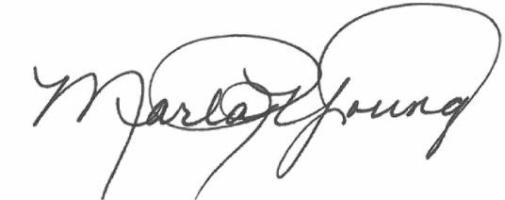
Marla R. Young - County Clerk
Box Elder County

NOTE: Please turn off or silence cell phones and pagers during public meetings. This facility is wheelchair accessible and accessible parking spaces are available. Requests for accommodations or interpretive services must be made three (3) working days prior to this meeting. Please contact the Commission Secretary's office at 734-2247 or FAX 734-2038 for information or assistance.

