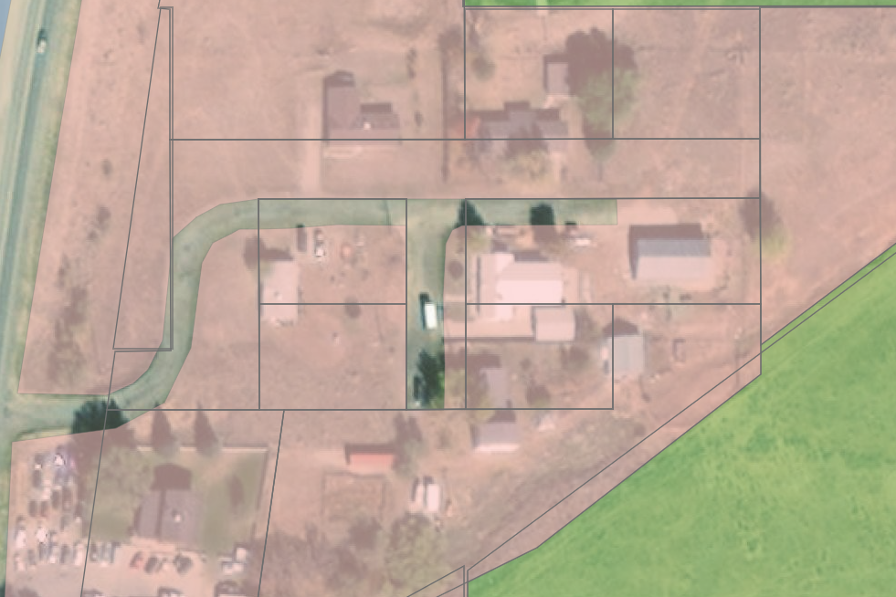
Pink: R-2 Residential Zone
Green: A-1 Residential-Agricultural
Pehrson Ln
Highway 191

