Kanosh Town is committed to taking steps to protect the health, safety, and well-being of our community. With the recent spread of COVID-19, some changes are necessary for conducting Kanosh Town public meetings. To follow the "Stay Safe, Stay Home" directive given by Governor Gary Herbert on March 26, 2020, we will suspend all Kanosh Town face-to-face public meetings until this directive is lifted and conditions within our State are deemed safe for social interaction.
Kanosh Town Corporation held a Public Hearing on Wednesday, February 10, 2021, in the town office at 7:00 p.m.

Members present, Mayor Frank Paxton, Council members Rodney Whatcott, Neil Shumway, Hayden George, and Brandon Stephenson. Kanosh Town Treasurer: Karen Crook and Kanosh Town Clerk: Cindy Turner.

Others in attendance: Kanosh Town Employee Lorin Shumway, CERT Captain Geri Minton, Owen DeGraffenreid, Brandon George, Jennifer George, Delise Fullmer, Jared Blad, Jens Christensen, Ben Coray, Kristen Gamble, Mel Gamble, and Janice Shumway.

Public Hearing:
Kanosh Town held a Public Hearing before the regularly scheduled council meeting to address and gather input on the following Amendment to Ordinance 120920:

*Exhibit A: Map of the culinary water service boundary: Water service area is the Kanosh town limits and water rates:
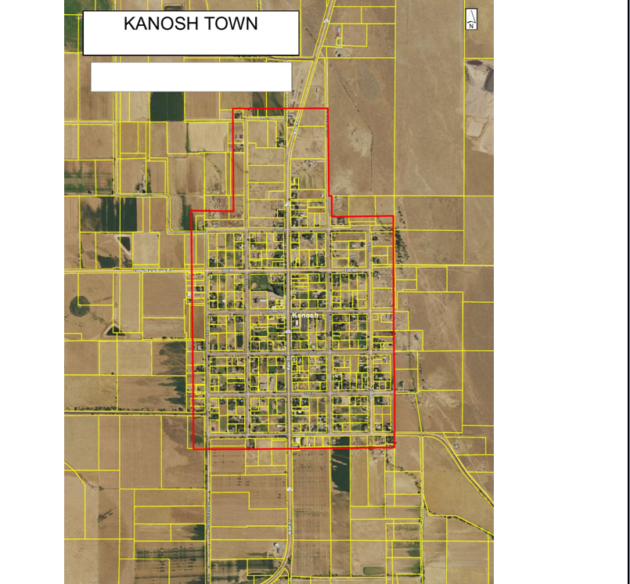

*Water Rates:
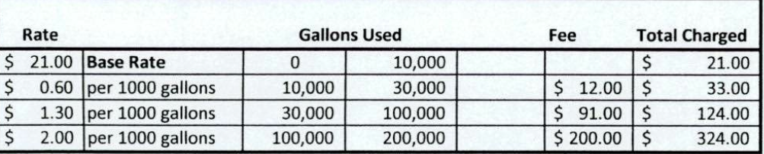

*Ordinance 120920 Establishing water designated service area:

ORDINANCE NO. 120920
AN ORDINANCE ESTABLISHING KANOSH TOWN WATER RATES
AS REQUIRED PURSUANT TO UTAH CODE ANN. §10-8-22.

WHEREAS, Kanosh Town, Millard County, State of Utah, a body politic, is a municipal corporation organized and established for the purpose of providing municipal services to its residents; and
WHEREAS, Kanosh Town provides various services to its residents, including culinary water services, which municipal water system is operated, maintained, and improved at a cost to the Town, and which rates are established and fixed based upon the costs necessary for providing water services to Town’s retail customers; and
WHEREAS, Kanosh Town requires different water rates based upon the nature and type of water services provided, differences in the cost of providing services to a particular area or type of use, requirements to maintain a system differently for certain customers, water conservation policies, and the nature of the water use to its retail customers; and
WHEREAS, Kanosh Town has historically adopted by resolution various rate schedules according to each service or utility provided, and it is the desire of Kanosh Town, by the adoption of this Ordinance, to give notice to all retail customers of the proposed rate schedule by establishing the various water uses connection sizes, and base fees including each rate associated therewith; and
WHEREAS, Kanosh Town desires to enter into a contract with any water user outside its designated service area prior to supply water to the retail customer; and

WHEREAS, Kanosh Town is required to adopt and it is the desire of the Town to provide a more concise and uniform method of establishing water rates which are uniform, clear and readily accessible.
NOW, THEREFORE, IT IS HEREBY ORDAINED by the Town Council of Kanosh Town, Millard County , Utah, that until further ordinance is adopted, the following water rates are hereby established:
SEE EXHIBIT “A”
Map of the culinary water service boundary
BE IT FURTHER ORDAINED that all prior resolutions, and parts of resolutions, in conflict herewith be hereby repealed.

There were several public comments. Most in attendance verbalized their desire to be included or cherry stemmed into the water service boundary.

Kanosh Town is committed to taking steps to protect the health, safety, and well-being of our community. With the recent spread of COVID-19, some changes are necessary for conducting Kanosh Town public meetings. To follow the "Stay Safe, Stay Home" directive given by Governor Gary Herbert on March 26, 2020, we will suspend all Kanosh Town face-to-face public meetings until this directive is lifted and conditions within our State are deemed safe for social interaction.
Kanosh Town Corporation held its regular Council on Wednesday, February 10, 2021, in the town office immediately following the Public Hearing.

Members present Mayor Frank Paxton, Council members Rodney Whatcott, Neil Shumway, Hayden George, and Brandon Stephenson. Kanosh Town Treasurer: Karen Crook and Kanosh Town Clerk: Cindy Turner.

Others in attendance: Kanosh Town Employee Lorin Shumway, CERT Captain Geri Minton, Owen Degraffenreid, Brandon George, Jennifer George, Delise Fullmer, Jared Blad, Jens Christensen, Ben Coray, Kristen Gamble, Mel Gamble, and Janice Shumway

Councilmember Brandon Stephenson led all in attendance in a moment of reverence.

Councilmember Neil Shumway led all in attendance in the Pledge of Allegiance.

Minutes of the January 2020 meeting were read and approved as amended through motion by Councilmember Rodney Whatcott, Councilmember Neil Shumway provided a second to the motion, all Councilmembers voted in favor as noted below:
Mayor Frank Paxton: Aye
Council members
Rodney Whatcott: Aye
Brandon Stephenson: Aye
Neil Shumway: Aye
Hayden George: Aye

Warrants for February 2021 were read and approved for payment through motion by Councilmember Hayden George, Councilmember Rodney Whatcott provided a second to the motion, all Councilmembers voted in favor as noted below:
Mayor Frank Paxton: Aye
Council members
Rodney Whatcott: Aye
Brandon Stephenson: Aye
Neil Shumway: Aye
Hayden George: Aye

CERT Geri Minton
CERT Captain Geri Minton reported that there was no County meeting however the Fillmore Emergency Manager contacted her requesting CERT members come tomorrow at 8 a.m. and on the 18th to come and help with the COVID vaccine at the Fillmore Fire Station. CERT will not administer the vaccination, they will be helping with observing the shot recipients for the 15 minute waiting period following the injection.

EMT: We have two ladies from Kanosh taking the EMT class, Cindy Whitaker and Sharon Taylor. These women have already put out $400.00 each out of their pocket for the training. These women would like to have financial help of $200.00/each to help with the remainder of their training. In light of the fact Kanosh Town would benefit from having two EMT's in our community on sight, Councilmember Hayden George motioned to help with the expense of the EMT class through an award of $200.00 each, Councilmember Rodney Whatcott provided a second to the motion, all Councilmembers voted in favor as noted below:
Mayor Frank Paxton: Aye
Council members
Rodney Whatcott: Aye
Brandon Stephenson: Aye
Neil Shumway: Aye
Hayden George: Aye

Fire Department:
Fire Chief Lorin Shumway reported that things in the Fire department have been pretty quiet for now. They will be starting training again soon. The Fire department would also like to be involved in the Harassment training that our attorney will be providing. The fire department members would prefer having the training on either the 2nd and 4th Thursdays of the month when they have other training scheduled.

Planning and Zoning:
Building Permits:
Mrs. Geri Minton presented the building permits of Jared Blad and Jens Christensen, each permit is for a new home and each has met with the building inspector.

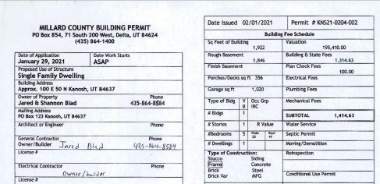

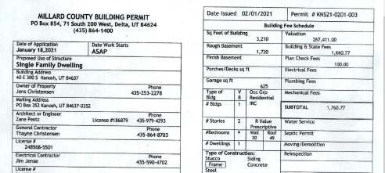
Planning and Zoning spokesman Geri Minton presented the permits to the Council, recommending the approval of the Planning and Zoning Commission. Councilmember Rodney Whatcott motioned to approve the permit as presented, Councilmember Hayden George provided a second to the motion, all Councilmembers voted in favor as noted below:
Mayor Frank Paxton: Aye
Council members
Rodney Whatcott: Aye
Brandon Stephenson: Aye
Neil Shumway: Aye
Hayden George: Aye

Follow up on the public hearing:
Councilmember Hayden George motioned to amend Ordinance 120920 exhibit A; Map of the culinary water service boundary to cherry stem all existing water meters, Councilmember Rodney Whatcott provided a second to the motion, Councilmembers voted as noted below:
Mayor Frank Paxton: Aye
Council members
Rodney Whatcott: Aye Brandon Stephenson: Nay
Neil Shumway: Aye
Hayden George: Aye

The majority overruled, motion passed.

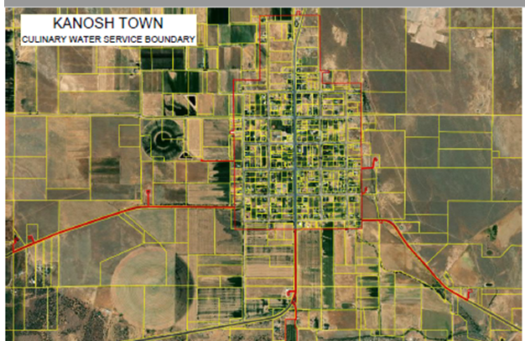

Resolution: 021021 Kanosh Town Cemetery Burial Fee Schedule and Definitions
Following a review of Resolution 021021 (see a copy of the resolution below) Councilmember Hayden George motioned to approve Resolution 021021 Councilmember Brandon Stephenson provided a second to the motion, all Councilmembers voted in favor as noted below:
Mayor Frank Paxton: Aye
Council members
Rodney Whatcott: Aye
Brandon Stephenson: Aye
Neil Shumway: Aye
Hayden George: Aye

Resolution # ______021021_____________
Kanosh Town Cemetery Burial Fee Schedule and Definitions

Residents.........: $300.00 per space for burial
Non Residents.: $600.00 per space for burial
Residents.........: $300 per grave opening and closing
$ 75.00 per grave opening and closing infant and cremation
Non Residents.........: $600 per grave opening and closing
$100.00 per grave opening and closing infant and cremation
Residents.........: $100 extra for Saturday burial (for Bonus to town employee as overtime)
Non Residents.........: $200 extra for Saturday burial (for Bonus to town employee as overtime)
Definition of burial space:
1. An adult burial space will be 4 feet by 9 feet long
2. Infant space 33" x 74", there may be 3 infant burial spaces on an adult burial space for adult or 4 cremation burial if space allows.
3. One burial per space for adult and/or cremation burials if space allows.
Definition of a Resident:
1. As per this resolution a resident will be defined as a person whose primary residence is located within Kanosh Town limits at the time of death.
2. A full-time student who lives away from home to attend school.
3. A person who is required to be placed into a medical facility or rest home for health and or safety reasons, and their primary residence was within Kanosh Town limits at the time of being placed into the facility.
4. No pet burial in the cemetery.
Rules and Regulations:
1. Kanosh Town reserves the right to move or alter spaces as needed.
2. A graveside will be over 1 hour before dusk to allow Town employees to close graves.
3. The Town may, and is hereby expressly reserves the right, at any time or times, with or without notice to owners to adopt new rules and regulations, or to amend, alter and/or repeal any rule, regulation, and/or article, section, or paragraph and/or sentence in these Rules and Regulations.
4. Special cases may arise in which the literal enforcement of a rule may impose unnecessary hardship. The Town, therefore reserves the right, without notice, to make exceptions or modifications in any of the Rules and Regulations when in its judgment, the same appear advisable; and such temporary exceptions or modifications shall in no way be construed as affecting the general application of such.
Passed, approved and adopted by the Mayor and Town Council of Kanosh Town this____10th________ day of ___February_______, 2021.
Kanosh Town Corporation

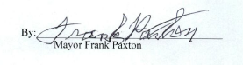

Easter Egg Hunt:
Councilmember Brandon Stephenson has been approached by members of the community requesting a Town Easter Egg hunt for the children. Mrs. Jessica Whitaker has volunteered to spearhead the activity. The activity would be held on the 3rd of April. With the completion of the park, there is plenty of room so social distancing would not be a problem, and following COVID guidelines would not be a problem. Guidelines would be posted and publicly acknowledged. Councilmember Rodney Whatcott motioned to approve sponsoring this activity pending approval by the Public Health Department, Councilmember Hayden George provided a second to the motion, all Councilmembers voted in favor as noted below:
Mayor Frank Paxton: Aye
Council members
Rodney Whatcott: Aye
Brandon Stephenson: Aye
Neil Shumway: Aye
Hayden George: Aye

Departmental Reports:
*Park:
Councilmember Hayden George reported all is good in the park for now. Councilmember George continues to work on the signs discussed previously.

*Cemetery:
Kelly Gillins of Sunrise Engineering called and talked to Councilmember Hayden George, where Mr. Gillins reported they are doing a new system online where you can search a name and it will take you right to the grave. The directory would be available online. The only drawback would be the initial setup fee of $10,000.00. Town Employee Lorin Shumway offered the option of engraving the register, he has the equipment to provide this service.

*Electrical Department:
The Town has paid for tree trimming when the tree interferes with our power line. If tree trimming is needed on the property owner's side of the tree it requires the property owner's permission.

*Roads:
The new snow plow is a good truck, just the right size! The employees have already plowed a little snow!

Beaver Lawnscape would like to get started fertilizing the grounds and applying killzall to the road sides. Councilmember Stephenson will obtain bids in an effort of insuring the most cost efficient company.

*Water Department:
Nothing new to report, continuing with the well citing project.
REVIEW OF UTILITY DELINQUENCIES:
Council members reviewed the monthly delinquency list. It was determined, again, to handle those accounts in arrears according to established Town policy.

Public Comment:
There were no public comments.

There being no further business to come before the board, the meeting adjourned.

Frank Paxton Cindy Turner
Ka+nosh Town Mayor Kanosh Town Clerk

