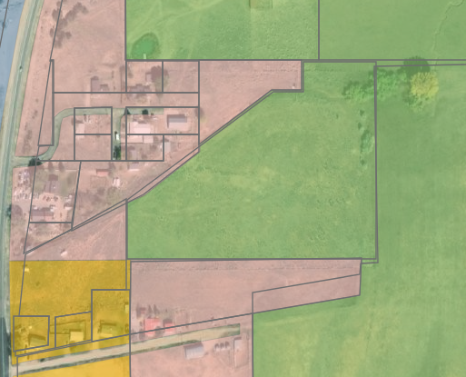
A-1 Residential-Agricultural
to C-1 Commercial
combined commercial/residential
zone change request.
R-2 Residential to C-1 Commercial
zone change request
for northern portion of parcel.
(above red line)

