Moroni City Council Meeting
February 18, 2021
5:30 p.m.

- MOTION TO START MEETING
MOTION Councilmember Craig Draper to begin the Moroni City Council meeting. SECOND Councilmember Thayne Atkinson. All AYE. MOTION carried.

ROLL CALL
Mayor Paul Bailey, Council members: Craig Draper, Thayne Atkinson, Jenifer Lamb, Troy Prestwich, Bevan Wulfenstein.

- GARY RICHARDS – VARIANCE REQUEST
Mr. Richards presented his request to place a small apartment and connect to city services on the back portion of his lot at 300 East 100 South. Discussion followed. Council tabled the request so that they might review the ordinance to come to a better conclusion.
.
- IRRIGAITON – TROY PRESTWICH
Councilmember Troy Prestwich led the discussion stating that with the summer of 2020’s watering schedule the city had a savings of 1,036,340 in gallons of water pumped at well #1. Councilmember Prestwich would like to continue with the same schedule as last summer. Discussion followed regarding the enforcement of the ordinance regarding the watering schedule. Council agreed to have the schedule placed in an upcoming newsletter and work to enforce the timetable.

- RESOLUTION 2021-1
MOTION Councilmember Troy Prestwich to adopt the Parameters Resolution 2021-01 authorizing the issuance of Parity Water Revenue Bonds of Moroni City and calling of a public hearing to receive input with respect to the issuance of such Bonds and any potential impact to the private sector from the construction of the project. SECOND Councilmember Bevan Wulfenstein.

Craig Draper YES
Thayne Atkinson YES
Jenifer Lamb YES
Troy Prestwich YES
Bevan Wulfenstein YES

- LAND OPTION AGREEMENT
MOTION Councilmember Thayne Atkinson to accept the Option Agreement with Sheldon Wayne Holgreen. Parcel No. 0000025286. SECOND Councilmember Jenifer Lamb.

Craig Draper YES
Thayne Atkinson YES
Jenifer Lamb YES
Troy Prestwich YES
Bevan Wulfenstein YES

- DISCUSSION OF SALE OF PROPERTY AT 138 EAST 100 NORTH
Mayor Bailey led the discussion of selling the lot at 138 East 100 North. The proposed sale of the property will be noticed in the newspaper for two weeks and presented for a public hearing at the March 25, 2021 council meeting.

- DISCUSSION OF SALE OF 1994 GMC SIERRA DUMP TRUCK
Council agreed to place an ad for the sale of the dump truck by closed bid. Mayor Bailey will get with Carol and one other councilmember and open the bids after the closing date of April 2, 2021.

- FRAUD RISK ASSESSMENT – GARY KEDDINGTON
Mr. Keddington led the discussion regarding the Fraud Risk Assessment that will be turned into the Utah Auditors’ Office. The assessment will need to be done yearly.

- CULINARY IMPACT FEE ANALYSIS – ROBERT WORLEY/COLLIN PACE, SUNRISE ENGINEERING
Collin Pace with Sunrise Engineering presented the Culinary Impact Fee Analysis study.
- Purpose
- Identify the anticipated impact on existing facilities by new development.
- Identified the anticipated impact on system improvement by anticipated development.
- Demonstrate how those impacts are reasonably related to the anticipated development.
- Estimate the proportionate share of costs to be recouped by the impact fee.
- Identify how the impact fee was calculated.
- Demand
- Current and projected demand – 2% annual growth projection
- Current – 1497 population, 644 ERC’s
- Projected – 2269 population, 954 ERC’s.
- Impact Fee Eligible Projects
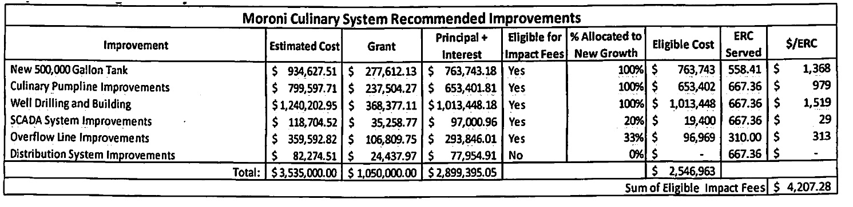

- Monthly User Credits
- New Debt Service
- Annual Payment: $96,289.06 with $84,898.75 of that payment impact fee eligible.
- Average of 8.84 years for new connections in service
- On average $108.93 per year per ERC will contribute to debt service
- A credit of $962.91 is calculated by multiplying 8.84 years by $108.93.
- Proposed Maximum Impact Fee
- Maximum impact = eligible impact fees – credit
- $4,207.28 - $962.91 = $3,244.37
- Maximum Impact Fee per ERC: $3,244.37

- DISCUSSION OF CULINARY WATER RATE INCREASE – JANELL BRAITHWAITE/CURTIS LUDVIEDSON, RURAL WATER
Ms. Braithwaite presented the council a Water Rate Analysis that she had prepared for them as a work sheet to show the needed rate increase to meet the payment of the new culinary bond. The council along with Gary Keddington discussed possible scenarios for a proposed culinary rate increase. Council thanked Ms. Braithwaite for her time in preparing the speed sheet.
Council will hold a work meeting March 11, 2021 to further discuss the needed rate increase.

- COUNCILMEMBERS REPORT
  - Craig Draper
Met January 20th with Mandy, Bert, Brennen, and Carol regarding the Opera House. Discussed issues with maintenance.
The city will be receiving a matching grant to replace the roof at the Opera House.
  - Thayne Atkinson
Dale Ashcraft, DCA Surveying has completed the survey project. The survey has been recorded with the county and is available at the city hall for all future surveying in the city.
  - Jenifer Lamb
  - Troy Prestwich
A new pole for the SCADA system has been installed at the shop.
Possible project – enclose pavilion and remodel bathrooms at the Recreation Park.
  - Bevan Wulfenstein
Will be working with Mayor Bailey on improvements at the city hall park this spring/summer.
Purchased 2004 Ford F550 Dump Truck for the Public Works Department.

- MAYOR PAUL BAILEY
Has sent a letter to UDOT requesting a flashing speed limit sign to go along Ducksprings Drive.
Facia repair work has been completed on the city hall and pavilion.

- APPROVAL OF MINUTES
MOTION Councilmember Bevin Wulfenstein to approve minutes of August 20, 2020. SECOND Councilmember Thayne Atkinson. All AYE. MOTION carried.

MOTION Councilmember Jenifer Lamb to approve minutes of October 15, 2020. SECOND Councilmember Troy Prestwich. All AYE. MOTION carried.

MOTION Councilmember Thayne Atkinson to approve minutes of October 19, 2020. SECOND Councilmember Troy Prestwich. All AYE. MOTION carried. Councilmember Jenifer Lamb abstains

MOTION Councilmember Bevin Wulfenstein to approve minutes of November 16, 2020. SECOND Councilmember Craig Draper. All AYE. MOTION carried.

MOTION Councilmember Bevin Wulfenstein to approve minutes of November 23, 2020. SECOND Councilmember Thayne Atkinson. All AYE. MOTION carried.

- ADJOURN
MOTION Councilmember Thayne Atkinson to adjourn. SECOND Councilmember Troy Prestwich. All AYE. MOTION carried. 8:23 p.m.

_______________________________
Carol Haskins, Recorder/Clerk

