Kanosh Town is committed to taking steps to protect the health, safety, and well-being of our community. With the recent spread of COVID-19, some changes are necessary for conducting Kanosh Town public meetings. To follow the "Stay Safe, Stay Home" directive given by Governor Gary Herbert on March 26, 2020, we will suspend all Kanosh Town face-to-face public meetings until this directive is lifted and conditions within our State are deemed safe for social interaction.
Kanosh Town Corporation held its regular Council on Wednesday, January 13, 2021, in the town office immediately following the Public Hearing.

Members present Mayor Frank Paxton, Council members Rodney Whatcott, Neil Shumway, Hayden George, and Brandon Stephenson. Kanosh Town Treasurer: Karen Crook and Kanosh Town Clerk: Cindy Turner.

Others in attendance: Kanosh Town Employee Lorin Shumway, CERT Captain Geri Minton, and Kanosh Town Attorney Justin Wayment. Bart Whatcott, Cleve Christensen.

Councilmember Hayden George led all in attendance in a moment of reverence.

Mayor Frank Paxton led all in attendance in the Pledge of Allegiance.

Minutes of the December 2020 meeting were read and approved as amended through motion by Councilmember Rodney Whatcott, Councilmember Hayden George provided a second to the motion, all Councilmembers voted in favor as noted below:
Mayor Frank Paxton: Aye
Council members
Rodney Whatcott: Aye
Brandon Stephenson: Aye
Neil Shumway: Aye
Hayden George: Aye

Wayne Urie, Watershed Coordinator USDA:
Mr. Urie provided an overview of the watershed proposal project. The small watershed projects are under public law 566. The law originated in the 1950s and through this law, thousands of reservoirs nationwide have been built, but the funding was cut for the program and just got renewed a few years ago. The 2018 farm bill came out there were 150 million dollars made available nationwide for this program. Ours and 8 other projects will be funded throughout the state.
Funding for these projects are done in three different phases:
- The first phase is the planning phase and is where we are right now. Franson Engineering will help work through the environmental assessment, in addition to the environmental assessment and the planning part of this a 30% of the design of the project to come up with the cost estimate.
- To start with Kanosh needs to get up to speed to accept these grants. Form SF424 was presented to the Mayor, this form requires a DUNS# which is required by everyone who gets a federal grant. Kanosh Town does not currently have a registered DUNS#, Councilmember Brandon Stephenson has been working diligently on obtaining the active status for our DUNS#. This must be complete before we can move forward, this is not a quick process.
- Form 424 B Assurance for Non-Construction Projects, was presented for Mayor Paxton's signature
- Certificate regarding lobbying was also presented for Mayor Paxton's signature
- And the final form AD3031 assurance regarding felony conviction was also presented for Mayor Paxton's signature
All of the aforementioned forms were signed and returned to Mr. Urie, except for Form SF424. Form SF424 will be sent as soon as the problems with the DUN# have been resolved.
- The second phase of the project is the complete design. But, this will be funded separately from the planning phase.
- The third phase is the construction phase, this is also funded separately.
Warrants for January 2021 were read and approved for payment through motion by Councilmember Brandon Stephenson, Councilmember Hayden George provided a second to the motion, all Councilmembers voted in favor as noted below:
Mayor Frank Paxton: Aye
Council members
Rodney Whatcott: Aye
Brandon Stephenson: Aye
Neil Shumway: Aye
Hayden George: Aye

CERT:
Nothing to report at this time.

Fire Dept:
*Fire Chief Lorin Shumway addressed the Council stating there isn't a lot to report, however, they will resume training through Zoom.
*Millard County burn restrictions have been lifted and therefore Kanosh has also lifted their restrictions.

Planning and Zoning:
Planning Commission spokesperson Geri Minton presented the following 3 Building Permits to the council for approval:
- Val Nafus: 60X45 building/garage to hold her trailer and 2 trucks, which will get them off of town property. Her plans allow her to come in one way and exit the other, having garage doors on either side.
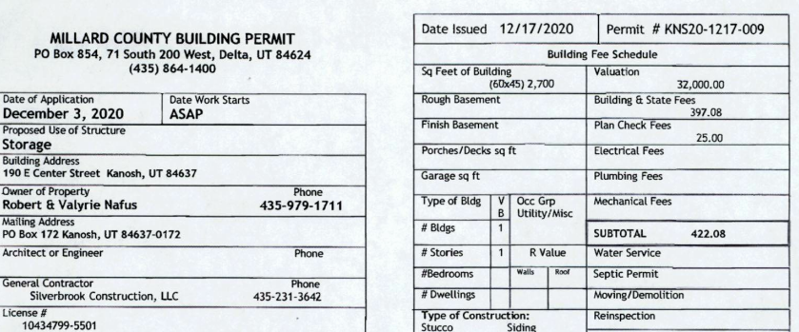
- Martha Stott's plans for a prefab home.
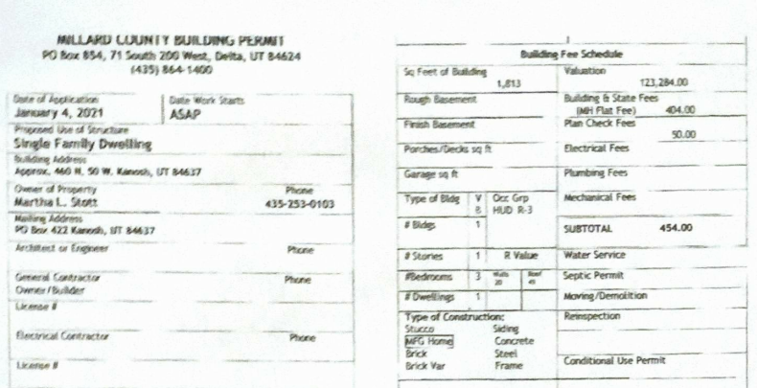
- Brandon Stephenson to finish basement
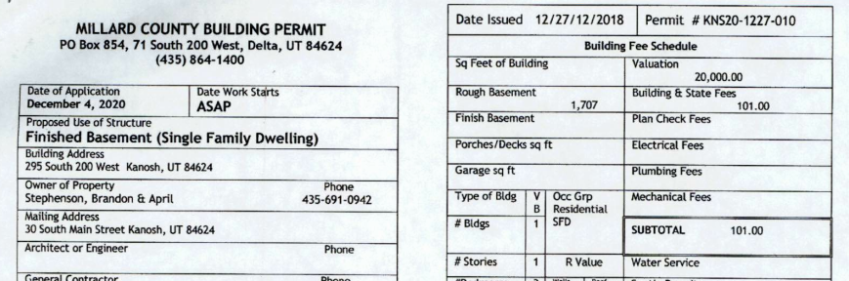

Following a review of each building permit, Councilmember Hayden George made the motion to approve each permit as presented, Councilmember Rodney Whatcott seconded the motion, all in favor, all Councilmembers voted in favor as noted below:
Mayor Frank Paxton: Aye
Council members
Rodney Whatcott: Aye
Brandon Stephenson: Aye
Neil Shumway: Aye
Hayden George: Aye
The clerk will email a copy of the approved building permits to arichins@co.millard.ut.us

Attorney Justin Wayment:
Mr. Wayment noted there have been quite a few changes in the law in the 2020 session
*Open Meeting Training:
What is a meeting:
"Meeting" means the convening of a public body, with a quorum present, including a workshop or an executive session whether the meeting is held in person or utilizing electronic communications, to discuss, receiving comments from the public about, or acting upon a matter over which the public body has jurisdiction or advisory power, about, or acting upon a matter over which the public has jurisdiction or advisory power.
*“MEETING” DOES NOT MEAN?
– A chance meeting. – A social meeting. – Meeting of a legislative body with both legislative and executive responsibilities. • No public funds are appropriated. • Meeting solely for discussion or to implement administrative/operational matters.
*ELECTRONIC MEETINGS –
Can meet by phone, computer or other electronic means. • Notice requirements still apply. • Public must have the means to attend or participate. • Must have adopted an existing rule, resolution, or ordinance.
*A “MEETING” CAN BE CLOSED TO:
Discuss an individual’s character, professional competence, or physical or mental health. – Discuss collective bargaining. – Discuss pending or reasonably imminent litigation. – Discuss the purchase, exchange, lease, or sale of real property. • Public notice of the terms and public approval of sale required. Discuss deployment of security personnel, devices, or systems. – For investigative proceedings regarding allegations of criminal misconduct. – Discuss commercial information, if a County legislative body.
*PROCESS TO CLOSE MEETINGS
A quorum must be present. – Two-thirds of the body must vote to close the meeting. – The body must first hold a public meeting with proper notice before entering into the closed meeting. – The body must publicly disclose: • The vote by name of each member for or against entering into the closed meeting. • The reasons for holding the closed meeting. • Location of the closed meeting. Closed session recordings must be preserved forever.
You may not: – Approve any ordinance, resolution, rule, regulation, contract, or appointment. – Interview a person to fill an elected position. – Take final action. • Final votes must be open and on the record.
*EMERGENCY MEETINGS –
The best notice practicable is given. – Must attempt to notify all of the members of the public body and a majority of them must approve the emergency meeting. – The minutes include a statement of the unforeseen circumstances that made the meeting necessary
*RECORDINGS
A recording must be kept of all open meetings. – A recording of an open meeting must be available to the public for listening within three business days after the meeting. – A recording is not required for site visits or traveling tours or certain small local districts. • A recording must be kept of all closed meetings, except: – A meeting closed to discuss the character, professional competence, or physical or mental health of an individual does not need to be recorded, but the presiding person must sign a sworn statement. – A meeting closed to discuss the deployment of security personnel, devices, or systems does not need to be recorded, but the presiding person must sign a sworn statement.
*MEETING MINUTES
Written minutes must be kept of all open meetings. – Written minutes shall be available to the public within a reasonable time. – A public body must establish and implement procedures for approval of written minutes. • Detailed written minutes may be kept of all closed meetings, except: – A meeting closed to discuss the character, professional competence, or physical or mental health of an individual does not need to be recorded or written minutes kept, but the presiding person must sign a sworn statement. – A meeting closed to discuss the deployment of security personnel, devices, or systems does not need to be recorded or written minutes kept, but the presiding person must sign a sworn statement.
REQUIREMENTS FOR WRITTEN MINUTES •
All minutes must include: – Date/time; – Place of meeting; and – Names of all members present or absent. • Minutes of open meetings must include: – All matters proposed, discussed, or decided; – All names and substance of information from individuals giving testimony; – Individual votes on each matter; and – Any additional information requested by a member.
*VIOLATIONS OF OPMA
"In addition to any other penalty under this chapter, a member of a public body who intentionally violates or intentionally abets or advises a violation of the closed meeting provisions of this chapter is guilty of a class B misdemeanor." – A court can void any action in violation of the law. – Sometimes a violation can be "cured" by discussing and taking a public vote in a subsequent meeting. – May have to pay court costs and attorney fees.
*LEGISLATIVE UPDATE • H.B. 189 – allows a closed meeting to be held to discuss the purchase, exchange, lease, or sale of a water right or water shares. • H.B. 315 – modifies the statutory requirements to publish or post a notice to the Utah Public Notice Website by providing a temporary exemption (until December 31, 2012) for a municipality, local district, or a special service district, with an annual budget of less than $1,000,000. • S.B. 136 – authorizes the Independent Legislative Ethics Commission to convene a closed meeting without first convening an open meeting, if the closed meeting relates to the receipt or review of an ethics complaint, and the Commission provides advance public notice of the closed meeting. This bill also provides that an ethics committee of the Legislature may close a meeting by a majority vote to conduct deliberations to reach a decision on an ethics complaint or to seek legal advice on legal, evidentiary, or procedural matters.
*DELIBERATIONS
Normally, deliberations are conducted in the open. • Exception: Quasi-Judicial vs. Administrative or Legislative. – But, information gathering still conducted in the open
*WORK SESSIONS
Covered by the OPMA. • No decision can be made in a work session but must be made in an open session. • Do not use to circumvent the information gathering and deliberation process.
*CONFLICTS OF INTEREST
County Officers’ and Employees’ Disclosure Act (U.C.A. Sections 17-16a-1 et seq.). • Municipal Officers’ and Employees’ Ethics Act (U.C.A. Sections 10-3-1301 et seq.). • Utah Public Officers’ and Employees’ Ethics Act (U.C.A. Sections 67-16-1 et seq.
If you are an employee, elected, or appointed officer: – "Elected officer" means any person elected or appointed to any office in the county. – "Appointed officer" means any person appointed to any statutory office or position or any other person appointed to any position of employment with a county, except special employees. Appointed officers include, but are not limited to persons serving on special, regular, or full-time committees, agencies, or boards whether or not such persons are compensated for their services. The use of the word "officer" in this part is not intended to make appointed persons or employees "officers" of the county. You can vote as long as you don't have an interest.
*PROHIBITIONS
It is an offense for an elected or appointed officer to (similar provisions apply to employees): – Disclose confidential information acquired because of the officer's official position or to use that information to secure special privileges or exemptions for himself or others; – Use or attempt to use the officer's official position to secure special privileges for the officer or others; or – Knowingly receive, accept, take, seek or solicit, directly or indirectly, any gift or loan for the officer or another, if the gift or loan tends to influence the officer in the discharge of the officer's official duties. • Exceptions: – An occasional no pecuniary gift having a value of less than $50; – An award publicly presented; – Any bona fide loan made in the ordinary course of business; or – Political campaign contributions used in a political campaign.
*INTERESTS CREATING A CONFLICT
Receives or agrees to receive compensation for assistance in a transaction involving the entity; • Have an interest in a business regulated by the entity; • Have an interest in a business doing business with the entity, or • Have an investment creating a conflict of interest with your duties.
I HAVE AN INTEREST, NOW WHAT? • Consult with the legal advisor. • File a sworn statement with the entity's governing body (for ongoing conflicts & for assistance in a transaction involving the entity). – Disclose the position held and the precise nature and value of the interest held. – File upon first becoming appointed or elected and each January thereafter. • Publicly disclose to the members of the body on which he is a member before the discussion of the matter in an open meeting. • Disclosure needs to be entered into the minutes of the meeting.
*VIOLATIONS
Any person who knowingly and intentionally violates, then Class A misdemeanor (more or less) and shall be dismissed from employment or removed from office. • If interest relates to business regulated by the entity, then the entity can rescind or void any contract without returning the consideration.

To view the code in its entirety please see:
https://le.utah.gov/xcode/Title52/Chapter4/C52-4_1800010118000101.pdf

Rule of thumb......"Believe in what you are doing. Be honest in your opinions.
Do what is right and move forward."

Mr. Wayment emphasized the importance of Avoiding litigation! Litigation is stressful!!!! Expensive consumes a huge amount of time, distracting, etc.
- Document everything! Agreements need to be in writing. Incidents need to be in writing immediately! Detail everything. Discuss with another worker immediately. Give it 48 hours and then go back over it. Take pictures.
- Act quickly. Before you react, put yourself in their shoes.
- Keep ALL evidence.
- Plan ahead. People make mistakes, train, train, and retrain.

When you come to the meetings, be prepared. It is better to change an opinion than to persist in the wrong one.

Mr. Wayment will provide the Sexual harassment training at a later date, inviting the fire department and planning and zoning commission to attend.

Discussion ensued over the water ordinance120920 approved in last month’s meeting, upon further review this may be revisited next month.
ORDINANCE NO. 120920
AN ORDINANCE ESTABLISHING KANOSH TOWN WATER RATES AS REQUIRED PURSUANT TO UTAH CODE ANN. §10-8-22.

WHEREAS, Kanosh Town, Millard County, State of Utah, a body politic, is a municipal corporation organized and established for the purpose of providing municipal services to its residents; and
WHEREAS, Kanosh Town provides various services to its residents, including culinary water services, which municipal water system is operated, maintained, and improved at a cost to the Town, and which rates are established and fixed based upon the costs necessary for providing water services to Town’s retail customers; and
WHEREAS, Kanosh Town requires different water rates based upon the nature and type of water services provided, differences in the cost of providing services to a particular area or type of use, requirements to maintain a system differently for certain customers, water conservation policies, and the nature of the water use to its retail customers; and
WHEREAS, Kanosh Town has historically adopted by resolution various rate schedules according to each service or utility provided, and it is the desire of Kanosh Town, by adoption of this Ordinance, to give notice to all retail customers of the proposed rate schedule by establishing the various water uses, connection sizes, and base fees including each rate associated therewith; and
WHEREAS, Kanosh Town desires to enter into a contract with any water user outside its designated service area prior to supply water to the retail customer; and
WHEREAS, Kanosh Town is required to adopt and it is the desire of the Town to provide a more concise and uniform method of establishing water rates which are uniform, clear and readily accessible.
NOW, THEREFORE, IT IS HEREBY ORDAINED by the Town Council of Kanosh Town, Millard County , Utah, that until further ordinance is adopted, the following water rates are hereby established:
SEE EXHIBIT “A”

BE IT FURTHER ORDAINED that all prior resolutions, and parts of resolutions, in conflict herewith be hereby repealed.
This ordinance is hereby passed and adopted by the Kanosh Town Council on the 9th day of December, 2020 And will take effect in accordance with the terms set forth herein.
Voting: Aye Nay Abstain
Neil Shumway X
Rodney Whatcott X
Hayden George X
Brandon Stephenson X

Kanosh Water Rates
Rate Gallons Used Fee Total Charged
$ 21.00 Base Rate 0 10,000 $ 21.00
$ 0.60 per 1000 gallons 10,000 30,000 $ 12.00 $ 33.00
$ 1.30 per 1000 gallons 30,000 100,000 $ 91.00 $ 124.00
$ 2.00 per 1000 gallons 100,000 200,000 $ 200.00 $ 324.00

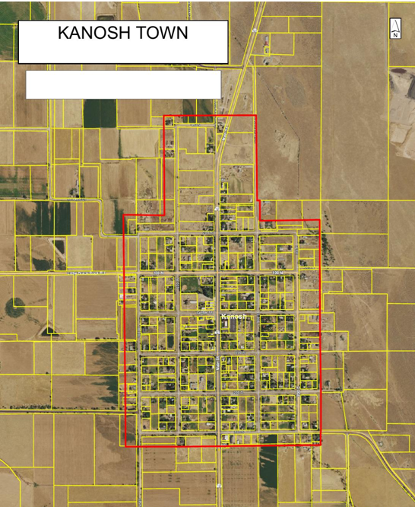

Resolution #011421 Kanosh Town Cemetery Burial Fee Schedule and Definitions:
Since changes were made in resolution 011421, this item of business was tabled and will appear as an agenda item next month and appear as Resolution #021021 Kanosh Town Cemetery Burial Fee Schedule and Definitions.

Park:
Mr. Bart Whatcott has continued his service to Kanosh Town as a member of the "Park Committee", others serving were Cleve Christensen, Thayne Christensen, Ed Phillips, Geri Minton. Mr. Cleve Christensen served as the draftsman, Geri Minton had a group of young men who dug trenches and filled in trenches, dug the holes for the playground equipment, Thayne Christensen with his ability as a contractor was nothing short of amazing, and the financial donation of Al Harrington, everyone worked so well together. Mr. Whatcott read the following memo to Kanosh Town as written by Mr. Ed Phillips:

January 13, 2021.

2019-1020 Kanosh Park Project.
Report and handoff to the Kanosh Mayor and Town Council.
Other than the occasional use of some Town equipment, The Park Project and all related expenses to that project were privately funded as a gift to the Town of Kanosh.
Hours spent by Town employees on the project were separate from their regular duties and were paid to them separately by the project, monthly, as they reported their time.
At the beginning of the project a professional survey was conducted to establish the Towns property boundaries. The Towns property has since been newly fenced where no fences existed and old fences have been replaced as needed.
Demolition and removal of old structures and a rough re-grading of the area was completed. Tree removal as necessary along with extensive tree trimming and shaping of all existing trees was completed.
Town power service infrastructure was upgraded with underground service replacing over head service to the Perkins shop, Town Office Building and the south service to the park area. New underground service was also installed servicing the Town Shop and service to the north park facilities.
Irrigation water service to the Degraffenried property was rerouted to facilitate new park construction.
New culinary water service was installed to the Town property, connected, both from main street and center street main lines, looping the service together for increased pressure reliability for sprinkler systems in the park and ball fields. Sprinkler systems along with controls were completely replaced and upgraded. All new underground infrastructure installations have been mapped and now has tracer wire installed to assist in locating it.
All other Park improvements are visible and easily seen. New year-a-round restrooms with adjoining food service facility, a completely refurbished existing pavilion, a new pavilion with a stage, storage room, sound system, dance floor and clock tower, all new walkways throughout the park, a sound wall, new playground, new separate picnic areas, drinking fountains, sports courts, fire pit w/seating, lighting and security systems thru out the park. New landscaping and shaping throughout the area including over twenty new trees. New off street parking area w/ partial paving. A new meat cooking pit with a locked safety lid.
All materials and workmanship utilized in this project have been of the highest quality available. No corners were cut at any stage of construction. The committee’s intent was to furnish the stage pavilion with adequate tables and chairs but the funds have been exhausted. Weather has delayed the placement of the clock in the clock tower but that will be completed in the spring.
The total cost of this project was over $760,000.00. No outstanding bills or encumbrances related to this project are known to exist
.

Note: The park is paid for free and clear, with the start of a simple "hello" from a young man we call Jace.

Note: Lorin Shumway installed the locator wires on everything, which will be of great benefit to all who come after us. They had received a bid for slightly over $10,000.00 from Roper Lumber company for the seating and tables for 200 people. (Maybe the town could look at doing this in the future)

Mr. Whatcott presented Town Employee Lorin Shumway with 2 copies of the maps for the existing power, water everything underground is located. A binder with every replacement part we could need for everything in the park!

Councilmember Rodney Whatcott spoke for the entire council in thanking the park committee for the countless hours they have so generously donated to this project, it means a lot to the entire town that this committee was so willing and generous with their time and efforts. Their service will continue to benefit generations.

Electric Department:
Councilmember Neil Shumway has been in contact with council member Starley in Meadow, about Meadow Town taking the substation in Meadow and that one customer we have served in Meadow. Councilmember Shumway will continue to work on this.

Flowell Electric Association is now becoming part of Dixie Power, they wanted to know if they could post their contact numbers, to include an after-hours number. Council concurs, stating they could not see any problem in doing so.

Cemetery:
Councilmember Hayden George will pursue getting an updated cemetery directory for the cemetery.

Roads:
*We are in a dire need of a snowplow, during one of the recent snowstorms the tire fell off the vehicle the town employee was using to plow snow. Contact was made with Millard County, and they graciously came and helped plow our roads.

*Councilmember Hayden George has located a dump truck with a plow! It is advertised for 34,000 however when Councilmember George contacted him he stated if we wanted it he would be willing to take $27000.00. It is actually in the paint shop right now being painted white. It has 27,000 miles, the blade is 11 foot and comes on and off easily. It has an 8.3 Cummins with an allison. Councilmember George is going north on Friday and will be able to take a hard look at it. Councilmember Rodney Whatcott made the motion to move forward with purchase the truck at $27,000.00 if Councilmember George feels it would serve the town well after he examines it, Councilmember Brandon Stephenson seconded, all Councilmember's voted in favor as noted below:
Mayor Frank Paxton: Aye
Council members
Rodney Whatcott: Aye
Brandon Stephenson: Aye
Neil Shumway: Aye
Hayden George: Aye

Water Department:
Councilmember Brandon Stephenson has been working ECWAG grant, as mentioned earlier in this meeting obtaining the DUNS# has been a great deal of work! We need to make sure that when we get the DUNS# it is documented well and kept up to date!!!!

Note: This was completed and approved on the 19th of January 2021 and will be noted in several different locations to lessen the probability of it lapsing: 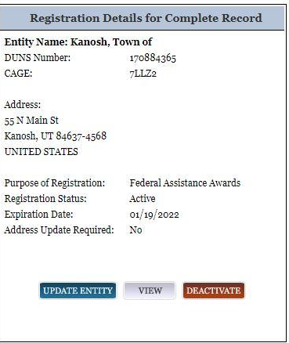

REVIEW OF UTILITY DELINQUENCIES:
Council members reviewed the monthly delinquency list. It was determined, again, to handle those accounts in arrears according to established Town policy.

Public Comments:
No public comments were offered at this meeting.

*Meter deposit refund
Kanosh Town Treasurer, Karen Crook presented the name of Roy Cox as being eligible for a meter refund, in two years he has not been on the delinquency list. The refunds are according to policy and procedure and therefore do not require the vote of the council.

There being no further business to come before the board, the meeting adjourned.

Frank Paxton Cindy Turner
Kanosh Town Mayor Kanosh Town Clerk

