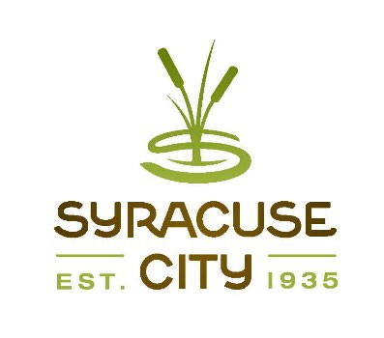SYRACUSE CITY

Syracuse City Redevelopment Agency Agenda
February 9, 2021 – immediately following the City Council Business Meeting, which begins at 6:00 p.m.

Electronic Via Zoom Meeting
Streamed on Syracuse City YouTube Channel

Public meeting will be held electronically in accordance with House Bill 5002, Open and Public Meetings Act Amendments, signed into law on June 25, 2020. Pursuant to written determination by the Mayor finding that conducting the meeting with an anchor location presents a substantial risk to the health and safety of those who may be present due to infections and potentially dangerous nature of COVID-19 virus, public meetings will be held electronically for the next thirty (30) days. The YouTube live stream of the meeting can be found at the following link.

- Meeting called to order Adopt agenda
Connect to the meeting using: https://us02web.zoom.us/j/89925860804 Meeting ID: 899 2586 0804
Connect via telephone: +1-301-715-8592 US Meeting ID: 899 2586 0804

- Proposed Resolution RDA21-01 authorizing the execution of an agreement for tax increment rebates related to development of office buildings. (5 min.) Board discussion, if necessary, will commence with Boardmember Teague.
- Adjourn.

~~~~~
In compliance with the Americans Disabilities Act, persons needing auxiliary communicative aids and services for this meeting should contact the City Offices at 801-825-1477 at least 48 hours in advance of the meeting.

CERTIFICATE OF POSTING
The undersigned, duly appointed City Recorder, does hereby certify that the above notice and agenda was posted within the Syracuse City limits on this 4th day of February, 2021 at Syracuse City Hall on the City Hall Notice Board and at http://www.syracuseut.com/. A copy was also provided to the Standard- Examiner on February 4, 2021.
CASSIE Z. BROWN, MMC SYRACUSE CITY RECORDER

