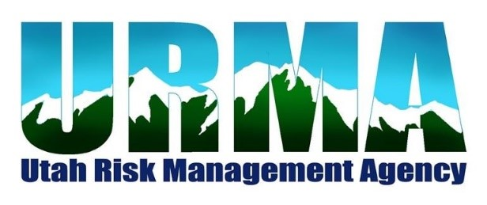
AGENDA
VIRTUAL BOARD MEETING
February 11, 2021, 12:00 p.m.
502 East 770 North
Orem, UT 84097

Google Meet access:
https://meet.google.com/rcg-jzks-yde

- WELCOME

- MOTION – Approval of Minutes from August 6, 2020 Board Meeting

- CONSENT AGENDA

QUARTERLY FINANCIAL REPORT – Dave Sanderson

AUDIT REPORT – HBME
- SCHEDULED ITEMS
  - PRESENTATION/DISCUSSION – Market Update – Moreton & Company
  - PRESENTATION/DISCUSSION/MOTION – JPP Updates
  - DISCUSSION – FY2022 Budget Proposal
  - SALARY STUDY – Seth Perrins
  - DISCUSSION – Police Physical Fitness Program – David Petersen & Jason Davis
  - DISCUSSION – Funding Driver Simulation Unit – Jason Davis

- OTHER ITEMS

5.1 UPDATES
- sUAS Training

5.2 UPCOMING TRAINING & MEETINGS

Risk Management Roundtable – April 29, 2021 11:00 a.m.-1:00 p.m. – location TBA
    - Executive Committee Meeting – May 13, 2021
    - Summer Conference tentative – July 28-July 30, 2021 – Ruby’s Inn, Bryce Canyon
    - Annual Board Meeting – July 30, 2021 10:00 a.m. – Ruby’s Inn, Bryce Canyon
    - Golf Tournament – September 10, 2021 – Lakeside Golf Course
1201 North 1100 West, West Bountiful, UT
6. ADJOURN

