Kanosh Town is committed to taking steps to protect the health, safety, and well-being of our community. With the recent spread of COVID-19, some changes are necessary for conducting Kanosh Town public meetings. To follow the "Stay Safe, Stay Home" directive given by Governor Gary Herbert on March 26, 2020, we will suspend all Kanosh Town face-to-face public meetings until this directive is lifted and conditions within our State are deemed safe for social interaction.
Kanosh Town Corporation held a Public Hearing on Wednesday, December 9, 2020, in the town office at 7:00 p.m.

Members present, Mayor Frank Paxton, Council members Rodney Whatcott, Neil Shumway, Hayden George, and Brandon Stephenson. Kanosh Town Treasurer: Karen Crook and Kanosh Town Clerk: Cindy Turner.

Others in attendance: Kanosh Town Employee Lorin Shumway, CERT Captain Geri Minton, Allyson Kristofferson, Jeremy Davis, and Kanosh Town Attorney Justin Wayment Virtually.

Public Hearing:
Kanosh Town held a Public Hearing before the regularly scheduled council meeting to address and gather input on the following:
*Exhibit A: Map of the culinary water service boundary: Water service area is the Kanosh town limits and water rates:
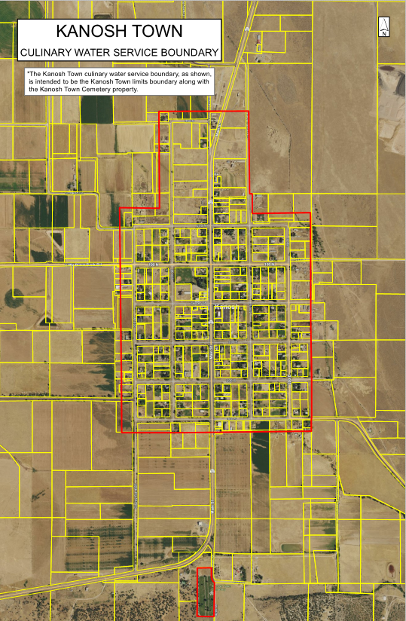

*Water Rates:
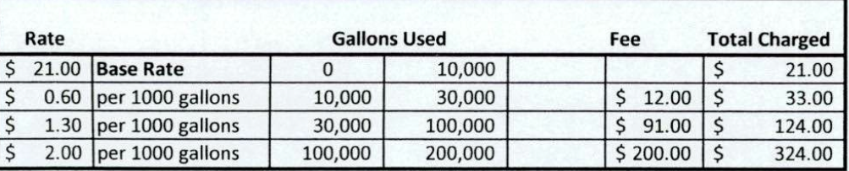

*Ordinance 120920 Establishing water designated service area:

ORDINANCE NO. 120920
AN ORDINANCE ESTABLISHING KANOSH TOWN WATER RATES
AS REQUIRED PURSUANT TO UTAH CODE ANN. §10-8-22.

WHEREAS, Kanosh Town, Millard County, State of Utah, a body politic, is a municipal corporation organized and established for the purpose of providing municipal services to its residents; and
WHEREAS, Kanosh Town provides various services to its residents, including culinary water services, which municipal water system is operated, maintained, and improved at a cost to the Town, and which rates are established and fixed based upon the costs necessary for providing water services to Town’s retail customers; and
WHEREAS, Kanosh Town requires different water rates based upon the nature and type of water services provided, differences in the cost of providing services to a particular area or type of use, requirements to maintain a system differently for certain customers, water conservation policies, and the nature of the water use to its retail customers; and
WHEREAS, Kanosh Town has historically adopted by resolution various rate schedules according to each service or utility provided, and it is the desire of Kanosh Town, by adoption of this Ordinance, to give notice to all retail customers of the proposed rate schedule by establishing the various water uses, connection sizes, and base fees including each rate associated therewith; and
WHEREAS, Kanosh Town desires to enter into a contract with any water user outside its designated service area prior to supply water to the retail customer; and

WHEREAS, Kanosh Town is required to adopt and it is the desire of the Town to provide a more concise and uniform method of establishing water rates which are uniform, clear and readily accessible.
NOW, THEREFORE, IT IS HEREBY ORDAINED by the Town Council of Kanosh Town, Millard County , Utah, that until further ordinance is adopted, the following water rates are hereby established:
SEE EXHIBIT “A”
Map of the culinary water service boundary
BE IT FURTHER ORDAINED that all prior resolutions, and parts of resolutions, in conflict herewith be hereby repealed.

This ordinance is hereby passed and adopted by the Kanosh Town Council on the 9th day of December, 2020, And will take effect in accordance with the terms set forth herein.

It should be noted that there were no public comments offered.

Councilmember Neil Shumway motioned to close the public hearing, Councilmember Rodney Whatcott provided a second to the motion, All in favor as noted below:
Mayor Frank Paxton: Aye
Council members
Rodney Whatcott: Aye
Brandon Stephenson: Aye
Neil Shumway: Aye
Hayden George: Aye

Kanosh Town is committed to taking steps to protect the health, safety, and well-being of our community. With the recent spread of COVID-19, some changes are necessary for conducting Kanosh Town public meetings. To follow the "Stay Safe, Stay Home" directive given by Governor Gary Herbert on March 26, 2020, we will suspend all Kanosh Town face-to-face public meetings until this directive is lifted and conditions within our State are deemed safe for social interaction.
Kanosh Town Corporation held their regular Council on Wednesday, December 9, 2020, in the town office immediately following the Public Hearing.

Members present Mayor Frank Paxton, Council members Rodney Whatcott, Neil Shumway, Hayden George, and Brandon Stephenson. Kanosh Town Treasurer: Karen Crook and Kanosh Town Clerk: Cindy Turner.

Others in attendance: Kanosh Town Employee Lorin Shumway, CERT Captain Geri Minton, Allyson Kristofferson, Jeremy Davis, and Kanosh Town Attorney Justin Wayment virtually.

Councilmember Brandon Stephenson led all in attendance in a moment of reverence.

Councilmember Rodney Whatcott led all in attendance in the Pledge of Allegiance.

Minutes of the November 2020 meeting were read and approved as amended by Councilmember Rodney Whatcott, Councilmember Brandon Stephenson provided a second to the motion, all Councilmembers voted in favor as noted below:
Mayor Frank Paxton: Aye
Council members
Rodney Whatcott: Aye
Brandon Stephenson: Aye
Neil Shumway: Aye
Hayden George: Aye

Warrants for December 2020 were read and approved for payment through motion by Councilmember Hayden George, Councilmember Neil Shumway provided a second to the motion, all Councilmembers voted in favor as noted below:
Mayor Frank Paxton: Aye
Council members
Rodney Whatcott: Aye
Brandon Stephenson: Aye
Neil Shumway: Aye
Hayden George: Aye

Corn Creek Irrigation Project:
Mayor Paxton read the following letter from USDA, indicating approval of the CCI project:
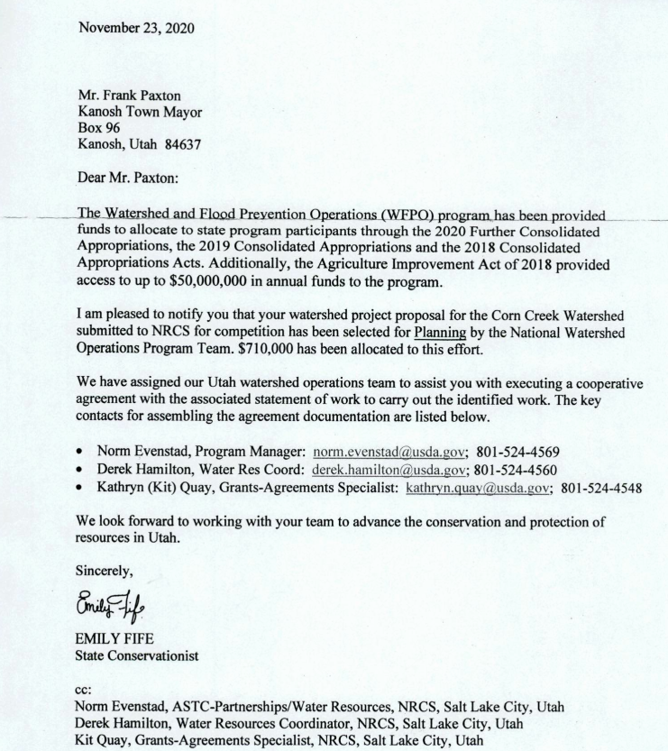
Mayor Paxton stated that the "go-to" person for the town in this project will be Councilmember Rodney Whatcott. Councilmember Brandon Stephenson has been working diligently on the project.

Planning and Zoning:
Mr. Ed Phillips presented the building permit of Jeremy Davis for a shop building. Mr. Davis has met with the building inspector. This will be a Military Surplus building, to be erected on a cement slab, with no power at this time. He will need an inspection of the electrical connection when he installs it. Planning and Zoning spokesman presented the permit to the Council, recommending approval. Councilmember Hayden George motioned to approve the permit as presented, Councilmember Rodney Whatcott provided a second to the motion, all Councilmembers voted in favor as noted below:
Mayor Frank Paxton: Aye
Council members
Rodney Whatcott: Aye
Brandon Stephenson: Aye
Neil Shumway: Aye
Hayden George: Aye

Fire Department:
Fire Chief Lorin Shumway reported that things are going well in the fire department. There has been a good response from the members when needed. There are plans to participate in further training after COVID.

Park Signs:
Mayor Paxton noted it would be of benefit to the park to have a couple of signs indicating no motorized vehicles except for park maintenance vehicles. Recently, an individual rode his four-wheeler through the park. Councilmember Brandon Stephenson motioned in favor of the purchase of the signs, Councilmember Rodney Whatcott seconded the motion, all Councilmembers voted in favor as noted below:
Mayor Frank Paxton: Aye
Council members
Rodney Whatcott: Aye
Brandon Stephenson: Aye
Neil Shumway: Aye
Hayden George: Aye

Snow Blower:
Town Employee Lorin Shumway stated there is a citizen who would have offered to sell the town a used Toro snowblower for $500.00. Such a purchase could help employees with snow removal. Councilmember Brandon Stephenson motioned in favor of the purchase of the snow blower, Councilmember Hayden George seconded the motion, all Councilmembers voted in favor as noted below:
Mayor Frank Paxton: Aye
Council members
Rodney Whatcott: Aye
Brandon Stephenson: Aye
Neil Shumway: Aye
Hayden George: Aye

Ordinance 120920
Following up on the Public hearing, Councilmember Rodney Whatcott motioned to approve Ordinance 120920, Councilmember Hayden George seconded the motion, all Councilmembers voted in favor through a roll call vote as noted below:
Mayor Frank Paxton: Aye
Council members
Rodney Whatcott: Aye
Brandon Stephenson: Aye
Neil Shumway: Aye
Hayden George: Aye

Departmental Reports:
*Electrical Department: As is the holiday tradition for the Town of Kanosh, Councilmember Neil Shumway motioned to award each electrical customer a holiday discount of 10% off of their December electrical billing. Councilmember Rodney Whatcott seconded the motion, all Councilmembers voted in favor as noted below:
Mayor Frank Paxton: Aye
Council members
Rodney Whatcott: Aye
Brandon Stephenson: Aye
Neil Shumway: Aye
Hayden George: Aye

*Water Department: Nothing new to report, we are continuing with the well siting project.
*Park: Nothing new to report at this time.
*Cemetery: Councilmember Hayden George is putting together an updated burial fee schedule and definitions for the cemetery. This will appear as an agenda item for next month.
*Roads: We still need a snowplow! In the meantime, we are making the best use of the equipment we have.

Holiday Celebration:
Santa's candy has been ordered and is now at the store! Council members will meet on the 17th at the fire station to help sack the candy. The town celebration will be on the 21st at the church parking lot @ 6:30 pm.

REVIEW OF UTILITY DELINQUENCIES:
Council members reviewed the monthly delinquency list. It was determined, again, to handle those accounts in arrears according to established Town policy.

Public Comments:
Allyson Kristofferson: concern over the old wreaths, many people worked hard to decorate and upkeep the old wreaths, and paid the $50.00 to display them. It was questioned if the new Christmas Wreath donation was approved through the council?
The council recognized that the donation of the wreaths did not come through the council.

Old Business:
* Full-time employee benefits: Our attorney is working on a final document and will present it when it is complete.
*Web site: Nothing new to report at this time.
*COVID funding: Everything with the COVID money must be purchased before 12/31/20. The Town employees will make a concerted effort to at least get all of the materials before the end of the month.
*Snow Plow: Councilmember Hayden George presented his findings on available snowplows at the auction. Councilmember Brandon Stephenson and proceed with looking into the purchase of a new truck. Councilmember Neil Shumway seconded the motion, all Councilmembers voted in favor as noted below:
Mayor Frank Paxton: Aye
Council members
Rodney Whatcott: Aye
Brandon Stephenson: Aye
Neil Shumway: Aye
Hayden George: Aye

*Meter deposit refund
Kanosh Town Treasurer, Karen Crook presented the name of Jerome Johnson as being eligible for a meter refund, in two years he has not been on the delinquency list. The refunds are according to policy and procedure and therefore do not require the vote of the council.

There being no further business to come before the board, the meeting adjourned.

Frank Paxton Cindy Turner
Kanosh Town Mayor Kanosh Town Clerk

