Environmental Assessment

For aerial application of pesticides for mosquito control in
Salt Lake County, Utah

Salt Lake City Mosquito Abatement District
2215 North 2200 West
Salt Lake City, Utah

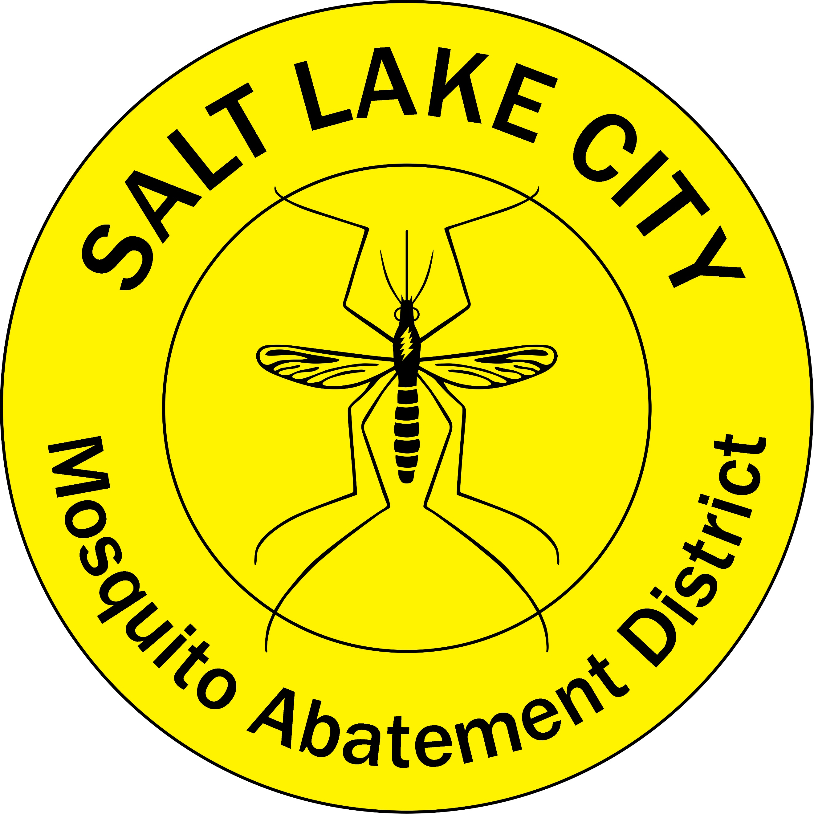

DOCUMENT OVERVIEW
This Environmental Assessment (EA) addresses the aerial control of mosquitoes in Salt Lake City, Utah (UT) to include Salt Lake City and surrounding unincorporated Salt Lake County lands. The EA is prepared in compliance with the National Environmental Policy Act (NEPA) of 1969, as amended, and in accordance with: 32 CFR Part 989; Title 40, Code of Federal Regulations (CFR), Part 1500‐1508, Council on Environmental Quality; Department of Defense (DoD) Instruction 4150.7, DoD Pest Management Program; and AFMAN 31-1053.

Surveillance results by the Salt Lake City Mosquito Abatement District indicate that mosquito species present in the northwest quadrant of Salt Lake City are extremely numerous during summer months and capable of transmitting serious human diseases. The mosquito populations are large enough to cause human pain, discomfort, and stress. The nuisance caused by mosquitoes during the summer can decrease the overall morale and quality of life within Salt Lake City if the mosquito number are not controlled.

Section 1 PURPOSE AND NEED FOR ACTION, provides the background for this action and outlines
objections and decisions to be made.

Section 2 DESCRIPTION OF THE PROPOSED ACTION, describes the aerial application of pesticides
for mosquito control.

Section 3 ALTERNATIVES CONSIDERED, discusses the preferred implementation action and
alternatives.

Section 4 AFFECTED ENVIRONMENT, presents the environmental and socioeconomic setting of
Salt Lake City and adjacent area.

Section 5 ENVIRONMENTAL CONSEQUENCES, covers the potential direct environmental effects of
the control action and describes planned mitigation actions.

Section 6 CONCLUSION, presents what was determined after examining the best currently
available information.

APPENDICIES

Section 1 PURPOSE AND NEED FOR ACTION

1.1 Purpose of the Proposed Action
Salt Lake City, Utah is the capital and most populous city of the state of Utah. The city is in the northeast corner of the Salt Lake Valley surrounded by the Great Salt Lake to the northwest and the steep Wasatch and Oquirrh mountain ranges on the eastern and southwestern borders, respectively. Rain water and snow melt from the Wasatch mountains travel through Salt Lake City moving towards the Great Salt Lake. However, most of the water never directly flows into the Great Salt Lake, as the water is impounded and used for different agricultural and recreational purposes. This water then becomes stagnant, creating about 43,000 acres of mudflats, duck hunting clubs, and wetlands that are an ideal habitat for mosquitoes to lay eggs and for juvenile mosquitoes to develop within. The most abundant mosquito species are Aedes dorsalis and Culex tarsalis. There are several other mosquito species also present in this habitat including Aedes increpitus, Aedes vexans, Anopheles freeborni, Culex erythrothorax, Culex pipiens, Culiseta inornata, and others. The Salt Lake City Mosquito Abatement District (SLCMAD) was created in 1923 to protect Salt Lake City residents from the large numbers of these pestiferous mosquitoes.

During the summer months, CO₂-baited mosquito surveillance traps collect on average, over 2,500 of these mosquitoes per night, with many traps collecting well over 15,000 individuals. Aedes dorsalis is extremely aggressive to people, and causes many people discomfort outdoors. This mosquito also elicits many service requests to SLCMAD. Culex tarsalis, in addition to being a pest, is also an important disease vector and thus of great public health importance. Culex tarsalis is the primary vector for Western equine encephalitis virus (WEE) and St. Louis encephalitis virus (SLE), which were common in the Salt Lake area prior to the introduction of West Nile virus (WNV). This mosquito is also the primary epidemic vector of WNV in the area. Since WNV was first detected in Utah during 2003, there has been 422 documented human cases, with the largest numbers being detected in the Salt Lake Valley.
In order to stop nuisance mosquitoes from biting people and to reduce pathogen transmission to residents, SLCMAD conducts mosquito adulticide applications. In the northwest rural areas of the District, where the vast majority of the mosquito abundance is within the Salt Lake City area, the District relies on fixed-wing ultra-low volume (ULV) applications of adulticides to control adult mosquitoes. Over 30 CO₂-baited traps are used to measure the mosquito abundance in the rural area, as well as to evaluate the efficacy of the ULV sprays. In many instances, the numbers of mosquitoes collected in some of the traps do not decrease after aerial ULV adulticide operations are conducted. In order to determine how to better control adult mosquitoes with aerial ULV applications we propose working with the US Air Force (USAF) to conduct ULV sprays in the northwest section of the Salt Lake City area.
1.2 Scope
This EA was prepared in accordance with Air Force Instruction (AFI) 32-7061, Environmental Impact Analysis Process; 32 CFR 989, Environmental Impact Analysis Process; and the President’s Council on Environmental Quality (CEQ) Regulations for Implementing the Procedural Provisions of the National Environmental Policy Act (40 CFR Parts 1500-1508). This EA identifies the possible environmental impacts the proposed action would have and the magnitude of those impacts. If the environmental impacts are found to be significant according to CEQ's criteria (40 CFR Part 1508.27), an Environmental Impact Statement (EIS) would be prepared before Salt Lake City Mosquito Abatement District implements the proposed action. If such impacts are found to be relatively minor, a Finding of No Significant Impact (FONSI) would be issued.
1.3 Issues Needing No Further Consideration
None of the alternatives would have an impact on transportation, cultural resources, floodplains, or socioeconomics of the proposed action area. Therefore, this EA will not consider transportation, cultural resources, floodplains, socioeconomics, and environmental justice further.
After a careful analysis of the proposed actions, no minority or low-income group would be unduly affected by implementing or by not implementing the proposed action for any of the alternatives. Thus, environmental justice is not an issue that will be pursued further in this EA.

1.4 Need for the Proposed Action
The primary objective to working with the USAF in conducting aerial ULV sprays is to better determine the optimal methods for controlling adult mosquitoes in a high desert environment with multiple geographic, environmental, and man-made features that make aerial ULV sprays difficult. Some of the challenges to aerial adult mosquito control in the Salt Lake City area include extreme temperature inversions that occur at sunset and remain until sunrise, nearby mountain ranges that create canyon wind effects, lake effects from the Great Salt Lake, high elevation (base elevation in the proposed area is over 4,200 feet), little to no humidity, and the location of the Salt Lake City International Airport which is situated at the edge of productive mosquito habitat – thus limiting where aerial spray flights can occur and disrupting desired pesticide movement by drift from some directions.

Models that describe aerial mosquito control efficacy, and many aerial ULV sprays that are conducted, fail to consider many of the unfavorable conditions listed above. As a result, how to perform mosquito control in less than optimal conditions, as well as what type of efficacy can be expected in an environment with multiple challenges, is not well understood. When mosquito numbers reach levels that cause distress to the local residents and when pathogens are being transmitted by mosquitoes, then the mosquito population needs to be suppressed quickly and efficiently. Gaining more experience in how to best control mosquitoes in these real-world scenarios will allow the soundest decisions to be made on how to protect public health from mosquitoes while balancing the health of the environment and the cost of operations.

Section 2 DESCRIPTION OF THE PROPOSED ACTION

2.1 – Treatment Site and Acreage
The proposed area to perform evaluations of aerial ULV applications of adult mosquito control products is in the northwest quadrant of Salt Lake City. The site is approximately 43,000 acres (Appendix A). The exact spray locations and spray block sizes will be determined by surveillance of the mosquito population prior to aerial ULV applications and the weather conditions.

2.2 – Target Mosquito Species
Primary target species to be controlled are Ae. dorsalis and Cx. tarsalis. These two species comprise over 90% of the total mosquitoes collected in the area to be treated. Both of these mosquitoes readily bite people, creating a significant nuisance in their large numbers. In addition, Cx. tarsalis is a major vector for SLE, WEE, and WNV. All of these viruses have been detected in the Salt Lake City area, with WNV currently being the major arboviral threat to the public since its introduction into the area in 2003.

2.3 – Biological Evaluations and Decision-Making Criteria
Aerial ULV spray determinations will be based a number of biological and environmental factors. Biological factors include the adult mosquito population, mosquito species composition, mosquito activity times, and disease surveillance. Environmental factors include temperature, water levels, wind speed and direction, and time of sunset.

The adult mosquito population is monitored primarily by 30 CO₂-baited traps operated by SLCMAD, that are placed throughout the area to be evaluated. These are set and collected overnight two times a week. The trapped mosquitoes are brought back to the laboratory at SLCMAD, and they are separated by species and enumerated. Adult mosquito levels are also monitored by landing counts on mosquito control technicians working in the area, and by service request calls from the public in the vicinity. From the mosquito collections, subsamples are taken of mosquitoes that are potential vectors of SLE, WEE, and WNV. These mosquitoes are tested by molecular methods for the evidence of infection by these viruses.

The following list contains thresholds determined by SLCMAD that may trigger mosquito ULV treatments in the area of the District where the aerial ULV evaluations are to take place:
- ≥ 300 adult mosquitoes of any species captured in a CO₂-baited trap in a single night.
- A 50% increase or more in adult mosquitoes at a trapping location compared to the previous trapping event at that location.
- Vector control technicians reporting a landing rate of ≥ 5 adult mosquitoes per minute.
- The detection of a mosquito-borne disease within the area.

Environmental conditions will be monitored to determine if an aerial ULV spray application can be conducted, and when the best time to make this application will be according to the pesticide label requirements. Wind speed will be monitored to ensure wind is moving at least 1 mph and no more than 10 mph. Temperature will be monitored at ground level and 30 ft above the ground to determine if an inversion has occurred. Sunset time will be used to determine when the ULV application should be initiated, as mosquito activity is tied to changes in light from the sunset. SLCMAD will also use two Biogents Counter Traps (real-time remote trapping device) to monitor mosquito activity prior to the aerial ULV applications to determine when mosquitoes are most active.

2.4 – Treatment Method
The treatment aircraft would be a C-130H specially outfitted for aerial spray application with a Modular Spray System (MASS) provided and staffed by specially trained and certified personnel from the USAF - Youngstown Air Reserve Station (ARS), Vienna, Ohio. This spray system is thoroughly maintained and calibrated to accurately deliver the precise quantity of pesticide needed for efficacy against mosquitoes.

Overflights of spray aircraft would be at an elevation of 100 to 300 feet. The spray operations would
concentrate on periods of high mosquito activity for adult control measures. The most common profile flown for adult mosquito control begins at sunset if weather permits, with the aircrew using night vision goggles. This is generally when mosquito activity (biting/feeding) is greatest and weather conditions (wind and humidity) are most favorable for insecticide applications. Additionally, some applications may be made before nightfall if mosquitoes are most active then.

2.5 – Treatment Materials
Two different types of control products will be used for controlling adult mosquitoes. These products have different classes of active ingredients and different physical properties which could influence how they perform. We will be conducting sprays with pyrethroid containing products like Biomist®30+30 and organophosphate containing products like Dibrom® and other adulticides of the same two chemical classes that are labeled for aerial applications. Pesticide applications will be performed below maximum allowable rates. Below is some label information on the pesticides that will be used.

- Biomist 30+30 ULV. EPA registration number: 8329-42. Active ingredients: 30% Permethrin, 30% Piperonyl Butoxide (PBO). Recommended for aerial ULV applications at up to 0.36 fl. oz. undiluted product per acre. Biomist 30+30 ULV may also be diluted with a suitable solvent such as mineral oil and applied by aerial ULV equipment so long as 0.007 lbs permethrin or PBO per acre are not exceeded.
- Dibrom Concentrate. EPA registration number: 5481-480. Active ingredient: 87.4% naled. Recommended for aerial ULV applications at 0.5 to 1.0 fl. oz. of undiluted product per acre. No lbs. per acre limit are listed on the label for this product. Do not treat any site with more than 2 fl. oz. of undiluted Dibrom Concentrate per acre within a seven-day period and the amount of undiluted Dibrom Concentrate applied to any site should not exceed 104 fl. oz. (10.73 pounds per acre of naled a.i./acre) per year. More frequent treatments may be made to prevent or control a threat to public and/or animal health determined by a state, tribal or local health or vector control agency on the basis of documented evidence of disease-causing agents in vector mosquitoes or the occurrence of mosquito-borne disease in animal or human populations.

See Appendix B for product labels and Appendix C for Safety Data Sheets (SDS). Because of operational, biological, ecological, or economic needs, other EPA-approved adulticides with the same class of active ingredients may be used as well.

Section 3. Alternatives Considered

- No Action
Under this scenario no action from the USAF to undertake aerial control methods would be conducted. Traditional control methods would be used by SLCAMD and progress in improving adult mosquito control in the area would be minimal. Effects to the environment would be similar or identical to those if the proposed actions took place, as SLCMAD will still apply the same pesticides proposed in this spray evaluation with the USAF, only more times and for a longer duration. In this scenario there would be no benefit to human health or the environment, and there would not be the benefit of determining the best methods to control mosquitoes in this type of environment in the future.

- Utilize Only One Adulticide
Under this scenario only one of the two selected adulticides would be used for sprays. The best pesticide for SLCMAD to utilize would be Dibrom, because that is the primary product used to control adult mosquitoes in the proposed spray area. The organophosphate Dibrom is the main pesticide used in this area for aerial ULV applications because it is very dense, thus reducing drift in the erratic winds, and it has a different mode of action from the adulticides used in the same area from ground based ULV equipment. All of the adulticides applied by SLCMAD from the ground are pyrethroid based products. These products are effective, but resistance management strategies emphasize the need to use multiple active ingredients against the same population of insect pests to reduce the likelihood of the resistance development.

It would be ideal to utilize both products and see how the two different types of products compare when they are aerially applied. This is the best way to determine which pesticides are most effective for adult mosquito control. If two different pesticides are used, they will be applied in a manner so they do not interfere with each other spatially or temporally. Whether the pesticides applications are spaced apart in time or location will depend on the mosquito activity and the availability of the USAF. In addition, the knowledge gained from testing both types of formulations could then be used in other places with similar environments (both for public and military benefits).

Section 4. Affected Environment

4.1 – Geomorphology and Land Use
Much of the northwest area of Salt Lake City boundaries was once covered by water of the Great Salt Lake as recently as 1872 and again in 1984. As the Great Salt Lake has receded, most of this land has been developed into a series of bordering duck-hunting clubs (marshes), constructed wetlands and a water fowl conservation area. The duck-hunting clubs are privately owned by groups of people who maintain the property in the interest of attracting water fowl for the October through December duck hunting season. During other times of the year, the duck-hunting clubs may serve as pasturage for cattle, trapping area for musk rats or for the most part unattended. There is little consideration given in these areas for the management of water for the purpose of mosquito control. During the last part of August and into September, most low areas within the duck-hunting clubs are flooded, which produces a huge hatch of invertebrates, including mosquitoes. Migrating water fowl are attracted to the fresh source of food. The District has an excellent working relationship with all of the duck-hunting clubs in the area and has full access into the area for the control of mosquitoes.

4.2 - Meteorological and Climatological Setting
Salt Lake City is located in a large valley, the Salt Lake Valley, separated by the Wasatch Mountains to the east and the Oquirrh Mountains to the west. The Salt Lake Valley receives approximately 15 inches (380 mm) of precipitation annually, usually with more on the east side and less on the west side. Most of this precipitation is received in spring. The summer is dry, with the majority of precipitation arriving from the monsoons that rise from the south. Short, localized, and often dry thunderstorms are usually associated with the monsoons. Precipitation is heaviest in late fall/early winter and in spring, while early summer is the driest season.

The valley receives 55 inches (140 cm) or more of snow in a year, with up to 100 inches (250 cm) received on the benches. Most of the snow falls from mid-November through March. The mountains receive up to 500 inches (1,270 cm) of light, dry snow and up to 55 inches (1,400 mm) of precipitation annually. The heavy snow totals across the county can be attributed to the lake-effect, where precipitation is intensified by the warm waters of the Great Salt Lake, which never entirely freezes due to the lake's high salinity. The lake-effect can affect any area of the county.

During winter, temperature inversions are a common problem, causing air pollution in the valley. The inversion will trap pollutants, moisture, and cold temperatures in the valley while the surrounding mountains enjoy warm temperatures and clear skies. This weather event lasts from a few days to up to a month in extreme cases, and is caused when an area of very strong high-pressure positions over the Great Basin.

4.4 - Demographics
The population of Salt Lake City according to 2016 estimates of the U.S. Census Bureau was 186,440 people, 75,177 households and 57,543 families. Salt Lake City is more densely populated than the surrounding metro area with a population density of 1,688.77/sq mi (1,049.36/km²). There are 80,724 housing units at an average density of 731.2 residences per square mile (454.35/km²). The city's major sectors are government, trade, transportation, utilities, and professional and business services. The daytime population of Salt Lake City swells to over 315,000 people, not including tourists or students. Some parts of the northwest section of unincorporated Salt Lake County may be treated as well. In this section of the county there are less than 20 residents.

4.5 – Non-target Organisms
From a broad perspective, non‐target organisms within the proposed treatment area include: the resident human population, domestic animals (e.g., dogs, cats, horses); woodland mammals (e.g., mule deer, pronghorn antelope, hares, skunks, fox, beaver, and muskrat); game and non‐game bird species (e.g., songbirds, ducks, geese, and hawks); freshwater fish (e.g., catfish and carp) reptiles and amphibians; and many terrestrial and aquatic invertebrates (e.g., insects and crustaceans).

Non‐target plants include many naturally occurring native plants as well as some irrigated crops. Plants of the Great Salt Lake system include flora typical of western riparian habitats and Great Basin environments, plus a number of halophytic (salt-adaptive) specialists (e.g., Red Swampfire, Alkali Dropseed, Four-Winged Saltbush, Baltic Rush, Scratchgrass, Common Reed, Greasewood, Inkweed, Iodine Bush, Pickleweed, Salt Grass, Sea Purslane, Shadscale, Tamarisk bulrush, and Phragmites); elevated sites support a mixed plains grassland community (e.g., Sandberg Bluegrass, Alkali-mallow, Cheatgrass, Little Barley); irrigated crops are primarily alfalfa and corn.

The target organisms in this project are adult mosquitoes (order Diptera, family Culicidae). The most likely group of non‐target organisms that would be potentially affected by the proposed adulticide treatment would be other insects. Flying insects, exposed at the time of application, especially those of similar class size to mosquitoes such as midges, gnats, and brine flies may be killed upon direct contact with the adulticide spray material. Bees, while larger than mosquitoes, are susceptible to permethrin and naled and can be affected adversely. Dragonflies and damselflies (Odonata) are normally not affected by the small sized droplets used in ULV sprays, the density of the droplets, and the timing of the applications. See section 5.3 of this document for a more thorough explanation on the limited consequences on on-target organisms.

Further information relating to non‐target organisms and precautionary steps taken to protect them may be found in Section 5, Environmental Consequences.

4.6 – Threatened, Endangered and Sensitive Species

According to the US Fish and Wildlife Service Environmental Conservation Online System, there are three threatened and one endangered species found in Salt Lake County. The endangered animal, the June Sucker (Chasmistes liorus) is a fish that is not likely found in the spray area. The only known location for this fish in Salt Lake County is in the Red Butte Reservoir which is far to the east of where the proposed spray area is located. The Yellow-billed Cuckoo (Coccyzus americanus), Ute Ladies’ Tresses (Spiranthes diluvialis), and Canada Lynx (Lynx canadensis) are also on the threatened list but not likely to be in the affected area. The Yellow-billed Cuckoo is found in areas with bodies of water well lined with trees. The proposed spray area does not have enough trees along rivers and streams to be a suitable habitat for this bird. The salinity of the soil in the proposed spray area is too high for the Ute Ladies’ Tresses to grow. The Canada Lynx has not been seen in the proposed spray area and this is not thought to be a habitat where the lynx would be located.

A list of Federally-listed or candidate species in Salt Lake County as well as species recognized by the state of Utah that are likely to occur within the proposed treatment area. Threatened (T), Endangered (E) and Candidate (C) species and State-sensitive species (SS)

Table 1 Threatened, Endangered and Sensitive Species in Project Area
Species | Type | Status | Occurrence Potential | Environmental Effects for all Alternatives
June Sucker  Chamistes liorus | Fish | E | Unlikely | June sucker is endemic to Utah Lake and is not known to occur in spray area. The only known location for this fish in Salt Lake County is in the Red Butte Reservoir which is over 8 miles to the east of where the proposed spray area is located.
Least Chub  Iotichthys phlegethontis | Fish | C | Unlikely | No known habitat in the project area
Western Yellow-billed Cuckoo  Coccyzus americanus occidentalis | Bird | T | Unlikely | Suitable nesting habitat does not exist on the project site for western yellow-billed cuckoo, which is thought to need large (100-acre minimum) tracts of contiguous riparian forest. The project site is not likely to provide foraging habitat for this species either, as no suitable breeding habitat is found near the project site.
Canada Lynx  Lynx canadensis | Mammal | T | Unlikely | No suitable habitat in the project area
Bonneville Cutthroat Trout  Oncorhynchus clarkii utah | Fish | C | Unlikley | No suitable habitat in the project area
Columbia Spotted Frog  Rana luteiventris | Amphibian | C | Unlikely | No suitable habitat in the project area
Ute Ladies Tresses Spiranthes diluvialis | Plant | T | Unlikely | No suitable habitat in the project area
American White Pelican  Pelecanus erythrorhynchos | Bird | SS | Likely | Proposed actions would not likely affect health, food source or habitat of organism
Bald Eagle  Haliaeetus leucocephalus | Bird | SS | Likely | Proposed actions would not likely affect health, food source or habitat of organism
Burrowing Owl Athene cunicularia | Bird | SS | Likely | Proposed actions would not likely affect health, food source or habitat of organism
Ferruginous Hawk Buteo regalis | Bird | SS | Likely | Proposed actions would not likely affect health, food source or habitat of organism
Long-billed Curlew Numenius americanus | Bird | SS | Likely | Proposed actions would not likely affect health, food source or habitat of organism
Short-eared Owl  Asio flammeus | Bird | SS | Likely | Proposed actions would not likely affect health, food source or habitat of organism

Section 5. Environmental Consequences

5.1 – Consequences Relating to Human Health and Safety

Biomist 30+30 is a pyrethroid‐based pesticide registered for use in mosquito control by the EPA. It has
low toxicity to humans, mammals, and the environment. In the many years of its use, there have been no reports of toxic effects of Biomist 30+30 to people, pregnant women, pets, or other mammals. The active ingredient in Biomist 30+30 is permethrin, which is used in shampoos and other products to treat people and animals for ectoparasites. The EPA’s summary of Permethrin, Resmethrin, d-Phenothrin (Sumithrin®): Synthetic Pyrethroids For Mosquito Control states that “pyrethroids can be used for public health mosquito control programs without posing unreasonable risks to human health when applied according to the label.”(EPA 2020) In large concentrations (e.g., during the loading process), mild eye and skin irritation may occur with exposure to Biomist 30+30, which can be treated by washing the eyes and skin thoroughly with water after contact. Pyrethroids are considered to pose slight risks of acute toxicity to humans, but at high doses, pyrethroids can affect the nervous system so individuals loading the material use personal protection measures. When applied as a ULV spray, under 0.36 oz per acre, the dosage would be less than a percent of this.

Dibrom, like Biomist 30+30, at the rates applied would present only slight risks of acute toxicity to humans. According to the EPA’s Naled Summary for mosquito control, “When applied according to label instructions, EPA does not expect the use of naled for public health mosquito control to raise a human health concern. People are unlikely to breathe in amounts large enough or touch anything with enough insecticide on it to harm them.” (EPA 2019)

Aerial ULV applications of mosquito control products commonly occur through the USA and several studies on this procedure have not found any negative impact on human health (Karpati et al. 2004, O’Sullivan et al. 2005, Peterson et al. 2006, Macedo et al 2007, Preftakes et al. 2011, Chung et al, 2013).

Aerial application using the proposed aircraft has proven to be safe. No life-threatening mishap or crash has occurred with the USAF and proposed aircraft in any past spray operations.

5.2 – Consequences Relating to Air Quality

The recommended ULV aerial application rate for Biomist 30+30 and Dibrom generates droplets averaging less than 50 microns across (about the width of a human hair). Depending on the climatological conditions, these droplets would mostly settle to the earth in a within 30 minutes. There would be temporary increases in volatile organic compounds within the proposed treatment area as a result of the proposed action. However, this activity would not exceed local standards for air emissions and would not result in nonconformance with the Clean Air Act and its amendments based on the type of materials in the spray as well as the spray volume and the longevity of the product in the air column. It is recognized that humans and other vertebrates can inhale ULV sprays. There are very few residences in the proposed spray area. Careful attention would also be paid by the applicators to avoid drift into non‐target areas.

5.3 – Consequences Relating to Water Quality

In the proposed concentration, Biomist 30+30 or Dibrom would have no impact on the water quality of the area. A summary of some of the key points on the persistence of permethrin, the active ingredient in Biomist 30+30 from detailed reviews on the subject (NPIC – permethrin 2019, PMED – permethrin 2019) is as follows: When permethrin enters an aquatic system, some is degraded by sunlight while in the water column but the majority binds tightly to the sediment. In water, permethrin is broken down by photolysis into 3-phenoxybenxzyl alcohol (PBA) and dichlorovinyl acid (DCVA). The average half-life range for permethrin in the water column is about 19-27 hours, however permethrin adsorbed to sediments can persist more than a year. Permethrin is not likely to contaminate groundwater due to its low water solubility and strong adsorption to soil.

Applications of naled at the proposed rates would not impact the quality of the water in the proposed treatment area. A summary of some of the key points on the persistence of naled the active ingredient in Dibrom from detailed reviews on the subject (NPIC – naled 2019, PMEP – naled 2019) is as follows: Naled is nearly insoluble in water, and hydrolysis of the compound is initiated immediately upon contact with moisture, and the breakdown is proportional to the temperature and pH of the water. At 25°C the half-life of naled in water is 15.4 hours at pH of 7, as the temperatures at the time of application are typically close to 33°C the half-life is expected to often be shorter than the 15.4 hours half-life. The material is applied by ULV at a rate of 0.75 oz per acre, thereby eliminating the possibility of runoff onto non-target areas due to application procedures. Limited data indicate that the rapid dissipation and relatively low mobility of naled and intermediate mobility of DDVP (a degradation product of naled) in soil would mitigate contamination of ground water.

The District is legally able to apply the pesticides proposed for use in these treatments with the USAF. SLCMAD has a Pesticide Discharge Management Plan which covers pesticide discharge under the required National Pollutant Discharge Elimination System (NPDES) permit. SLCMAD is eligible to apply Federal Insecticide, Fungicide Rodenticide, Act (FIFRA) labeled pesticides to waters of Utah under the Utah Water Quality Act, Title 19, Chapter 5, Utah Code Annotated (“UCA”) 1953, as amended (the “ACT”), Pesticide General Permit (PGP) For Point Source Discharges To Waters Of The State Of Utah From The Application Of Pesticides, permit No. UTG17000. The permit covers any qualified “operator” that meets the eligibility requirements identified in Part I.C.1 and part I.D.1, and if so required, submits a Notice of Intent (NOI) in accordance with Part I.A.3.
As a mosquito abatement district (activity covered in Part I.C.1.a. Mosquito and Other Insect Pests), SLCMAD is eligible for coverage under the PGP. Also, as an “Operator Group 2” (I.D.1.b.), the SLCMAD is required to submit a NOI regardless of the area to be treated. SLCMAD has submitted a NOI for all proposed treatment areas. The area of control contains no impaired bodies of water.

5.4 - Fish, Wildlife and Other Non-target Considerations

The most likely group of non-target organisms that would be potentially affected by the proposed adulticide treatment evaluations would be other insects. Flying insects, especially those active during the spray period and of similar size to mosquitoes, may be affected by the mosquito adulticiding activities. Studies have shown that there would likely be little to no impact on medium- to large-bodied insects like larger wasps (Hymenoptera), dragonflies and damselflies (Odonata), and moths and butterflies (Lepidoptera) after single and multiple ULV applications. (Boyce et al, 2007, Davis and Peterson 2008, Kwan et al. 2009, Schleier and Peterson 2010). Losses in the adult Chironomid (non-biting midge) populations would be expected. There would not be any impact to the overall Chironmid population as the larval stage would not be affected and the spray area is only a small portion of the overall Chironomid habitat around this area of the Great Salt Lake and in similar habitats night flying insects were shown to recover from ULV applications within 48 hrs (Jensen et al. 1999). Also, timing of the pesticide application to occur not until sunset may likely reduce the already limited effects on non-target insects (Breidenbaugh and Szalay 2010). Insects close to the ground especially under cover from vegetation, rocks or other debris, would likely be very minimally impacted as well (Peterson et al. 2016).

Bees, are highly sensitive to both products. High mortality in bee populations is not likely as measures would be put in place to mitigate bee losses. In the proposed spray area, there are no honey bee hives registered through the state. ULV sprays would be conducted around sunset, which is when bees are back in their hives, so there would be minimal risk to foraging bees. Bees that are within hives are mostly protected from ULV applications applied at rates for mosquito control, so even if there were hives present any loss of bee life would be minimal and the overall health of bee hives would not be affected. Native bees should also not experience major impacts from aerial ULV sprays either as they are also mostly active during the day and not during times when spraying would occur. Most native bees excavate their nest underground and above ground nesting bees use existing cavities or excavate their nests in stems or wood. (Sgolastra et al 2018) These cavities would provide protection to bees within them to ULV droplets as seen from minimal mortality to bees within hives. The droplet size of the ULV spray is also small enough that mortality in insects like honey bees is minimal (Zhong et al. 2004, Chaskopoulou et al. 2014). Active ingredients in both Biomist 30+30 and Dibrom break down rapidly, so there would be very minimal risk of residual pesticide exposure in the treated area (summarized in section 5.2).

A reduction in adult mosquitoes and similar sized flying insect numbers due to treatment would have negligible impact on the bird species in the proposed treatment area due to the type, diversity, and availability of organisms that they are known to feed upon. It should be noted that there are documented cases of some of bird species nesting or brooding in or near the treatment area, whose populations have not appeared to be adversely affected by decades of aerial ULV treatments for mosquitoes based on anecdotal observations by the District.

Due to the short residual and the low application rates of both of these products, domestic animals are highly unlikely to be affected in any way (www.epa.gov/mosquitocontrol/naled).

In summary, based upon currently available information, the proposed treatments of Biomist 30+30 and Dibrom should not significantly impact wildlife and non‐target organisms due to these materials’ target specificity, mode of action, low persistence, rapid biodegradability, and limited numbers of applications. Actually, the ULV sprays could improve survivability in avian and mammalian spp. by removing the arbovirus vectors. And since these materials would be applied well within the parameters of the allowed spectrum of applications, there would be minimal impact to non‐target organisms.

5.5 – Alternatives
1. No Action - Under these circumstances any concerns about the aerial application of the insecticides and the effects that may result from such treatment on the environment would be eliminated. Non‐target insects, particularly other Diptera and Hymenoptera (e.g., honeybees), would not be affected. The knowledge about the best large‐scale intervention in a potential mosquito‐borne disease cycle in a high desert environment near mountains would not be obtained.

2. Utilize Only One Adulticide – In utilizing only one adulticide instead of two there would likely not be any difference in the effects that may result from such treatment on the environment. Both Dibrom and Biomist 30+30 as applied aerially for mosquito control would likely have very similar impacts. If only half of the number of sprays with the USAF are conducted then there likely would be less of a direct impact on the environment from aerial ULV applications performed by the USAF, however, SLCMAD will be monitoring the mosquito populations through the entirety of the mosquito season and will apply pesticides as needed to control the mosquito population. Because the sprays conducted with the USAF and SLCMAD will be for just a few weeks, the amount of pesticide applied as a result of these spray missions will be just a small portion of the applications that will be conducted by SLCMAD during the course of the mosquito season. Any difference in the amount of pesticide applied and therefore any difference in an impact to the environment as a result pesticide usage differences from conducting sprays with just one type of product applied in spray evaluations would be insignificant compared to the pesticide applications that will be made by SLCMAD to control the mosquito populations. If fewer pesticide applications are made during evaluations, then it is likely more applications will need to be conducted by SLCMAD to protect the residents of SLCAMD.

Section 6. Cumulative Impacts

A “cumulative impact” is defined in 40 CFR 1508.7 as “the impact on the environment
which results from the incremental impact of the action when added to other past, present, and reasonably foreseeable future actions regardless of what agency (Federal or non- Federal) or person undertakes such other actions.” Cumulative impacts can result from individually minor but collectively significant actions taking place over a period of time.

Based on the findings of this EA, implementation of the Proposed Action would not result in significant direct or indirect impacts to any environmental, physical, cultural, or socioeconomic resource. The use of best management practices and protective measures during their implementation minimizes their potential to impact the environment.

Potential cumulative impacts to regional air quality would be short term and insignificant. The anticipated low levels of emission from the Proposed Action and the future projects would not occur at the same time; therefore, no cumulative issues associated with air emissions would apply.

Given the limited and short-term nature of the project, no cumulative impacts to surface water or ground-water quality would be anticipated.

The Proposed Action would not result in significant cumulative effects to native wildlife species. All environmentally sensitive areas will be identified on the spray map and only sprayed if proper approval is obtained. Apiaries and sensitive individuals will be identified and public notifications will be carried out with the cooperation of SLCMAD.

Following review of this site‐specific environmental analysis which, in turn, was based upon the best currently available information, we have determined that conducting aerial ULV sprays in the manner described would not cause significant environmental impact or adverse effects.

References

Boyce WM, Lawler SP, Schultz JM, McCauley SJ, Kimsey LS, Niemela MK, Nielsen CF, and Reisen WK. 2007. Nontarget effects of the mosquito adulticide pyrethrin applied aerially during a West Nile virus outbreak in an urban California environment. J Am Mosq Control Assoc. 23: 335–339.

Breidenbaugh MS, de Szalay FA. 2010. Effects of aerial applications of naled on nontarget insects at Parris Island, South Carolina. Environ Entomol. 39: 591-599.

Chung WM, Buseman CM, Joyner SN, Hughes SM, Fomby TB, Luby JP, Haley RW. 2013. The 2012 West Nile encephalitis epidemic in Dallas, Texas. J Am Med Assoc. 310: 297-307.

EPA (United States Environmental Protection Agency) – naled www.epa.gov/mosquitocontrol/naled-mosquito-control##3 (Accessed 1 February 2019).

EPA (United States Environmental Protection Agency) - Permethrin, Resmethrin, d-Phenothrin (Sumithrin®): Synthetic Pyrethroids For Mosquito Control www.epa.gov/mosquitocontrol/permethrin-resmethrin-d-phenothrin-sumithrinr-synthetic-pyrethroids-mosquito-control (Accessed 28 April 2020).

Karpati AM, Perrin MC, Matte T, Leighton J, Schwartz J, Barr RG. 2004. Pesticide spraying for West Nile virus control and emergency department asthma visits in New York City, 2000. Environ Health Perspect. 112: 1183-1187.

Macedo PA, Peterson RK, Davis RS. 2007. Risk assessments for exposure of deployed military personnel to insecticides and personal protective measures used for disease-vector management. J Toxicol Environ Health A. 70: 1758-1771.

NPIC (National Pesticide Information Center)– Naled. npic.orst.edu/ingred/naled (Accessed 1 February 2019).

NPIC (National Pesticide Information Center)– Permethrin. npic.orst.edu/ingred/permethrin (Accessed 1 February 2019).

O'Sullivan BC, Lafleur J, Fridal K, Hormozdi S, Schwartz S, Belt M, Finkel M. 2005. The effect of pesticide spraying on the rate and severity of ED asthma. Am J Emerg Med. 23: 463-467.

Peterson RK, Macedo PA, Davis RS. 2006. A human-health risk assessment for West Nile virus and insecticides used in mosquito management. Environ Health Perspect. 114: 366-372.

Pesticide Management Education Program (PMED) – naled. pmep.cce.cornell.edu/profiles/extoxnet/metiram-propoxur/naled-ext.html#16 (Accessed 1 February 2019).

Pesticide Management Education Program (PMED) – permethrin. pmep.cce.cornell.edu/profiles/extoxnet/metiram-propoxur/permethrin-ext.html (Accessed 1 February 2019).

Preftakes CJ, Schleier JJ III, Peterson RK. 2011. Bystander exposure to ultra-low-volume insecticide applications used for adult mosquito management. Int J Environ Res Public Health. 8: 2142-2152.

Schleier JJ III, Peterson RK. 2010. Toxicity and risk of permethrin and naled to non-target insects after adult mosquito management. Ecotoxicology. 19: 1140-1146.

Sgolastra F, Hinarejos S, Pitts-Singer TL, Boyle NK, Joseph T, Lūckmann J, Raine NE, Singh R, Williams NM, Bosch J. 2019. Pesticide exposure assessment paradigm for solitary bees. Env Entomol. 48: 22–35.

Zhong HE, Latham M, Payne S, Brock C. 2004. Minimizing the impact of the mosquito
adulticide naled on honey bees, Apis mellifera (Hymenoptera: Apidae): aerial ultra-low-volume
application using a high-pressure nozzle system. J Econ Entomol. 97: 1–7.

Appendix A – Vicinity Map

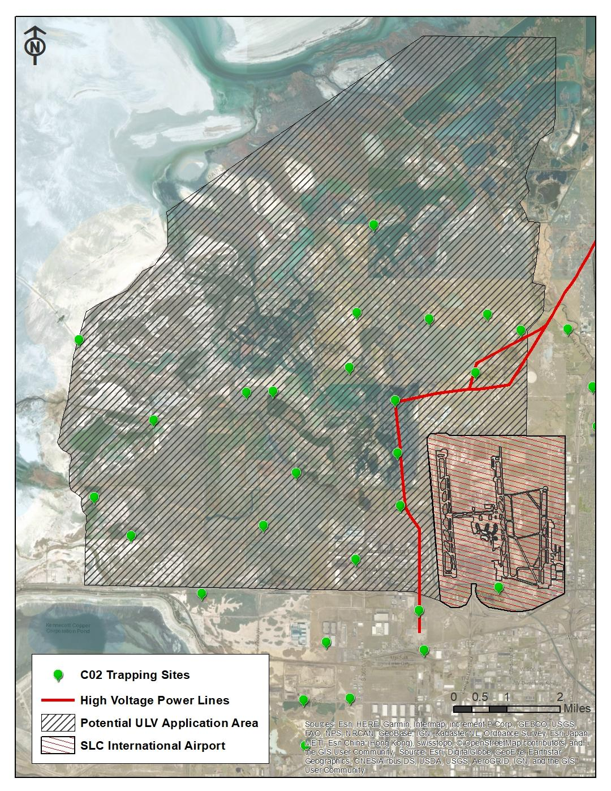

Appendix B. Pesticide Labels
Biomist 30+30
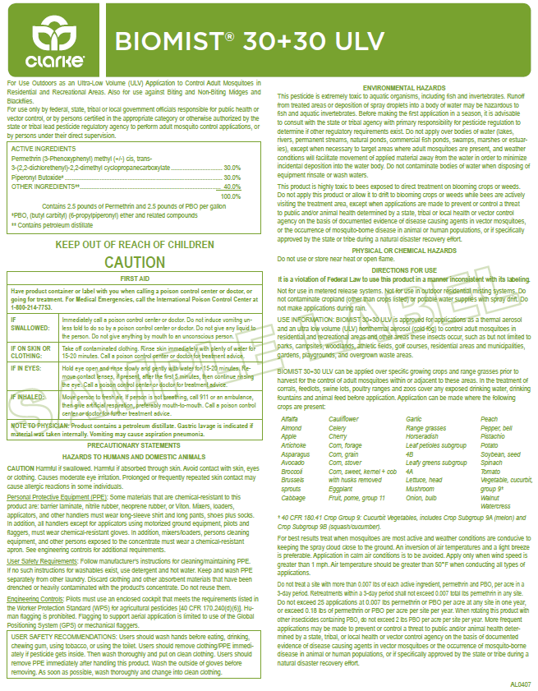

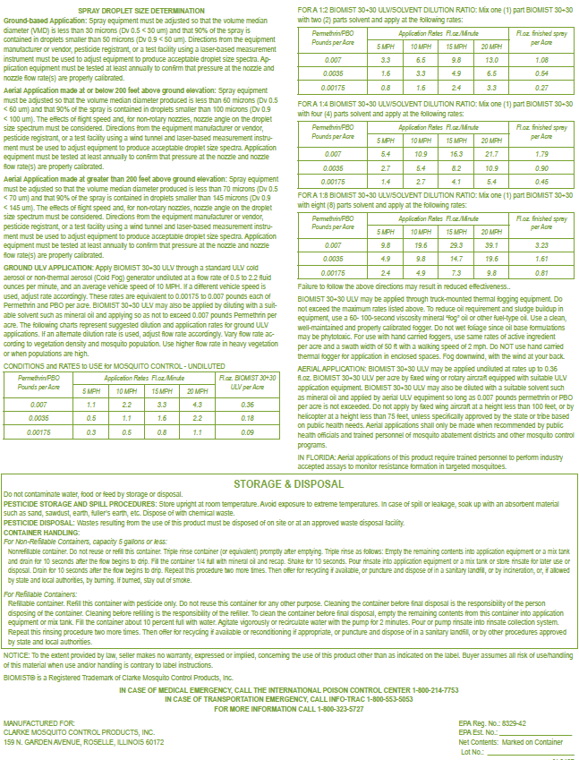

Dibrom
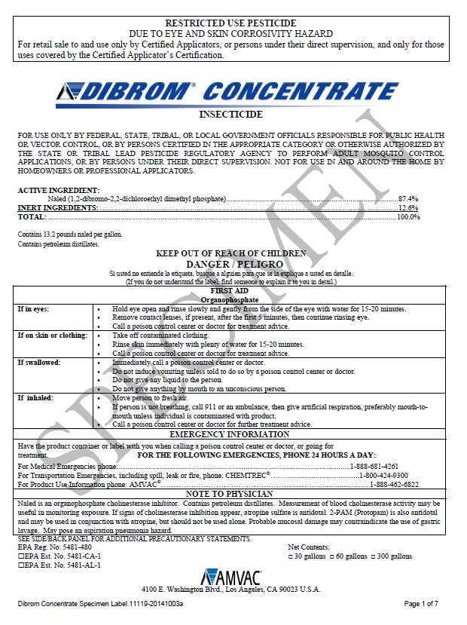
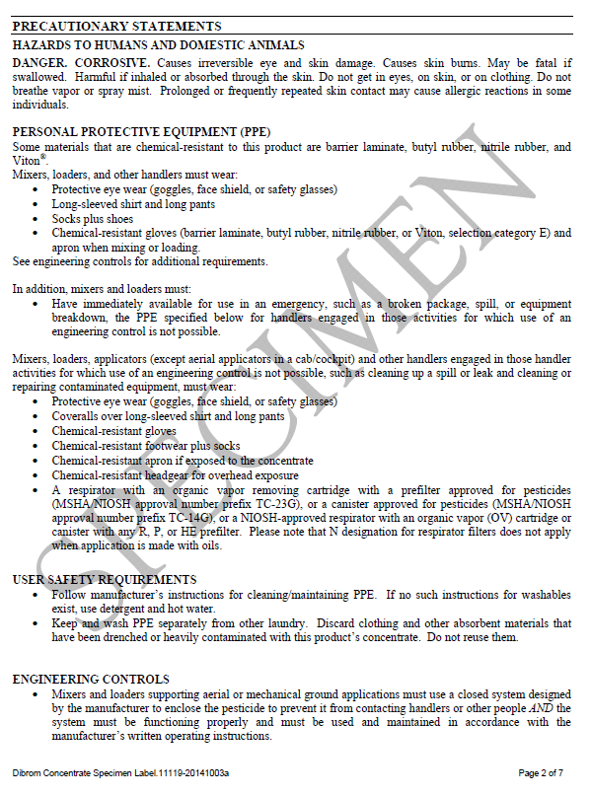

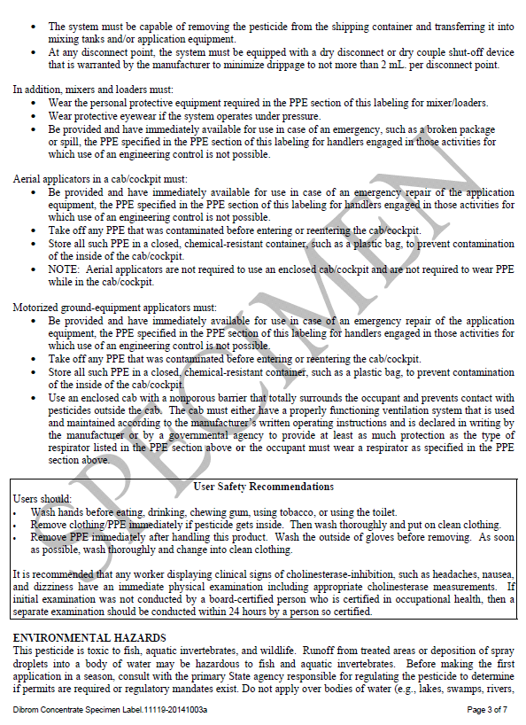

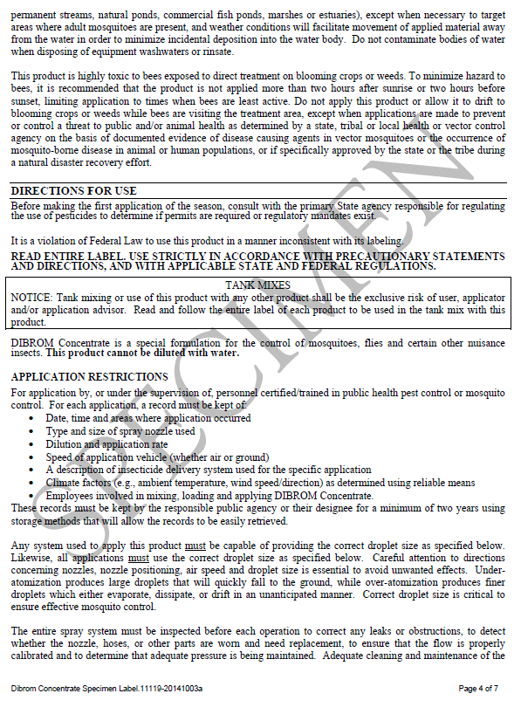

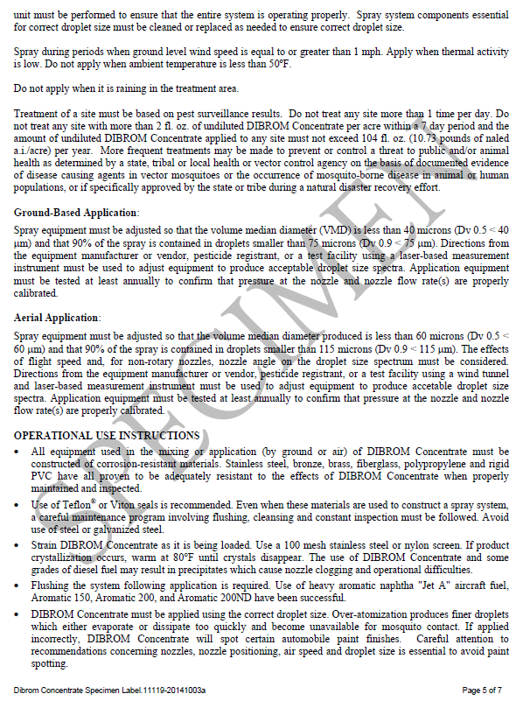

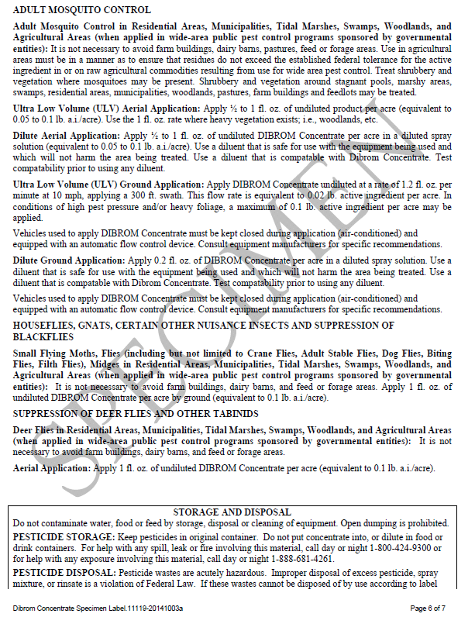

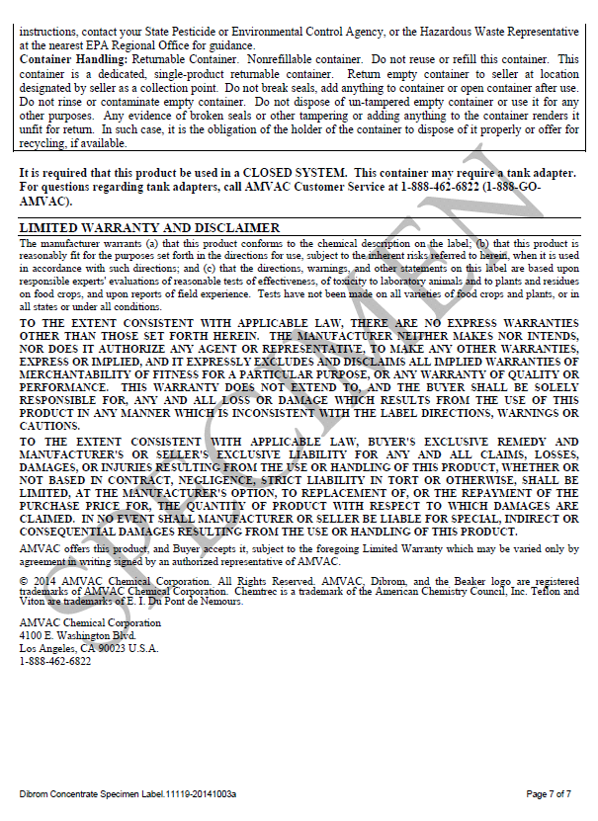

Appendix C. Pesticide Safety Data Sheets (SDS)
Biomist 30+30
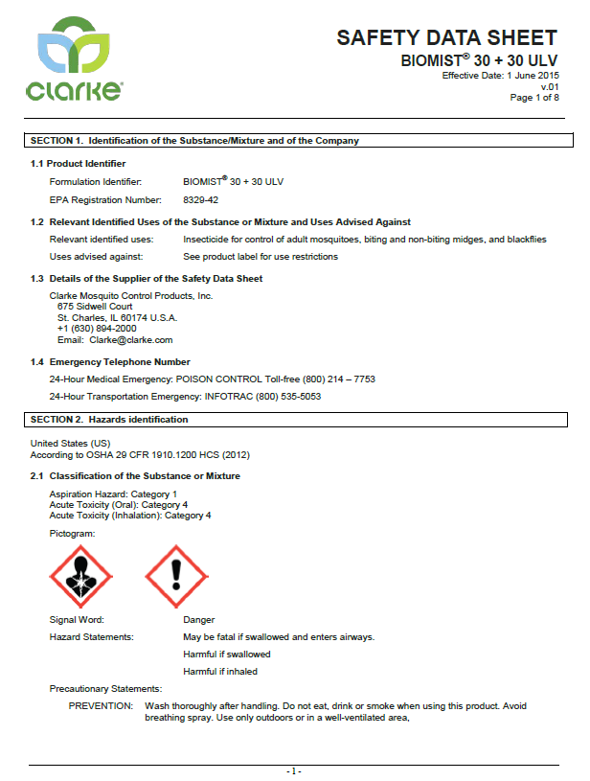
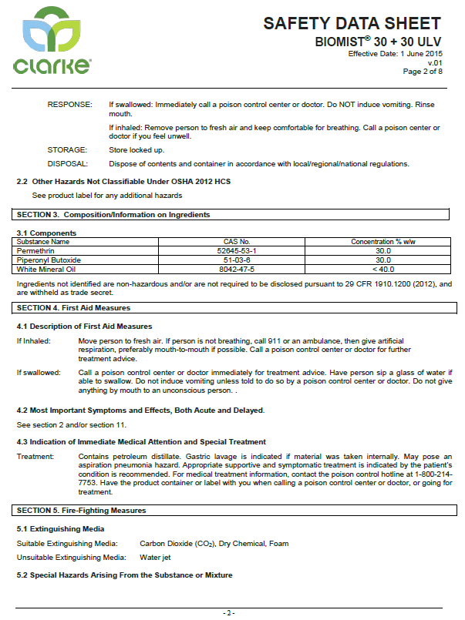

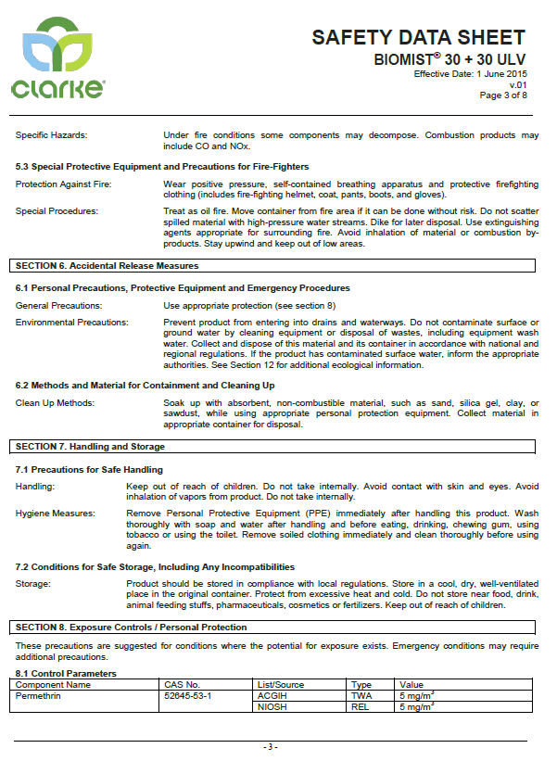

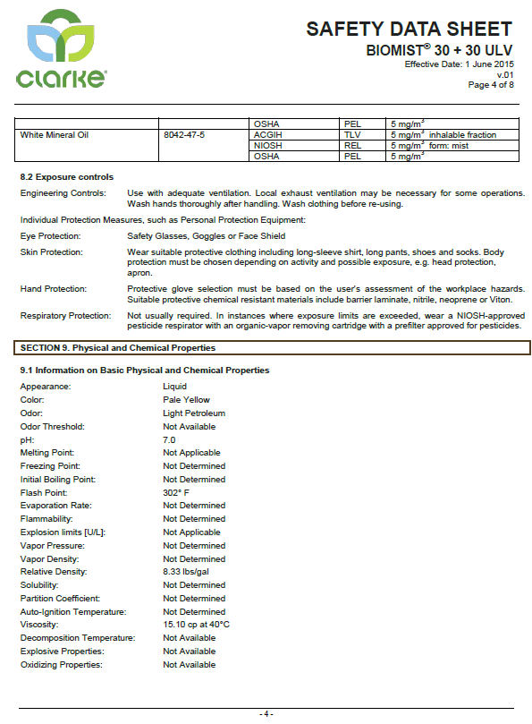

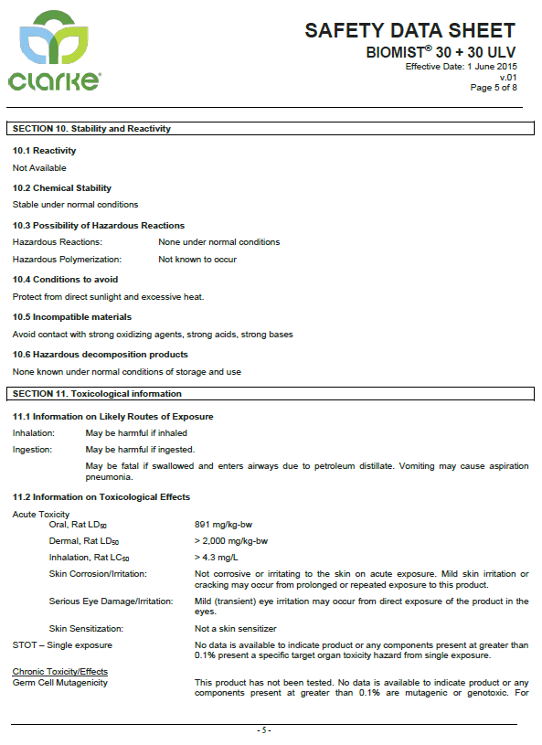

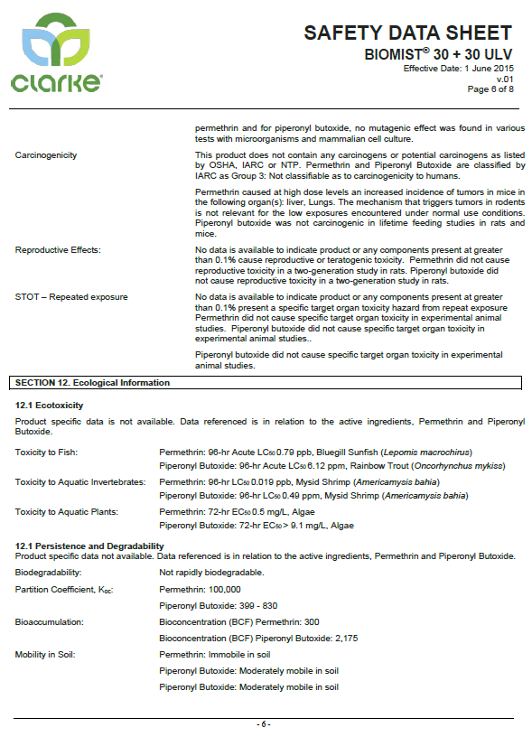

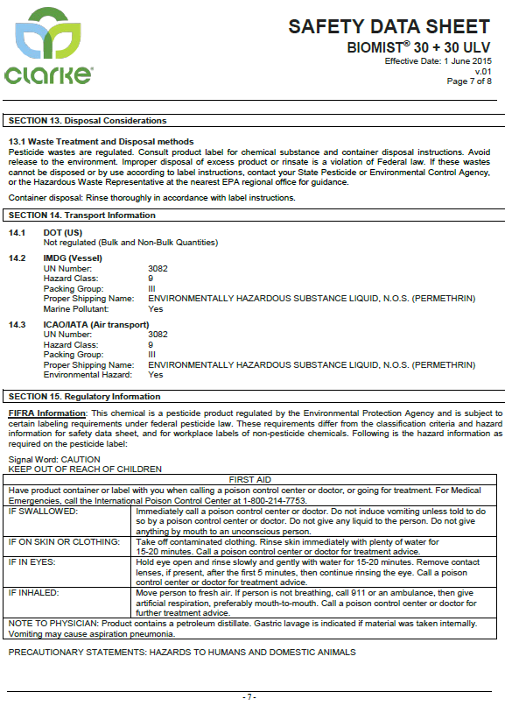

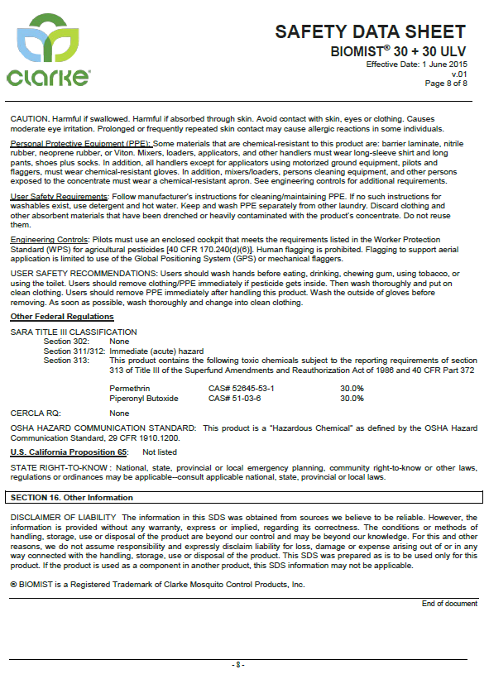

Dibrom
