1| Page Council Meeting________________________________________________December 1, 2020

REGULAR MEETING AND PUBLIC HEARING OF THE HENEFER TOWN COUNCIL
December 1, 2020
Electronic Meeting via Zoom
150 W Center Street
Henefer, UT 84033

Minutes of the Regular Council Meeting of the Henefer Town Council held December 1, 2020.

Roll Call: Mayor Kay H. Richins, Detton L. Fawcett, James A. Rees, Robin K. Riches, Matthew Shill, Shelley D. Richins, Richard Butler, Robyn Knudsen, Wade Knudsen.

Mayor Kay H. Richins opened the meeting at 7:00 p.m. The prayer was offered by Detton Fawcett and the Pledge of Allegiance was led by Robin Knudsen.

The first item on the agenda was an emergency preparedness presentation by Wade and Robyn Knudsen. Matt explained that he had met with Wade and Robyn regarding emergency preparedness for Henefer. Matt turned the time over to Robyn. Robyn explained that she had attended a CERT class several years ago. This class provided detailed training for all kinds of emergencies that communities need to be prepared for. Robyn explained that in the case of an emergency, FEMA has already prepared an emergency plan for our community. FEMA has already established which buildings in Coalville would be used for hospitals, food distribution, shelter, etc in case of an emergency situation. Robin explained that she had learned that in case of a large disaster, such as an earthquake, FEMA would not be able to assist Henefer for probably 3-4 weeks. Robyn explained that Wade would be presenting ideas for the following:
- 1-way communications – SMS sent out as a mass broadcast. Citizens can not respond to this SMS
- 2-way communications – allows town officials to send communication and instructions. This would allow citizens to respond and ask questions.
- Emergency and medical supplies and preparations via Kathy Stephens

Wade presented the council with documents which explained the technology which is available for communications during an emergency. Wade explained the procedure to send notifications through SMS
- We will set up a phone number that is able to send SMS messages.
- When someone texts the word subscribed to your phone number, they will be signed up for broadcast messages from Administrators.
- Administrator phone numbers can text broadcast, followed by the text of a message they’d like to send out, to send that message out to anyone who has subscribed to the service.
The cost of this type of service would cost $15.00/month, $10.00/thousand texts, and a $100.00 set up fee. Citizens would have to be informed of the procedure to subscribe to the SMS message service. This type of service would be specific to Henefer. Matt Shill commented that the drawback to this system is that it would only be available as long as cell service is working.

Wade presented information for a 2-way communication system. Wade explained that he had performed some testing for a GMRS/FRS hybrid system for Henefer. The majority of Henefer would

2| Page Council Meeting________________________________________________December 1, 2020
have great communications from this type of system. Wade explained that a General Mobile Radio System (GMRS ) system would be a $70.00 licensing fee for each household. If you use the hybrid system, then each household would just have to have a walkie talkie radio with no licensing fees. Wade feels that the hybrid system would be a much more cost effective and feasible system for Henefer. Wade suggested that Henefer purchase 2-3 GMRS licenses and radios and encourage citizens to have a walkie talkie in each household. Monthly tests could be conducted to make sure the system was working. Wade explained that the system would work as follows: Citizens (FRS) would communicate to Henefer Town (GMRS) which would communicate to Ham Radio operators whom would communicate with emergency services in the event of a major disaster. Wade presented the following cost breakdown:

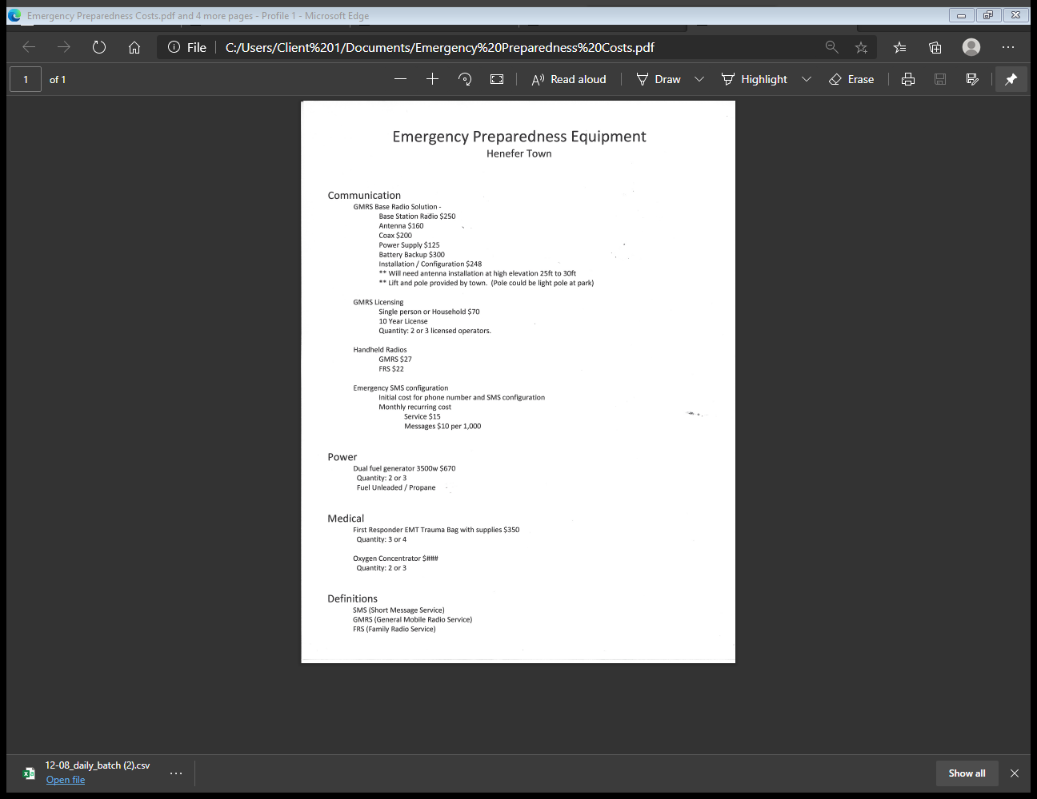
Robin informed the council that the GMRS system would be coordinated with surrounding areas. One example of this is that there would be a roll call in case of a disaster and this information would be relayed to Coalville.

3| Page Council Meeting________________________________________________December 1, 2020

Robyn explained that Kathy Stephens was unable to attend, but that she had spoken with her to identify specific emergency preparedness needs for Henefer. Kathy suggested that Henefer have the following items in case of an emergency:
- First Aid supplies are a priority
- Communication system
- Medications (difficult due to expiration dates)
- Oxygen Concentrator
- Specific locations for medical care, clothing distribution, and food distribution
- Evacuation plan
- List of all citizens than are oxygen dependent or bed bound.
- PPE/Needles

Mayor Kay Richins thanked the Knudsen’s for the presentation and called for comments from the council. Matt questioned how quickly the council could move on getting the systems set up. Mayor Kay Richins expressed that he feels it is very important to get the emergency communication systems implemented. Detton Fawcett expressed that he feels the SMS system would be very effective to communicate with citizens. Matt expressed that he likes the SMS for instant communication. Matt feels that we need the GMRS system in case communications go down. Robyn expressed that she feels that the system would be a great idea for communication in case of an emergency. The council agreed that the SMS system should be set up immediately. Matt will gather more information on the GMRS/FRS system for presentation at the next meeting. The council agreed that it would be crucial to get the information out to the public and get everyone to sign up for notifications.

The next item on the agenda was the 2019-2020 audit report. Shelley Richins informed the council that the audit had been completed. The audit was passed with 100% compliance, there were no findings.

The next item on the agenda was a CARES funding spending plan. Shelley Richins informed the council that Henefer had received $56,438.00 in CARES funding so far. A fiber build had been purchased from Allwest for $6991.00 to help improve telecommunications. A conference room camera and microphone had also been purchased for $900.00 to accommodate for Zoom meetings. Shelley explained that there is approximately $48,546.00 remaining that must be spent on Covid related expenses by December 30, 2020.

Mayor Kay Richins informed the council that he had spoken with Cade Sargent regarding expansion of the Henefer Town Council room to allow for social distancing recommendations. The costs associated with the remodel would be eligible for the Covid funding. Jim Rees expressed concern for the engineering of the remodel. Jim explained that the Covid money could be used to pay for engineering and also as a construction material draw to meet the December 30 deadline. Jim will have Epic Engineering perform a site visit so that a concept sketch can be drafted.

Options were discussed for the remaining bays in the building which are owned by the North Summit School District. Susan Richins with the NS School Board will be contacted to discuss possible purchase or lease of the remaining portion of the building. Acquisition of the remainder of the building would allow Henefer Town to expand the office to allow for social distancing and remote meeting capabilities.
4| Page Council Meeting________________________________________________December 1, 2020
Additional office space would also aid in adherence to the Summit County Health Department guidelines during the COVID-19 pandemic.

The next item on the agenda was a public discussion. There were no comments from the public.
The next item on the agenda was a review of the November 3, 2020. Corrections suggested were; Page 2, public hearing paragraph, add “water shares have already been received by Henefer Town.” Mayor Kay Richins called for a motion to approve the November 3, 2020 meeting minutes. James A. Rees made a motion to approve the November 3, 2020 Henefer Town Council meeting minutes, once corrections are made. Robin K. Riches seconded the motion. VOTE: AYE: Kay H. Richins, James A. Rees, Detton L. Fawcett, Robin K. Riches, Matthew Shill. NAY: none, ABSTAINING: none, ABSENT: none

The next item on the agenda was reports by council members

Robin Riches reported that the spring to fix the playground equipment has been delivered to the town office. Big T Recreation will be up to install the spring under warranty. Robin informed the council that the Christmas tree has been decorated at the DUP Heritage Park. Robin also informed the council that she had attended a RAP Tax Grant interview. Robin has applied for $118,000,00 to purchase new bleachers for the rodeo grounds. Robin feels there is a good chance for Henefer to receive the funding. Robin informed the council that the community members have organized a Santa drive by on Saturday and also a Santa mailbox has been set up at the DUP park. The Henefer Christmas House contest will be on December 17th.

Matt Shill had nothing to report on cemetery.

Kay reported that he had spoken with Tom Boyer regarding the appraisal on the Paskett and Ovard properties. Tom is almost finished with the appraisal. Once the appraisal is complete and easement agreements have been signed, JUB Engineering will finalize the pump house design. Hopefully, the contract for the secondary system can be put out to bid in the Spring of 2021 and the work can commence once the contract is awarded.

Detton L. Fawcett reported that the clamp-on meter for the sewer system will not work. Brent has found a different option for approximately $2500.00. Brent will order this meter from USA Blue Book this week. A new meter for the influx will also need to be ordered.

James Rees reported that there was a sewer clog at the Wright residence. Roto Rooter will be contacted to run a camera to diagnose the problem.

Shelley Richins read the letter regarding the expiration of the conditional preliminary approval for the Rocky Ridge Subdivision, which was requested at the November 3, 2020 Town Council meeting. The letter is to inform Courtney that according to Section 11.04, of the Planning & Zoning ordinance, which states that an approved preliminary plat is only valid for one year, the conditional preliminary approval is now void. The Town Council approved the letter and instructed Shelley to mail it to Courtney Richins.

Mayor Kay Richins called for a motion to adjourn the December 1, 2020 Henefer Town Council meeting.

5| Page Council Meeting________________________________________________December 1, 2020
Matthew P. Shill made a motion to adjourn the December 1, 2020 Henefer Town Council meeting. James A. Rees seconded the motion. VOTE: AYE: Kay H. Richins, James A. Rees, Detton L. Fawcett, Robin K. Riches, Matthew Shill. NAY: none, ABSTAINING: none, ABSENT: none

_______________________ _________________________
Kay H. Richins, Mayor Shelley D Richins, Town Clerk

