OPEB Board Meeting
Monday, August 17, 2020- 9:00 AM
WebEx – Electronic Meeting Only
Link: shorturl.at/dikFP
Meeting video/audio(log in first)
- Roll Call
Trustees Present:
Darrin Casper, Chief Financial Officer
K. Wayne Cushing, Treasurer
David Delquadro, Council Fiscal Manager
Lori Okino, Mayor Operations
Other Attendees:
Zachary Lancaster, District Attorney’s Office
Tim Bodily, District Attorney’s Office
Shanell Beecher, Mayor’s Financial Administration
Brett Carlson, Mayor’s Financial Administration
Mari Vellido, Mayor’s Financial Administration
Jason Williams, Moreton & Company
Dawn Dachenhausen, Moreton & Company
Absent:
No members of the public attended.
- Review minutes from 07/15/20 and move to approve
Mr. Casper asked the board members if they had a chance to review the minutes from July 15, 2020 and asked if they had any edits or corrections.
Mr. Delquadro suggested adding: “after a brief discussion, the members unanimously approved the minutes as modified” on the first paragraph in lieu of all the discussion.
Ms. Okino had a couple of changes and edits.
The group was in favor of this idea and motioned to approve with all suggestions.
The modifications can be listened to on the audio and revised on the attached minutes.

- Additional Revenue Adjustments (Brett Carlson)
Mr. Casper moved on to discussion item #3 (Reduced revenues adjustments) and asked Mr. Carlson where they stood now and if they are continuing to track favorably based on the last board meeting.
Mr. Carlson shared the Jan-Aug 2020 OPEB Trust Fund Report for 8-17 Committee Mtg spreadsheet (attached)
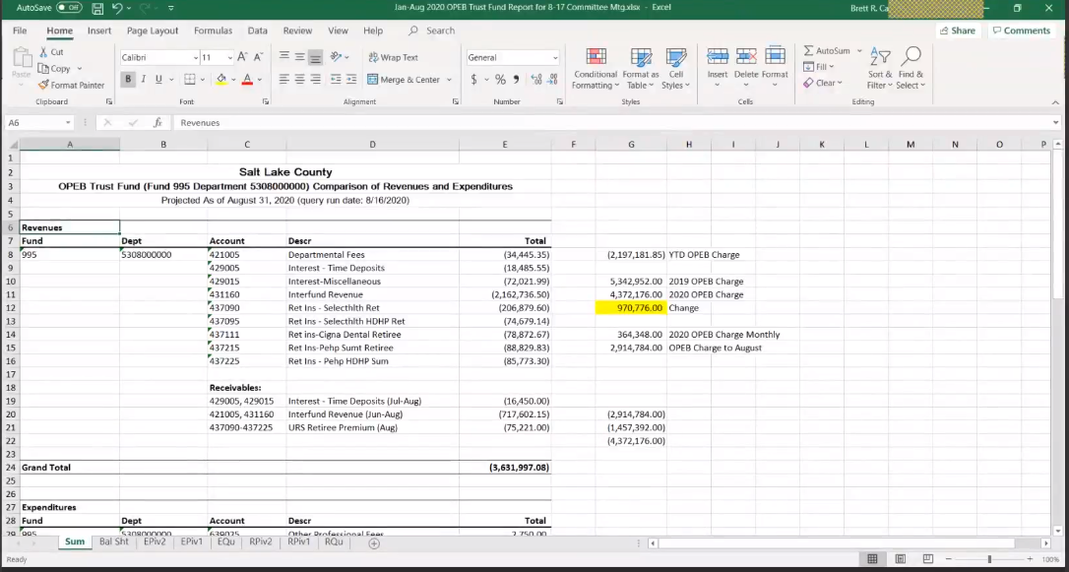
Mr. Carlson projected that the revenues to the end of August would be $3,631,997 after adjusting the for the lower OPEB charge.
After adjusting a few things, the expenditures $2,804,909 and that leaves it positive $827,887 in 2020 so it was better than last meeting which was positive $739,062.
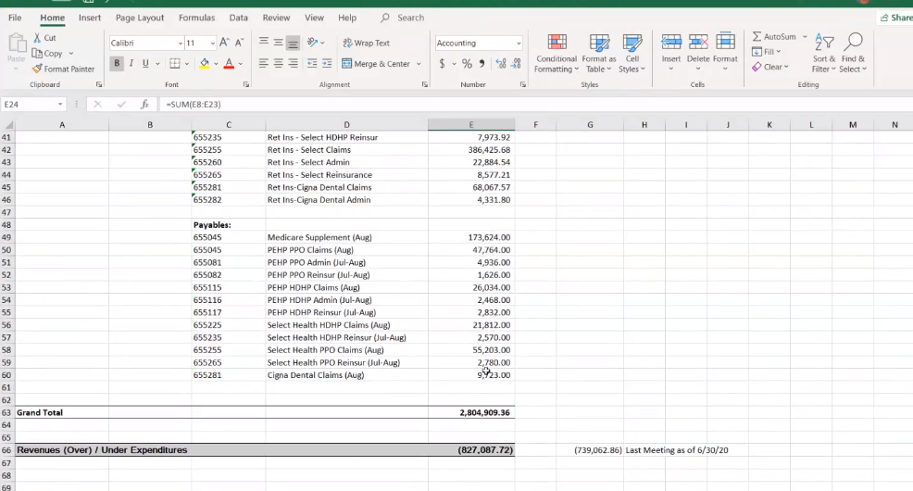
Mr. Carlson then referred to the Balance Sheet tab and pointed out the $7,992,717 at Moreton and $6,110,528 in the initial 3.8 million in the books for a total $9,910,000.
Mr. Carlson indicated that if he added the pending receivables and estimated expenses the amount would be $10,368,429 until the end of August. 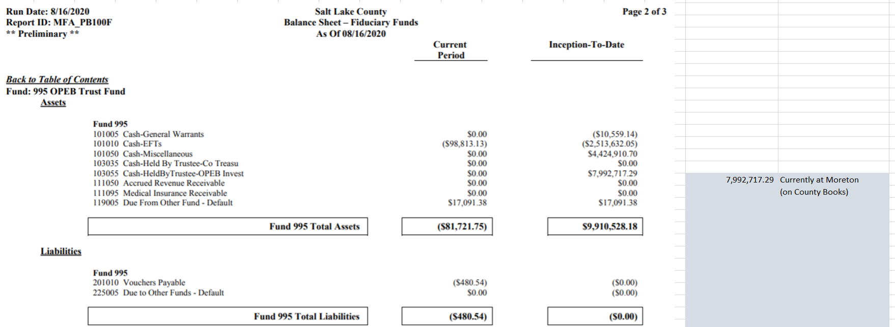
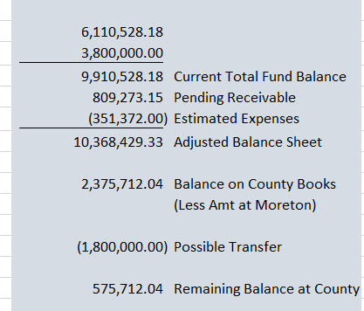
The difference between what Moreton has and what would be left in the balance sheet through the end of August, it would be $2,375,000. If 1.8 million were transferred that would leave it with $575,000 which is a little better that was demonstrated in the last meeting.
Mr. Casper then asked Mr. Carlson if there was anything in the update that would cause recoil from the thoughts of the last meeting to which Mr. Carlson replied that there was nothing he could see. Mr. Casper moved on to the next agenda item regarding strategy moving forward.

4. Moreton Strategy (Wayne Cushing, Jason Williams and Dawn Dachenhausen from Moreton)
Watch Meeting video/audio(log in first) – Presentation starts at 07:56
Mr. Cushing said that Moreton was prepared to discuss items: 1) what they would do with the 1.8 million and 2) report on the success of the equity investment group.
Mr. Williams shared various documents in his presentation that showed where they stood on fixed income markets and equity. He said that there was a lot of volatility to walk through because of the pandemic. He mentioned that there were successful quarters and executed some of the buys on the equity side of the portfolio during the trough of the epidemic.
Mr. Williams updated the committee on what has happened since the beginning of March and the start of COVID-19. He continued with summarizing on the income side as a “race to zero” by familiarizing the committee with what the interest rates are doing. He then would talk about the equity markets.

Portfolio Recommendation from Moreton (screenshot) (30:34-44:32)
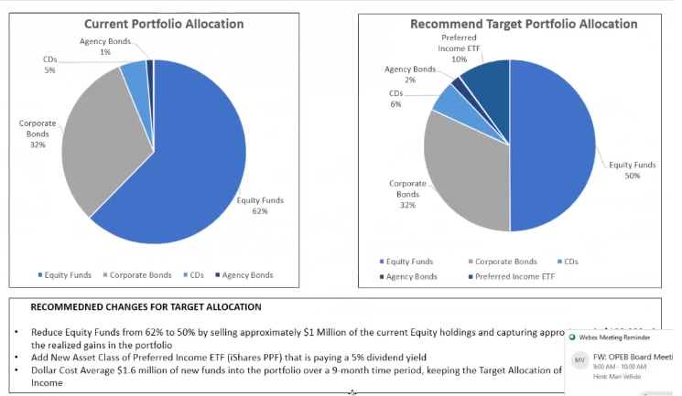
Summary of Motion (44:35-56:21)
Mr. Bodily asked what the long-term portfolio balance was and if it was 50-50. Mr. Casper confirmed that it was and mentioned that they would not necessarily change that based on the presentation by Moreton. Mr. Casper said that the board could be open to an allocation between 50% and 75% of equities based on Moreton’s professional recommendation.
Mr. Bodily said the preferred stock would traditionally be considered equity and that it was already going to be 60% by moving in that direction. Mr. Bodily then suggested to consider a motion for the long-term investment plan to be 75% equity. He then said that it would take several years to get there, and Mr. Cushing would be granted enough discretion to move based upon the recommendation of the investment advisors. That way, the portfolio would remain 50% and non-preferred stocks and 10% preferred stocks that was suggested. But as the market changes, Moreton can make that recommendation and Mr. Cushing can authorize it without having to reconvene the board.
Mr. Casper asked for input from the group and asked if there was a motion in that regard. Mr. Delquadro asked Moreton (Mr. Williams and Ms. Dachenhausen) why they (Moreton) were putting the preferred stocks on the fixed income side. Mr. Williams replied that the preferred state are hybrids so that there are some fixed income characteristics to the asset class. They have a set dividend whereas common stocks do not, and Moreton is classifying them as fixed income securities because of those characteristics. He went on to say that the target in terms of the exposure to common stocks allowed in terms of highest volatility of what is allowed under the Utah Management Act is still going to be at 50% long term as the recommendation set forth.
Mr. Williams re-stated that the long-term target is going to stay at 50% in terms of volatility. He mentioned that when OPEB started working with Moreton three years ago, the upper and lower bands were looked at in terms of volatility of a 50-50 versus a 70-30 versus a 30- 70. Mr. Williams will bring those figures for the next meeting for the committee to look at.
Mr. Delquadro then referred to Mr. Bodily and asked if the board needed to create a definition that includes preferred stock and the equity side or despite its hybrid characteristics. He then asked if they were looking for the cleanest language to allow up to 70% for equities which would include preferred stock. Mr. Bodily agreed that it was the simplest way to say it, and then went on to say that if you are including the preferred stock on the equity side, you go to move it from 50% to something like 60% to meet the recommended portfolio.
Mr. Bodily then said that for long term he was not sure that for the 30-year investment -- the 50% or even 60% (with included preferred stock) is going to give rate of return long term that the actuary is going to be looking at.
Mr. Delquadro then said that the committee needed to go up to 60% if not 70% and theorized that they could have the flexibility of using common stock instead of that two-thirds blend. For example, if the target was changed 1/3 fixed and 2/3 market equities (including the preferred stock) that does not mean that they must adhere to a percentage in the future.
Mr. Bodily added that if this was to be done, there should be some clarity that there is no impetus or suggestion that this must be done within the next 3-5 years because the markets are too unstable based on Moreton’s presentation. The re-balance would not be done until Moreton recommends when the GMP and the prices of stocks get into a more acceptable level.
Mr. Casper agreed with Mr. Bodily’ s possible motion to invest up to 75%. Mr. Cushing joined in saying that he would leave it up to 75%.
Motion: (1:01-1:05)
Mr. Delquadro motioned to change the parameters for the investment that the equities can represent up to 75% of the balance which would include preferred stock. Mr. Casper asked for any further discussion. Mr. Bodily wanted to make sure that the plan was inserted in the report (OPEB Trust Annual Report) so that it is publicly disclosed.
Mr. Cushing then asked Mr. Williams if they (Moreton) was ready for the $1.8 M transfer to which Mr. Williams replied that they were. Mr. Casper asked if there was a formal motion to transfer the $1.8 million to which there was no concrete answer. Ms. Okino motioned to move $1.8 M to Moreton for investments.
Mr. Casper then took the vote on both motions and they passed unanimously with all in favor. Mr. Casper then asked if there were any more items on the board. The group did not have any.

Mr. Casper made a motion to adjourn and the meeting was adjourned at 10:08 AM.
The next OPEB meeting was scheduled for Monday, September 21st at 1:30 PM via WebEx.

