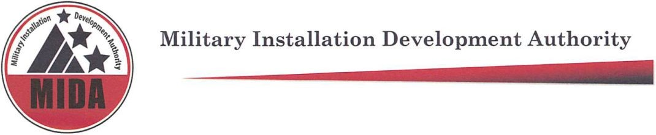

Military Installation Development Authority Board Meeting Draft Minutes
January 5, 202 @ 9:00 a.m.
Zoom Teleconference
To hear the Audio recording of this meeting please go to:
https://www.utah.gov/pmn/

Board Members Present: Jerry Stevenson, Stuart Adams, Mark Shepard, Gary Harter, ^Mike Ostermiller, Ben Hart* (arrives late)

Board Members Excused: Gage Froerer

*Non-voting Board Member
^ Entered meeting late

Agenda Item (1) Welcome: Stuart Adams

Agenda Item (2) Stuart Adams reads: Pursuant to section 52-4-207(4) Utah Code, the Chair made this written determination that conducting this meeting with an anchor location presents a substantial risk to the health and safety of those who may be present at the anchor location. This written determination is based on the current COVID-19 pandemic and the recommendation of health officials to avoid public gatherings.

Agenda item (3) Approval of Minutes for December 1, 2020

Jerry Stevenson: Motion to approve the minutes for December 1, 2020.

Mark Shepard: Second.

Stuart Adams, Jerry Stevenson, Mark Shepherd, Mike Ostermiller, vote “aye” in favor of approving minutes from December 1, 2020. None are opposed. The motion passes.

^Gary Harter enters meeting

Agenda item (4) FY2019-20 Audit Report

Rowley and Keddington explain the Audit report and outcome of the audit conducted.

Mike Ostermiller: Motion to accept the Audit Report.

Mark Shepard: Second.

Stuart Adams, Jerry Stevenson, Mark Shepherd, Gary Harter, Mike Ostermiller, vote “aye” in favor of accepting the Audit Report. None are opposed. The motion passes.

Agenda Item (5) Midyear Financial Update
Paul Morris introduces Paula Eldredge, CFO.

Paula Eldredge presents slides on screen and explains Mid-year financial information.
Paul Morris explains that MIDA does not have truth in taxation.

Stuart Adams: We need to help Wasatch County if needed. We appreciate you Paula
No Motion required.

Agenda item (6) Consideration of Resolution 2021- 01 Conforming MIDA’s Administrative Policies to Resolution 2019-08
Paul Morris explains that many of organizational administrative policies need to be amended in order to support MIDA’s growth.

Mark Shepard: Motion to approve Resolution 2021-01.

Jerry Stevenson: Second.

Stuart Adams, Jerry Stevenson, Mark Shepherd, Gary Harter, Mike Ostermiller vote “aye” in favor of approving Resolution 2021- 01 Conforming MIDA’s Administrative Policies to Resolution 2019-08

Agenda item (7) 2021 Legislative Session

Paul Morris explains MIDA legislative priorities.

Jerry Stevenson: The Bill File is open, and the drafters will work with you Paul.

Paul Morris: We are careful with what we ask for from the state. Private industry is backing a lot of money. We have an opportunity to preserve a trail in a once in a lifetime opportunity. It is the same for the MRF. We a lot of money backed by private investors.

Stuart Adams: It makes sense for the state to step in when projects have that level of economic impact on the state.

No motion required

Agenda Item (8) Other Business Including Update on MIDA projects

Kurt Krieg presents updates on the screen and discusses the MRF project area.

Taylor Woodbury presents his updates of the Falcon Hill Project Area
.
No Motion required.

Agenda Item (9) Open Meetings Training- cancelled.

Paul Morris: We may need to call a special meeting for the MRF

Agenda Item (10) Adjourn

Jerry Stevenson: Motion to adjourn.

Gary Harter: Second.

Stuart Adams, Jerry Stevenson, Mark Shepherd, Gary Harter, Mike Ostermiller, vote “aye” in favor of adjourning the meeting. None are opposed. The motion passes.

Meeting is adjourned at: 9:48 a.m.

Next meeting – April 6, 2021 at 9:00 am Legislure in Session

Meeting attendees: Steven Rowley, Ashley Burr, Paula Eldredge, Mike Wagstaff, Rob Donigan, Cory Shupe, Detlef Galke, David Williamsen, Richard Catten, Nicole Cottle, Kurt Krieg, Taylor Woodbury, Tyler Aldous, Roger Henricksen, Robert McConnell, Michael Kosakowski, Jack Walkenhorst, Thomas Leavens, Brooke Hontz, Michael Gladson, Glen Clement, Chris Holman, Brett Christensen, Bill Coleman, DR Theobold, Julie Fisher, Douglas DeVore, Val Oveson, Joshua Horner, Abraham Van der Spek, Derek Brenchley, Hannah Wilson, Dallin Koecher, Henrich Deters, SkyRidge Development, Brent Hall, Alexander Cramer, Allison Aafedt, Ben Vera,

NOTICES
The Military Installation Development Authority does not discriminate on the basis of race, color, national origin, sex, religion, age or disability in employment or the provision of services. If you are planning to attend this meeting and, due to a disability, need assistance in understanding or participating in the meeting, please notify the Authority eight or more hours in advance of the meeting and we will try to provide assistance. Please contact the Authority at (385) 232-1919.
Authority Board Members will participate in the meeting via videoconferencing or telephonic communication. Both videoconference and telephone communication will be enabled so that Members and all other meeting participants and attendees will be able to hear all discussions. General public attendees will be able to join this meeting after registration which is posted in conspicuous view on the Utah State Website. In the event of an absence of a majority quorum, agenda items will be continued to the next regularly scheduled meeting. By motion of a member of the Authority Board, the Board may vote to hold a closed meeting for any of the purposes allowed by law, Utah Code 52-4-204, 52-4-205, 52-4-206.
At least 24 hours before the meeting, this agenda was posted in conspicuous view on the Utah State Webpage.

