
November 10, 2020
DETERMINATION REGARDING CONDUCTING TOWN OF HIDEOUT PUBLIC MEETINGS
WITHOUT AN ANCHOR LOCATION

The Mayor of the Town of Hideout hereby determines that conducting a meeting with an anchor location presents a substantial risk to the health and safety of those who may be present at the anchor location pursuant to Utah Code section 52-4-207(4) and Hideout Town Ordinance 2020-03. The facts upon which this determination is based include: The percent and number of positive COVID-19 cases in Utah has been over 20% of those tested since November 2, 2020. The seven-day average of cases has been over 2437 since November 2, 2020. COVID-19 patients in Utah hospitals has been significant during the same time period.
This meeting will not have a physical anchor location. All participants will connect remotely. All public meetings are available via YouTube Live Stream on the Hideout, Utah YouTube channel at: https://www.youtube.com/channel/UCKdWnJad-WwvcAK75QjRb1w/
Public comments may be emailed to hideoututah@hideoututah.gov or by pre-registering to attend via Zoom application by emailing hideoututah@hideoututah.gov. Emailed comments received prior to the scheduled meeting will be read during the public comment portion and entered into public record.
This determination will expire in 30 days on December 10, 2020.

BY:
____________________________
Phil Rubin, Mayor

ATTEST:
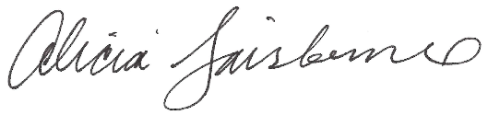
________________________
Alicia Fairbourne, Town Clerk

