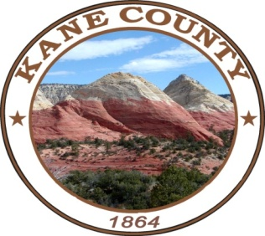
NOTICE AND AGENDA OF A MEETING OF THE KANE COUNTY COMMISSION
CEDAR MOUNTAIN FIRE PROTECTION
***************************************

PUBLIC NOTICE IS HEREBY GIVEN that the Commissioners of Kane County, State of Utah, will hold a CMFP Meeting in the Commission Chambers at the Kane County Courthouse, 76 North Main St., Kanab Utah on November 24, 2020 At 3:00 PM

WE WELCOME EVERYONE TO ATTEND ELECTRONICALLY BY PHONE.
CALL IN INFORMATION: Meeting call in # 435-676-9000 participant code 168030#
(This is a local call within the South Central service area)

CALL MEETING TO ORDER
WELCOME
INVOCATION
PLEDGE OF ALLEGIANCE

REGULAR SESSION

- Approval of 2021 Tenitive Budget / Wade Heaton

- CMFP Update / Wade Heaton

NOTICE OF SPECIAL ACCOMMODATION DURING PUBLIC MEETINGS:
In compliance with the Americans with Disabilities Act, individuals needing special accommodations (including auxiliary communicative aids and services) during this meeting should notify Karla Johnson at (435) 644-2458. Agenda items may be accelerated or taken out of order without notice as the Administration deems appropriate. All items to be placed on the agenda must be submitted to the Clerk’s office by noon Thursday, prior to the meeting.

