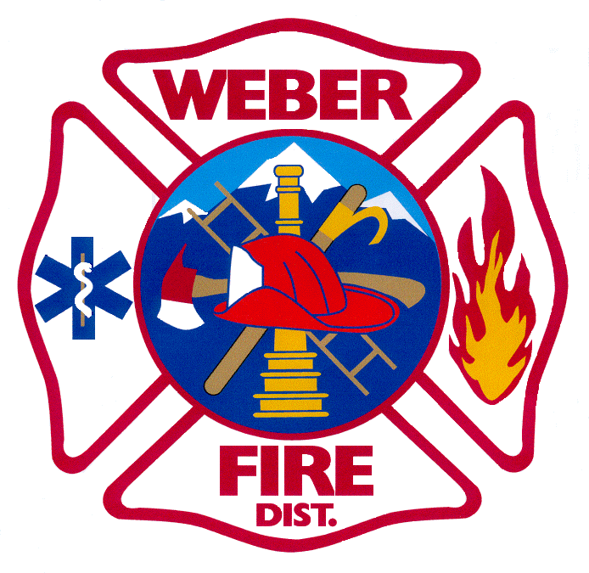

WEBER FIRE DISTRICT

NOTICE OF PUBLIC HEARING

Notice is hereby given that the Weber Fire District Board of Trustees will meet on Tuesday, November 10, 2020 at 5:30 p.m. at Station 61 located at 2023 West 1300 North, Farr West, Utah.
At 6:00 p.m. a public hearing will be held on the proposed 2020 Amended Budget reflecting adjustments in projected revenues and expenditures for the year ending December 31, 2020. The purpose of the public hearing is to hear comments regarding the District’s proposed 2020 Amended Budget. A copy of the 2020 Amended Budget will be on file for public inspection in the Administrative Office.
In compliance with the American Disabilities Act, persons requesting special accommodations for District-sponsored public meetings should call 801-782-3580 at least 24 hours before the meeting.

