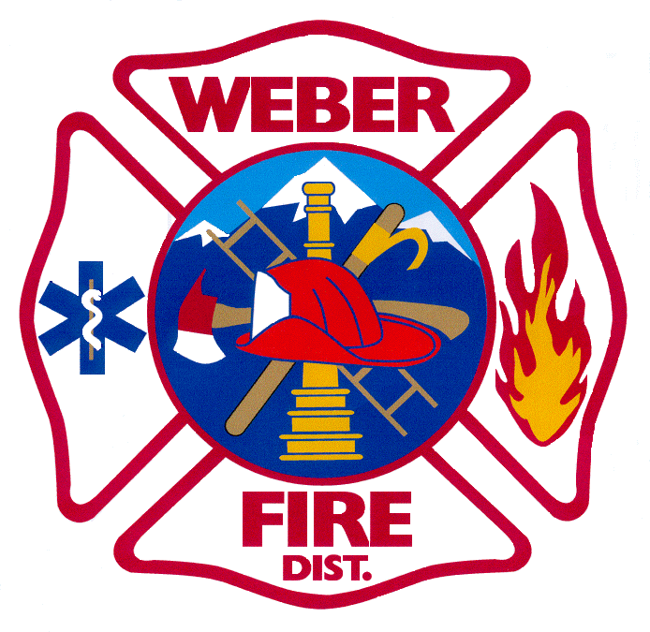

WEBER FIRE DISTRICT

NOTICE OF PUBLIC HEARING

Notice is hereby given that the Weber Fire District Board of Trustees will meet on Tuesday, November 10, 2020 at 5:30 p.m. at Station 61 located at 2023 West 1300 North, Farr West, Utah.
At 6:01 p.m. a public hearing will be held on the Tentative 2021 Budget. The purpose of the public hearing is to hear comments regarding the District’s proposed 2021 Budget. A copy of the 2021 Tentative Budget will be on file for public inspection at the Administrative Office.
In compliance with the American Disabilities Act, persons requesting special accommodations for District-sponsored public meetings should call 801-782-3580 at least 24 hours before the meeting.

