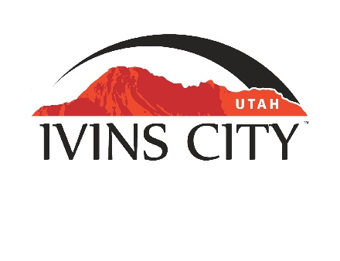
IVINS CITY

COUNCIL MEETING

AGENDA

October 17, 2019

Mayor Chris Hart

City Council Members

Ron Densley

Miriah Elliott

Jenny Johnson

Cheyne McDonald

Dennis Mehr

City Manager/Attorney:

Dale Coulam

The Ivins City Council will hold a regular meeting in the City Council Chambers, 55 N. Main St., Ivins, UT, on Thursday, October 17, 2019. The meeting will begin at 5:30 P.M.

Note: The order of items discussed on this agenda is subject to change

- WELCOME AND CALL TO ORDER
- Acknowledgement of Quorum
- Flag Salute
- Invocation
- Disclosures

- REPORTS AND PRESENTATIONS
- Department Reports: Building Department; Public Works/Engineering; Finance [TAB A]
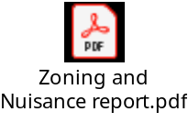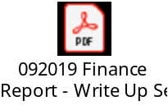
- Quarterly Finance Report
- Planning Commission Report

- CITIZEN COMMENT REQUESTING FUTURE AGENDA ITEMS
Any person wishing to bring an item not otherwise on the Agenda to the attention of the Mayor and City Council may address the City Council at this point by stepping to the microphone and giving his or her name and address for the record. Speaker forms shall be filled out in advance and given to the City Recorder. Remarks shall be limited to no more than two minutes, unless the Governing Body allocates additional time. The Mayor and City Council will take no action this evening.

- PUBLIC HEARING AND ACTION ITEMS - NONE

- DISCUSSION AND POTENTIAL ACTION ITEMS
- Discuss issues regarding the sale of the City’s 15.52 acres of real property located at approximately 750 East Center Street
- Discuss and consider approval of the selection of an Architect and expenditure for new City Hall design [TAB B]

- Discussion regarding the Arts Commission proposal for evaluation criteria for Arts RAP tax applications [TAB C]

- Discussion regarding the Arts Commission proposal for a student art exhibition [TAB D]

- Discussion regarding 2020 employee benefits

- Continued discussion regarding amendments to overlay provisions of Chapters 7 and 8 of the Ivins City Zoning Ordinance [TAB E]
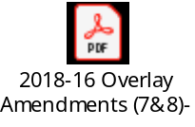

6) CONSENT AGENDA
- Appointment of Poll Workers for Municipal General Election [TAB F]

- Approval of City Council Meeting Minutes for October 3, 2019 [TAB G]


7) CONSENT AGENDA ITEMS FOR DISCUSSION

8) REPORTS
- Council
- Mayor
- City Manager/Attorney Dale Coulam
- Items to be placed on future agendas

9) CLOSED MEETING
10) ADJOURNMENT

Reasonable accommodation: Ivins City will make efforts to provide reasonable accommodation to disabled members of the public in accessing City programs. Please contact the City Recorder at least 24 hours in advance if you have special needs.

I hereby certify that I have posted copies of the agenda in three public and conspicuous places on Friday, October 11, 2019. Ivins City Hall, the Ivins Post Office, and the Kayenta Sales Office. I have also sent a copy of this agenda to The Spectrum newspaper, St. George News and posted it on the Utah Public Notice website.

Kari Jimenez, MMC
City Recorder

