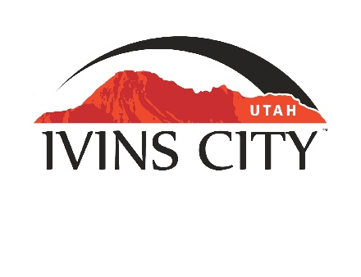
IVINS CITY

COUNCIL MEETING

*AMENDED AGENDA

September 5, 2019

Mayor Chris Hart

City Council Members

Ron Densley

Miriah Elliott

Jenny Johnson

Cheyne McDonald

Dennis Mehr

City Manager/Attorney:

Dale Coulam

The Ivins City Council will hold a regular meeting in the City Council Chambers, 55 N. Main St., Ivins, UT, on Thursday, September 5, 2019. The meeting will begin at 5:30 P.M.

Note: The order of items discussed on this amended agenda is subject to change

- WELCOME AND CALL TO ORDER
- Acknowledgement of Quorum
- Flag Salute
- Invocation
- Disclosures

- REPORTS AND PRESENTATIONS
- Concept Plan Report for T&L Parkway, located at approximately 175 West 100 South. Eric Gish-Owner; Eric McFadden, Premier Design-Applicant [TAB A]

- Concept Plan Report for Blake Subdivision, located at approximately 301West Highway 91. Daniel F. Pendleton Family Ltd Partnership-Owner; Ben and Heidi Blake-Applicants [TAB B]

- Department Reports: Parks and Recreation and Public Safety [TAB C]

- Planning Commission Report

- CITIZEN COMMENT REQUESTING FUTURE AGENDA ITEMS
Any person wishing to bring an item not otherwise on the Agenda to the attention of the Mayor and City Council may address the City Council at this point by stepping to the microphone and giving his or her name and address for the record. Speaker forms shall be filled out in advance and given to the City Recorder. Remarks shall be limited to no more than two minutes, unless the Governing Body allocates additional time. The Mayor and City Council will take no action this evening.

- PUBLIC HEARING AND ACTION ITEMS
- Public Hearing on the Planning Commission’s recommendation to approve amending the requirements for roof variations
- Discuss and consider approval of Ordinance No. 2019-07, an Ordinance of Ivins City, Utah, amending the requirements for roof variations [TAB D]


- DISCUSSION AND POTENTIAL ACTION ITEMS
- Discuss and consider approval of a Proclamation regarding Constitution Week [TAB E]

- *Discuss and consider approval of a Proclamation regarding the 2019-2020 School Year as an Alcohol-Free School Year for Youth [TAB F]

- Discuss and consider approval of Resolution No. 2019-10R, a Resolution of Ivins City, Utah, appointing an Arts Commission Member [TAB G]

- Discuss and consider approval of the Development Agreement for the Sage Villas Subdivision project [TAB H]

- *Discuss and consider an accessible Toe Trail trailhead on 100 East
- Discussion regarding a comprehensive outdoor lighting ordinance as proposed by Ivins Night Sky Initiative

- Discuss and consider Resolution No. 2019-20R, a Resolution of Ivins City, Utah, stating intent of Ivins City to adjust a common boundary with Santa Clara for 6.05 acres [TAB I]

- Continued discussion regarding amendments to Title 16, Chapter 7 of the Ivins City Code, except Part 5 regarding Subdivision Enhancement Overlay, as recommended by the Planning Commission in Ordinance No. 2018-16 [TAB J]


6) CONSENT AGENDA
- Approval of expenditure for Public Works vehicle [TAB K]

- Approval of expenditure for Plumbing Supplies for the Shinava pump station [TAB L]

- Approval of City Council Meeting Minutes for August 15, 2019 [TAB M]

- Approval of City Council Special Meeting Minutes for August 27, 2019 [TAB N]


7) CONSENT AGENDA ITEMS FOR DISCUSSION

8) REPORTS
- Council
- Mayor
- City Manager/Attorney Dale Coulam
- Items to be placed on future agendas

9) CLOSED MEETING

10) ADJOURNMENT

Reasonable accommodation: Ivins City will make efforts to provide reasonable accommodation to disabled members of the public in accessing City programs. Please contact the City Recorder at least 24 hours in advance if you have special needs.

I hereby certify that I have posted copies of the amended agenda in three public and conspicuous places on September 4, 2019. Ivins City Hall, the Ivins Post Office, and the Kayenta Sales Office. I have also sent a copy of this amended agenda to The Spectrum newspaper, St. George News and posted it on the Utah Public Notice website.

Kari Jimenez, MMC
City Recorder

