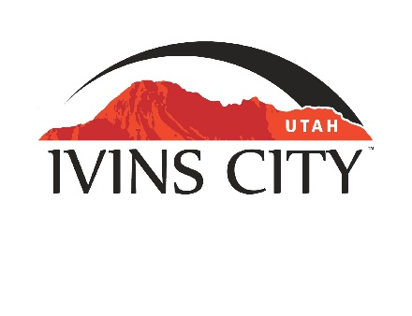
IVINS CITY

COUNCIL MEETING

AGENDA

August 15, 2019

Mayor Chris Hart

City Council Members

Ron Densley

Miriah Elliott

Jenny Johnson

Cheyne McDonald

Dennis Mehr

City Manager/Attorney:

Dale Coulam

The Ivins City Council will hold a regular meeting in the City Council Chambers, 55 N. Main St., Ivins, UT, on Thursday, August 15, 2019. The meeting will begin at 5:30 P.M.

Note: The order of items discussed on this agenda is subject to change

- WELCOME AND CALL TO ORDER
- Acknowledgement of Quorum
- Flag Salute
- Invocation
- Disclosures

- REPORTS AND PRESENTATIONS
- Department Reports: Building Department; Public Works/Engineering; Finance [TAB A]


- CITIZEN COMMENT REQUESTING FUTURE AGENDA ITEMS
Any person wishing to bring an item not otherwise on the Agenda to the attention of the Mayor and City Council may address the City Council at this point by stepping to the microphone and giving his or her name and address for the record. Speaker forms shall be filled out in advance and given to the City Recorder. Remarks shall be limited to no more than two minutes, unless the Governing Body allocates additional time. The Mayor and City Council will take no action this evening.

- PUBLIC HEARING AND ACTION ITEMS

- DISCUSSION AND POTENTIAL ACTION ITEMS
- Discuss and consider approval of Resolution No. 2019-19R, a Resolution of Ivins City, Utah, appointing Grand Marshals for the Ivins Heritage Days Parade [TAB B]

- Discuss and consider approval of the Development Agreement for the Sage Villas Subdivision project [TAB C]

- Discuss and consider approval of Ordinance No. 2018-18, an Ordinance of Ivins City, Utah, amending Outdoor Lighting Standards regarding color [TAB D]
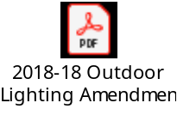
- Presentation and discussion regarding recommendations for updating entire outdoor lighting ordinance. Ivins Night Sky Initiative
- Discuss and consider approval of an expenditure for construction of the 200 West Sewer Diversion, Highway 91 Sewer extension and lower Tuacahn Wash Sewer Line improvements [TAB E]

- Discuss and consider approval of tortoise monitoring, material testing and additional engineering design services for the Red Mountain Dams Rehabilitation project [TAB F]

- Discuss and consider an expenditure to purchase a used dump truck [TAB G]

- Discuss and consider approval of an expenditure to purchase a skid steer loader [TAB H]

- Discuss and consider approval of Ordinance No. 2019-10, an Ordinance of Ivins City, Utah, amending the Purchasing Ordinance [TAB I]

- Discuss and consider approval of one 2020 Ford F-150 truck for the Public Safety Department [TAB J]

- Discussion regarding the Planning Commission’s recommendation regarding Ordinance No. 2019-07 regarding roof variations [TAB K]

- Continued discussion regarding amendments to Title 16, Chapters 7 and 8 of the Ivins City Code, except Chapter 7 Part 5 regarding Subdivision Enhancement Overlay, as recommended by the Planning Commission in draft Ordinance No. 2018-16

6) CONSENT AGENDA
- Approval of City Council Meeting Minutes for August 1, 2019 [TAB L TO FOLLOW]

7) CONSENT AGENDA ITEMS FOR DISCUSSION

8) REPORTS
- Council
- Mayor
- City Manager/Attorney Dale Coulam
- Items to be placed on future agendas

9) CLOSED MEETING

10) ADJOURNMENT

Reasonable accommodation: Ivins City will make efforts to provide reasonable accommodation to disabled members of the public in accessing City programs. Please contact the City Recorder at least 24 hours in advance if you have special needs.

I hereby certify that I have posted copies of the agenda in three public and conspicuous places on Friday, August 9, 2019. Ivins City Hall, the Ivins Post Office, and the Kayenta Sales Office. I have also sent a copy of this agenda to The Spectrum newspaper, St. George News and posted it on the Utah Public Notice website.

Kari Jimenez, MMC
City Recorder

