Kanosh Town is committed to taking steps to protect the health, safety, and well-being of our community. With the recent spread of COVID-19, some changes are necessary for conducting Kanosh Town public meetings. To follow the "Stay Safe, Stay Home" directive given by Governor Gary Herbert on March 26, 2020, we will suspend all Kanosh Town face-to-face public meetings until this directive is lifted and conditions within our State are deemed safe for social interaction.
Kanosh Town Corporation held the regular council meeting on Wednesday, September 9, 2020, in the town office at 7:00 p.m.

Members present:, Mayor Frank Paxton, Council members Rodney Whatcott, Neil Shumway, and Brandon Stephenson. Kanosh Town Treasurer: Karen Crook and Kanosh Town Clerk: Cindy Turner.
Councilmember Hayden George did not attend tonight's meeting

Others in attendance Kanosh Town Employee Lorin Shumway, CERT Captain Geri Minton, Chad Whitaker, Ben Corray, and Robert Worley.

Councilmember Brandon Stephenson led everyone in attendance in a moment of reverence.

Mayor Frank Paxton led everyone in attendance in the pledge of Allegiance.
Mayor Frank Paxton welcomed everyone in attendance at the September 2020 council meeting.
Mayor Paxton reported that the Park Committee has made arrangements to hydroseed the park. There cannot be any events scheduled for the park this year. A short cement wall will be poured around the power box between the new oil parking stalls and the fire station to protect the power supply to the park and also to protect the telephone pedestal in that same area. There are a few more items/holes to close up around the amphitheater and the basketball court. The new concession stand has marble countertops and cabinets. A sink and water heater will also be installed.
Minutes of the August 12, 2020 meeting were approved as amended through motion by Councilmember Rodney Whatcott, Councilmember Brandon Stephenson provided a second to the motion, all Councilmembers voted in favor as noted below:
Mayor Frank Paxton: Aye
Council members
Rodney Whatcott: Aye
Brandon Stephenson: Aye
Neil Shumway: Aye

Warrants for September 2020 were read discussed and approved to be paid through a motion by Councilmember Brandon Stephenson, Councilmember Rodney Whatcott seconded the motion, all Council members voted in favor as noted below:
Mayor Frank Paxton: Aye
Council members
Rodney Whatcott: Aye
Neil Shumway: Aye
Brandon Stephenson: Aye
CERT:
Kanosh CERT Captain Geri Minton stated there is nothing new to report, all meetings have been canceled due to COVID.

FIRE DEPARTMENT:
Kanosh Fire Chief Lorin Shumway reported that right now things are slow in the department, they have responded to a couple of small fires but were able to stay on top of them. Our volunteers have provided good support whenever we do have a fire!

*The Fire Department is keeping their meetings to a minimum due to COVID.

*Cameras have been installed throughout the park and inside and outside of the fire station.

PLANNING AND ZONING:
Planning and Zoning spokesman Geri Minton presented the building permit for a metal farm equipment storage building of Chad Whitaker to the Council, everything has been signed off and approved by the Planning and Zoning Committee. The building will be located behind Mr. Whitakers' residence.

*Mr. Kerry Black submitted a permit for new water and electrical connection for his property at
35 E 200 N. the request has been signed off and approved by the Planning and Zoning Committee.

Councilmember Rodney Whatcott motioned in approval of Mr. Chad Whitaker and Mr. Kerry Black's building permit as presented. Councilmember Neil Shumway seconded the motion, all Council members voted in favor as noted below:
Mayor Frank Paxton: Aye
Council members
Rodney Whatcott: Aye
Neil Shumway: Aye
Brandon Stephenson: Aye

FULL-TIME EMPLOYMENT:
The attorney has been out of town and has not been available to put together a full-time employment policy. He will begin working out the policy and procedures, and the legalities associated with full-time employment. Councilmember Whatcott will continue to follow up with the attorney.

Councilmember Brandon Stephenson has met Moreton and Company Financial Advisors, they will set up whatever benefits Kanosh wants to offer and can have it ready by the first of next month. They have asked to meet electronically with those interested, on Friday to go over the packages.

HALLOWEEN PARTY:
Councilmember Brandon Stephenson commented, the park project has been going quite a while, it was scheduled to be complete in time for the 24th of July celebration (a celebration we were unable to hold) it would be good for our community to have some kind of celebration. Council members discussed several ideas. However, the majority of all in attendance was to hold off on town supported functions until next spring.

PARK RESOLUTION AND FEES:
The existing park resolution and fees were reviewed and discussed. Councilmember Rodney Whatcott volunteered to take into consideration all of the suggestions and compile a resolution or draft resolution addressing the park fees to present at the October meeting.

WATER SYSTEM:
Councilmember Rodney Whatcott brought all in attendance up to date on what is going on in the water department. Over the last couple of years, Councilmember Whatcott and Mr. Worley have met to try to determine the best and most cost-effective avenues to increase our water flow. Currently, options for a Town well are being researched.

Mr. Robert Worley of Sunrise Engineering submitted the following letter to Mayor Paxton and the other Councilmember's:
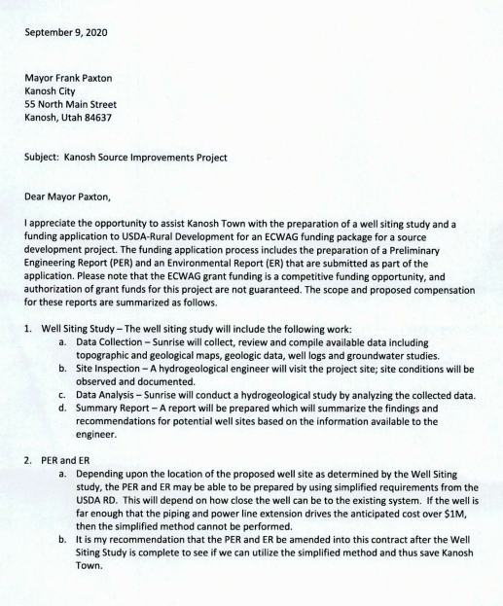
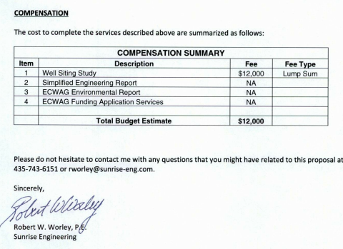

Mr. Worley explained that if we could capture another 15 gallons a minute through a spring development, that would be the equivalent of about 10 homes. We have discussed the possibility of a well, targeting about 300 gallons a minute. The spring development is a more expensive option compared to what you would get, than the development of a well. Either option involves risky measures. A couple of weeks ago the government issued their drought map:
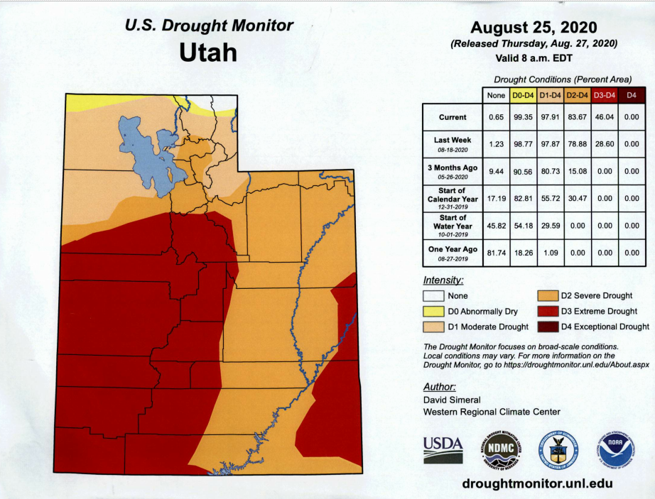

Right now we are considered to be in an extreme drought situation. Over the last few years, emergency grants have been available for this kind of situation. The grants are strictly for emergency situations that are a result of a natural disaster. Drought is considered a natural disaster. This grant is through the USDA, they will not accept an application without the Preliminary Engineering Report (PER) and an Environmental Report (ER). Each of these reports is costly, that is the downside, however, they are 100% grants. It is capped at $1,000,000,000.00. Note: see explanation below:

Emergency Community Water Assistance Grants (ECWAG)

ECWAG is a program set up by USDA Rural Development to help communities with populations under 10,000 improve culinary water sources that were depleted by the western drought
- Code of federal regulations:
- Title 7
- Subtitle B
- Chapter XVII
- Part 1778
§ 1778.6 Eligibility.
(a) Grants may be made to public bodies and private nonprofit corporations serving rural areas. Public bodies include counties, cities, townships, incorporated towns and villages, boroughs, authorities, districts, and other political subdivisions of a State. Public bodies also include Indian tribes on Federal and State reservations and other federally recognized Indian Tribal groups in rural areas.
(b) Any entities responsible for willfully or purposely fouling a drinking water supply are not eligible to be the recipients of an award under this program.
(c) In the case of grants made to alleviate a significant decline in quantity or quality of water available from the water supplies of rural residents, the applicant must demonstrate that the decline occurred within two years of the date the application was filed with the Agency. This would not apply to grants made for repairs, partial replacement, or significant maintenance on an established water system. In situations involving imminent decline, the evidence must be presented to demonstrate that the decline is likely to occur within one year of the date the application is filed with the Agency.

Mr. Worley stated he would recommend chasing this ECWAG emergency money. In looking at the spring output, it is lower now than it has been.
When our Master plan was developed some 20 years ago, spring capacity was 330 - 334 GPM our capacity today is 292 GPM. With this drop in GPM, it increases our likelihood of qualifying for the emergency grant.

The well would serve as our secondary water source.

Mr. Worley recommended to proceed in a two-step fashion noting that it is better to get it in sooner than later, because of the current drought conditions:
1) conduct a well sighting study (looking at the underground geology, find out where our best chance is to find a good water source)
2) quick cost estimate, if under a million dollars we go with the simplified version of the (PER) at the cost of about $12,000.00, if the project is over a million dollars we would have to go with a standard version which is about double that cost.

Mr. Worley also recommended getting the master plan and impact fees updated and the best way to pay for that is through the CIB. They could give us a 50% grant to do it.

Councilmember Rodney motioned to continue with the well sighting study as presented by Mr. Robert Worley, Councilmember Neil Shumway seconded the motion, all Council members voted in favor as noted below:
Mayor Frank Paxton: Aye
Council members
Rodney Whatcott: Aye
Neil Shumway: Aye
Brandon Stephenson: Aye

Councilmember Rodney Whatcott noted the willows are coming back at the springs, they will need to be taken care of. We may be able to get the Millard County inmate work crew out here again.

ELECTRICAL DEPARTMENT:
Councilmember Neil Shumway stated there is nothing new to report in the electrical department at this time.

ROAD DEPARTMENT:
Councilmember Brandon Stephenson has followed up with the contractor who did the chip seal project, there was not anything in the contract for anything at the cemetery.

Councilmember Stephenson is still working on the waterways.

The roads may benefit from being swept with a street sweeper. Kanosh Town does not own a street sweeper at this time, options will be researched.

PUBLIC COMMENTS:
Ben Corray questioned if the gravel pit has operating hours?
Response: it is a WW Clyde gravel pit, in Millard County, Kanosh has no jurisdiction.

REVIEW OF UTILITY DELINQUENCIES:
Council members reviewed the monthly delinquency list. It was determined, again, to handle those accounts in arrears according to established Town policy.

OLD BUSINESS:
CARES ACT: we are waiting on quotes for the project before we can fill out the application.

There being no further business to come before the board, the meeting adjourned.

Frank Paxton Cindy Turner
Kanosh Town Mayor Kanosh Town Clerk

