
September 24, 2020

DETERMINATION REGARDING CONDUCTING TOWN OF HIDEOUT PUBLIC MEETINGS
WITHOUT AN ANCHOR LOCATION

The Mayor of the Town of Hideout hereby determines that conducting a meeting with an anchor location presents a substantial risk to the health and safety of those who may be present at the anchor location pursuant to Utah Code section 52-4-207(4) and Hideout Town Ordinance 2020-03. The facts upon which this determination is based include: The percent and number of positive COVID-19 cases in Utah has been over 5% of those tested since May 27, 2020. The seven-day average of cases has been over 200 since May 27, 2020. COVID-19 patients in Utah hospitals has been significant during the same time period.
This meeting will not have a physical anchor location. All attendees will connect remotely. All public meetings are available via ZOOM conference call. Interested parties may join by dialing in as follows:
Meeting URL: https://zoom.us/j/4356594739
To join by telephone dial: US: +1 408-638-0986
Meeting ID: 4356594739
Additionally, comments may be emailed to the Town Clerk afairbourne@hideoututah.gov.
This determination will expire in 30 days on October 21, 2020.
BY:


____________________________
Phil Rubin, Mayor

ATTEST:
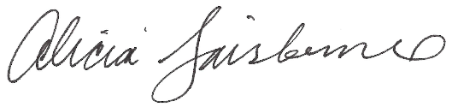
________________________
Alicia Fairbourne, Town Clerk

