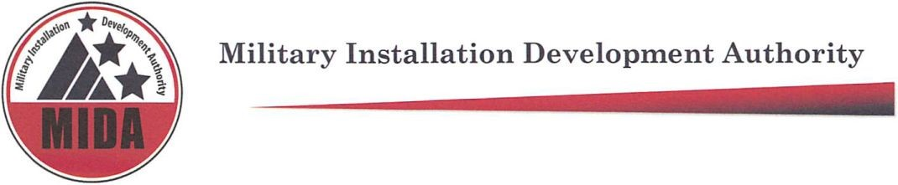

MIDA Board Meeting Approved Minutes
September 1, 2020 @ 9:00 a.m.
Zoom Teleconference
To hear the audio recording of this meeting please go to: https://www.utah.gov/pmn/sitemap/notice/606743.html

Board Members Present: Mark Shepherd, Gary Harter, Mike Ostermiller, Steve Farrell and Gage Froerer Board Members
Excused: Stuart Adams*, Jerry Stevenson, Ben Hart*^
*Enter the meeting late
^Non-voting board member
Agenda item (1) Welcome: Mark Shepherd.
Agenda item (2) Mark Shepherd Reads: Pursuant to section 52-4-207(4) Utah Code, the Chair made this written determination that conducting this meeting with an anchor location presents a substantial risk to the health and safety of those who may be present at the anchor location. This written determination is based on the current COVID-19 pandemic and the recommendation of health officials to avoid public gatherings.
Agenda item (3) Approval of Minutes for May 26, 2020
Gary Harter: Motion to Approve the May 26, 2020 minutes
Mike Ostermiller: Second
Steve Farrell, Mark Shepherd, Gary Harter, Mike Ostermiller, Gage Froerer vote “aye” in favor of approving minutes from May 26, 2020. None are opposed. The motion passes.
Agenda item (4) Extell Update- Gary Barnett Provides updates for MRF and the MIDA Mountain PID.
Agenda item (5) Consideration of Resolution 2020-26 Approving the North Mayflower Master Development Plan.
Rob Donigan presents the North Mayflower development plan on the screen and explains the recommendations from the staff report.
9:24 Senator Stuart Adams joins the meeting.
9:33 Ben Hart enters the meeting.
Rob Donigan explains the approved ERUs per parcel
Gary Harter and Paul Morris discuss the frontage road, the updated map from the fire district, and road configurations.
Mark Shepherd: Motion to approve Resolution 2020-26.
Mike Ostermiller: Second.
Stuart Adams, Mark Shepherd, Gary Harter, Mike Ostermiller, Gage Froerer vote “aye” in favor of approving resolution 2020-06. None are opposed. The motion passes.
Stuart Adams takes over as chair for the MIDA board Meeting.
Agenda item (6) MIDA Mayflower Village Public Infrastructure District Series 2020 Assessment Bond Update.
Laura Lewis presents updates on the Bond assessment process for the MRF Project Area.
Agenda item (7) Other Business Including Updates on Various MIDA Projects
Tyler Aldous presents updates on Skyridge Development.
Taylor Woodbury presents updates on the Falcon Hill Project Area.
Agenda item (8) Adjourn
Mark Shepherd: Motion to Adjourn
Steve Farrell: Second
Stuart Adams, Mark Shepherd, Gary Harter, Mike Ostermiller, Gage Froerer vote “aye” in favor of adjourning the meeting. None are opposed. The motion passes.
Meeting Adjourned 10:17
Meeting Attendees: Mark Dalton, Bill Coleman, Brett Christiansen, Michael Wosin, Robert McConnell, Roger Henriksen, Mark Dalton, Brooke Hontz, Danielle Haymond, Glen Clement, Hannah Wilson, Jack Johnson, Jack Wolkenhorst, John Burdick, Joshua Horner, Sid Embree, Gary Barnett, Heather Kruse . Kurt Krieg, Laura Lewis, Michael Wagstaff, Paula Eldredge, Richard Catten, Robert Donigan, Taylor Woodbury, Cory Shupe, Detlef Galke, Bret Whalen, David Williamsen, Tyler Aldous

