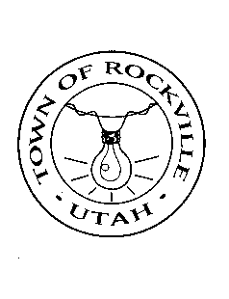

ETHICAL BEHAVIOR PLEDGE FORM

Annual Ethics Pledge

The following pledge is required to be made annually by all officers and employees of the Town of Rockville.

I, _____________________________________ am the duly elected/appointed
_______________________________________of the Town of Rockville, Utah.

I pledge to adhere to the code of ethics as approved by the Rockville Town Council. These topics include, but are not limited to: improper use of official position, accepting gifts or loans, disclosing privileged information, retaining a financial or beneficial interest in a transaction, nepotism, misuse of public resources or property, outside employment, political activity, fair and equal treatment, and conduct after leaving office or employment. Additionally, I pledge to disclose all conflicts of interest on the conflict of interest disclosure form. I understand that state statute and Town of Rockville Employee Policy provide for penalties for violation of specific unethical behavior. Signing this document verifies that I have been provided time to read applicable statutes and ordinances, as well as the Town of Rockville Code of Ethics.

Dated this ______ day of ____________________, 2020.

By: ________________________________

Title/Office:__________________________

_______________________________________
Attested: Vicki S. Bell, Town Clerk

